Supplementary information

Additional file 1: Interview topic guide

Part 1
Question examples | General knowledge of vitamin D
1 | Could you tell me what you know about vitamin D?
2 | Tell me about what you know about the importance of vitamin D
3 | Tell me about any benefits you know about vitamin D
4 | Can you name any sources of vitamin D?
5 | Where did you hear about this information?
6 | How does this information make you feel?

Question examples | General knowledge of vitamin D deficiency
1 | Could you tell me what you know about vitamin D deficiency?
2 | Tell me about what you know about the health consequences of VDD
3 | Are you aware of any diseases linked with vitamin D deficiency?
4 | Are you able to identify any symptoms of vitamin D deficiency?
5 | How common do you think vitamin D deficiency is in the UK?
6 | How important do you think vitamin D deficiency is in the UK?
7 | Are you aware of any risk factors for vitamin D deficiency?
8 | Which individuals do you feel may be at higher risk of vitamin D deficiency?

Part 2
Question examples | Diet, lifestyle, culture
1 | Tell me about an average day of eating for you and what foods you usually consume at each meal
2 | Could you tell me about any sources of vitamin D in either food or elsewhere?
3 | Describe your lifestyle in terms of activity and going outdoors
4 | How do you feel about the amount of outdoor time you are getting during the year?
5 | How does your own culture influence your dietary choices?
6 | Can you describe typical foods that are part of your culture?
7 | What are your feelings and thoughts about how culture can influence health?
8 | How do you feel your own culture can influence vitamin D exposure and intake?
9 | How do you feel culture in general can influence vitamin D exposure and intake?
10 | How do you feel cultural diets can affect nutrient intake?
11 | Can you think of any cultural barriers to vitamin D intake?
12 | How do you think wearing headscarves or veils in some cultures may affect vitamin D levels?
13 | What is your perception of vitamin D deficiency in your culture?
14 | How might culture affect the amount of vitamin D someone gets?

Part 3
Question examples | Debates: sun protection vs sun exposure
1 | Tell me what you know about the importance of sun protection
2 | Tell me what you know about the importance of sun exposure
3 | Tell me your thoughts about any confusion you might have between sun exposure vs sun protection

Part 4
Question examples | Perceptions to vitamin D supplementation and food fortification
1 | Tell me what you know about vitamin D supplementation
2 | Tell me how you feel about vitamin D supplementation
3 | Do you take or have you ever taken vitamin D supplements?
4 | Have you ever come across information with regards to taking vitamin D supplements?
5 | Tell me your thoughts and attitudes to food fortification with vitamin D
6 | How do you feel about the idea of food being fortified with vitamin D?
7 | How do you feel about the idea of taking vitamin D supplements?
8 | Are you aware of where to get vitamin D supplements?
9 | In order to increase vitamin D levels, what form of vitamin D would you prefer to take?

Part 5
Question examples | Public health and cultural barriers
1 | Are you aware of any public health guidelines with regards to vitamin D? Are you aware of the UK guideline for vitamin D?
2 | Where did you find out about this?
3 | How does this guideline make you feel?
4 | What else do you know about this guideline?
5 | How does knowing about this UK guideline make you feel? (after telling them the guideline)
6 | Are you aware of the vitamin D supplementation scheme in Newham?
7 | How would you feel about engaging with local community schemes/ services like this?
8 | How much vitamin D do you think adults require each day?
9 | How culturally inclusive do you feel the public health guidance is with regards to vitamin D?
10 | Tell me of any ideas you have on how public health can improve vitamin D levels in the population
11 | Do you feel that current health guidelines are inclusive to everyone and all cultures?
12 | What suggestions do you have for improving vitamin D awareness in the public?
13 | How could public health improve vitamin D awareness?
14 | Are there any further comments or ideas you have to discuss?

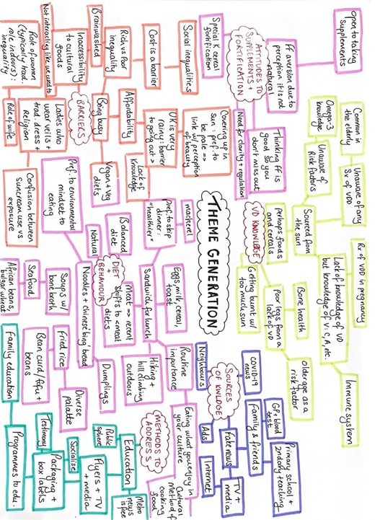
Additional file 2:

