Supplementary Fig. S1
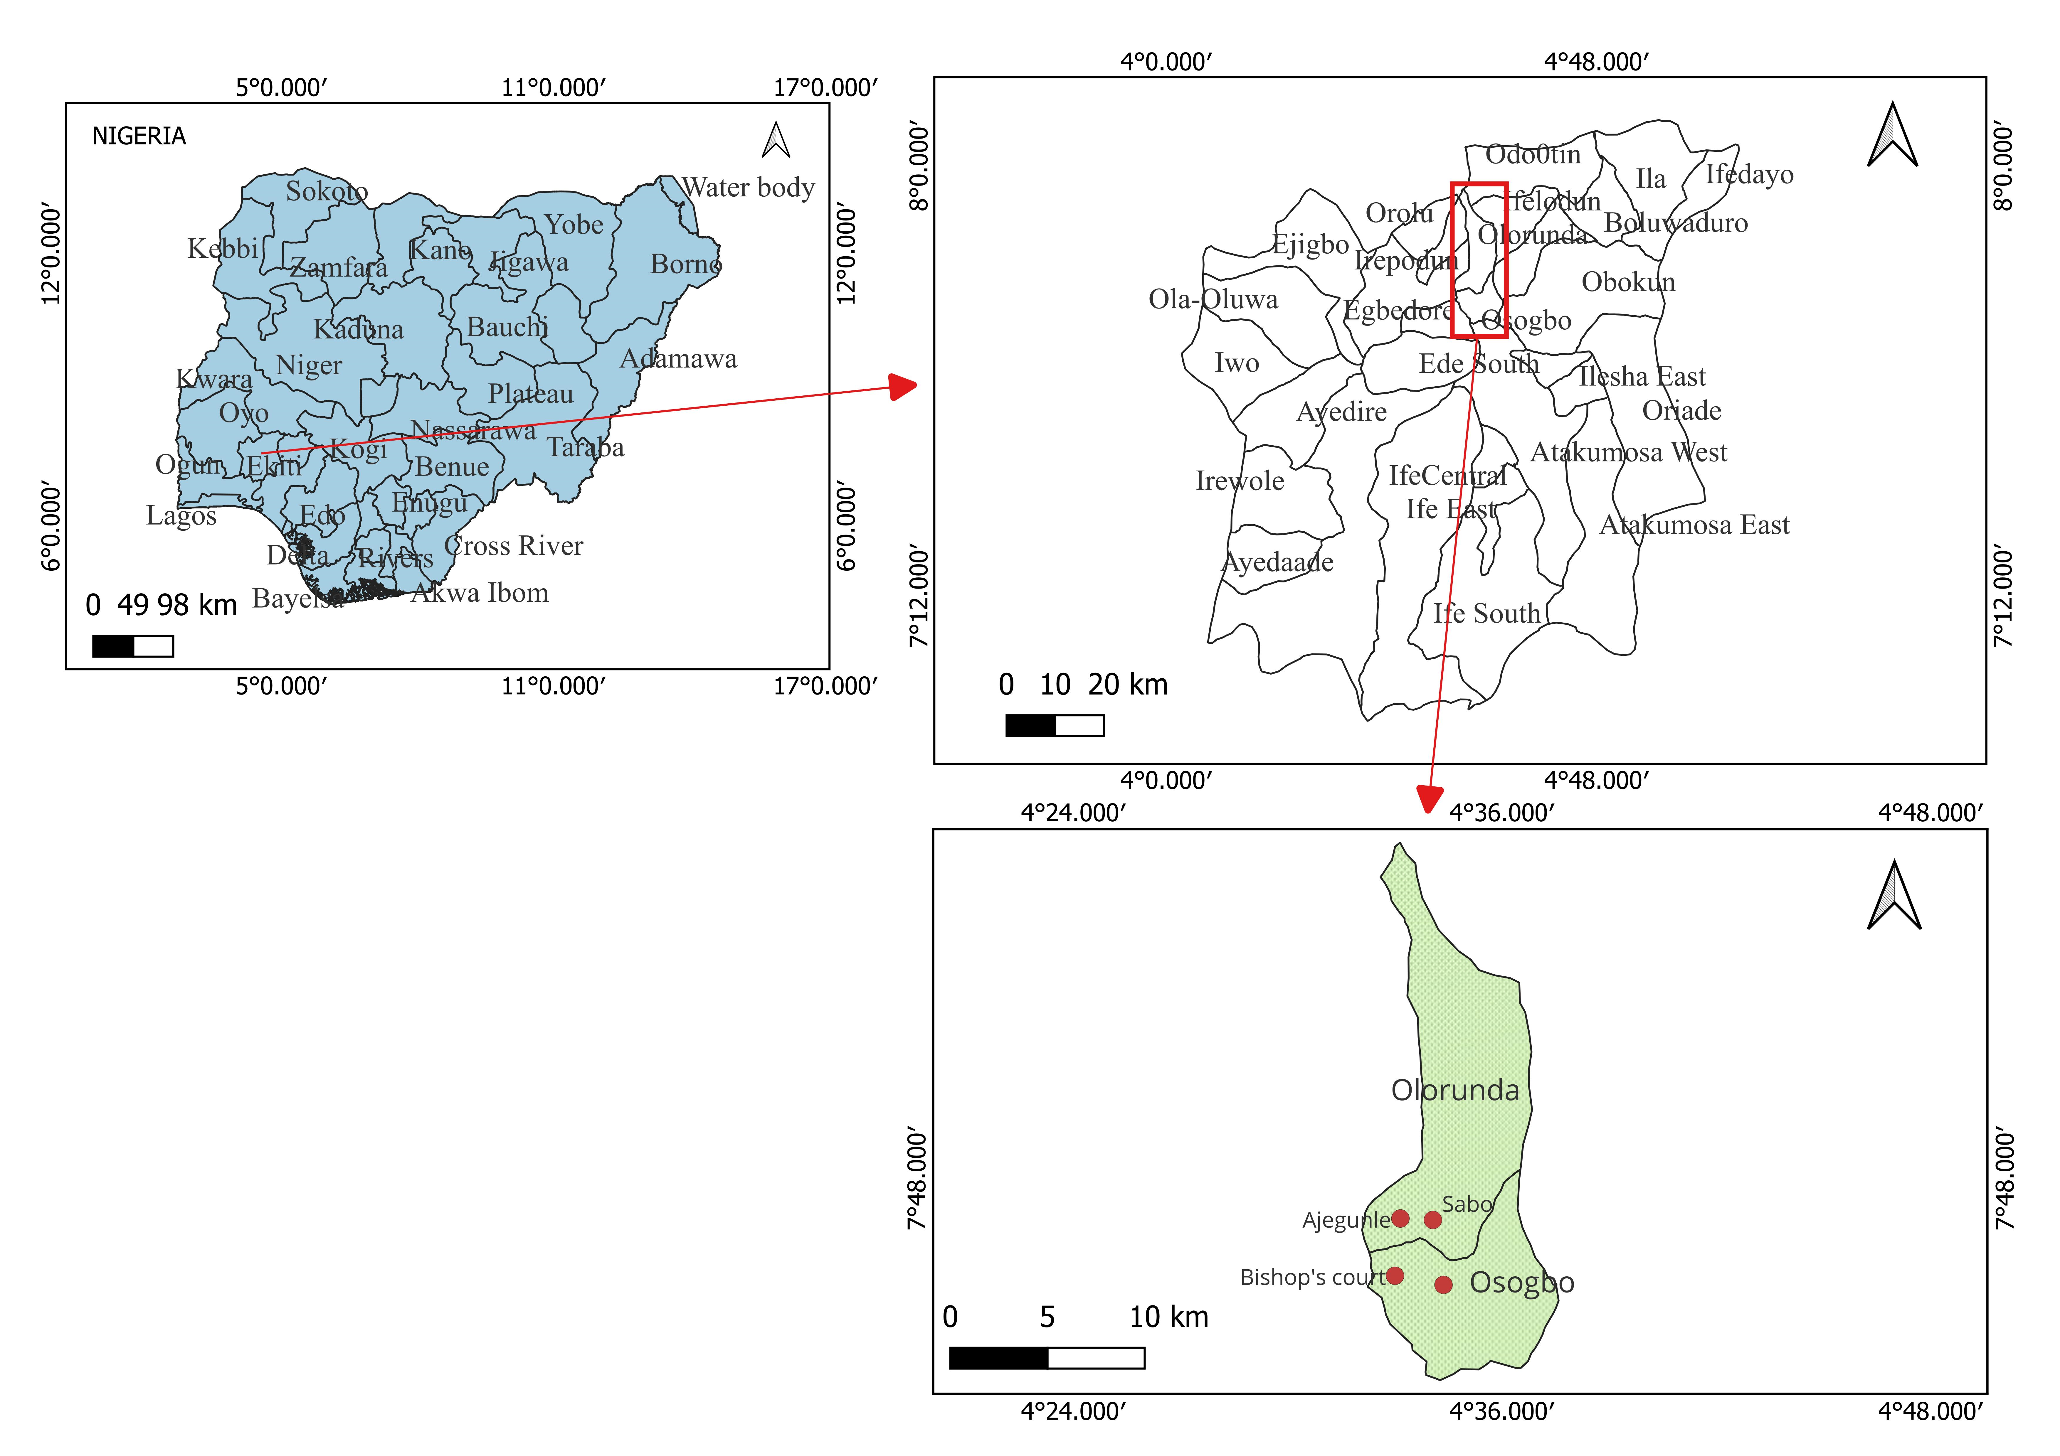
Fig. S1. Map showing the location of the four mosquito breeding sites considered in this study
Supplementary Table S1. The primer sets used in this study
Gene | Primer | Reference
Bacterial 16S rDNA | Forward: 27F: 5′-AGAGTTTGATCCTGGCTCAG-3′  Reverse: 1492R: 5′-GGTTACCTTGTTACGACTT-3′ | [14]
Fungal internal transcribed spacer (ITS) | Forward: ITS1 (5' TCCGTAGGTGAACCTGCGG–3')  Reverse: ITS4 (5'–TCCTCCGCTTATTGATATGCA–3') | [15]
Wolbachia-specific primer | Forward: WolbF (5′-GAAGATAATGACGGTACTCAC-3′)  Reverse: Wspecr (5′-AGCTTCGAGTGAAACCAATTC-3′) | [16]

Supplementary Fig S2
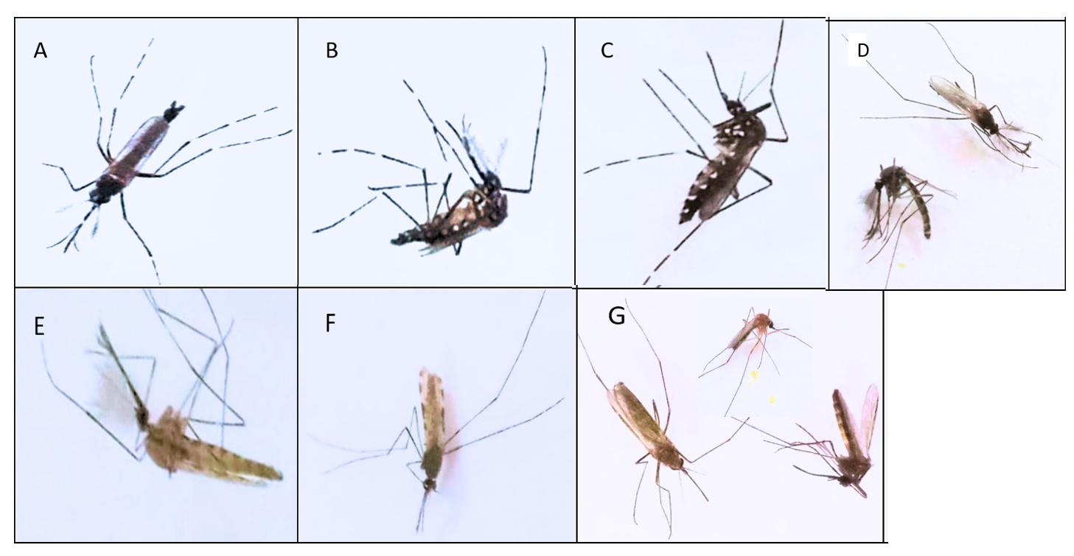
Fig. 2. Pictures of mosquitoes that emerged from the collected larvae and pupae. (A). The dorsal part of Aedes sp. (B). The ventral part of male Aedes sp. (C). Female Aedes sp. (D). Male Toxorhynchites sp. (E). Male Anopheles sp. (F). Female Anopheles sp. (G). Female Culex sp.

Supplementary Fig. S3
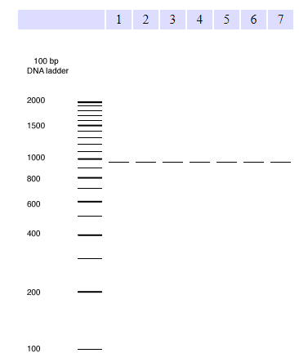
Fig. S3. The result of the in silico PCR analysis to test the integrity and specificity of Wolbachia-specific primer used in this study. 1 - Wolbachia endosymbiont of Culex quinquefasciatus Pel; 2 - Wolbachia endosymbiont of Drosophila melanogaster; 3 - Wolbachia endosymbiont of Drosophila simulans wHa; 4 - Wolbachia endosymbiont of Drosophila simulans wNo; 5 - Wolbachia endosymbiont of Onchocerca ochengi; 6 - Wolbachia endosymbiont strain TRS of Brugia malayi; 7 - Wolbachia sp. wRi

