SUPPLEMENTARY

Supplementary Table 1 ETEC-S3 Annotation Results using UniprotKB
Protein Names | Organism | Taxonomy ID | Length | Positives (%)
Putative colanic acid-degrading protein | Escherichia phage nepoznato | 2696431 | 1017 | 99,8
Tail fiber protein | Escherichia phage ESCO13 | 1881104 | 958 | 99,8
DNA polymerase | Escherichia phage ESCO14 | 1881104 | 865 | 100
Putative primase/helicase | Escherichia phage anhysbys | 2696383 | 592 | 100
Ribonucleoside-diphosphate reductase | Escherichia phage vB_EcoM_Schickermooser | 2508195 | 746 | 100
Putative terminase large subunit | Escherichia phage anhysbys | 2696383 | 691 | 100
Tape measure protein | Escherichia phage phAPEC8 | 1229753 | 662 | 100
Anaerobic ribonucleoside-triphosphate reductase | Escherichia phage ESCO5 | 1897495 | 604 | 99,7
Tail sheath protein | Escherichia phage vB_EcoM-Ro121c4YLVW | 2144176 | 457 | 100
Portal protein | Escherichia phage vB_EcoM-Ro121c4YLVW | 2144176 | 464 | 100
Baseplate protein J-like domain-containing protein | Escherichia phage anhysbys | 2696383 | 495 | 100
DNA 3'-5' helicase | Escherichia phage anhysbys | 2696383 | 530 | 100

Supplementary Table 2 ETEC-S3 Annotation Results using PhageScope
Protein Product | Function classification | Start – End Point | Strand
Transferase activity | Immune | 10103-10696 | +
N-acetylmuramoyl-L-alanine amidase activity | Lysis | 12095-14767 | -
Lipoprotein | Lysis | 20000-20288 | -
Caudovirales tail fibre assembly protein | Assembly, infection | 20298-20843 | -
Membrane protein | Assembly, lysis | 24034-24276 | -
Outer membrane | Assembly, lysis | 24273-24581 | -
Minor head protein | Assembly | 41038-41478 | -
Phage major capsid protein E | Assembly | 42975-43976 | -
Rz-like spanin | Lysis | 50000-50143 | -
ATPase | Assembly | 59378-59782 | +
hol-like chemotaxis | Lysis | 60000-60118 | +
peptidase HsIV family | Lysis | 77817-78509 | +
Histidyl tRNA synthetase | tRNA | 134675-135229 | +
Cysteine-type peptidase active | Lysis | 141271-141744 | +
Cell wall hydrolase | Assembly, infection | :150000-150478 | +

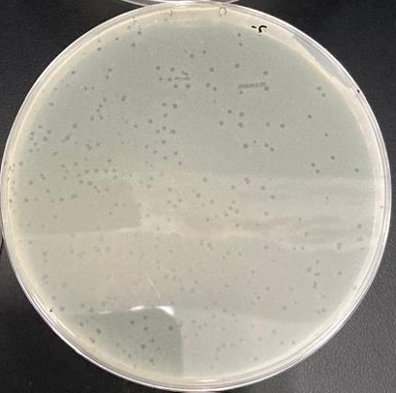
Supplementary Figure 1 Plaques of bacteriophage ETEC-S3

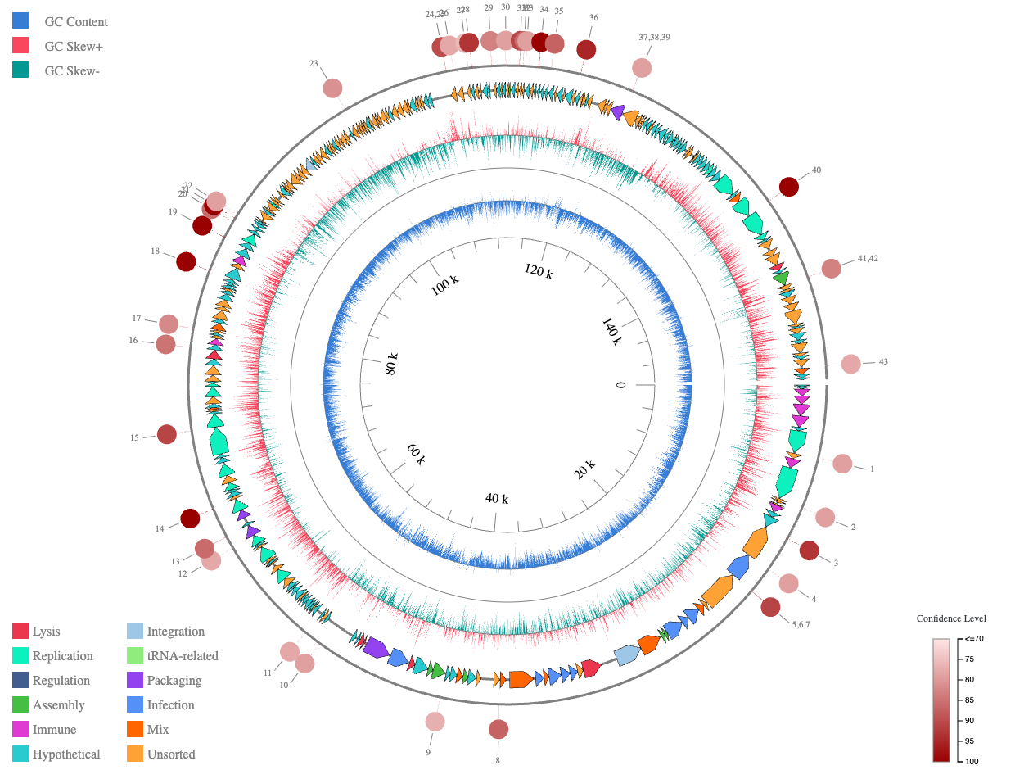
Supplementary Figure 2 Phage annotation graph using PhageScope. GC Content (blue): shows the GC content in each genome segment. GC Skew (+ red, – light green): indicates the dominance of G or C bases, red: more G than C, light green: more C. The colored arrows indicate the identified open reading frames (ORFs) (lysis, replication, regulation, assembly, immune, hypothetical, integration, tRNA-related, packaging, infection, mix, unsorted), with the direction of the arrow indicating the direction of transcription (forward or reverse strand). The size and shade of red dots indicate the annotation confidence level for each gene. Deep red: very strong annotation (high homology with the database), pink: less certain annotation.

