Supplementary Table 1: Finalized Free-Text Goal-Elicitation Items

Item | Prompt
Item 1 | Why do you want to lose weight? Please write your thoughts below.
Item 2 | Why is what you wrote above important to you? What do you want to achieve through it?

Development Process of Free-text Questions

We used a laddering approach to elicit the goal content [9,17,18]. Two rounds of pre-testing were conducted to finalize the questionnaire.

Pre-test 1
Following Höchli [17], we used three items: (1) “Why do you want to lose weight? Please write your thoughts below.” (2) “Why is what you wrote above important to you? What do you want to achieve through it?” and (3) “Based on what you wrote above, what kind of person do you want to become by achieving weight loss? Please write your thoughts below.” Each item included examples. Among the 27 respondents (participants in Issin’s program between April to June 2023), responses tended to rely on the examples; overlap rates with the examples were 25.9%, 14.8%, and 22.2% for items 1, 2, and 3, respectively.
Pre-test 2
We removed examples and assessed whether sufficient text and goal diversity could be obtained. We recruited 17 adults (30s–60s) via snowball sampling. Even without examples, the quantity of text was comparable to that in Pre-test 1, and the number of extracted goal categories was comparable (see Supplementary Table 2). Responses to item 2 yielded the greatest diversity across the two pretests. Furthermore, responses to item 3 tended to be more abstract than those to item 2, which reduced goal diversity; therefore, we adopted a two-item questionnaire and deleted item 3. Segar used a similar laddering structure [9].

Supplementary Table 2: Pre-Test Results on Free Text Questions Form

Free text questions form | Pre-test 1 (n=27)  (3 items with examples) | Pre-test 2 (n=17)  (3 items w/o examples) | Pilot (n=47)  (2 items w/o examples)
Mean characters
Item 1 | 30.56 | 13.76 | 40.51
Item 2 | 26.74 | 22.41 | 24.64
Item 3 | 20.51 | 18.53 | -
Overlap rates with examples
Item 1 | 25.93% | - | -
Item 2 | 14.81% | - | -
Item 3 | 22.22% | - | -
Classification: Aspiration Index
Item 1
- Health | 19 (70.4%) | 11 (64.7%) | 28 (59.6%)
- Image | 3 (11.1%) | 5 (29.4%) | 8 (17.0%)
- Personal Growth | 0 (0%) | 0 (0%) | 1 (2.1%)
- Relationship | 0 (0%) | 0 (0%) | 1 (2.1%)
- Multiple categories | 5 (18.5%) | 0 (0%) | 8 (17.0%)
- Others | 0 (0%) | 1 (5.9%) | 1 (2.1%)
Item 2
- Health | 9 (33.3%) | 6 (35.3%) | 18 (38.3%)
- Image | 6 (22.2%) | 4 (23.5%) | 20 (42.5%)
- Personal Growth | 4 (14.8%) | 4 (23.5%) | 3 (6.4 %)
- Relationship | 3 (11.1%) | 2 (11.8%) | 5 (10.6%)
- Multiple categories | 5 (18.5%) | 1 (5.9%)
- Others | 0 (0%) | 0 (0%) | 1 (2.1%)
Item 3
- Health | 11 (40.7%) | 8 (47.1%) | -
- Image | 8 (29.6%) | 4 (23.5%) | -
- Personal Growth | 5 (18.5%) | 5 (29.4%) | -
- Relationship | 1 (3.7%) | 0 (0%) | -
- Multiple categories | 0 (0%) | 0 (0%) | -
- Others | 2 (7.4%) | 0 (0%) | -
Classification: Goal Content for Weight Management Scale
Item 1
- Health | 18 (66.7%) | 11 (64.7%) | 27 (57.4%)
- Image | 3 (11.1%) | 5 (29.4%) | 8 (17.0%)
- Social Recognition | 0 (0%) | 0 (0%) | 0 (0%)
- Challenge | 0 (0%) | 0 (0%) | 0 (0%)
- Multiple categories | 6 (22.2%) | 0 (0%) | 10 (21.3%)
- Others | 0 (0%) | 1 (5.9%) | 2 (4.3%)
Item 2
- Health | 11 (40.7%) | 6 (35.3%) | 15 (31.9%)
- Image | 4 (14.8%) | 2 (11.8%) | 16 (34.0%)
- Social Recognition | 2 (7.4%) | 2 (11.8%) | 1 (2.1%)
- Challenge | 2 (7.4%) | 1 (5.9%) | 4 (8.5%)
- Multiple categories | 6 (22.2%) | 1 (5.9%) | 2 (4.3%)
- Others | 2 (7.4%) | 5 (29.4%) | 9 (19.1%)
Item 3
- Health | 10 (37.0%) | 6 (35.3%) | -
- Image | 2 (7.4%) | 4 (23.5%) | -
- Social Recognition | 2 (7.4%) | 2 (11.8%) | -
- Challenge | 6 (22.2%) | 0 (0%) | -
- Multiple categories | 2 (7.4%) | 0 (0%) | -
- Others | 5 (18.5%) | 5 (29.4%) | -

*Multiple-category coding was retained for pretest summaries.

Supplementary Table 3: Coding Guide

Aspiration Index (AI)

Code | Definition by AI scale | Examples | Ambiguity Resolution Rules
Health | To be physically healthy,  To feel good about my level of physical fitness,  To keep myself healthy and well,  To be relatively free from sickness,  To have a physically healthy lifestyle. | I want to live a long and healthy life,  I want to be healthy,  I want to overcome my health issues,  I want to be active. | This definition focuses on physical health.
Image | To successfully hide the signs of aging,  To have people comment often about how attractive I look,  To keep up with fashions in hair and clothing,  To achieve the "look" I've been after,  To have an image that others find appealing | I want to be an attractive person,  I want to be called a cool dad,  I want to get in shape,  I want to wear the clothes I like. | Wanting to feel confident is classified under Appearance when the surrounding context relates to physical appearance.  Expressions like “wanting to be told ~”/“wanting to be thought of as ~,” where the focus is on external evaluation, are classified under Image even if the subject is family.
Personal growth | To grow and learn new things, at the end of my life,  To be able to look back on my life as meaningful and complete,  To choose what I do, instead of being pushed along by life,  To know and accept who I really am,  To gain increasing insight into why I do the things I do. | I want to be someone who can take on all kinds of challenges,  I want to enjoy a wonderful 60s,  I want to travel and play sports on my own two feet,  I want to stay active in my career for life. | Key themes include challenges, self-actualization, autonomy, and a sense of fulfillment in life.
Meaningful relationships | To have good friends that I can count on,  To share my life with someone I love,  To have committed, intimate relationships,  To feel that there are people who really love me, and whom I love,  To have deep, enduring relationships | I want to build up my stamina to play with my grandchildren at the park,  I want to stay healthy for my family,  I want to spend lots of time with my children. | The focus is on affection, intimacy, and lasting relationships.  Wanting children to think you're cool is classified under image, as it primarily seeks external evaluation rather than building deep human connections.

Goal Content for Weight Management Scale (GCWMS)

Code | Definition by GCWMS | Examples | Ambiguity Resolution Rules
Health | To increase my resistance to illness and disease  To increase my energy level  To improve my overall health  To improve my endurance, stamina | I want to live a long and healthy life,  I want to be healthy,  I want to overcome my health issues,  I want to be active. | Focusing more on physical health. Mental health is not included.
Image | To improve the look of my overall body shape  To improve my appearance  To change my appearance by altering a specific area of my body | I want to be an attractive person,  I want to get in shape, | When the primary focus is on external evaluations of appearance—such as wanting to be told you look cool—it falls under social recognition. (Wanting to be cool is classified as image. Wanting to be told you look cool is classified as SR.)
Challenge | To give me goals to work towards  To give me personal challenges to face  To develop personal skills | I want to try all sorts of things.  Once I lose weight, I want to challenge myself in short-distance running. | Challenging oneself and skill improvement are the focus. Wanting to enrich one's life is not a challenge, so it does not apply.
Social Recognition | To be socially respected by others  To gain favorable approval from others  So that others recognize me as a healthy person | I want to be called a cool dad/grandpa,  I want to be seen as young, | Everything focused on seeking approval/evaluation from others (wanting to be told, wanting to be seen) is the target.

Supplementary Table 4: Associations with motivational types (n=46)

Goal content (AI) | n | Autonomous  (M±SD) | Introjected  (M±SD) | External  (M±SD) | Amotivation  (M±SD)
Health | 18 | 6.12 ± 0.61 | 4.86 ± 1.70 | 3.85 ± 1.60 | 2.22 ± 1.04
Image | 20 | 6.08 ± 0.65 | 4.95 ± 1.67 | 4.13 ± 1.46 | 2.33 ± 1.08
Personal growth | 3 | 5.89 ± 0.48 | 5.17 ± 1.76 | 4.25 ± 1.95 | 2.44 ± 0.51
Relationship | 5 | 6.23 ± 0.40 | 5.30 ± 0.76 | 4.70 ± 0.54 | 2.20 ± 0.69
Total | 46 | 6.10 ± 0.59 | 4.97 ± 1.57 | 4.09 ± 1.46 | 2.28 ± 0.98

No statistically significant between-category differences were observed across motivational subscales (all p > .70; partial η² = .005–.032).
Supplementary Figure 1: Descriptives for AI, AM, engagement, and weight loss outcomes
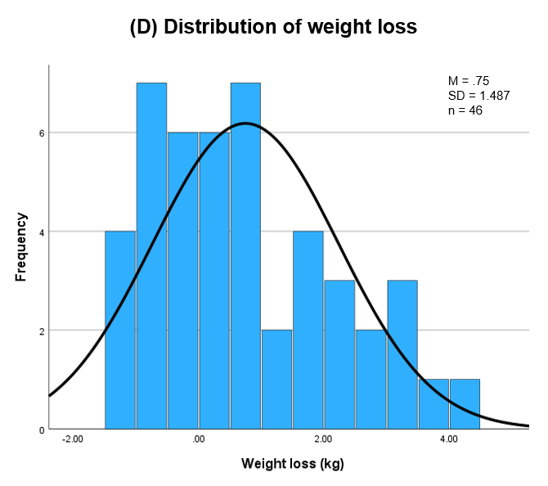
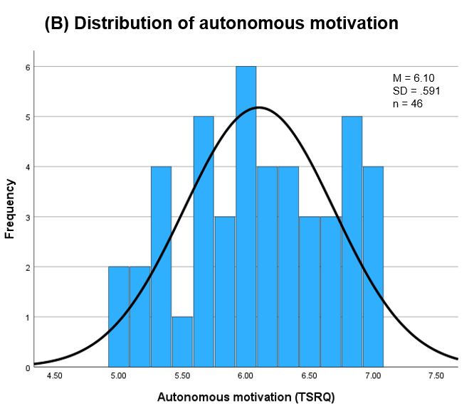
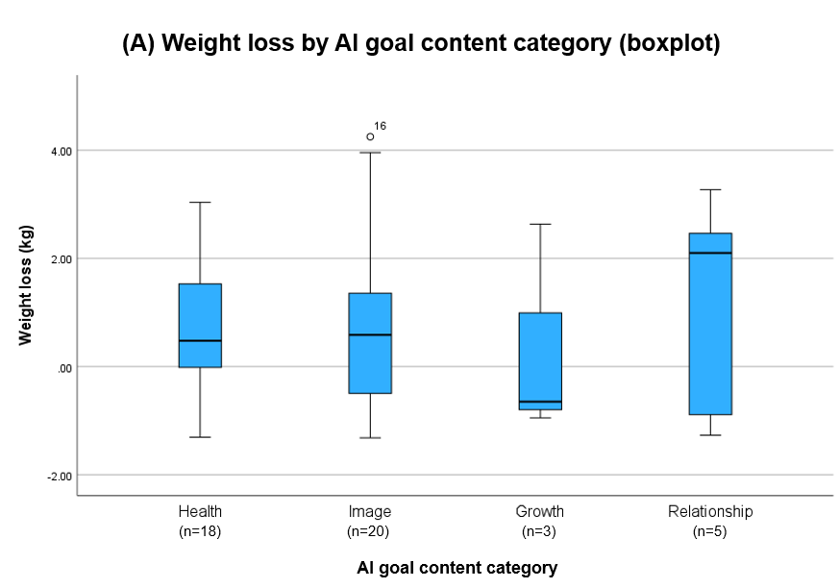
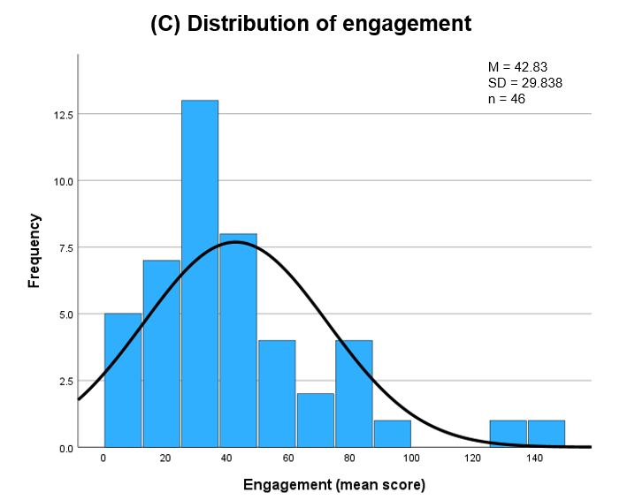
Supplementary Figure 1. Descriptive distributions of key variables.
(A) Weight loss by AI goal content category (boxplot). (B) Distribution of autonomous motivation.
(C) Distribution of engagement. (D) Distribution of weight loss.
Note. AI = Aspiration Index; TSRQ = Treatment Self-Regulation Questionnaire.

