Supplementary Materials
Metabolomic Profiling Reveals Candidate Discriminatory Metabolites in Stable COPD and Acute Exacerbation

Supplementary Methods

Clinical characterisation
Demographic and clinical data were collected, including the gender, age, body mass index (BMI), smoking status (former smokers were defined as those who had quit smoking for at least six months prior to study enrollment), and smoking index [SI = (number of cigarettes smoked per day /20) × number of years of smoking]. Comorbidities were documented, including cerebrovascular disease, coronary artery disease, hypertension, and type 2 diabetes mellitus. For both the SCOPD and AECOPD groups, dyspnea was assessed using the modified Medical Research Council (mMRC) scale, as established by the United Kingdom. Additionally,PFT parameters - including FEV1% predicted and the FEV1/FVC ratio - as well as medication usage, were recorded for all COPD patients.

Clinical statistical analysis
Continuous variables were assessed for normality within each applicable group using the Shapiro–Wilk test and for homogeneity of variance using Levene's test. Normally distributed variables are presented as mean ± standard deviation and were compared using one-way analysis of variance (ANOVA); Welch ANOVA was used when variances were unequal. Non-normally distributed or ordinal variables are presented as median (interquartile range) and were compared using the Kruskal–Wallis test. Variables available only in the two COPD groups were compared using an independent-samples t test, Welch t test, or Mann–Whitney U test, as appropriate. Categorical variables are reported as n (%) and were compared using Pearson's χ² test; Fisher's exact test or the Fisher–Freeman–Halton exact test with 100,000 Monte Carlo samples was used when expected cell counts were small. Pairwise comparisons were calculated using tests consistent with the primary analysis and adjusted within each variable using the Holm method; pairwise findings were interpreted primarily when the omnibus test was significant. All tests were two-sided, and P<0.05 was considered significant.

Spirometry measurements
Spirometry measurement (Yeager, German) was based on the American Thoracic Society/European Respiratory Association guidelines [11]. All subjects underwent spirometry to confirm the diagnosis of COPD and non-COPD. The pulmonary function of patients with AECOPD was measured 8 weeks after the acute exacerbation period. The Spirometry measurements were performed by two senior physicians.

Sample collection, metabolite identification and statistical analysis
After an overnight fast (8–12 h), peripheral venous blood was collected and centrifuged at 3,000 rpm for 15 min at 4 °C, and serum aliquots were stored at −80 °C. For metabolite extraction, 50 μL serum was mixed with 300 μL pre-chilled extraction solvent (20% acetonitrile–methanol containing internal standards), vortexed, centrifuged (12,000×g, 4 °C), protein-precipitated at −20 °C, and clarified supernatants were subjected to LC–MS analysis. Quality control (QC) samples were prepared by mixing equal aliquots from all serum samples. The pooled QC samples were extracted and analyzed using the same procedures as the study samples. Before formal sample analysis, QC samples were injected to equilibrate the LC–MS/MS system. Chromatographic separation was performed on a Shimadzu LC-30A system using a Waters ACQUITY Premier HSS T3 column with a 0.1% formic acid water/acetonitrile gradient, and data were acquired in information-dependent acquisition mode. Raw data were converted to mzXML format and processed in R using XCMS for peak detection, retention-time correction, alignment, and normalization. Metabolites were identified by accurate mass (≤5 ppm) and MS/MS matching against in-house and public databases (HMDB, KEGG, METLIN), retaining features with qualitative scores ≥0.5 and QC CV <0.3. Multivariate analysis was performed using OPLS-DA, with model validity assessed by 200 permutations. Metabolite annotation and identification were performed using a combination of accurate mass, retention time, isotope pattern, and MS/MS fragmentation information. MS/MS spectra were matched against public databases and reference spectral libraries, including HMDB, KEGG, METLIN, MassBank, and the in-house metabolite database when available. The MS/MS matching quality was evaluated using spectral similarity scores. Metabolites confirmed by comparison with authentic standards, including retention time and MS/MS fragmentation patterns, were assigned as level 1 identifications, whereas metabolites annotated based on accurate mass and MS/MS spectral matching without authentic standards were assigned as level 2 putative identifications. Differential metabolites were defined using a combination of multivariate and univariate statistical criteria, including VIP values from the OPLS-DA model, fold change, and statistical significance. To account for multiple testing, raw P values were adjusted using the Benjamini–Hochberg false discovery rate method. Metabolites with VIP > 1, P < 0.05, and FDR-adjusted P values meeting the predefined significance threshold were considered statistically robust differential metabolites.

Pathway and exploratory statistical analyses
KEGG pathway enrichment was conducted for significant metabolites. Clinical data were analyzed using chi-square tests for categorical variables and Student’s t test or one-way ANOVA for continuous variables, with ROC curves evaluating diagnostic performance. Statistical analyses were performed using SPSS 22.0, and P <0.05 was considered statistically significant.

Supplementary Results

Detailed clinical comparisons
mMRC score differed between groups (overall P=0.008); Acute exacerbation COPD vs Stable COPD (Holm-adjusted P=0.008). FEV₁, % predicted differed between groups (overall P=<0.001); Healthy controls vs Stable COPD (Holm-adjusted P=<0.001); Healthy controls vs Acute exacerbation COPD (Holm-adjusted P=<0.001); Stable COPD vs Acute exacerbation COPD (Holm-adjusted P=0.001). FVC, % predicted differed between groups (overall P=<0.001); Healthy controls vs Stable COPD (Holm-adjusted P=0.034); Healthy controls vs Acute exacerbation COPD (Holm-adjusted P=<0.001); Stable COPD vs Acute exacerbation COPD (Holm-adjusted P=0.036). FEV₁/FVC, % differed between groups (overall P=<0.001); Healthy controls vs Stable COPD (Holm-adjusted P=<0.001); Healthy controls vs Acute exacerbation COPD (Holm-adjusted P=<0.001); Stable COPD vs Acute exacerbation COPD (Holm-adjusted P=<0.001). C-reactive protein, mg/L differed between groups (overall P=0.007); Acute exacerbation COPD vs Healthy controls (Holm-adjusted P=0.013). Neutrophil count, ×10⁹/L differed between groups (overall P=0.021); Acute exacerbation COPD vs Healthy controls (Holm-adjusted P=0.016). Eosinophil count, ×10⁶/L differed between groups (overall P=0.025); Stable COPD vs Acute exacerbation COPD (Holm-adjusted P=0.028). NT-proBNP, pg/mL differed between groups (overall P=0.010); Acute exacerbation COPD vs Healthy controls (Holm-adjusted P=0.023); Acute exacerbation COPD vs Stable COPD (Holm-adjusted P=0.026). Troponin T, ng/mL differed between groups (overall P=<0.001); Stable COPD vs Healthy controls (Holm-adjusted P=0.023); Acute exacerbation COPD vs Healthy controls (Holm-adjusted P=<0.001); Acute exacerbation COPD vs Stable COPD (Holm-adjusted P=0.016). IL-8, pg/mL differed between groups (overall P=<0.001); Stable COPD vs Healthy controls (Holm-adjusted P=<0.001); Acute exacerbation COPD vs Healthy controls (Holm-adjusted P=0.003). IL-1β, pg/mL differed between groups (overall P=0.013); Stable COPD vs Healthy controls (Holm-adjusted P=0.008). Soluble IL-2 receptor, pg/mL differed between groups (overall P=0.006); Acute exacerbation COPD vs Healthy controls (Holm-adjusted P=0.018); Acute exacerbation COPD vs Stable COPD (Holm-adjusted P=0.014).

Additional metabolomics visualizations
Additional class-level scatter plots, Z-score-normalized metabolite distributions, KEGG enrichment plots, differential-abundance score plots, exploratory ROC curves, and metabolite-clinical correlation analyses are provided in Supplementary Figures S1-S6. These visualizations support the descriptive interpretation in the main text and should be interpreted as exploratory because no independent validation cohort was available.

Supplementary Table Files
Supplementary Tables S1-S3 are provided as the accompanying Excel workbook Supplementary_Tables_S1-S3.xlsx. The workbook includes metabolite name, biochemical class, formula, identification level, annotation score, CAS identifier, VIP, P value, FDR, fold change, log2 fold change, and direction of change where available.

Supplementary Figures

Supplementary Figure S1. PCA score plots of serum metabolomics data with quality-control samples.
(A) PCA score plot of the positive ion mode dataset. (B) PCA score plot of the negative ion mode dataset. Each point represents an individual serum sample or pooled QC sample. Healthy controls, SCOPD, AECOPD, and QC samples are shown in different colors. The shaded ellipses indicate the distribution of each study group. QC samples clustered closely in both ion modes, indicating acceptable analytical stability and reproducibility of the LC–MS/MS platform.
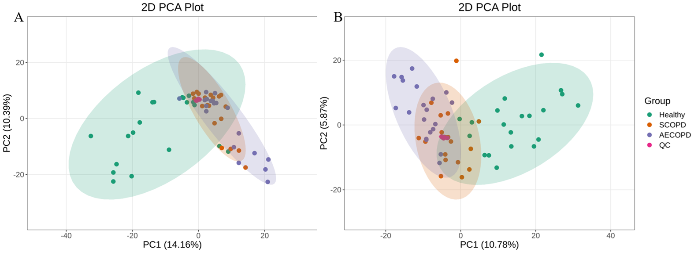

Supplementary Figure S2. Distribution of differential metabolites by chemical class in pairwise group comparisons.
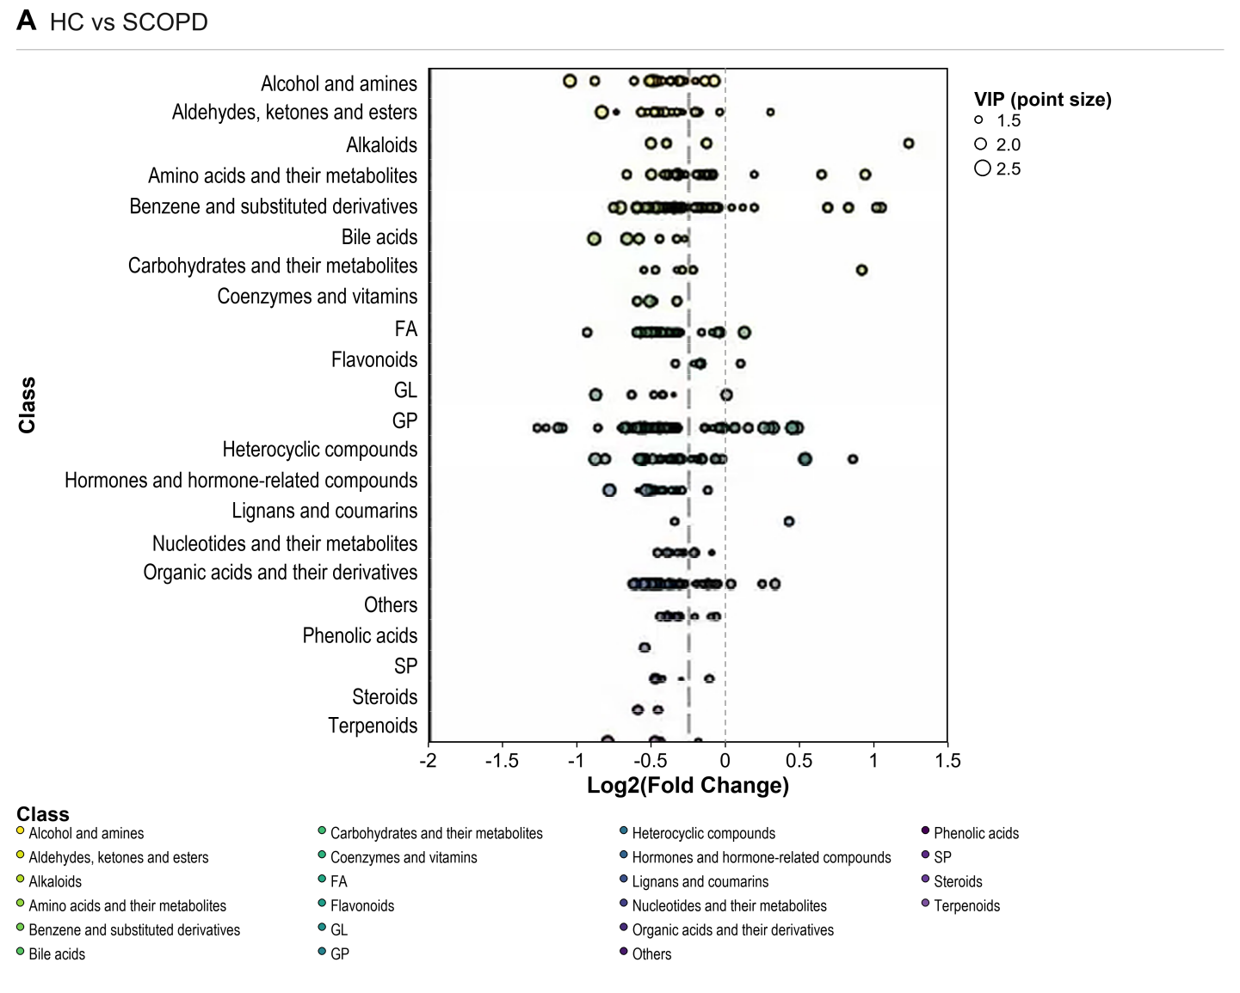
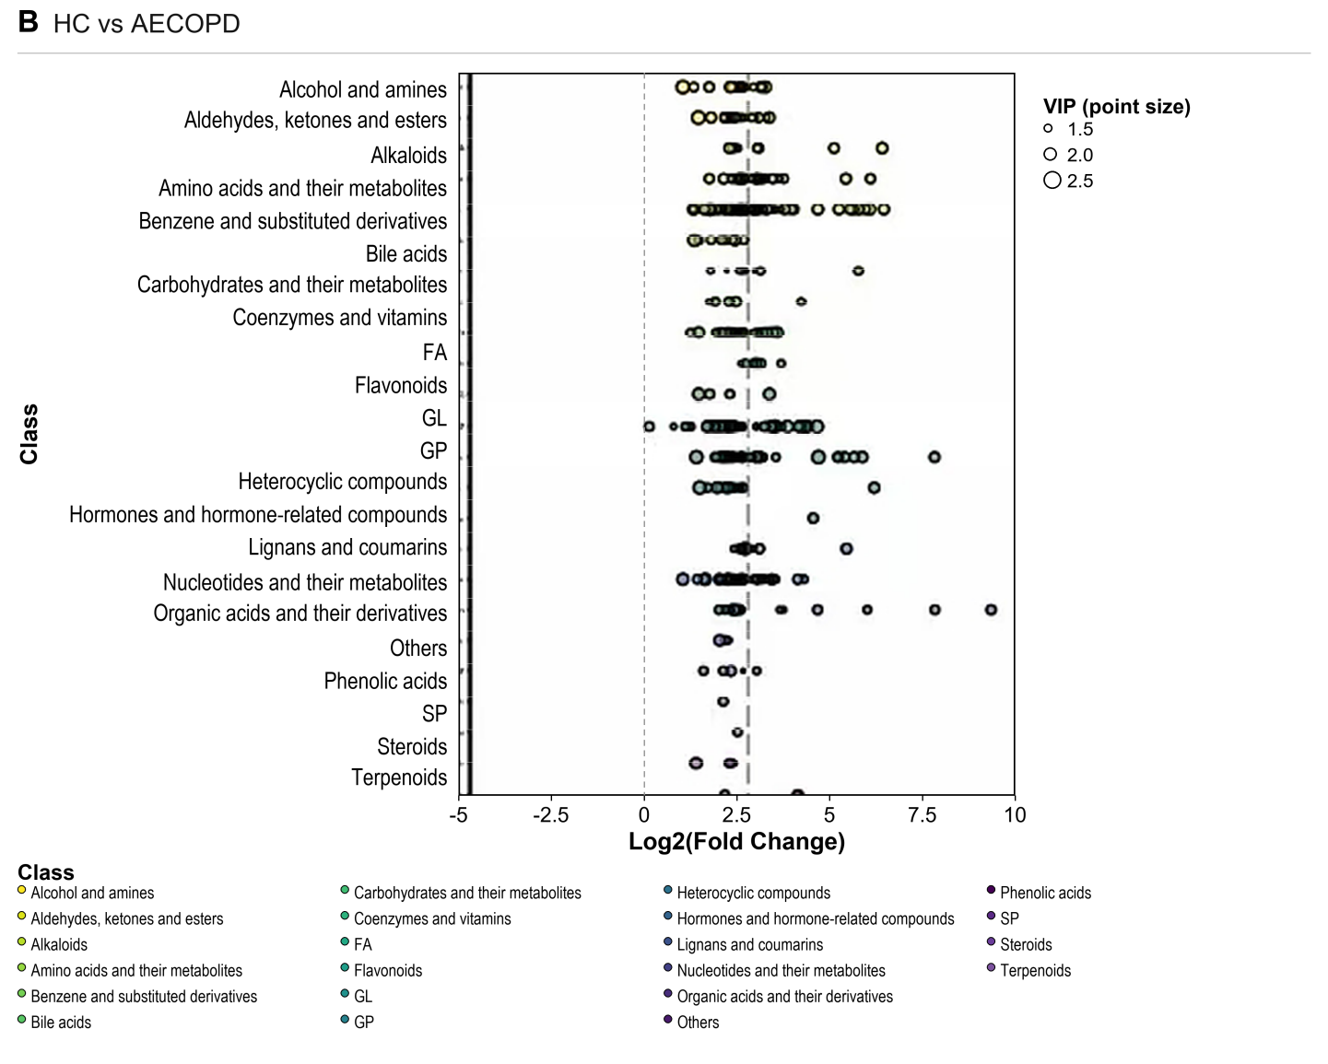
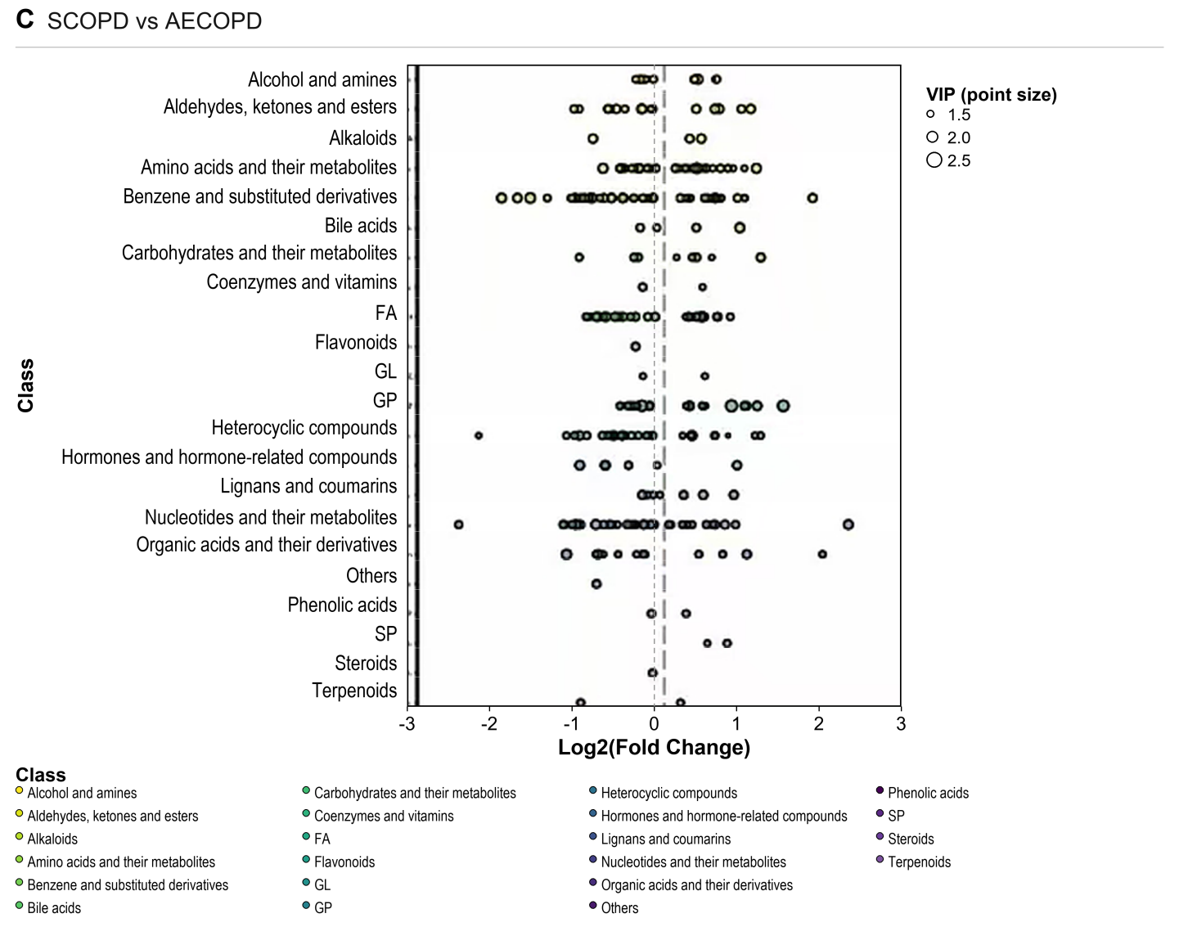
A, HC versus SCOPD; B, HC versus AECOPD; C, SCOPD versus AECOPD. Each circle represents one differential metabolite and is positioned by chemical class and log2 fold change. Circle size is proportional to VIP score, and color identifies metabolite class.

Supplementary Figure S3. Standardized relative abundance of differential metabolites across HC, SCOPD, and AECOPD.
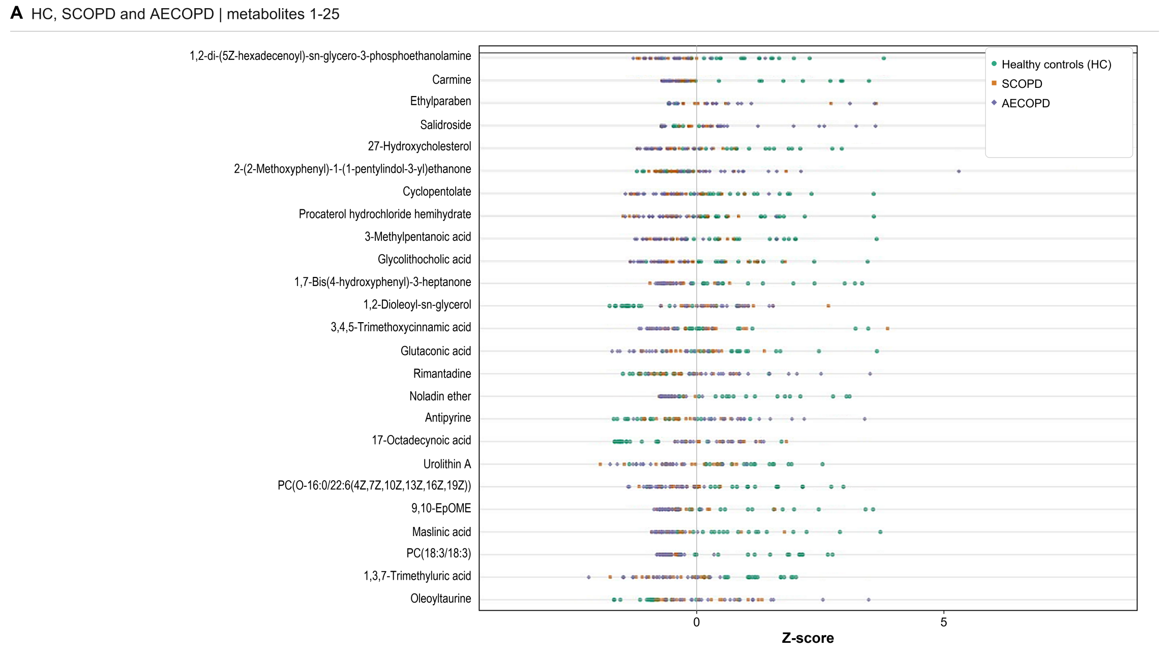
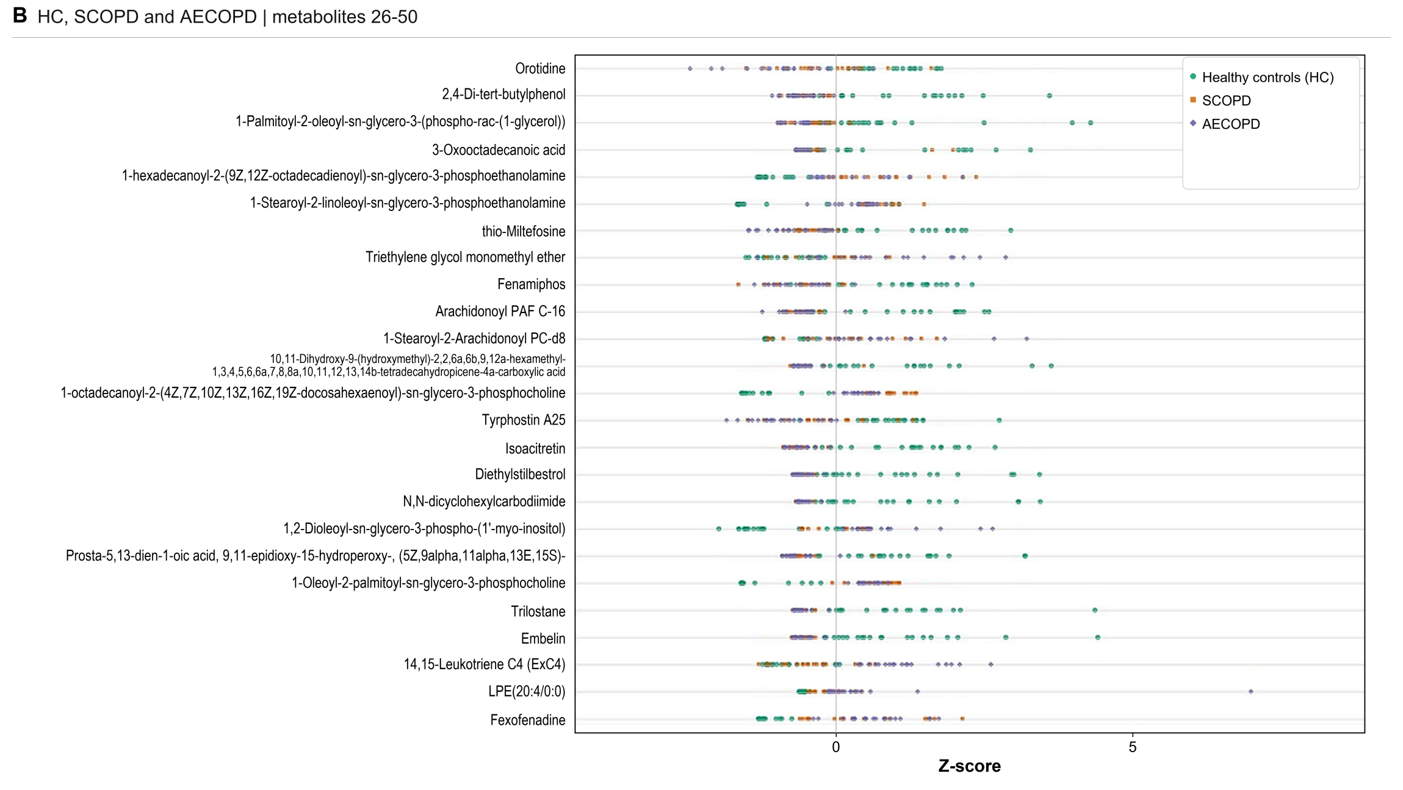
For legibility, the 50 metabolites are displayed in two panels. Z-scores were calculated separately for each metabolite across all samples; positive and negative values indicate abundances above and below the metabolite-specific mean.

Supplementary Figure S4. KEGG enrichment analysis of differential metabolites between groups.
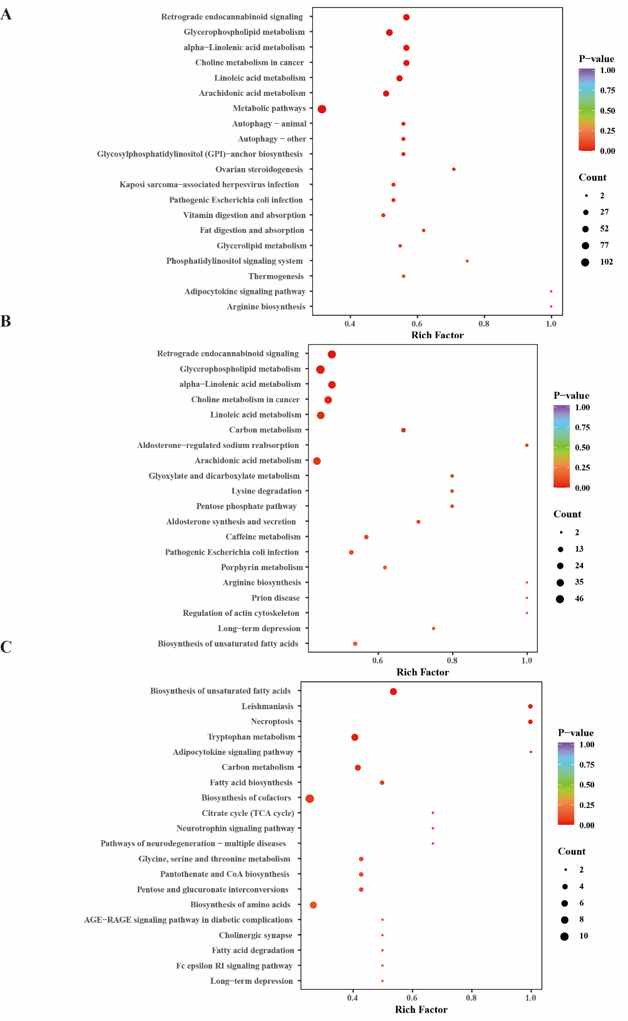
Pathway enrichment analysis is shown for HC versus SCOPD, HC versus AECOPD, and SCOPD versus AECOPD comparisons.

Supplementary Figure S5. Differential abundance scores for KEGG pathways.
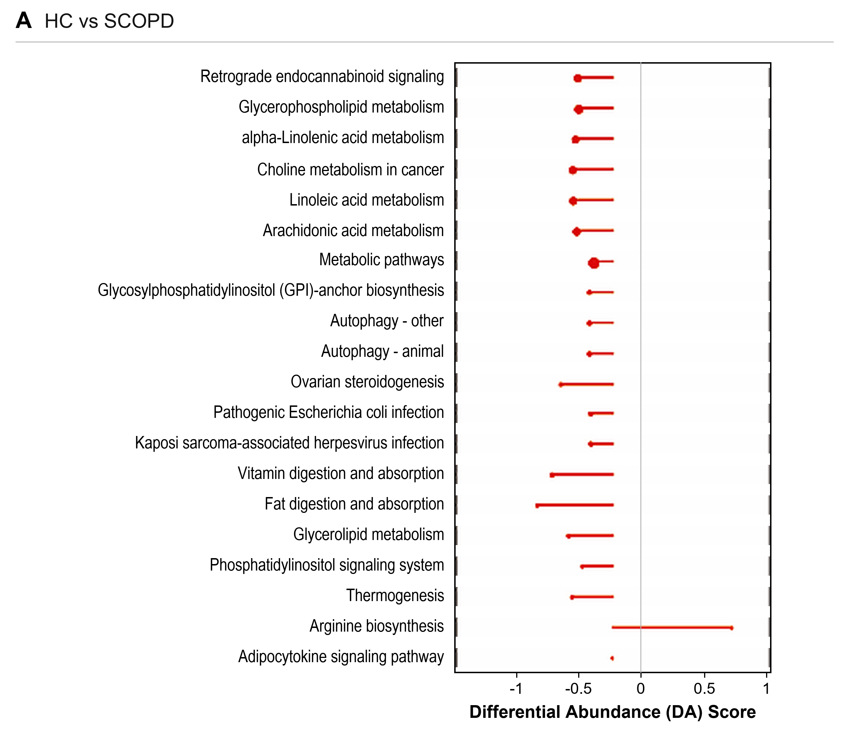
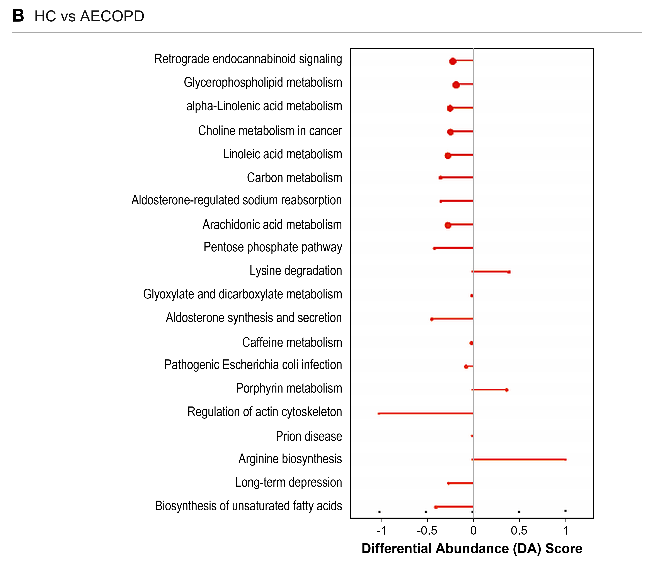
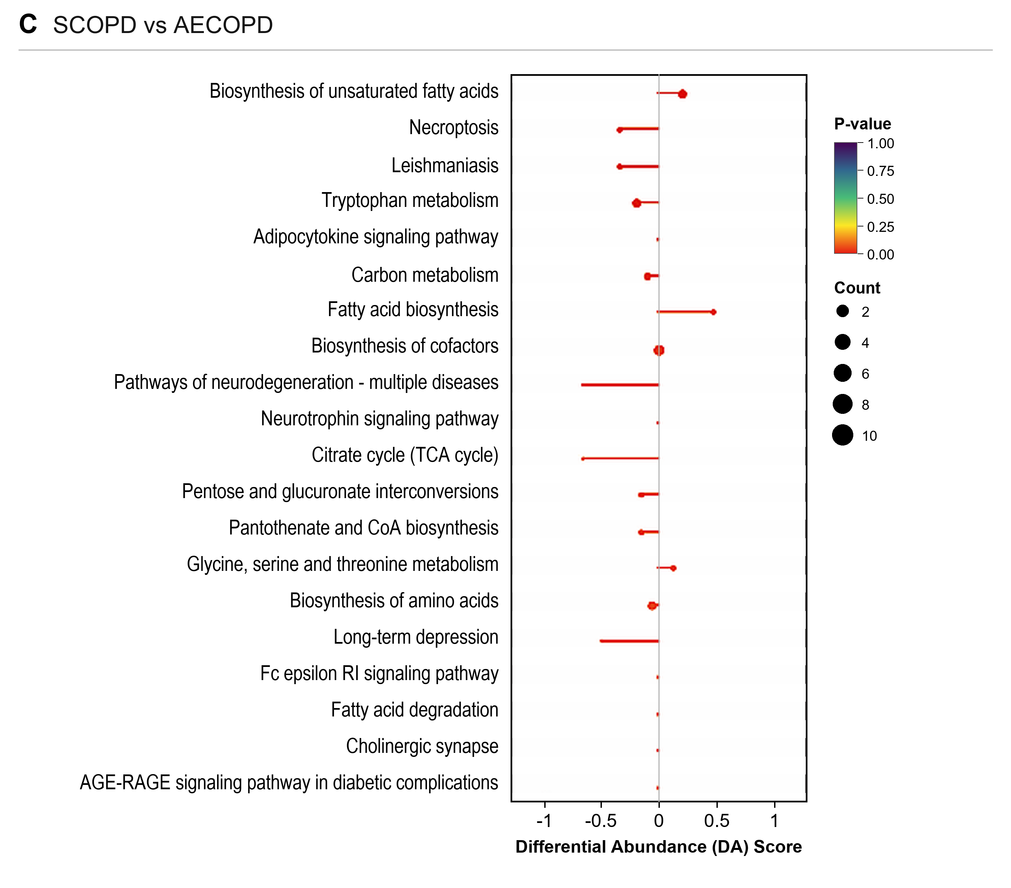
For each pathway, the differential-abundance score summarizes the balance between increased and decreased differential metabolites and ranges from -1 to +1.

Supplementary Figure S6. ROC curve analysis of selected differential metabolites.
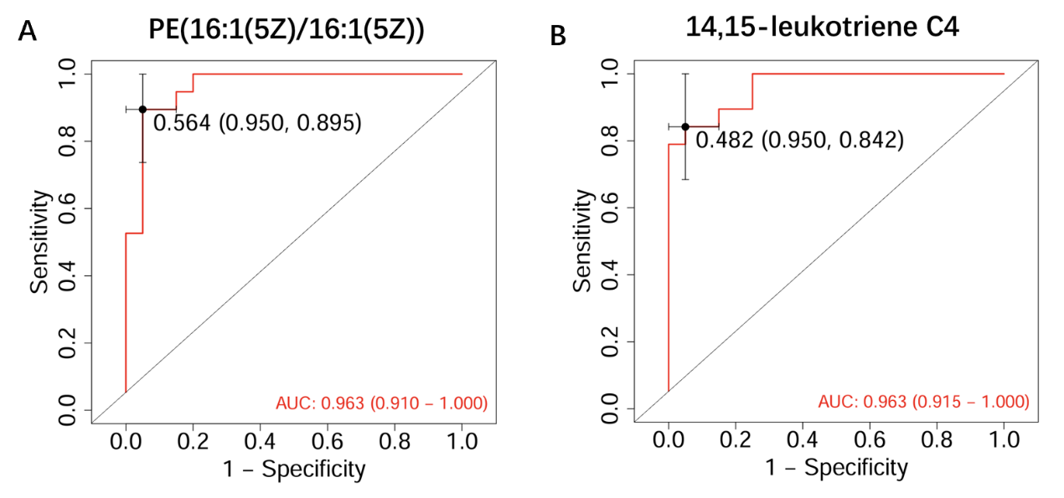
ROC curves are shown for exploratory discrimination of COPD from healthy controls and SCOPD from AECOPD. These values were generated in the discovery dataset and require external validation.

Supplementary Figure S7. Correlations between representative differential metabolites and clinical or inflammatory indicators.
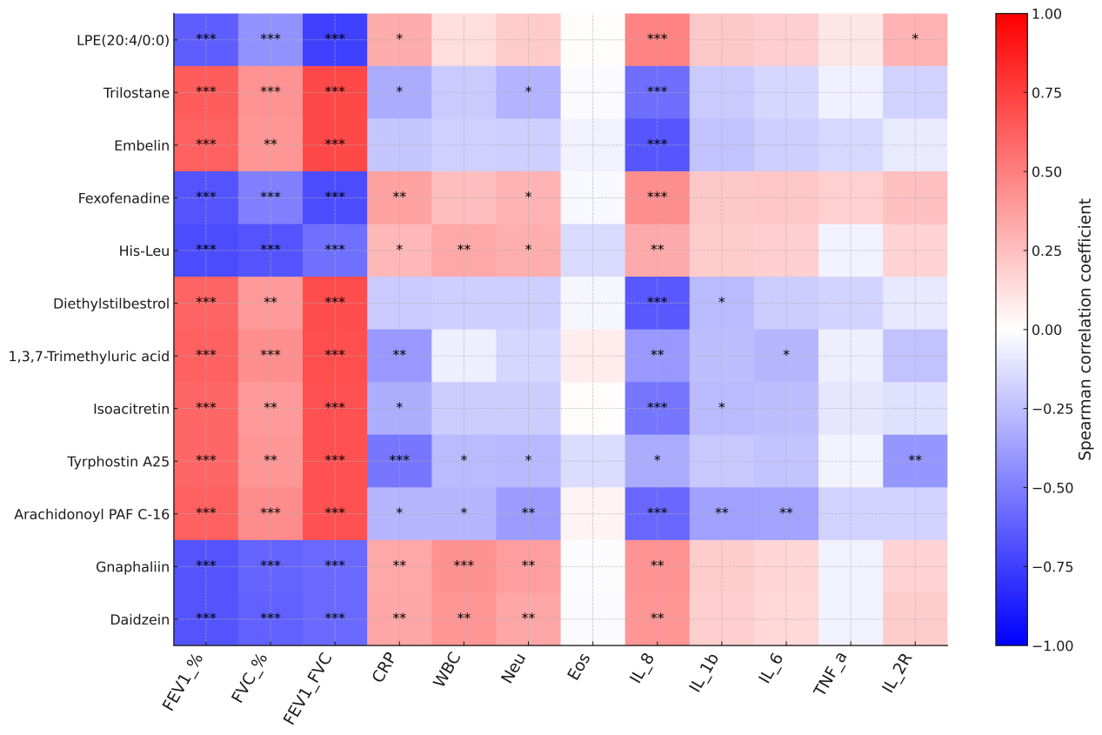
Spearman correlation analysis evaluated associations between selected differential metabolites and pulmonary-function parameters, systemic inflammatory markers, and circulating cytokines.

Table S1. Differential metabolites between stable COPD (SCOPD) and healthy controls (HC).
Table S2. Differential metabolites between acute exacerbation of COPD (AECOPD) and healthy controls (HC).
Table S3. Differential metabolites between stable COPD (SCOPD) and acute exacerbation of COPD (AECOPD).

