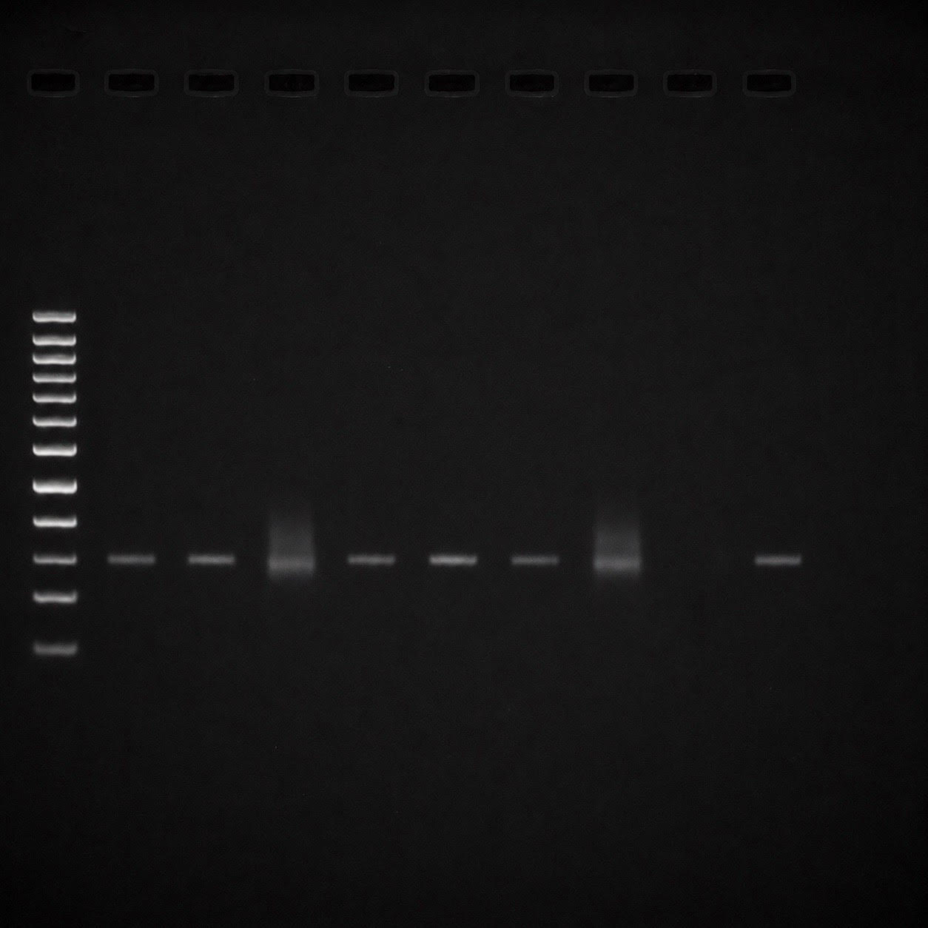
Figure S1. Original agarose gel image corresponding to Figure 1 in the main manuscript. The image is presented without changing contrast.
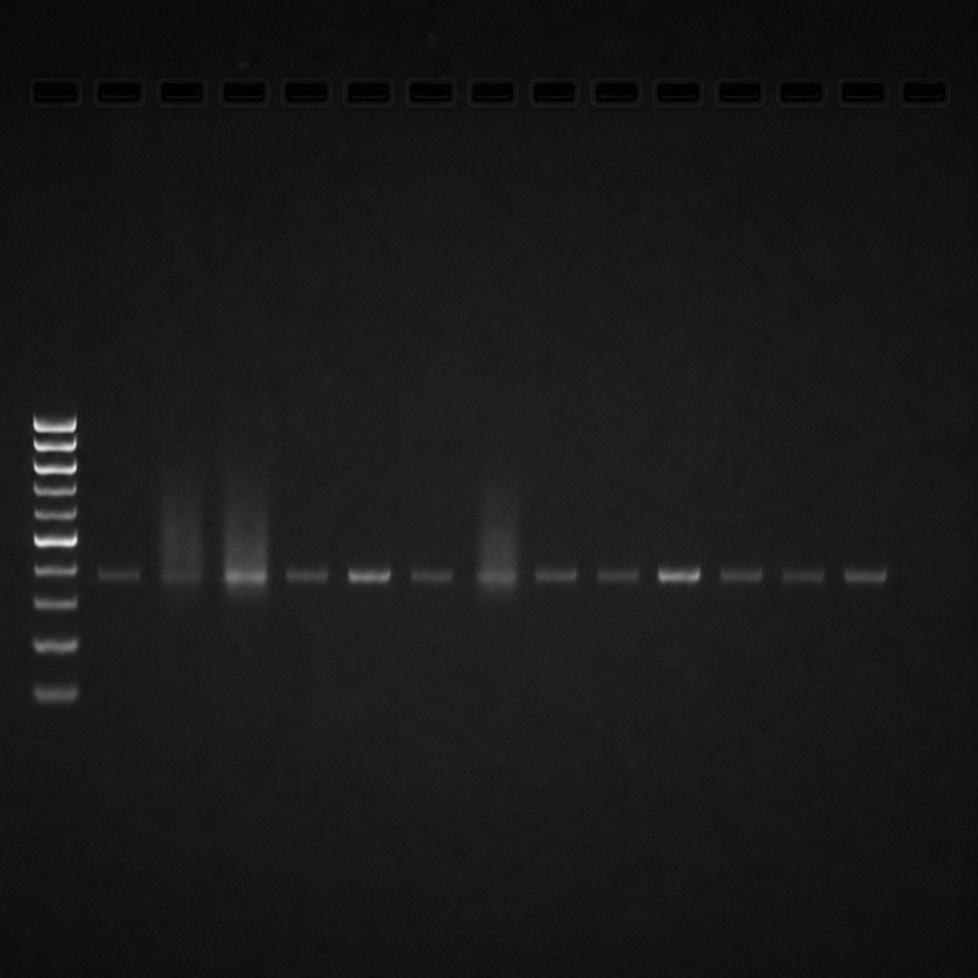
Figure S2. Original agarose gel corresponding to Figure 2.

