Supplementary Table 1: Comparison of cytokine concentrations by OC use status using the Mann-Whitney U tests
 | OC use status
 | Yes | No
Cytokine | Median (IQR) concentration | Median (IQR) concentration | p-value
IL15 | 106.5 (82–118.3) | 78.4 (63.7–103) | 0.015
IL18 | 1573.8 (1136.1–1722.3) | 1195.1 (881.7–1573.4) | 0.029
IL33 | 85 (70.1–101.9) | 66.1 (57.6–95.3) | 0.070
IL8 | 1246.2 (579.4–1637.1) | 614.2 (332.7–1601) | 0.072
IL6 | 144.4 (102.1–230) | 74.1 (52.9–232.9) | 0.077
TNFα | 30.1 (21.3–52.5) | 27.4 (13.3–52.5) | 0.317
IL1β | 195.7 (131.56–276.28) | 131.6 (131.56–261.69) | 0.134

Supplementary Table 2: Adjusted geometric mean ratios (GMRs) and 95 % confidence intervals (CIs) for host determinants of IL15 and IL18 expression, stratified by OC use.
Cytokine | Covariate | OC use | GMR | 95% CI | FDR
IL15 | Age (per SD) | No | 0.89 | 0.73 – 1.09 | 0.25
IL15 |  | Yes | 0.95 | 0.84 – 1.09 | 0.46
IL15 | CD4⁺ (per SD) | No | 0.89 | 0.77 – 1.02 | 0.14
IL15 |  | Yes | 0.91 | 0.82 – 1.02 | 0.09
IL15 | ART duration (per SD) | No | 1.08 | 0.89 – 1.32 | 0.42
IL15 |  | Yes | 0.98 | 0.88 – 1.10 | 0.73
IL15 | Male vs Female | No | 1.07 | 0.81 – 1.42 | 0.78
IL15 |  | Yes | 1.30 | 1.00 – 1.67 | 0.095
IL18 | Age (per SD) | No | 0.82 | 0.63 – 1.07 | 0.25
IL18 |  | Yes | 0.84 | 0.71 – 1.01 | 0.11
IL18 | CD4⁺ (per SD) | No | 0.87 | 0.73 – 1.05 | 0.14
IL18 |  | Yes | 0.88 | 0.76 – 1.01 | 0.09
IL18 | ART duration (per SD) | No | 1.16 | 0.89 – 1.50 | 0.42
IL18 |  | Yes | 1.11 | 0.96 – 1.30 | 0.32
IL18 | Male vs Female | No | 0.95 | 0.66 – 1.37 | 0.78
IL18 |  | Yes | 1.30 | 0.92 – 1.83 | 0.14

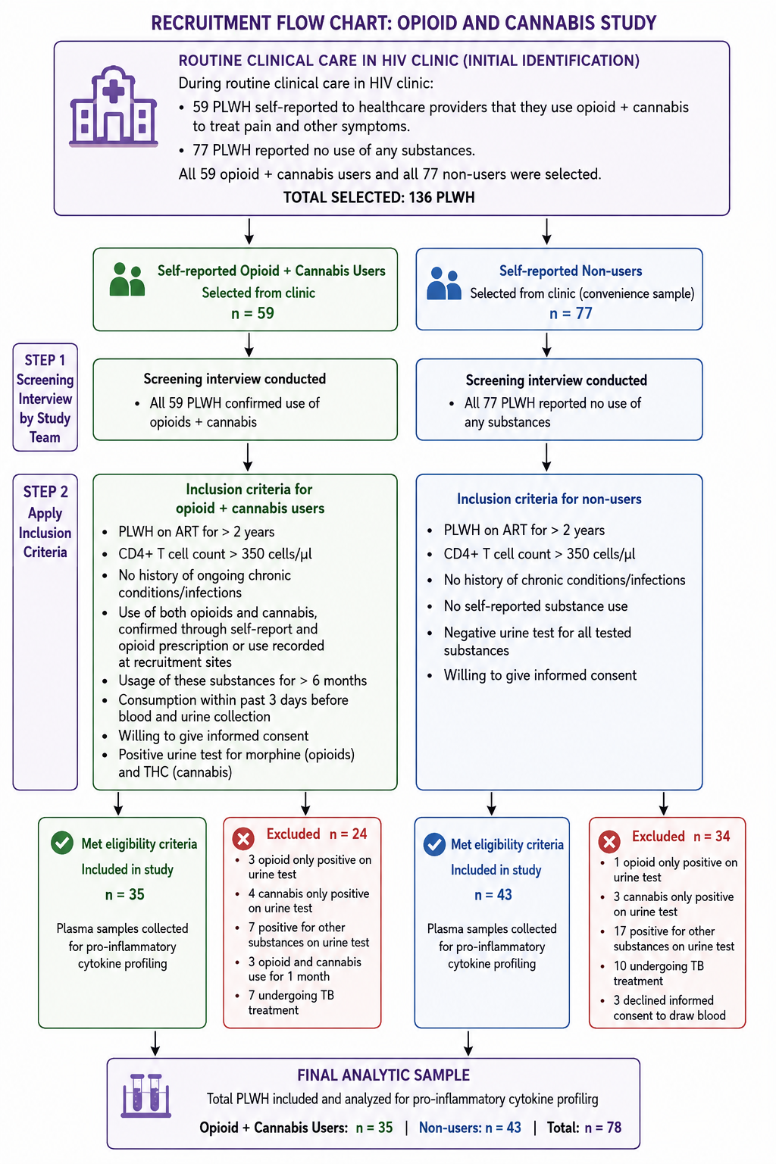

Supplementary Figure 1: Participant flow diagram

