Receiver operating characteristic (ROC) curves

Figure S1. ROC curve of the logistic regression model (A); ROC curve of the score-based model (B); and ROC curves comparing logistic regression and score-based models.

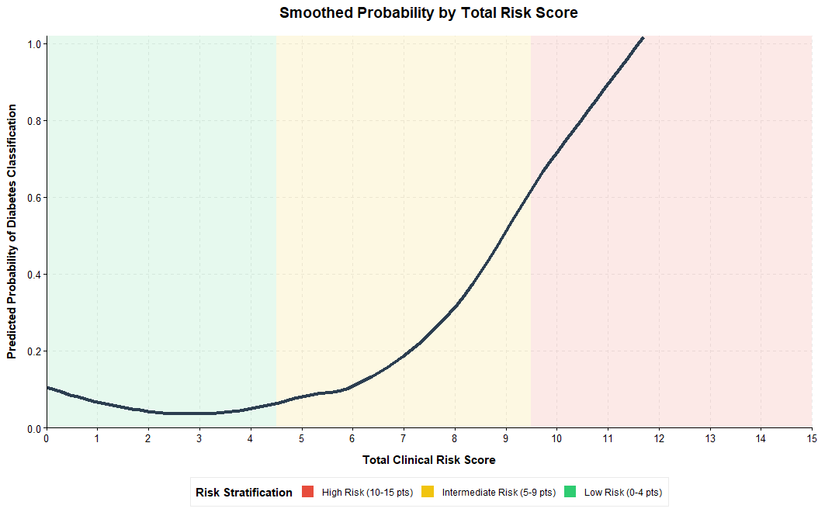
Figure S2. Smoothed predicted probability of diabetic kidney disease by total risk score. DKD, diabetic kidney disease.

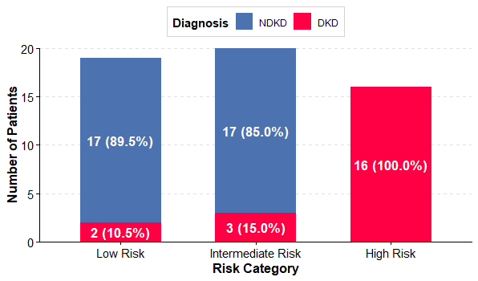

Figure S3. Patient Distribution by Total Risk Score and Diagnosis. NDKD non-diabetic kidney disease, DKD, diabetic kidney disease

Figure S4. Calibration plots for the clinical risk score (A) and logistic regression model (B)predicting diabetic kidney disease.
Clinical risk score: Nagelkerke R² = 0.620; Hosmer–Lemeshow χ² = 7.97, df = 5, p = 0.158; logit(P) = −4.9108 + 0.6093 × (clinical risk score). Logistic regression model: Nagelkerke R² = 0.703; Hosmer–Lemeshow χ² = 3.49, df = 3, p = 0.322; logit(P) = −2.9101 + 11.2229 × (logistic model probability).

Figure S5. Predictive probability curves for diabetic kidney disease based on our score formula and the Bermejo et al. score model.

