Ultrasonic Vocalisations of the Bavarian Pine Vole: Preliminary Evidence for a Diverse Ultrasonic Repertoire
Alice Mengarelli^{1,2}, Elizabeth R. Wilkinson¹, Bettina Wernisch³, Dustin J. Penn³, Peter Balazs^{1,4}, André Stadler⁵, Angela S. Stoeger*^{1,6,7}
¹ Acoustics Research Institute, Austrian Academy of Sciences, Vienna, Austria
² Department of Life Sciences and Systems Biology, University of Turin, Turin, Italy
³ Konrad Lorenz Institute of Ethology, Department of Interdisciplinary Life Sciences, University of Veterinary Medicine Vienna, Vienna, Austria
⁴ Acoustics, Analysis and AI, Interdisciplinary Transformation University Austria, Linz, Austria
⁵ Alpenzoo Innsbruck-Tirol, Innsbruck, Austria
⁶ Department of Behavioural & Cognitive Biology, University of Vienna, Vienna, Austria
⁷ Zoo Conservation Science Lab, Vienna Zoo, Vienna, Austria
Corresponding author:
*Angela S. Stoeger
Current affiliation: Department of Behavioural & Cognitive Biology, University of Vienna, Vienna, Austria and Zoo Conservation Science Lab, Vienna Zoo, Vienna, Austria
E-mail: angela.stoeger-horwath@univie.ac.at
Subjects and housing conditions
The cages housing the voles measured 112 × 92 × 61 cm and contained a 10-15-cm-deep layer of natural soil as substrate. Pieces of bark, roots, stones, and sticks were placed within and on the substrate to facilitate tunnel construction. When the substrate was unstable, additional hay was provided to support tunnel building, although its use was limited to reduce the risk of mould growth. Dry grasses were also planted to provide additional structural support within the enclosure. The controlled environmental conditions were 14-16.5 °C, 63-75 % humidity; 12:12 light-dark cycle. The animals were provided with a diverse, species-appropriate diet consisting of fresh herbs (depending on seasonal availability), root vegetables, nuts, fresh berries, and fresh branches. The provided plant material also allowed the voles to gnaw and naturally wear down their teeth.
One of the individuals was captured in the wild under an official authorisation issued by the State of Tyrol (Department of Environmental Protection, Tyrolean Provincial Government); the capture was carried out by a biologist from the University of Vienna, and the animal was transported to the zoo by an animal keeper from Alpenzoo Innsbruck (approximately a 1.5-hour drive).



Table A1
Identity, sex, place and date of birth, sire and cage number of each vole included in the study.
ID | Sex | Place of birth | Date of birth | Sire | N° of enclosure (Pair number)
M1429 | Female | Alpenzoo | 15.03.2023 | M1405 | 1
M1416 | Male | Alpenzoo | 07.09.2022 | M1373 | 1
M1374 | Female | Tyrol: Wild born | Estimated 15.06.2020 | NA | 2
M1405 | Male | Alpenzoo | 13.06.2022 | M1373 | 2
M1458 | Female | Alpenzoo | 06.06.2023 | M1405 | 4
M1459 | Male | Alpenzoo | 19.07.2023 | M1405 | 4
The sire and exact birth date of the wild-born individual are unknown. The numbering of the enclosure is the one present in the zoo, this is why it doesn’t follow the progressive order.
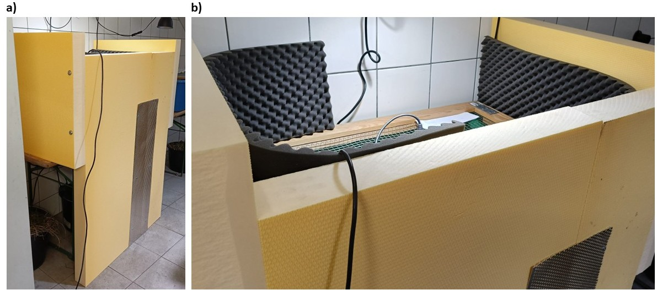Figure A1. Pictures showing the acoustic isolation (a) entire and b) closer focus), made of acoustic foam and styrofoam, installed around the enclosure while recording.
Male intruder context
The male intruder was placed in a small cage, measuring 77 * 47 * 58 mm, with substrate from its own territory, inside the established pair’s enclosure. The small cage had a solid and opaque bottom, a middle section with small openings, and a translucent top lid. The established pair and the male intruder could likely detect each other’s auditory, olfactory, and perhaps partial visual signals. The transfer of the male intruder to the established pair’s box was conducted exclusively by trained keepers, who minimized the handling time. Individuals were gently captured and transferred immediately to the designated enclosure. If short-term temporary housing was required, individuals were placed in small holding boxes provided with adequate hiding opportunities to reduce stress. All handling procedures were carried out calmly and with constant attention to animal welfare.
Figure A2. Drawing showing the recording context (not to scale). It is shown the cage housing the established pair and the smaller cage used to introduce the male intruder. During the male intruder context, the smaller cage containing the intruder was placed inside the larger cage of the established pair. The ultrasonic microphone suspended through the mesh lid is also shown. The larger cage retained the established pair’s original substrate, while the smaller cage contained substrate from the male intruder’s home cage.
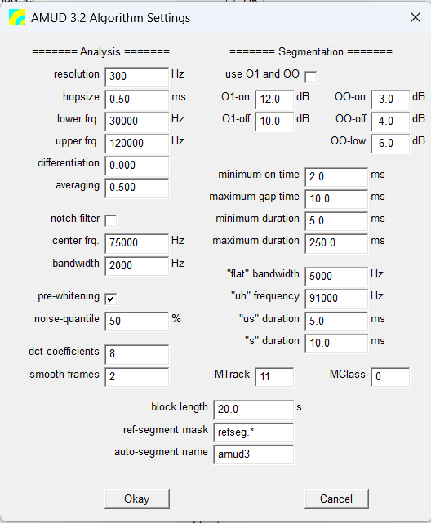
Figure A3. AMUD (v. 3.2) algorithm settings used for segment (USV) identification and computation. “Pre-whitening” indicates the filter applied to remove background noise. For further information, refer to the AMUD manual, but note that it refers to an earlier version of the one we used (https://www.oeaw.ac.at/en/ari/das-institut/software/amud) (regarding A-MUD v. 3.2 please refer to the supplementary materials of Zala et al. (2020).

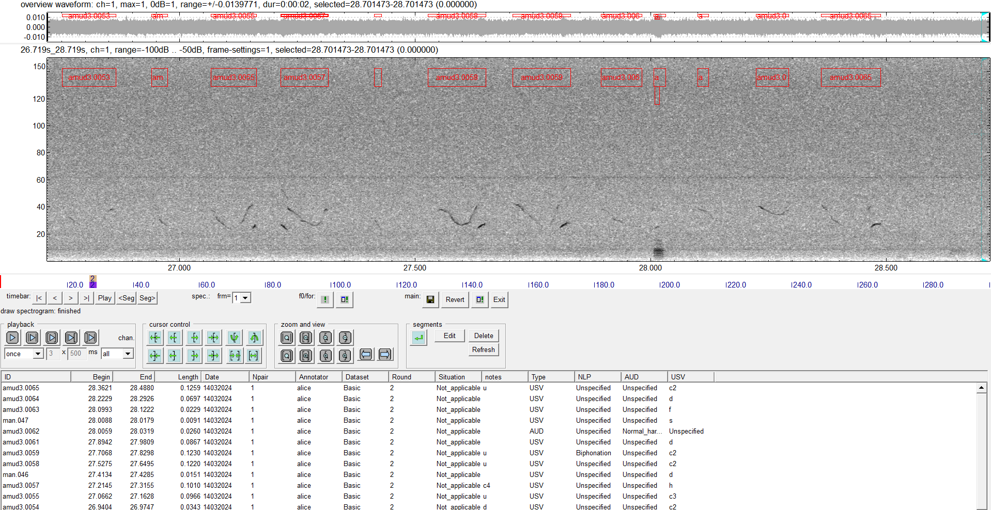
Figure A4. Example of annotation conducted in STx (Balazs et al., 2010; Noll & White, 2017; Noll et al., 2019), with the spectrogram at the top, where the labels (in red) of the classified USVs are visible. At the bottom is the template defined in Notepad++ (v. 8.6.8) and loaded into STx to note the desired metadata (e.g., date, pair’s number, context, etc.). Please note that “Dataset” corresponds to the “Context” (established pair, male intruder).
Table A2
USVs’ classification system applied to the Bavarian pine vole, adapted from Dymskaya et al. (2022, 2025), Klenova et al. (2021), Yurlova et al. (2020), Volodin et al. (2022, 2026), Zaytseva et al. (2019), Marconi et al. (2020), and Zala et al. (2020).
USV’s category | Abbreviation | Definition | Spectrogram | Spectrograms’ references
Ultrasonic | USV/s | With > 50 % of the call > ~ 20 kHz. The lower portion of the call (f_{o} or harmonics) could fall within the audible range (< 20 kHz).
Flat | f | Less than 5 kHz frequency modulation |  | Volodin et al., 2026
Down | d | (nearly) Monotonic decrease in frequency > 5 kHz | 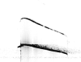 | Dymskaya et al., 2022
Up | up | (nearly) Monotonic increase in frequency > 5 kHz | 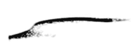 | Volodin et al., 2026
U-shaped | u | First decrease then increase in frequency > 5 kHz each |  | Marconi et al., 2020
Chevron | ch | First increase then decrease in frequency > 5 kHz each |  | Volodin et al., 2026
Complex | c | Two/more directional changes in frequency > 5 kHz |  | Volodin et al., 2026
Discontinuous variations | c2, c3, c4, c5, etc. | Two/more elements (notes) separated by 1/more frequency jumps without time separation |  | Volodin et al., 2026
Short | s | < 10 ms | Any shape
Ultrashort | us | < 5 ms | Any shape
Unclassified | Uncl | Calls that could not be assigned to any USV category. | 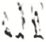 | Marconi et al., 2020
Spectrogram images are displayed without time reference, to illustrate frequency contour only.

Table A3
Acoustic features extracted by A-MUD (3.2) (Zala et al., 2017, 2020) and used for the analysis of Microtus bavaricus USVs.
Feature | Explanation | Unit
Duration | Duration of the detected USV | ms
fSlope | Frequency slope obtained by linear regression with all points in the detected frequency segment | kHz/ms
f_{o}mean | The mean of the detected frequencies in the segment (mean of f_{o}) | kHz
f_{o}beg | Frequency of the first point of the detected USV | kHz
f_{o}end | Frequency of the last point of the detected USV | kHz
f_{o}min | Frequency of the point with the minimum frequency of a detected USV | kHz
f_{o}max | Frequency of the point with the maximum frequency of a detected USV | kHz
Preliminary analyses
We performed preliminary analyses, running the K-means clustering (500 repetition, 100 maximum clusters, 100 random starts) analysis in two steps. In the first, all USV observations were used and we obtained some clusters with very few observations (< 10). In addition, by looking at these few USVs we noticed that the acoustic feature we observed on STx was different from the one calculated by A-MUD (e.g. f_{o}mean > vs the one measured with the cursor in STx), indicating an A-MUD problem in the extraction of those acoustic features and thus generating observations with extreme values (this was for the very few calls). In the second step, the extreme values regarding f_{o}mean were then eliminated. Then, K-means was run again (500 repetition, 100 maximum clusters, 100 random starts), again obtaining clusters with very few observations. Thus, we decided to eliminate extreme values for all acoustic variables, which is the scenario presented in the main manuscript, obtaining no clusters with < 10 calls. Extreme values were obtained as described in the main text: we exclude calls which had extreme values in the acoustical features that exceeded the interquartile range by a factor of 3, in relation to the central value of the acoustic features.
GLMM details
We assessed the overall contribution of each fixed factor in the model with a Type II Wald chi-square test using an ANOVA (“car” package; Fox & Weisberg, 2019). The model converged successfully (optimizer convergence code = 0), although a singular fit was detected (isSingular = TRUE). Specifically, the estimated variances of the random intercepts for pair identity (Pair ID) and experimental round (Round) were both zero (resp.: Pair ID: variance = 0, SD = 0; 3 levels; Round: variance = 0, SD = 0; 2 levels). This indicates that, given the present dataset, the model did not detect additional variability attributable to these grouping factors beyond that explained by the fixed effect. Nevertheless, Pair ID and Round were retained in the model because they were specified a priori to reflect the hierarchical structure of the experimental design and to account for the potential non-independence of observations originating from the same pair and experimental round. Their retention therefore reflects the experimental structure rather than evidence of substantial between-group variability. We tested the significance of the full model (Forstmeier & Schielzeth, 2011), comparing it against a null one comprising the random factors only (Faraway, 2006), by using a likelihood ratio test (ANOVA with argument test “Chisq”) (Dobson, 2002). We verified the absence of residuals’ overdispersion using the “DHARMa” package (Hartig, 2022). We evaluated the model’s discriminatory ability using the receiver operating characteristic (ROC) curve and the area under the ROC curve (AUC), calculated with the “pROC” package (Robin et al., 2011). The ROC curve was visually inspected relative to the diagonal reference line representing chance-level discrimination, while the AUC was used to quantify the model’s ability to discriminate between the two outcome categories. Logistic regression models by default return the coefficients as log-odds of the response as a function of the independent variables. Consequently, we used the tbl_regression function (“gtsummary” package; Sjoberg et al., 2021) to report the model coefficients as odds ratios, which are more interpretable.
Figure A5. Correlation matrix showing the correlation between each possible pair of acoustic features, using the Spearman rank correlation coefficient. Empty squares indicate the resulting P value to be not significant (P < 0.05).

Figure A6. Graph obtained using the K-means with the Elbow method and showing the optimal number of clusters. The elbow method identifies the optimal number of clusters at the point where further increases in cluster number result in progressively smaller reductions in within-cluster variation (here, k = 9). The SSE within is the within-cluster Sum of Squared Errors, representing the variability remaining within clusters, whereas the total SSE represents the total variability in the data before partitioning them into clusters.

Ellipses details
Ellipses were computed using a multivariate normal approximation of each group’s point distribution, based on the group centroid and covariance structure, providing a summary of the central tendency and dispersion of each context in the reduced-dimensional space.
Table A4
Distribution of recording files and USVs’ number (in brackets in the first column) within the used dataset.
Pair number | Number of recording files (Filename number in brackets) | Context | USVs’ number per context
1 (299) | 1 (n. 029) | Established pair | 335
2 (36) | 1 (n. 128) | Established pair | 335
4 (1103) | 2 (n. 002, 007) | Male intruder | 1103
Recording files 002 and 007 were obtained involving the same male intruder (526 and 577 USVs respectively).
Table A5
Mean ± standard deviation for each acoustic feature for USVs.
Feature | Mean ± SD | Mean ± SD established pair context | Mean ± SD male intruder context | Unit
Duration | 79.29 ± 50.54 | 54.41 ± 40.25 | 86.00 ± 50.95 | ms
fSlope | -0.01 ± 0.15 | -0.02 ± 0.18 | -0.01 ± 0.14 | kHz/ms
f_{o}mean | 29.2 ± 6.16 | 35.59 ± 7.34 | 27.47 ± 4.43 | kHz
f_{o}beg | 30.98 ± 8.28 | 36.88 ± 9.19 | 29.38 ± 7.24 | kHz
f_{o}end | 30.3 ± 7.29 | 36.42 ± 8.92 | 28.65 ± 5.76 | kHz
f_{o}min | 24.91 ± 6.61 | 32.62 ± 6.70 | 22.83 ± 4.79 | kHz
f_{o}max | 37.15 ± 11.32 | 40.96 ± 13.01 | 36.12 ± 10.59 | kHz

Table A6
USV’s count for each category.
USV category | Count (on the total USV in the dataset) | Count per established pair context (on the total USV in the context) | Count per male intruder context (on the total USV in the context)
f | 349 (24.27%) | 100 (29.85%) | 249 (22.57%)
up | 100 (6.95%) | 18 (5.37%) | 82 (7.43%)
d | 123 (8.55%) | 48 (14.33%) | 75 (6.80%)
us | 14 (0.97%) | 6 (1.79%) | 8 (0.73%)
s | 66 (4.59%) | 23 (6.87%) | 43 (3.90%)
u | 150 (10.43%) | 31 (9.25%) | 119 (10.79%)
c | 15 (1.04%) | 8 (2.39%) | 7 (0.63%)
c2 | 423 (29.42%) | 85 (25.37%) | 338 (30.64%)
c3 | 145 (10.08%) | 14 (4.18%) | 131 (11.88%)
c4 | 41 (2.85%) | 2 (0.60%) | 39 (3.54%)
c5 | 12 (0.83%) | / | 12 (1.09%)

Figure A7. ROC Curve for logistic regression to test the effect of context type on the occurrence of discontinuous USVs (AUC = 0.56, 95% CI: 0.54-0.58).
Table A7
Summary results of the GLMM testing the effect of context type on occurrence of discontinuous USVs and the relative dispersion test.
The full model significantly differed from the null model (ANOVA: $χ^{2}$₁ = 7.83, P < 0.01).
 | Estimate | SE | Z value | P value
(Intercept) | -0.84 | 0.12 | -7.06 | <0.0001
Male intruder context | 0.73 | 0.13 | 5.44 | <0.0001
Dispersion = 1.0008, P = 0.95
Table A8
Acoustic features (mean ± SD) for each cluster obtained by the K-means clustering method (number of USVs per cluster in brackets).
Acoustic feature | 1  (241) | 2  (33) | 3  (75) | 4  (186) | 5  (72) | 6  (125) | 7  (205) | 8  (116) | 9  (241)
Duration (ms) | 137.92 ± 33.76 | 113.77 ± 45.69 | 72.40 ± 43.71 | 43.42 ± 27.21 | 49.69 ± 31.95 | 34.15 ± 25.15 | 43.43 ± 26.63 | 62.81 ± 40.73 | 116.45 ± 24.26
fSlope (kHz/ms) | -0.03 ± 0.07 | -0.02 ± 0.11 | -0.02± 0.13 | -0.04 ± 0.08 | -0.34 ± 0.11 | 0.19 ± 0.10 | -0.10± 0.09 | 0.13 ± 0.14 | 0.04 ± 0.07
f_{o}mean(kHz) | 29.02 ± 2.81 | 29.62 ± 5.35 | 43.47 ± 4.46 | 23.14 ± 2.24 | 36.64 ± 5.02 | 27.38 ± 2.71 | 29.99 ± 2.79 | 35.32 ± 4.41 | 24.64 ± 2.34
f_{o}end(kHz) | 29.80 ± 4.56 | 29.68 ± 6.07 | 47.13 ± 6.33 | 22.93 ± 2.88 | 32.05 ± 5.52 | 29.16 ± 3.24 | 28.92 ± 3.63 | 40.88 ± 4.42 | 27.50 ± 3.22
f_{o}max(kHz) | 42.62 ± 6.59 | 76.58 ± 8.47 | 54.58 ± 7.82 | 25.39 ± 3.91 | 43.53 ± 6.65 | 30.68 ± 4.81 | 33.74 ± 4.73 | 42.47 ± 4.83 | 31.74 ± 4.32

Table A9
Kruskall-Wallis test results showing global significant differences across all clusters obtained from the K-means algorithm (significant P values are highlighted in bold).
Acoustic feature | H | df | P value
f_{o}max | 949.29 | 8 | <0.0001
f_{o}mean | 890.469 | 8 | <0.0001
Duration | 803.985 | 8 | <0.0001
f_{o}end | 743.168 | 8 | <0.0001
fSlope | 721.355 | 8 | <0.0001

Additional File 1 References

Abbasi R, Nicolakis D, Marconi MA, Klaus T, Wernisch B, Peng M, Balazs P, Penn DJ, Zala SM. Bioacoustic processing and analyses of mouse vocalizations: Current methods and future directions. Behavioural Brain Research. 2026; 513, 116337. https://doi.org/10.1016/j.bbr.2026.116337.
Balazs P, Laback B, Eckel G, Deutsch WA. Time–frequency sparsity by removing perceptually irrelevant components using a simple model of simultaneous masking. IEEE Transactions on Audio, Speech, and Language Processing. 2010; 18(1), 34–49. https://doi.org/10.1109/TASL.2009.2023164.
Dobson A. J. An introduction to generalized linear models (2nd ed.). 2002. Chapman and Hall/CRC Press.
Forstmeier W, & Schielzeth H. Cryptic multiple hypotheses testing in linear models: Overestimated effect sizes and the winner’s curse. Behavioral Ecology and Sociobiology. 2011; 65, 47–55. https://doi.org/10.1007/s00265-010-1038-5.
Fox J, Weisberg S. An R companion to applied regression (3rd ed.). 2019. Sage. https://www.john-fox.ca/Companion/.
Grimsley JMS, Sheth S, Vallabh N, Grimsley CA, Bhattal J, Latsko M, Jasnow A, Wenstrup JJ. Contextual Modulation of Vocal Behavior in Mouse: Newly Identified 12 kHz “Mid-Frequency” Vocalization Emitted during Restraint. Frontiers in Behavioral Neuroscience. 2016; 10:38. https://doi.org/10.3389/fnbeh.2016.00038.
Hanson JL, Hurley LM. Female presence and estrous state influence mouse ultrasonic courtship vocalisations. PLoS ONE. 2012; 7(7), e40782. https://doi.org/10.1371/journal.pone.0040782.
Hartig F. _DHARMa: Residual Diagnostics for Hierarchical (Multi-Level / Mixed) Regression Models. 2022. R package version 0.4.6. https://CRAN.R-project.org/package=DHARMa.
Hoffmann F, Musolf K, Penn DJ. Spectrographic analyses reveal signals of individuality and kinship in the ultrasonic courtship vocalisations of wild house mice. Physiology & Behavior. 2012; 105(3), 766–771. https://doi.org/10.1016/j.physbeh.2011.10.011
Marconi MA, Nicolakis D, Abbasi R, Penn DJ, Zala SM. Ultrasonic courtship vocalisations of male house mice contain distinct individual signatures. Animal Behaviour. 2020; 169, 169–197. https://doi.org/10.1016/j.anbehav.2020.09.006.
Musolf K, Meindl S, Larsen AL, Kalcounis-Rueppell MC, Penn DJ. Ultrasonic vocalisations of male mice differ among species and females show assortative preferences for male calls. PLoS ONE.2015; 10(8), e0134123. https://doi.org/10.1371/journal.pone.0134123.
Noll A, & White J. S_Tools-STx online manual [Computer software]. 2017. Version 5.0.6. https://www.oeaw.ac.at/isf/outreach/software/stx.
Noll A, Stuefer J, Klingler N, Leykum H, Lozo C, Luttenberger J, Pucher M, Schmid C. Sound Tools eXtended (STx) 5.0. A powerful sound analysis tool optimized for speech. Proceedings of Interspeec. 2019; 2370-2371.
Scattoni ML, Gandhy SU, Ricceri L, & Crawley JN. Unusual repertoire of vocalisations in the BTBR T+tf/J mouse model of autism. PLoS ONE. 2008; 3(8), e3067. https://doi.org/10.1371/journal.pone.0003067.
Scattoni ML, Ricceri L, & Crawley JN. Unusual repertoire of vocalisations in adult BTBR T+tf/J mice during three types of social encounters. Genes, Brain and Behavior. 2011; 10(1), 44–56. https://doi.org/10.1111/j.1601-183X.2010.00623.x.
Sjoberg DD, Whiting K, Curry M, Lavery JA, Larmarange J. Reproducible summary tables with the gtsummary package. The R Journal. 2021; 13, 570–580. https://doi.org/10.32614/RJ-2021-053.
Zala SM, Nicolakis D, Marconi MA, Noll A, Ruf T, Balazs P, Dustin JP. Primed to vocalize: Wild-derived male house mice increase vocalisation rate and diversity after a previous encounter with a female. PLoS ONE. 2020; 15(12), e0242959. https://doi.org/10.1371/journal.pone.0242959.
Zaytseva AS, Volodin IA, Ilchenko OG, & Volodina EV. Ultrasonic vocalisation of pup and adult fat-tailed gerbils (Pachyuromys duprasi). PLoS ONE. 2019; 14(7), e0219749. https://doi.org/10.1371/journal.pone.0219749.

