Supplementary Figure 1. Q-Q plot for the genome-wide association study of HTGW.
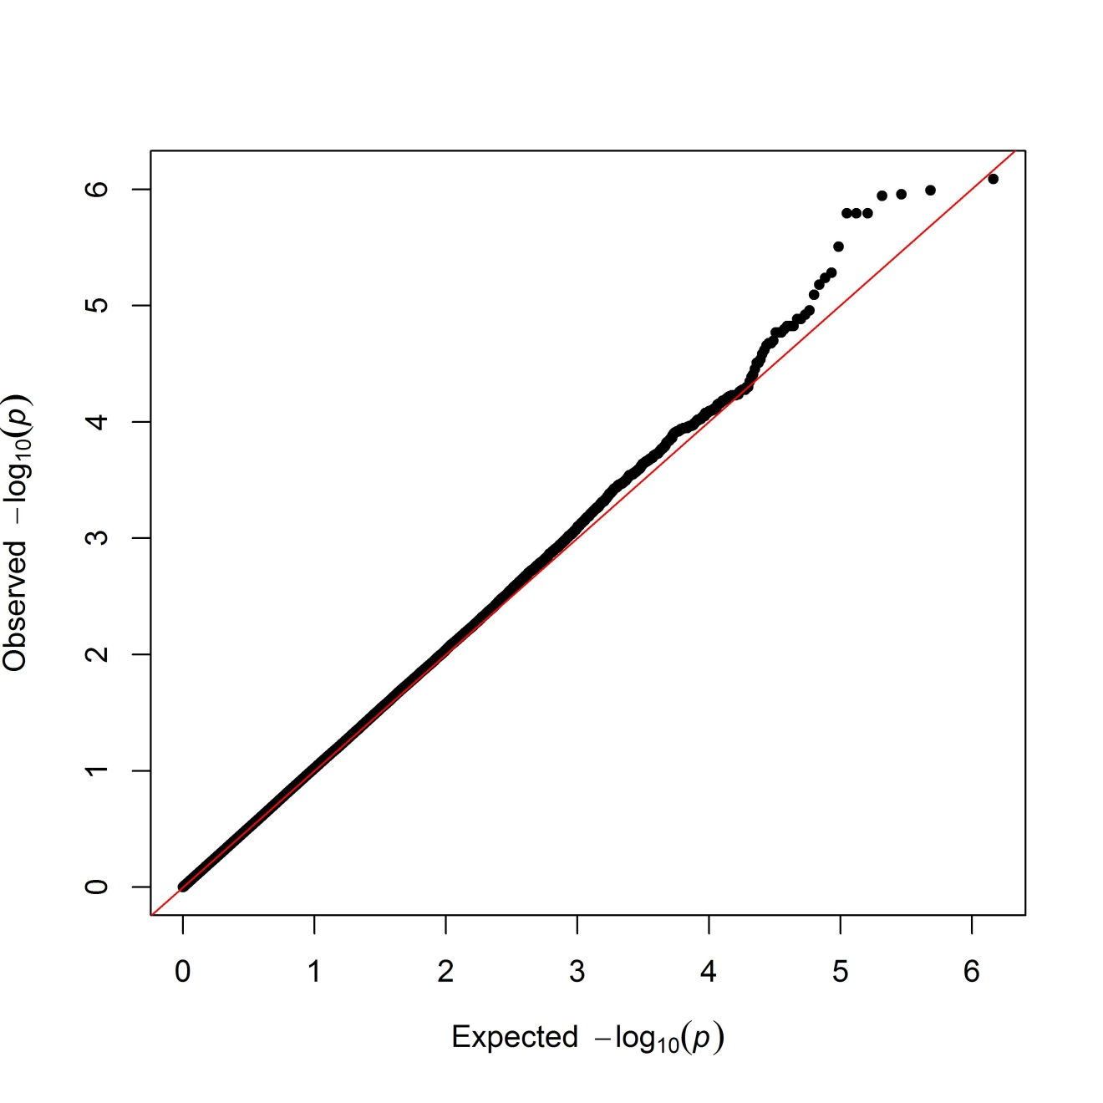

Supplementary Figure 2. Q-Q plot for the epigenome-wide association study of HTGW.
