Suppl. Figure 1. Pyrosequencing validation of the PLAGL1, GRB10, NDN and SNRPN assay. 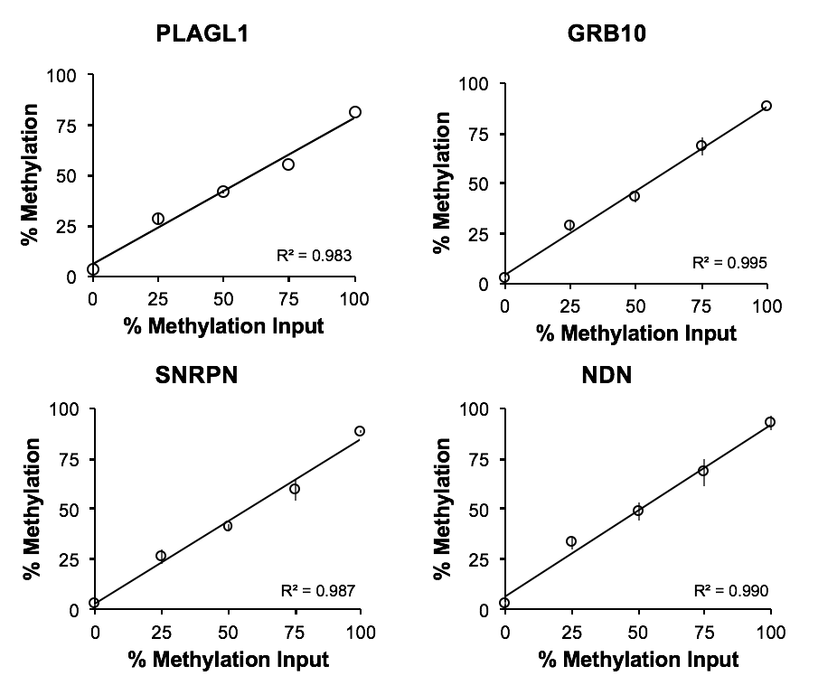
Defined mixtures of Qiagen Epitect Bisulfite Modified control DNAs (0%, 25%, 50%, 75% and 100% methylated; x-axis) were analyzed by pyrosequencing, with the actual percent methylation measured shown on the y-axis. Error bars indicate the standard deviation for triplicate measures.

