Supplementary Appendix to

Smoking-associated DNA methylation markers predict lung cancer incidence
Yan Zhang¹, Magdeldin Elgizouli², Ben Schöttker¹, Bernd Holleczek³, Alexandra Nieters², Hermann Brenner^{1,4,5}
¹Division of Clinical Epidemiology and Aging Research, German Cancer Research Center (DKFZ), Heidelberg, Germany; ²Centre of Chronic Immunodeficiency (CCI), Module Epidemiology, University Medical Center Freiburg, Freiburg, Germany; ³Saarland Cancer Registry, Saarbrücken; ⁴Germany Division of Preventive Oncology, German Cancer Research Center (DKFZ) and National Center for Tumor Diseases (NCT), Im Neuenheimer Feld 460, D-69120 Heidelberg, Germany; ⁵German Cancer Consortium (DKTK), German Cancer Research Center (DKFZ), Heidelberg, Germany

Table S1. The primers for the pyrosequencing analyses
Table S2. Associations of methylation at AHRR, 6p21.33, and F2RL3 with lung cancer risk in training set
Table S3. Smoking-history stratified associations of methylation at AHRR, 6p21.33, and F2RL3 with lung cancer risk
Table S4. Individual and joint performance of methylation at AHRR, 6p21.33, and F2RL3 in training and validation
Table S5. Optimism-corrected AUC (95% CI) among heavy and light smokers
Figure S1. Correlation between AHRR, 6p21.33, and F2RL3 methylation

Table S1. The primers for the pyrosequencing analyses
Marker | Primer
AHRR | F AGGGGTTGTTTAGGTTATAGATT  R b-CTCCAAAACCCCAAAAACCAACCTATC  S GTTTTGGTTTTGTTTTGTATT
6p21.33 | F TTGGAGAATTTGATGGAGATTGAAGTTAA  R b-AAACTACAAACAAACCAACCCCAACA  S TTTTTTTGAAATTTTATGATTTAGT
F2RL3 | F GGTTTATTAGTAGTATGGTGGAGGG  R b-CCCAAACCAAATCTATACCAATAACAATAAC  S TAGTATGGTGGAGGG
F – forward; R – reverse; S – sequencing; b - biotin

Table S2. Associations of methylation at AHRR, 6p21.33, and F2RL3 with lung cancer risk in training set
 | Methylation level ª / Smoking status | Controls | Cases | OR (95% CI)
 |  |  |  | Model 1^{b} | Model 2^{c} | Model 3^{d}
AHRR_cg05575921 | ≥ 85 (Quartile 4) | 59 | 3 | Ref. | Ref. | Ref.
 | < 85 (Quartile 3) | 52 | 3 | Ref. | Ref. | Ref.
 | < 80 (Quartile 2) | 56 | 14 | 6.36 (2.19 - 18.48) | 2.51 (0.69 - 9.11) | 2.35 (0.51 - 10.86)
 | < 68 (Quartile 1) | 55 | 56 | 26.93 (10.02 - 72.36) | 7.31 (1.97 - 27.17) | 6.44 (1.48 - 28.10)
 | Per SD less methylation |  | --- | 2.54 (1.95 - 3.32) | 1.49 (0.99 - 2.26) | 1.71 (1.04 - 2.80)
 | Never smoker | 86 | 5 | Ref. | Ref. | Ref.
 | Former smoker | 90 | 29 | 4.86 (1.46 - 16.16) | 2.42 (0.61 - 9.56) | 1.34 (0.29 - 6.27)
 | Current smoker | 40 | 43 | 11.02 (2.81 - 43.15) | 3.02 (0.61 - 14.99) | 2.19 (0.36 - 13.44)
 | Per 24 (= 1SD) pack-years |  | --- | 1.97 (1.23 - 3.14) | 1.72 (1.07 - 2.76) | 2.01 (1.13 - 3.59)
6p21.33_cg06126421 | ≥ 73 (Quartile 4) | 58 | 3 | Ref. | Ref. | Ref.
 | < 73 (Quartile 3) | 57 | 16 | Ref. | Ref. | Ref.
 | < 66 (Quartile 2) | 53 | 27 | 3.31 (1.67 - 6.57) | 1.89 (0.82 - 4.37) | 1.92 (0.74 - 4.97)
 | < 57 (Quartile 1) | 54 | 30 | 3.59 (1.83 - 7.06) | 0.76 (0.31 - 1.90) | 0.88 (0.31 - 2.53)
 | Per SD less methylation |  | --- | 1.75 (1.33 - 2.31) | 0.93 (0.63 - 1.38) | 0.92 (0.59 - 1.43)
 | Never smoker | 86 | 5 | Ref. | Ref. | Ref.
 | Former smoker | 90 | 29 | 4.86 (1.46 - 16.16) | 4.63 (1.37 - 15.63) | 2.39 (0.63 - 9.13)
 | Current smoker | 40 | 43 | 11.02 (2.81 - 43.15) | 14.11 (3.34 - 59.54) | 8.36 (1.63 - 42.98)
 | Per 24 (= 1SD) pack-years |  | --- | 1.97 (1.23 - 3.14) | 1.97 (1.21 - 3.22) | 2.27 (1.26 - 4.10)
F2RL3_cg03636183 | ≥ 81 (Quartile 4) | 74 | 3 | Ref. | Ref. | Ref.
 | < 81 (Quartile 3) | 49 | 7 | Ref. | Ref. | Ref.
 | < 78 (Quartile 2) | 47 | 11 | 3.22 (1.26 - 8.22) | 1.29 (0.44 - 3.8) | 1.20 (0.33 - 4.38)
 | < 73 (Quartile 1) | 52 | 55 | 14.88 (6.84 - 32.37) | 4.43 (1.64 - 11.97) | 6.56 (1.94 - 22.2)
 | Per SD less methylation |  | --- | 2.28 (1.76 - 2.94) | 1.44 (0.99 - 2.09) | 1.58 (1.01 - 2.46)
 | Never smoker | 86 | 5 | Ref. | Ref. | Ref.
 | Former smoker | 90 | 29 | 4.86 (1.46 – 16.16) | 2.82 (0.77 - 10.3) | 1.34 (0.31 - 5.92)
 | Current smoker | 40 | 43 | 11.02 (2.81 – 43.15) | 3.23 (0.66 - 15.79) | 1.65 (0.26 - 10.61)
 | Per 24 (= 1SD) pack-years |  | --- | 1.97 (1.23 – 3.14) | 2.05 (1.25 – 3.36) | 2.44 (1.32 – 4.50)
ª Quartiles of each sites among controls in the training set; ^{b}Model1: adjusted for age and sex; ^{c}Model 2: like model 1, additionally adjusted for smoking status + pack-years/methylation quartiles; ^{d}Model 3: like model 2, additionally adjusted for educational level, BMI, physical activity, systolic blood pressure, total cholesterol, family history of cancer, prevalence of hypertension, cardiovascular disease, and diabetes.
Abbreviations: OR, odds ratio; CI, confidence interval; Ref., reference category; SD, standard deviation.

Table S3. Smoking-status stratified associations of methylation at AHRR, 6p21.33, and F2RL3 with lung cancer risk
CpG site | Smoking statusª | OR (95% CI)^{b}
CpG site | Smoking statusª | Model 1^{c} | Model 2^{d} | Model 3e
AHRR_cg05575921 | Light smoker | 1.82 (1.39 – 2.38) | 1.52 (1.05 – 2.21) | 1.41 (0.92 – 2.14)
 | Heavy smoker | 1.40 (0.97 – 2.01) | 1.23 (0.80 – 1.90) | 1.29 (0.81 – 2.07)
6p21.33_cg06126421 | Light smoker | 1.63 (1.19 – 2.22) | 1.34 (0.91 – 1.97) | 1.41 (0.92 – 2.16)
 | Heavy smoker | 1.04 (0.75 – 1.45) | 0.97 (0.68 – 1.38) | 1.07 (0.70 – 1.64)
F2RL3_cg03636183 | Light smoker | 2.03 (1.53 – 2.69) | 1.82 (1.25 – 2.65) | 1.65 (1.07 – 2.53)
 | Heavy smoker | 1.23 (0.86 – 1.78) | 1.07 (0.72 – 1.60) | 1.15 (0.71 – 1.87)
ª Light smokers include participants with <30 pack-years of smoking or who quit smoking >15 years ago for former smokers; Heavy smokers include participants with ≥30 pack-years of smoking who were current smokers or quit smoking ≤15 years ago; ^{b}OR for per standard deviation (SD) less methylation level of each CpG sites; ^{c}Model1: adjusted for age and sex; ^{d}Model 2: like model 1, additionally adjusted pack-years and time since quitting; ^{e}Model 3: like model 2, additionally adjusted for educational level, BMI, physical activity, systolic blood pressure, total cholesterol, family history of cancer, prevalence of hypertension, cardiovascular disease, and diabetes.
Abbreviations: OR, odds ratio; CI, confidence interval.

Table S4. Individual and joint performance of methylation at AHRR, 6p21.33, and F2RL3 in training and validation
Markers | AUC (95% CI)
Markers | Training set | Validation set
AHRR_cg05575921 | 0.792 (0.736 – 0.848) | 0.799 (0.733 – 0.866)
6p21.33_cg06126421 | 0.662 (0.597 – 0.726) | 0.789 (0.725 – 0.853)
F2RL3_cg03636183 | 0.791 (0.735 – 0.846) | 0.812 (0.725 – 0.871)
β1×M_{AHRR}+β2×M_{6p21.33} +β3×M _{F2RL3}+β4×M_{6p21.33}×M _{F2RL3}ª | 0.829 (0.778 – 0.881) | 0.799 (0.737 – 0.861)
Smoking index^{b} | 0.797 (0.744 – 0.850) | 0.819 (0.759 – 0.880)
Methylation score^{c} | 0.771 (0.713 – 0.830) | 0.811 (0.753 – 0.870)
AHRR_Binary +6p21.33_Binary +F2RL3_ Binary^{d} | 0.818 (0.769 – 0.866) | 0.788 (0.725 – 0.850)
ª βs derived from regression coefficients in the training set: β1=-.0685, β =.4673, β3 =.3173, and β4=-.00612;
^{b} Smoking index bases on 3 CpGs, computed according to algorithm introduced by Teschendorff et al. JAMA Oncol. 2015;1(4):476-485;
^{c} Methylation score constructed according to quartiles of controls in the training set, with value of 3, 2, 1, and 0, respectively, for participants in the lowest quartiles of all 3 CpGs, of 2 of the 3 CpGs, of 1 of the 3 CpGs, and others;
^{d} optimal cut points of each CpG determined by Youden's J Index, AHRR_Binary=1/ 0 if cg05575921 >74%/ ≤74%, 6p21.33_Binary=1/ 0 if cg06126421 >70%/ ≤70%, and F2RL3_ Binary =1/0 if cg03636183 >70%/ ≤70.
Abbreviations: AUC, areas under the curve; CI, confidence interval.

Table S5. Optimism-corrected AUC (95% CI) among heavy and light smokers
Group | AUC (95% CI)
Group | Pack-years (PY) | AHRR_cg05575921 | 6p21.33_cg06126421 | F2RL3_cg03636183 | combinationª
Heavy smokers  N=150 (77 lung cancer cases)  (97 current smokers with ≥30 PY +  53 former smokers with ≥30PY and quit≤ 15 years ago) | 0.563  (0.471 - 0.656) | 0.540  (0.445 - 0.635) | 0.504  (0.410 - 0.598) | 0.528  (0.433 - 0.622) | 0.587  (0.495 - 0.679)
Light smokers  N=231 (51 lung cancer cases)  (51 current smokers with <30 PY +  153 former smokers with <30 PY +  27 former smokers with ≥30 PY and quit >15years ago) | 0.561  (0.454 - 0.668) | 0.704  (0.618 - 0.789)  (p=0.04, vs. PY) | 0.617  (0.529 - 0.706) (p=0.42, vs. PY,) | 0.743  (0.666 - 0.820)  (p=0.007, vs. PY) | 0.747  (0.669 - 0.825) (p=0.006, vs. PY)
Light smokers (Sensitivity analysis)^{b}  N=204 (41 Lung cancer cases)  (51 current smokers with <30 PY +  153 former smokers with <30 PY) | 0.491  (0.372 -0.610) | 0.700  (0.604 - 0.795) | 0.632  (0.537 - 0.729) | 0.755  (0.674 - 0.837) | 0.757  (0.673 - 0.840)
ªCombination formula: β1×M_{AHRR}+β2×M_{6p21.33} +β3×M_{F2RL3}+β4× M_{6p21.33} × β3×M_{F2RL3}=(-0.0685) ×cg05575921 + 0.4673 × cg06126421 + 0.3173 × cg03636183 + (-0.00612) × cg06126421 × cg03636183, where underlined coefficients were derived from regression coefficients in training set. ^{b}A sensitivity analysis was conducted among light smokers after excluding participants with ≥30 pack-years and quit smoking >15years ago.
Abbreviations: AUC, areas under the curve; CI, confidence interval; PY, pack-years.

Figure S1. Correlation between AHRR, 6p21.33, and F2RL3 methylation
Training set Validation set
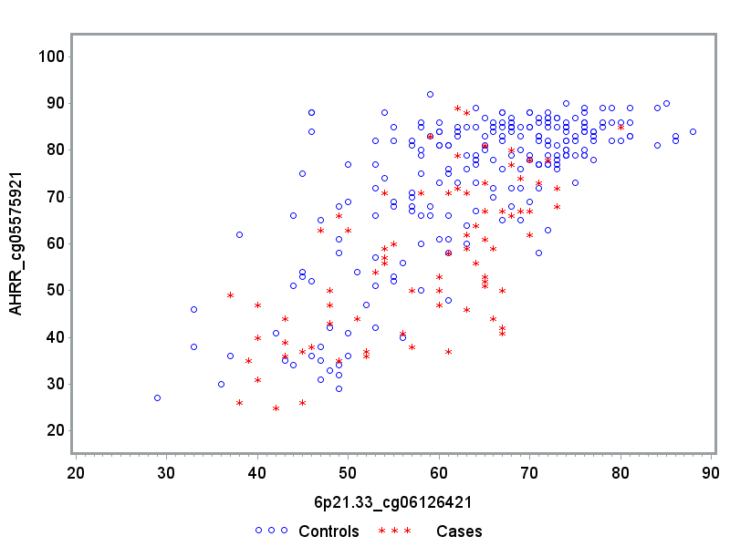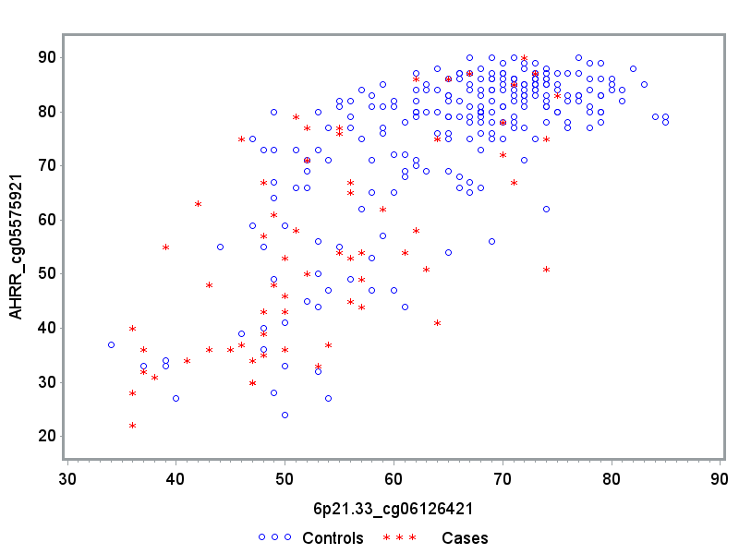
r = 0.6587
r = 0.6594
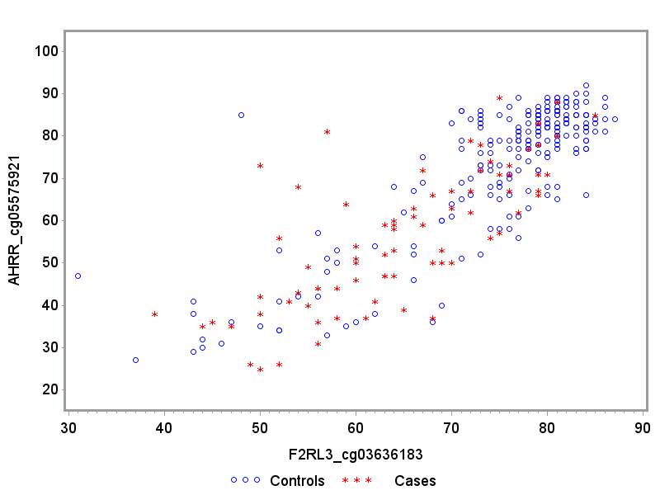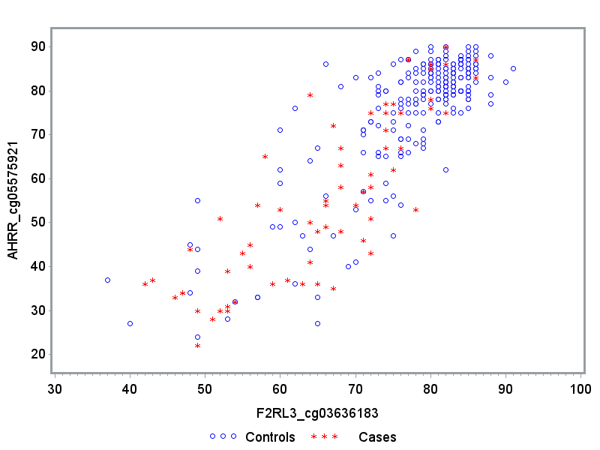
r = 0.7244
r = 0.7867
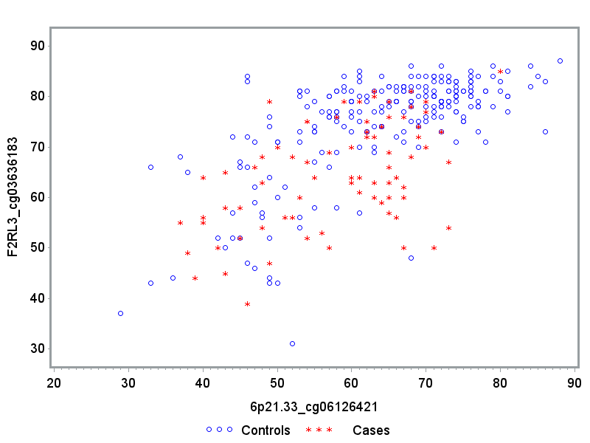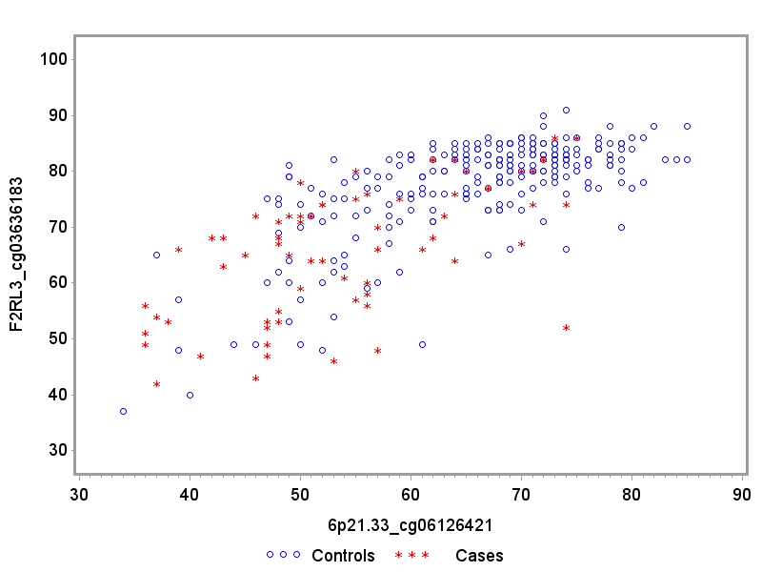
r = 0.6293
r = 0.6178

