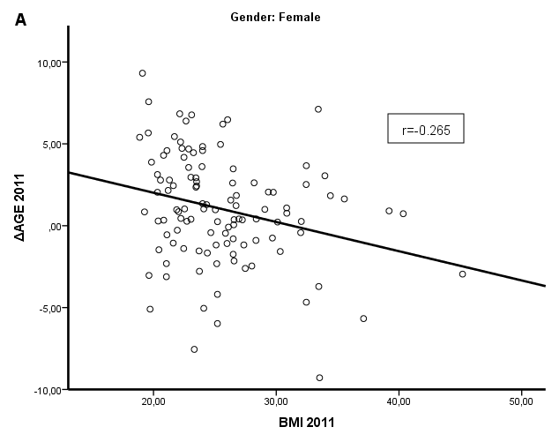

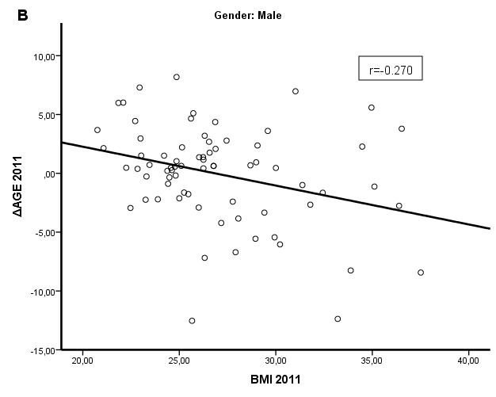

Additional file 3: Figure S2. Gender-specific correlations of ΔAGE and BMI in middle-aged individuals. In panel A, scatterplot of ΔAGE and BMI in middle-aged female individuals (r=-0265, p=0.05). In panel B, scatterplot of ΔAGE and BMI in middle-aged male individuals (r=-0.270, p=0.022).

