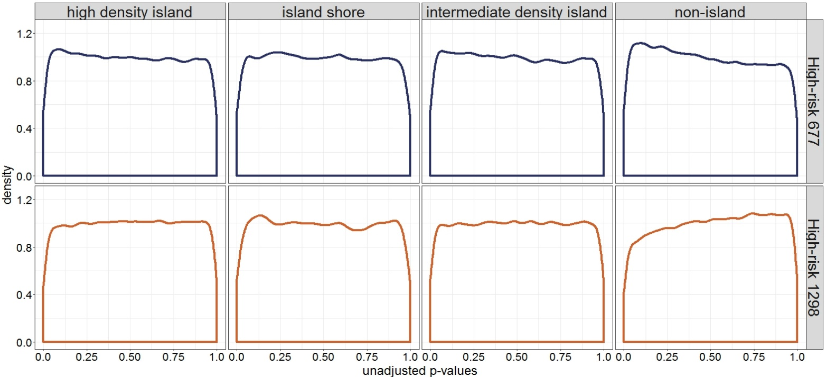
Figure S3. Distribution of unadjusted p-values by CpG density between high-risk 677 or high-risk 1298 placentas compared to reference placentas. N=442,355 CpGs on the 450k array were separated into four CpG density categories, and the linear model (MTHFR group as the main effect and fetal sex and gestational age included as covariates) was re-run within each CpG density category. No CpG density category (high density island, island shore, intermediate density island, non-island) showed a trend for differential methylation by either MTHFR high-risk genotype group.

