Additional materials

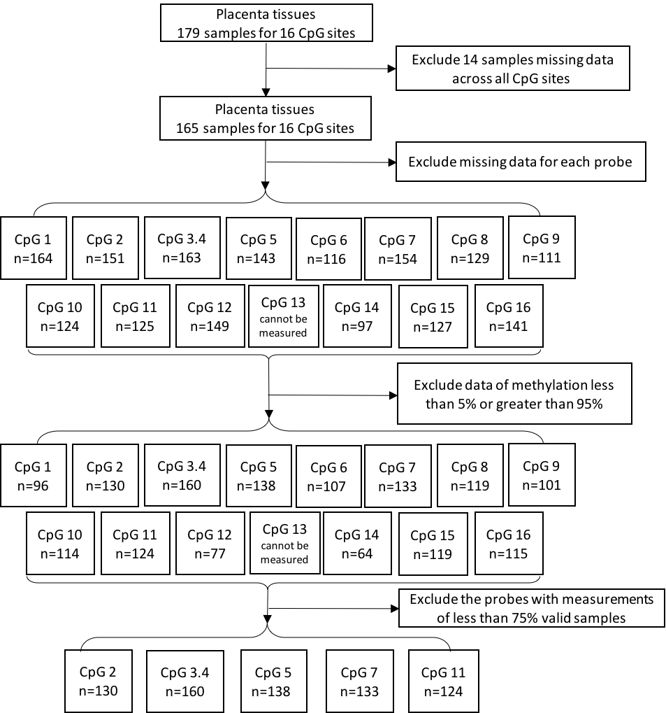

Figure S1. Quality control flow chart

Table S1. PCR primers for FGFR2 gene region.
Chromosomal Regionª | chr10:123355182 to 123355644
Target sequence  (3’→5‘) | cagaatgcaggggaattttctacctctaacaC^{[16]}GacttcaggaacaatcctaagtcctC^{[15]}GcagaggtttcaccccaggctccttcccC^{[14]}GgcctgctC^{[13]}GcccacctgtccctgcccagaggagcctccttggctccaggcagagaaaggtggacagggC^{[12]}GctcC^{[11]}GctgaatctcaagcC^{[10]}GttccatcatccC^{[9]}GctagctggcactagaaatttgcatttcagccatttccaggtccaaaccccaC^{[8]}GgcagccccctccccaaaactctggaaggC^{[7]}GgagacctaaggC^{[6]}GacaggtctgcacagttcctcacaccagtggacaaaagtatggtgC^{[5]}GacctcctaggcaggataattaggtccccaggctC^{[4]}GgtgttgggaatacaggcccagcatgcC^{[3]}GctggC^{[2]}GgccacaatccC^{[1]}Ggcttcctgccttcaataccataatccttcctggagtctgagccccagtg
location | 5'UTR; N-shore
Primers (5’→3’) | Forward: aggaagagagTATTGGGGTTTAGATTTTAGGAAGG  Reverse: cagtaatacgactcactatagggagaaggctCAAAATACAAAAAAATTTTCTACCTCT
Amplicon length (bp) | 463
ª UCSC GRCh37/hg19

Table S2. Genomic sites of methylation interrogated in the current study.
Analytic Sites | Genomic locationª
CpG 1 | Chr10: 123355594
CpG 2 | Chr10: 123355582
CpG 3 | Chr10: 123355577
CpG 4 | Chr10: 123355548
CpG 5 | Chr10: 123355513
CpG 6 | Chr10: 123355467
CpG 7 | Chr10: 123355454
CpG 8 | Chr10: 123355424
CpG 9 | Chr10: 123355371
CpG 10 | Chr10: 123355358
CpG 11 | Chr10: 123355343
CpG 12 | Chr10: 123355338
CpG 13 | Chr10: 123355277
CpG 14 | Chr10: 123355268
CpG 15 | Chr10: 123355239
CpG 16 | Chr10: 123355213

ª UCSC GRCh37/hg19
Grey shading CpG sites cannot be detected by Sequenom MassARRAY

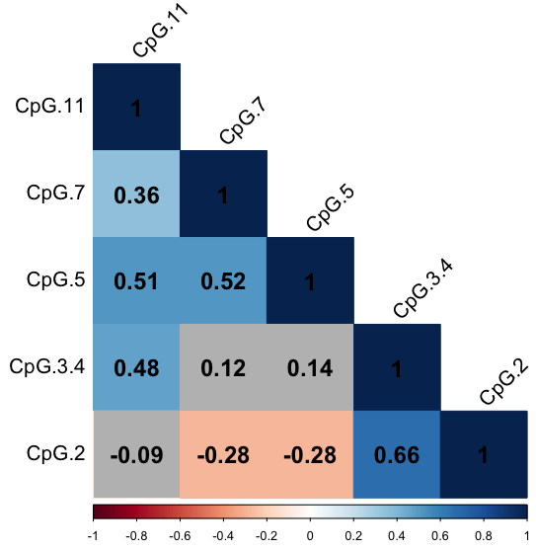
Figure S2. The correlation of DNA methylation across all the valid CpG sites invalid samples. The correlation coefficients with a grey background are not statistically significant (P > 0.05).

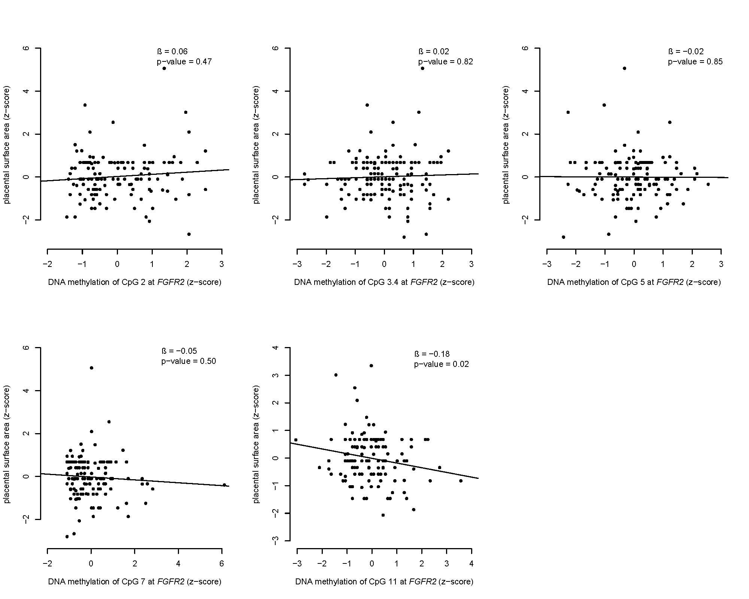
Figure S3. The scatter plots of placental surface area versus DNA methylation of CpG sites at FGFR2. The coefficient and P-value were given by regression of placental surface area on DNA methylation using multiple linear regression models adjusted for maternal age, education, family monthly income, ETS exposure during pregnancy, gestational age and sex.

Table S3. Sensitivity analyses on the associations between the valid CpGs methylation of FGFR2 in placenta and risk of FT-LBW.
CpG sites | N |  | Odds ratio for per standard deviation increment in DNA methylation (95% CI) ª | P - value
CpG sites | FT-LBW | FT-NBW |  | P - value
All subjects
CpG 2 | 65 | 65 | 0.93 (0.65, 1.35) | 0.71
CpG 3.4 | 82 | 78 | 1.07 (0.77, 1.49) | 0.68
CpG 5 | 73 | 65 | 1.11 (0.79, 1.58) | 0.54
CpG 7 | 69 | 64 | 1.13 (0.76, 1.67) | 0.54
CpG 11 | 69 | 55 | 1.61 (1.06, 2.45) | 0.02
Girls
CpG 2 | 40 | 35 | 0.76 (0.48, 1.21) | 0.25
CpG 3.4 | 49 | 44 | 1.29 (0.81, 2.04) | 0.29
CpG 5 | 44 | 39 | 1.27 (0.79, 2.03) | 0.33
CpG 7 | 44 | 34 | 1.20 (0.73, 1.96) | 0.47
CpG 11 | 43 | 32 | 1.90 (1.10, 3.31) | 0.02
Boys
CpG 2 | 25 | 30 | 1.27 (0.66, 2.45) | 0.47
CpG 3.4 | 33 | 34 | 0.80 (0.47, 1.35) | 0.41
CpG 5 | 29 | 26 | 0.83 (0.47, 1.46) | 0.52
CpG 7 | 25 | 30 | 0.93 (0.47, 1.84) | 0.84
CpG 11 | 26 | 23 | 1.31 (0.63, 2.71) | 0.48
ª In all subjects, the models were adjusted for maternal age, education, family monthly income, gestational age and newborn's sex. In girls and boys, the models were adjusted for all the covariates mentioned above, except the newborn's sex.

Table S4. Sensitivity analyses on the associations between the valid CpGs methylation in placenta and risk of FT-LBW after excluding the subjects who had prenatal alcohol use.
FGFR2  CpG sites | FT-LBW |  | FT-NBW |  | Odds ratio for per standard deviation increment in DNA methylation (95% CI) ª | P - value
FGFR2  CpG sites | N | Mean (SD) | N | Mean (SD) |  | P - value
All subjects
CpG 2 | 60 | 0.35 (0.20) | 63 | 0.37 (0.23) | 1.01 (0.69, 1.47) | 0.98
CpG 3.4 | 77 | 0.37 (0.08) | 76 | 0.37 (0.08) | 1.08 (0.77, 1.52) | 0.66
CpG 5 | 69 | 0.49 (0.13) | 63 | 0.48 (0.14) | 1.07 (0.75, 1.54) | 0.70
CpG 7 | 64 | 0.19 (0.14) | 62 | 0.18 (0.12) | 1.12 (0.75, 1.68) | 0.57
CpG 11 | 65 | 0.39 (0.11) | 53 | 0.35 (0.09) | 1.76 (1.12, 2.77) | 0.01
Girls
CpG 2 | 37 | 0.35 (0.20) | 35 | 0.39 (0.23) | 0.94 (0.57, 1.54) | 0.79
CpG 3.4 | 46 | 0.37 (0.08) | 44 | 0.36 (0.07) | 1.30 (0.81, 2.10) | 0.28
CpG 5 | 42 | 0.49 (0.10) | 39 | 0.47 (0.14) | 1.17 (0.71, 1.92) | 0.54
CpG 7 | 41 | 0.20 (0.15) | 34 | 0.18 (0.11) | 1.22 (0.72, 2.07) | 0.47
CpG 11 | 41 | 0.40 (0.11) | 32 | 0.34 (0.11) | 2.03 (1.10, 3.76) | 0.02
Boys
CpG 2 | 23 | 0.37 (0.19) | 28 | 0.34 (0.22) | 1.51 (0.71, 3.24) | 0.29
CpG 3.4 | 31 | 0.36 (0.09) | 32 | 0.37 (0.08) | 0.77 (0.44, 1.36) | 0.37
CpG 5 | 27 | 0.48 (0.16) | 24 | 0.50 (0.12) | 0.82 (0.46, 1.47) | 0.51
CpG 7 | 23 | 0.18 (0.10) | 28 | 0.19 (0.12) | 0.85 (0.41, 1.75) | 0.65
CpG 11 | 24 | 0.39 (0.12) | 21 | 0.37 (0.05) | 1.34 (0.57, 3.15) | 0.50
ª In all subjects, the models were adjusted for maternal age, education, family monthly income, ETS exposure during pregnancy, gestational age, and newborn's sex. In girls and boys, the models were adjusted for all the covariates mentioned above, except the newborn's sex.

FGFR2  CpG sites | N ª |  | Model 0 ^{b} |  | Model 1 ^{b} |  | Model 2 ^{b} |  | Model 3 ^{b}
FGFR2  CpG sites | FT-LBW | FT-NBW | β-coefficient (95%CI) | P-value | β-coefficient (95%CI) | P-value | β-coefficient (95%CI) | P-value | β-coefficient  (95%CI) | P-value
CpG 2 | 10 | 12 | 5.61 (0.56, 56.09) | 0.14 | 5.40 (0.52, 56.54) | 0.16 | 5.86 (0.41, 84.32) | 0.19 | 14.06 (0.12, 1602.42) | 0.27
CpG 3.4 | 11 | 12 | 3.01 (0.73, 12.45) | 0.13 | 3.07 (0.75, 12.63) | 0.12 | 3.21 (0.75, 13.73) | 0.12 | 3.08 (0.58, 16.41) | 0.19
CpG 5 | 10 | 10 | 1.46 (0.60, 3.56) | 0.40 | 1.46 (0.60, 3.57) | 0.40 | 1.39 (0.53, 3.66) | 0.51 | 1.03 (0.20, 5.21) | 0.97
CpG 7 | 12 | 11 | 1.11 (0.41, 3.01) | 0.84 | 0.98 (0.34, 2.79) | 0.97 | 1.07 (0.33, 3.47) | 0.91 | 1.22 (0.28, 5.35) | 0.79
CpG 11 | 10 | 10 | 2.08 (0.58, 7.39) | 0.26 | 2.10 (0.59, 7.52) | 0.25 | 2.17 (0.56, 8.46) | 0.26 | 1.95 (0.25, 15.08) | 0.52
cg25052156 (CpG 7) ^{c} | 14 | 12 | 1.10 (0.59, 2.00) | 0.81 | 1.15 (0.59, 2.22) | 0.68 | 1.15 (0.50, 2.64) | 0.75 | 1.25 (0.52, 3.77) | 0.51
Table S5. Comparisons of the effect size across the CpG sites between the adjusted model (adjusted for age, gender and surrogate variables) and the raw model (adjusted for age and gender).
a: The sample size for the individual CpG sites analyses was varied depending on the numbers of invalid samples excluded from analyses of each CpG site in the EpiTYPER data.
b: Model 0, adjusted for maternal age and child’s gender; Model 1, adjusted for maternal age, child’s gender and the first surrogate variable; Model 2, adjusted for maternal age, child’s gender and the first three surrogate variables; Model 3, adjusted for maternal age, child’s gender and all the five surrogate variables.
c: To replicate the association between DNA methylation of CpG 7 (EpiTYPER data) and FT-LBW using Methylation 450K data of cg25052156. CpG 7 in EpiTYPER approach is the site of cg25052156 in Methylation 450K approach.

Table S6. Maternal, placental and fetal characteristics of the subset samples with the epigenome-wide DNA methylation data available.
 | FT-LBW(N=14) | FT-NBW(N=12) | P-value
Mothers
Age (y), mean (SD) | 26.14 (3.66) | 30.17 (4.26) | 0.02
Pre-pregnancy BMI, mean (SD) | 18.99 (2.55) | 19.51 (3.09) | 0.64
College or above, N (%) | 3 (21.40) | 6 (50.00) | 0.22
Family income <=￥3000/month, N (%) | 9 (64.30) | 7 (58.30) | 1.00
Married, N (%) | 13 (92.90) | 12 (100.00) | 1.00
Environmental tobacco smoke, N (%) | 9 (64.30) | 7 (58.30) | 1.00
Primiparity, N (%) | 11 (78.60) | 7 (58.30) | 0.40
Placenta
Weight (g), mean (SD) | 438.25 (40.63) | 512.59 (74.45) | 0.004
Major axis length (cm), mean (SD) | 19.00 (2.19) | 19.83 (1.90) | 0.41
Minor axis length (cm), mean (SD) | 17.79 (2.01) | 18.83 (1.79) | 0.19
Area (cm²) | 268.77 (68.87) | 295.77 (61.68) | 0.31
Thickness (cm) | 2.07 (0.27) | 2.00 (0.00) | 0.37
Newborns
Female | 6 (42.90) | 4 (33.30) | 0.70
Gestational weeks, mean (SD) | 38.07 (0.92) | 38.42 (0.90) | 0.34
Birth weight (g), mean (SD) | 2390.36 (87.17) | 3222.08 (353.70) | 4.00 × 10⁻⁶
Length (cm), mean (SD) | 46.86 (1.03) | 49.25 (1.14) | 8.00 × 10⁻⁶
HC (cm), mean (SD) | 30.93 (1.39) | 33.50 (1.31) | 6.40 × 10⁻⁶

