Additional file
miR-29c plays suppress roles in breast cancer by activating
TIMP3/STAT1/FOXO1 pathway
Wan Li^{1,2,*}, Jie Yi^{3*}，Xiangjin Zheng^{1,2}, Shiwei Liu⁴,Weiqi Fu^{1,2}, Li Li ², Dave Hoon⁵, Jinhua Wang^{1,2,£}, Guanhua Du^{1,2,£}
¹The State Key Laboratory of Bioactive Substance and Function of Natural Medicines;
²Key Laboratory of Drug Target Research and Drug Screen, Institute of Materia Medica, Chinese Academy of Medical Science and Peking Union Medical College. Beijing, China 100050.
³Department of Clinical Laboratory, Peking Union Medical College Hospital, Beijing, China 100730.
⁴Department of Endocrinology, Shanxi DAYI Hospital, Shanxi Medical University, Taiyuan, Shanxi, China, 030002.
⁵ Department of Molecular Oncology, John Wayne Cancer Institute (JWCI) at Providence Saint John’s Health Center, Santa Monica, CA 90404.

* These authors contributed equally to this work.
£Both authors should be considered as corresponding authors:
Jinhua Wang, Email: wjh@imm.ac.cn, Fax:86-10-63165184
Guanhua Du, Email: dugh@imm.ac.cn, Fax:86-10-63165184

Table S1: Sequence of DNMT3B siRNA
DNMT3B siRNA | Sequence
siRNA 1 | Sense strand, 5’-AGAUGACGGAUGCCUAGAGUUCCU GUCUC A-3’
siRNA 1 | Anti-sense strand, 5’-GCUCUAGGCAUCCGUCAUCUUU CCUGUCUC -3’
siRNA 2 | Sense strand, 5’- UCUGUCCGUUCACAUGUGUUU-3’
siRNA 2 | Anti-sense strand, 5’-GUACACAUGUGAACGGACAGAUU-3’

Table S2: Primers of miR-29c and DNMT3B
Gene name | Primer sequence
miR-29c | Forward: 5’-CTGACCTTAGCACCATTTGAAATC-3’
miR-29c | Reverse: 5’-TATCGTTGTACTCCACTCCTTGAC-3’
DNMT3B | Forward: 5’-AGGGAAGACTCGATCCTCGTC-3’
DNMT3B | Reverse: 5’-GTGTGTAGCTTAGCAGACTGG-3’

Table S3: Primers of TIMP3 for methylation specific PCR and unmethylation PCR
Primer type | Primer sequence
M primer | Forward: 5’-TCGAGAGATAGAAATATTTTTACGA-3’
M primer | Reverse: 5’-TAACATTAAAACAACAAAAACCGAA-3’
U primer | Forward: 5’-TTGAGAGATAGAAATATTTTTATGA-3’
U primer | Reverse: 5’-TAACATTAAAACAACAAAAACCAAA-3’

Figure S1. Quantification of protein expression level of DNMT3B in human breast cancer tissues and the paired adjacent non-tumor tissues. Data were presented as mean ± SD, n = 8, *P < 0.05.

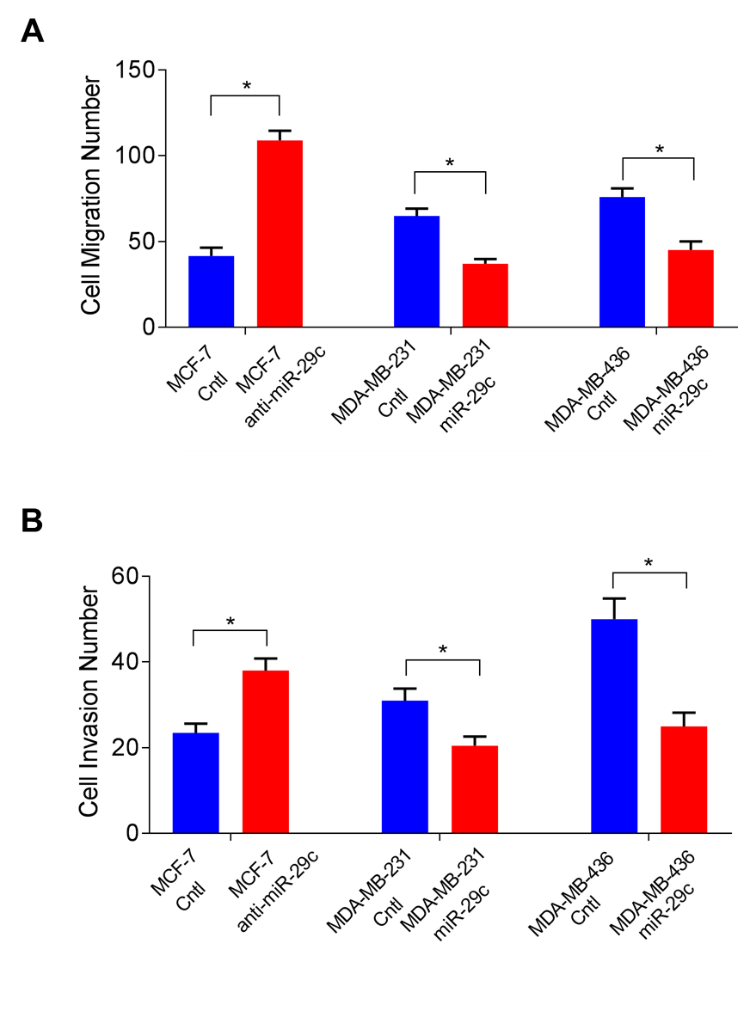
Figure S2. Migration and invasion of cells.
A: Quantification of migration number of MCF-7 Cntl and MCF-7 transfected with anti-miR-29c, MDA-MB-231 Cntl and MDA-MB-231 transfected with mimic-miR-29c, MDA-MB-436 Cntl and MDA-MB-436 transfected with mimic-miR-29c. B. Quantification of invasion number of MCF-7 Cntl and MCF-7 transfected with anti-miR-29c, MDA-MB-231 Cntl and MDA-MB-231 transfected with mimic-miR-29c, MDA-MB-436 Cntl and MDA-MB-436 transfected with mimic-miR-29c. Data are presented as mean ± SD. from three independent experiments, and every experiment was repeated three times, *P < 0.05.

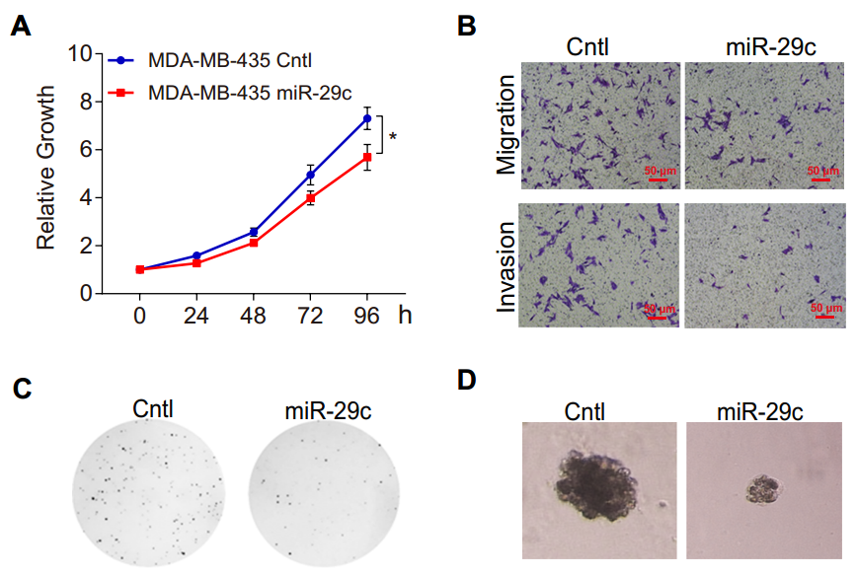
Figure S3. miR-29c inhibited proliferation, migration and invasion, colony formation and growth in 3D Matrigel of MDA-MB-436 cells. A. CCK8 proliferation assays of MDA-MB-436 cells after overexpression of miR-29c. B. Migration and invasion assays of MDA-MB-436 cells after overexpression of miR-29c. C. Soft agar colony formation assays in MDA-MB-436 cells after overexpression of miR-29c. D. 3D Matrigel culture of MDA-MB-436 cells after overexpression of miR-29c. Data are presented as mean ± SD. from three independent experiments, and every experiment was repeated three times.

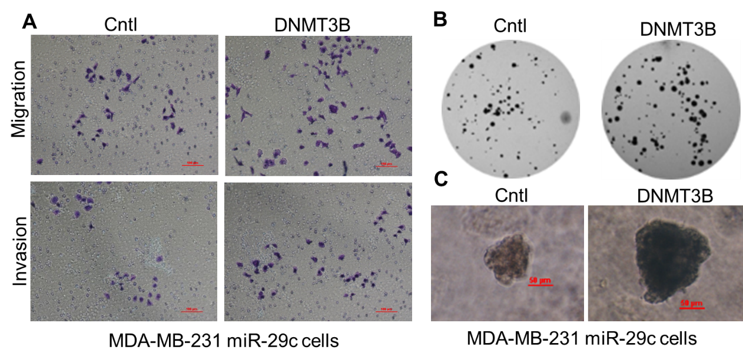
Figure S4. DNMT3B promoted migration, invasion, colony formation and growth in 3D Matrigel of MDA-MB-231 miR-29c cells. A. Migration and invasion assays of MDA-MB-231 miR-29c cells after the overexpression of DNMT3B. B. Soft agar colony formation assays in MDA-MB-231 miR-29c cells after the overexpression of DNMT3B. C. 3D Matrigel culture of MDA-MB-231 miR-29c cells after the overexpression of DNMT3B. Data are presented as mean ± SD. from three independent experiments, and every experiment was repeated three times.

Figure S5. Colony formation of cells
Quantification of colony formation of MCF-7 Cntl and MCF-7 transfected with anti-miR-29c, MDA-MB-231 Cntl and MDA-MB-231 transfected with mimic-miR-29c, MDA-MB-436 Cntl and MDA-MB-436 transfected with mimic-miR-29c. Data are presented as mean ± SD. from three independent experiments, and every experiment was repeated three times, *P < 0.05.

Figure S6. miR-29c reduced luciferase activity of wild type 3’ UTR of DNMT3B-luciferase reporter, and not the mutant type 3’ UTR of DNMT3B reporter in MCF-7 cells. Data are presented as mean ± SD. from three independent experiments, ***P < 0.001.

Figure S7. Expression of DNMT3B, TIMP3, STAT1 and FOXO1.
Quantification of protein expression of DNMT3B, TIMP3,STAT1 and FOXO1 in MCF-7 Cntl and MCF-7 transfected with anti-miR-29c, MDA-MB-231 Cntl and MDA-MB-231 transfected with mimic-miR-29c. Data are presented as mean ± SD. from three independent experiments, and every experiment was repeated three times, *P < 0.05.
Figure S8. Migration and invasion of cells. A. Quantification of migration number of MDA-MB-231 Cntl and MDA-MB-231 transfected with DNMT3B siRNA 1. B. Quantification of invasion number of MDA-MB-231 Cntl and MDA-MB-231 transfected with DNMT3B siRNA 1. C. Quantification of migration number of MDA-MB-231 Cntl and MDA-MB-436transfected with DNMT3B siRNA 1. D. Quantification of invasion number of MDA-MB-436 Cntl and MDA-MB-436 transfected with DNMT3B siRNA1. Data are presented as mean ± SD. from three independent experiments, and every experiment was repeated three times, *P < 0.05.

