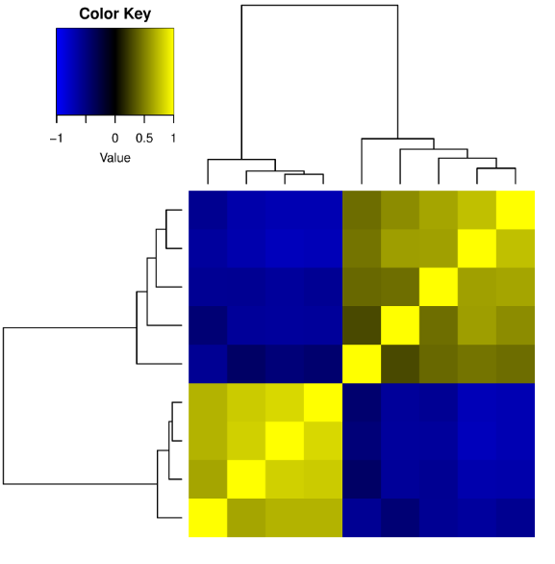
Additional file 2 Heatmap using differentially acetylated regions (A), MA plot (B) and V plot (C).
A

Control FGR
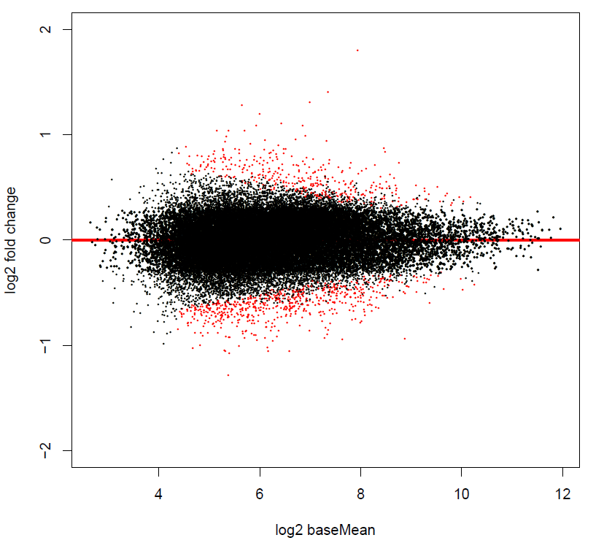
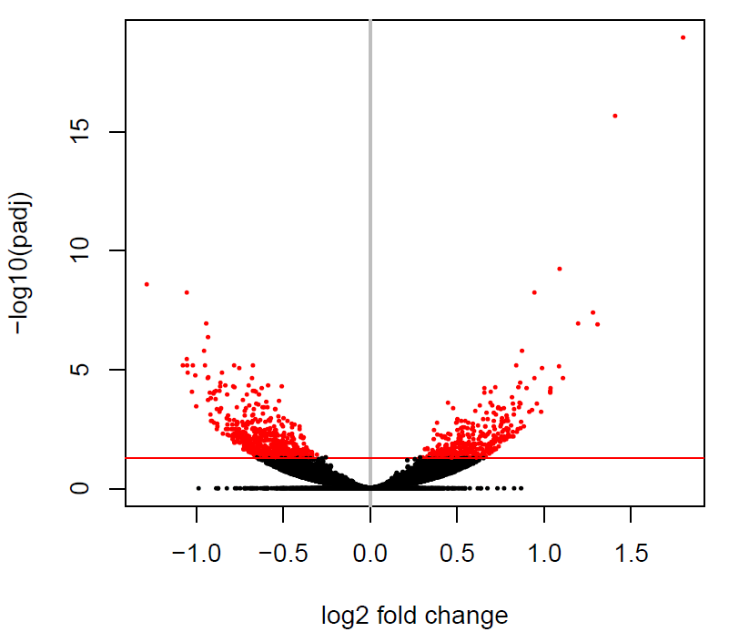
B C

