Table S1: Structure and class of the compounds used in this study

HDACi | Structure | Class
VPA | 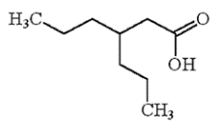 | Short chain fatty acid
SAHA | 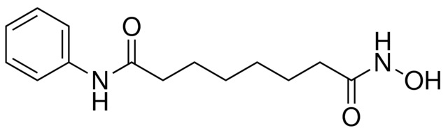 | Hydroxamic acid
ODB | 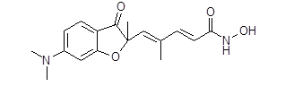 | Benzamide
NODB | 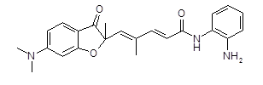 | Benzamide
ODH |  | Hydroxamic acid
NODH |  | Hydroxamic acid

