Supplement:

Table S1: Primer sequences and positions
Gene | Primers | CpG coverage | CpG positions
ERα | F: 5'-GGGTAGGGTTGGGGTTAGAG-3'  R: 5'-Biotin- ATCCCCRCAAAACAAAAAACTCAAA-3'  S: 5'-GGGTTGGGGTTAGAGT-3' | 10 | Chr6: 151,807,783  Chr6: 151,807,785  Chr6: 151,807,790  Chr6: 151,807,793  Chr6: 151,807,802  Chr6: 151,807,807  Chr6: 151,807,810  Chr6: 151,807,822  Chr6: 151,807,849  Chr6: 151,807,852

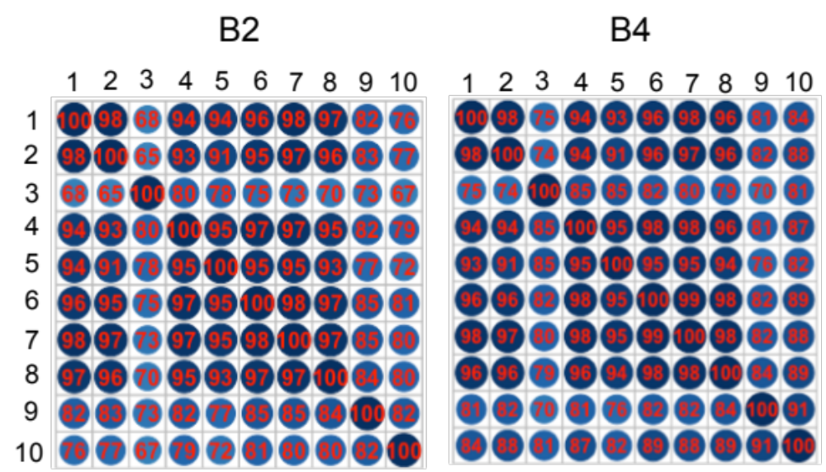

Figure S1: Correlation across CpG sites at B2 and B4 (Spearman rho= 0.65-98).

