Additional file 3

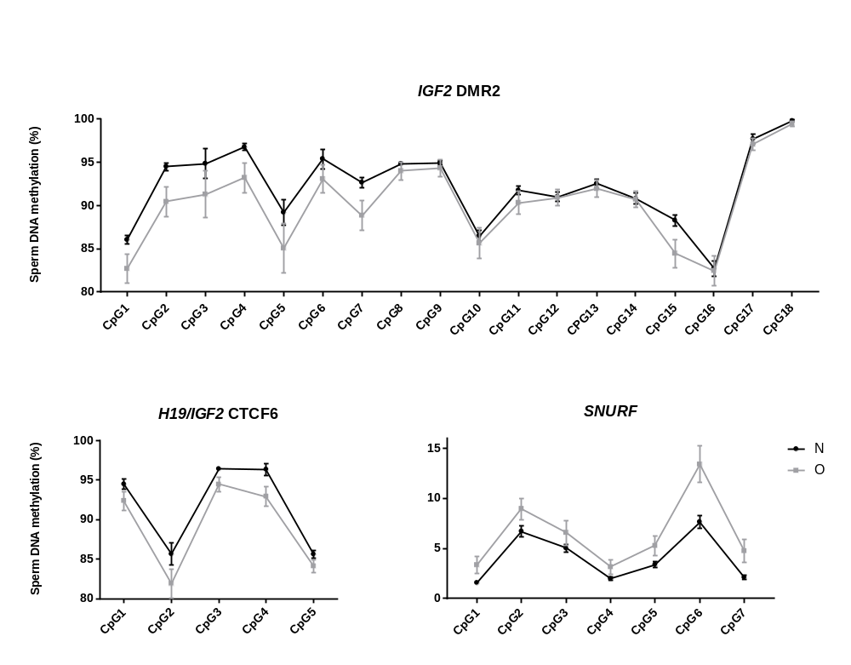A
*
*
*
*
*
**
**
*

