Figure S1 Diagnostic and prognostic ability of ProCUrE and age adjusted PSA in the training cohort.
- The percent false- and true-positive for ProCUrE or age adjusted PSA separating benign and PCa patients.
- The percent of patients positive for ProCUrE or age adjusted PSA for clinically insignificant (benign and low-risk) vs clinically significant (intermediate- and high-risk) based on Gleason score and GS6 vs GS≥7; benign-GS7(3+4) vs GS≥7(4+3).
- & (D) The percent of patients positive for ProCUrE or age adjusted PSA for clinically insignificant (benign and low-risk) vs clinically significant (intermediate- and high-risk) and low-risk vs intermediate- and high-risk as determined by CAPRA score (C), and D’Amico (D). N=267, χ²*p<0.05, **p<0.01, ***p<0.001
A)
**
***
B)
***
**
*
***
**
C)
***
***
***
*
D)
***
***
***
*

Figure S2 Receiver Operating Characteristic curve analysis of training cohort for (A) benign vs PCa, Clinically insignificant vs Clinically significant PCa as determined by (B) GS, (C) CAPRA, and (D) D’Amico.
A)
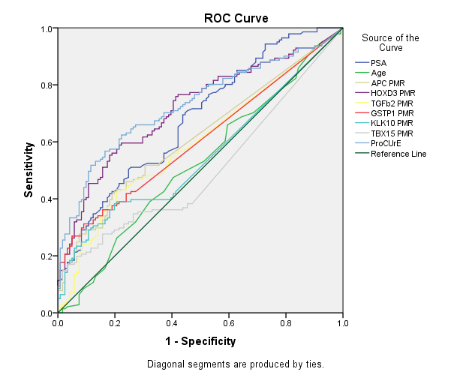
Benign vs PCa | AUC | 95% C.I. |  | p-value
PSA | 0.679 | 0.615 | 0.743 | 5.85E-07
Age | 0.523 | 0.453 | 0.594 | 5.13E-01
APC PMR | 0.617 | 0.549 | 0.684 | 1.11E-03
HOXD3 PMR | 0.718 | 0.656 | 0.779 | 1.23E-09
TGFb2 PMR | 0.596 | 0.527 | 0.664 | 7.52E-03
GSTP1 PMR | 0.605 | 0.538 | 0.673 | 3.30E-03
KLK10 PMR | 0.552 | 0.482 | 0.621 | 1.51E-01
TBX15 PMR | 0.502 | 0.431 | 0.572 | 9.63E-01
ProCUrE | 0.730 | 0.669 | 0.791 | 1.37E-10

B)
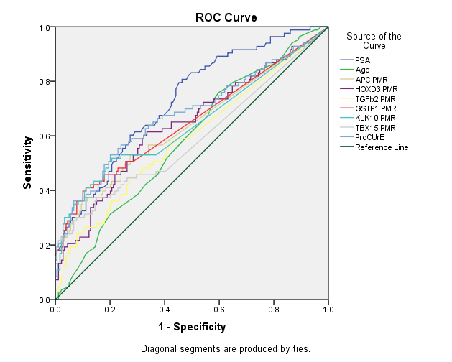
CI-PCa vs CS-PCa (GS) | AUC | 95% C.I. |  | p-value
PSA | 0.727 | 0.663 | 0.792 | 3.28E-09
Age | 0.586 | 0.513 | 0.658 | 2.60E-02
APC PMR | 0.637 | 0.560 | 0.714 | 3.71E-04
HOXD3 PMR | 0.640 | 0.565 | 0.715 | 2.71E-04
TGFb2 PMR | 0.590 | 0.513 | 0.667 | 1.93E-02
GSTP1 PMR | 0.649 | 0.572 | 0.726 | 1.00E-04
KLK10 PMR | 0.643 | 0.564 | 0.721 | 2.02E-04
TBX15 PMR | 0.588 | 0.508 | 0.668 | 2.17E-02
ProCUrE | 0.678 | 0.602 | 0.753 | 3.74E-06

C)
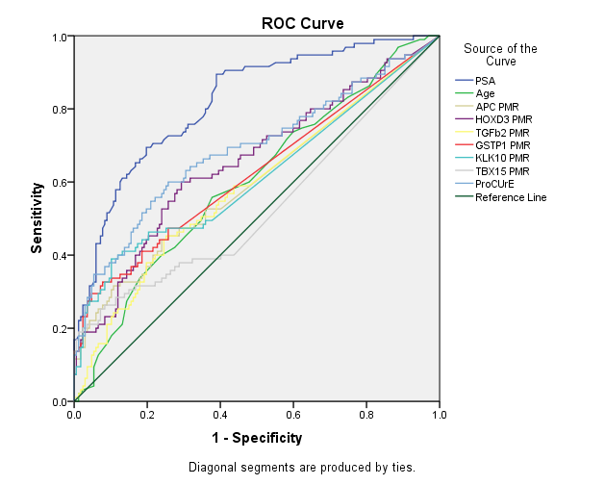
CI-PCa vs CS-PCa (CAPRA) | AUC | 95% C.I. |  | p-value
PSA | 0.820 | 0.768 | 0.872 | 7.31E-18
Age | 0.603 | 0.532 | 0.674 | 5.73E-03
APC PMR | 0.604 | 0.529 | 0.678 | 5.29E-03
HOXD3 PMR | 0.656 | 0.585 | 0.727 | 2.74E-05
TGFb2 PMR | 0.590 | 0.517 | 0.664 | 1.52E-02
GSTP1 PMR | 0.626 | 0.552 | 0.700 | 7.23E-04
KLK10 PMR | 0.614 | 0.539 | 0.690 | 2.09E-03
TBX15 PMR | 0.533 | 0.456 | 0.610 | 3.76E-01
ProCUrE | 0.689 | 0.618 | 0.760 | 3.77E-07

D)
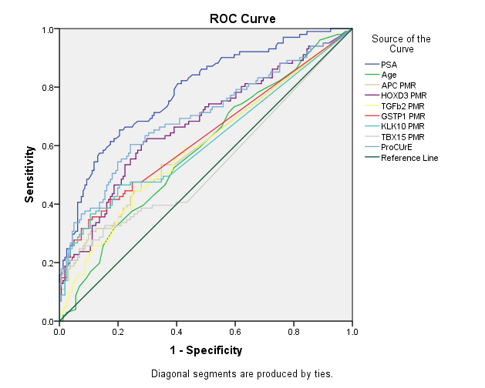
CI-PCa vs CS-PCa (D'Amico) | AUC | 95% C.I. |  | p-value
PSA | 0.786 | 0.729 | 0.843 | 6.61E-15
Age | 0.587 | 0.517 | 0.658 | 1.73E-02
APC PMR | 0.606 | 0.534 | 0.679 | 3.77E-03
HOXD3 PMR | 0.674 | 0.606 | 0.743 | 2.08E-06
TGFb2 PMR | 0.594 | 0.522 | 0.666 | 1.04E-02
GSTP1 PMR | 0.630 | 0.557 | 0.702 | 4.15E-04
KLK10 PMR | 0.613 | 0.539 | 0.686 | 2.17E-03
TBX15 PMR | 0.538 | 0.462 | 0.613 | 3.05E-01
ProCUrE | 0.697 | 0.628 | 0.765 | 8.42E-08

