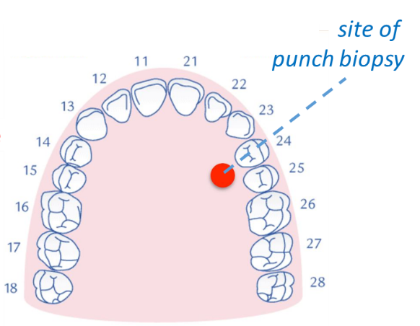
Supplementary Figures

Figure S1. Area of tissue sampling. The tissue samples were collected from the hard palate directly adjacent to the fourth and fifth tooth by the use of a tissue puncher (3 mm diameter).

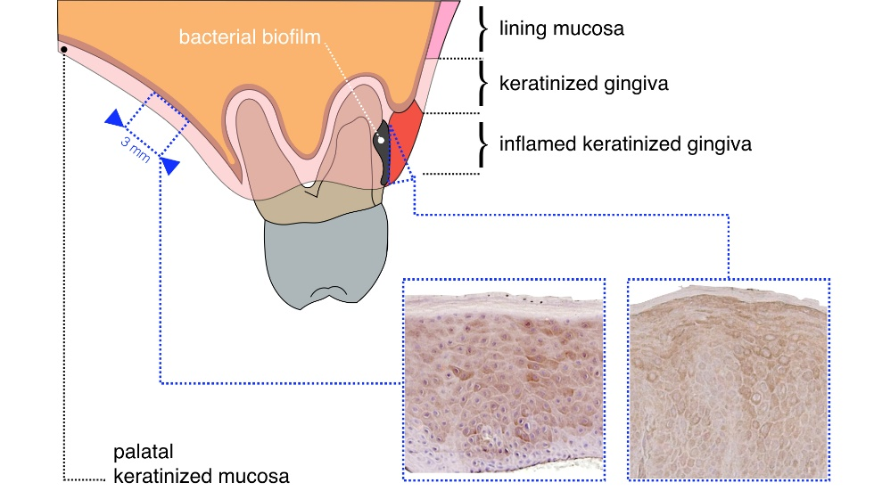

Figure S2. Histological features of the masticatory mucosa of the gingiva and the hard palate. The mucosa of both sites is characterised by the four layered orthokeratinised stratified squamous epithelium, overlaying the lamina propria. The lamina propria contains closely packed bundles of collagen fibers enabling the mucosa to resist heavy loading. The cells in the upper keratin layer have lost their nuclei. Because the function and appearance of the cells and cell layers from both extraction sites are similar, it is the broad agreement of the periodontologists participating in this study that both sites are comparable and are likely to share similar methylation patterns under normal conditions.

