Additional file 1

Table S1: Annotation of LEP CpGs used in the analyses.
Probe name | Chr | Mapinfo | UCSC CpG Island Name | Relation to UCSC CpG Island | Age group
cg00666422 | 7 | 127881440 | chr7:127880750-127881375 | S_Shore | 10Y,18Y
cg00840332 | 7 | 127881269 | chr7:127880750-127881375 | Island | 10Y,18Y
cg03084214 | 7 | 127880619 | chr7:127880750-127881375 | N_Shore | 10Y,18Y
cg04833007 | 7 | 127894849 | - | - | 10Y
cg05091920 | 7 | 127897975 | - | - | 10Y
cg05136031 | 7 | 127880567 | chr7:127880750-127881375 | N_Shore | 10Y
cg07464571 | 7 | 127881001 | chr7:127880750-127881375 | Island | 18Y
cg08349670 | 7 | 127882889 | chr7:127880750-127881375 | S_Shore | 10Y
cg11005360 | 7 | 127885181 | chr7:127880750-127881375 | S_Shelf | 10Y
cg11045943 | 7 | 127881293 | chr7:127880750-127881375 | Island | 10Y
cg12083122 | 7 | 127883819 | chr7:127880750-127881375 | S_Shelf | 10Y,18Y
cg12782180 | 7 | 127880932 | chr7:127880750-127881375 | Island | 10Y,18Y
cg13381984 | 7 | 127881344 | chr7:127880750-127881375 | Island | 10Y,18Y
cg14734794 | 7 | 127879920 | chr7:127880750-127881375 | N_Shore | 18Y
cg15792829 | 7 | 127881747 | chr7:127880750-127881375 | S_Shore | 10Y
cg16683741 | 7 | 127891959 | - | - | 10Y,18Y
cg18603538 | 7 | 127894591 | - | - | 10Y,18Y
cg19594666 | 7 | 127881280 | chr7:127880750-127881375 | Island | 10Y,18Y
cg20564991 | 7 | 127882514 | chr7:127880750-127881375 | S_Shore | 10Y
cg23381058 | 7 | 127888052 | - | - | 10Y
cg23753947 | 7 | 127889701 | - | - | 10Y,18Y
cg24862443 | 7 | 127896859 | - | - | 10Y,18Y
cg25435800 | 7 | 127890193 | - | - | 10Y,18Y
cg25730670 | 7 | 127891366 | - | - | 10Y,18Y
cg26814075 | 7 | 127881298 | chr7:127880750-127881375 | Island | 10Y,18Y
Columns: Probe name = Unique identifier from the Illumina CG database; Chr = Chromosome; Mapinfo = chromosomal coordinates of the CpG (hg19 build); UCSC CpG Island Name= Chromosomal coordinates of the CpG Island from UCSC; Relation to UCSC CpG Island = The location of the CpG relative to the CpG island (Shore = 0–2 kb from island; Shelf = 2–4 kb from island; N = upstream (5’) of CpG island; S = downstream (3’) of CpG island; Age group = Age group from IOWBC (10 years (10Y) or 18 years (18Y)).
(Source: https://support.illumina.com/content/dam/illumina-support/documents/downloads/productfiles/methylationepic/infinium-methylationepic-manifest-column-headings.pdf).

Table S2: Stability of LEP CpGs (between 10 and 18 years).
 |  | 95% Confidence Interval |  |  | F Test with True Value 0
Probe name | ICC | Lower Bound | Upper Bound |  | Values | df1 | df2 | P-value
cg00666422 | 0.65 | 0.52 | 0.74 |  | 2.87 | 161 | 161 | 3.36E-11*
cg00840332 | 0.66 | 0.53 | 0.75 |  | 2.91 | 161 | 161 | 1.78E-11*
cg03084214 | 0.26 | 0.00 | 0.46 |  | 1.35 | 161 | 161 | 0.03*
cg12083122 | 0.00 | 0.00 | 0.05 |  | 0.77 | 161 | 161 | 0.95
cg12782180 | 0.60 | 0.45 | 0.70 |  | 2.49 | 161 | 161 | 7.00E-09*
cg13381984 | 0.64 | 0.50 | 0.73 |  | 2.75 | 161 | 161 | 1.77E-10*
cg16683741 | 0.00 | 0.00 | 0.17 |  | 0.89 | 161 | 161 | 0.77
cg18603538 | 0.39 | 0.17 | 0.56 |  | 1.65 | 161 | 161 | 8.17E-04*
cg19594666 | 0.69 | 0.58 | 0.77 |  | 3.22 | 161 | 161 | 2.79E-13*
cg23753947 | 0.46 | 0.26 | 0.60 |  | 1.85 | 161 | 161 | 5.43E-05*
cg24862443 | 0.00 | 0.00 | 0.22 |  | 0.93 | 161 | 161 | 0.67
cg25435800 | 0.19 | 0.00 | 0.40 |  | 1.23 | 161 | 161 | 0.09
cg25730670 | 0.00 | 0.00 | 0.04 |  | 0.76 | 161 | 161 | 0.95
cg26814075 | 0.61 | 0.47 | 0.72 |  | 2.60 | 161 | 161 | 1.46E-09*
Single score Intraclass Correlation (ICC) was measured between 14 LEP CpGs in 162 matched samples at 10 and 18 years. Here, two-way analysis of variance has been done for the model where “consistency” between the two-time point has been assessed. Columns: Probe name = Common LEP CpG sites in Illumina Infinium HumanMethylation450 and MethylationEPIC Beadchips; ICC = intraclass correlation coefficient; Lower Bound and Upper Bound = lower and upper bound of the coefficient with 95% confidence interval; Values = F-test values; df1 and df2 = degree of freedom 1 and 2 for the F-test; P-value = significance level of the test.
Table S3: Association between total breastfeeding duration and LEP DNAm (16 CpGs) at 18 years.
Probe name | Beta | SE | P-value
cg00666422 | -0.0022 | 0.0018 | 0.23
cg03084214 | -0.0006 | 0.0010 | 0.55
cg12083122 | -0.0003 | 0.0006 | 0.61
cg14734794 | 0.0001 | 0.0005 | 0.85
cg16683741 | -0.0005 | 0.0006 | 0.40
cg18603538 | -0.0011 | 0.0011 | 0.31
cg23753947 | -0.0001 | 0.0005 | 0.83
cg24862443 | 0.0001 | 0.0005 | 0.84
cg25435800 | 0.0009 | 0.0009 | 0.27
cg25730670 | -0.0001 | 0.0005 | 0.89
cg07464571 | -0.0012 | 0.0011 | 0.29
cg12782180 | -0.0012 | 0.0017 | 0.47
cg13381984 | 0.0001 | 0.0016 | 0.93
cg19594666 | -0.0014 | 0.0019 | 0.47
cg26814075 | -0.0003 | 0.0014 | 0.83
cg00840332 | -0.0015 | 0.0016 | 0.35
Columns: Probe name = LEP CpG sites from Illumina Infinium HumanMethylation450 Beadchip; Beta = coefficient from regression model; SE = standard error of coefficient.

Table S4: Association between exclusive breastfeeding duration and LEP DNAm (16 CpGs) at 18 years.
Probe name | Beta | SE | P-value
cg00666422 | -0.00043 | 0.00037 | 0.25
cg03084214 | -0.00015 | 0.00020 | 0.47
cg12083122 | -0.00003 | 0.00012 | 0.78
cg14734794 | -0.00006 | 0.00011 | 0.60
cg16683741 | -0.00007 | 0.00012 | 0.56
cg18603538 | -0.00013 | 0.00023 | 0.58
cg23753947 | 0.00004 | 0.00011 | 0.74
cg24862443 | 0.00009 | 0.00010 | 0.40
cg25435800 | -0.00005 | 0.00018 | 0.79
cg25730670 | 0.00012 | 0.00010 | 0.23
cg07464571 | -0.00020 | 0.00023 | 0.38
cg12782180 | -0.00032 | 0.00035 | 0.36
cg13381984 | -0.00003 | 0.00033 | 0.92
cg19594666 | -0.00027 | 0.00040 | 0.50
cg26814075 | -0.00007 | 0.00029 | 0.81
cg00840332 | -0.00024 | 0.00033 | 0.47
Columns: Probe name = LEP CpG sites from Illumina Infinium HumanMethylation450 Beadchip; Beta = coefficient from regression model; SE = standard error of coefficient.

Table S5: Association between total breastfeeding duration and LEP DNAm (23 CpGs) at 10 years.

Probe name | Beta | SE | P-value
cg25435800 | 0.00012 | 0.00028 | 0.66
cg11005360 | -0.00024 | 0.00011 | 0.03
cg18603538 | 0.00033 | 0.00018 | 0.07
cg05136031 | -0.00015 | 0.00018 | 0.43
cg15792829 | 0.00017 | 0.00012 | 0.16
cg08349670 | 0.00006 | 0.00011 | 0.56
cg04833007 | -0.00016 | 0.00016 | 0.32
cg00666422 | 0.00005 | 0.00032 | 0.87
cg24862443 | -0.00016 | 0.00012 | 0.18
cg20564991 | 0.00018 | 0.00014 | 0.22
cg23381058 | -0.00049 | 0.00020 | 0.01
cg25730670 | -0.00011 | 0.00011 | 0.32
cg16683741 | 0.00000 | 0.00012 | 0.98
cg23753947 | 0.00017 | 0.00008 | 0.04
cg03084214 | 0.00052 | 0.00023 | 0.03
cg05091920 | 0.00020 | 0.00010 | 0.05
cg12083122 | -0.00013 | 0.00012 | 0.30
cg13381984 | -0.00018 | 0.00031 | 0.57
cg26814075 | -0.00031 | 0.00028 | 0.27
cg19594666 | -0.00010 | 0.00027 | 0.72
cg12782180 | -0.00038 | 0.00030 | 0.20
cg00840332 | -0.00028 | 0.00025 | 0.26
cg11045943 | -0.00047 | 0.00031 | 0.13
Columns: Probe name = LEP CpG sites from Illumina Infinium MethylationEPIC Beadchip; Beta=coefficient from regression model; SE = standard error of coefficient.

Table S6: Association between exclusive breastfeeding duration and LEP DNAm (23 CpGs) at 10 years.

Probe name | Beta | SE | P-value
cg25435800 | 0.00089 | 0.00056 | 0.11
cg11005360 | -0.00023 | 0.00022 | 0.30
cg18603538 | 0.00081 | 0.00037 | 0.03
cg05136031 | -0.00004 | 0.00037 | 0.90
cg15792829 | 0.00059 | 0.00024 | 0.01
cg08349670 | 0.00000 | 0.00022 | 0.99
cg04833007 | -0.00021 | 0.00032 | 0.51
cg00666422 | -0.00037 | 0.00065 | 0.57
cg24862443 | -0.00030 | 0.00023 | 0.20
cg20564991 | 0.00017 | 0.00029 | 0.56
cg23381058 | -0.00082 | 0.00040 | 0.04
cg25730670 | -0.00019 | 0.00022 | 0.39
cg16683741 | 0.00006 | 0.00024 | 0.81
cg23753947 | 0.00024 | 0.00017 | 0.15
cg03084214 | 0.00069 | 0.00048 | 0.15
cg05091920 | 0.00042 | 0.00021 | 0.05
cg12083122 | -0.00021 | 0.00025 | 0.40
cg13381984 | -0.00015 | 0.00063 | 0.81
cg26814075 | -0.00054 | 0.00057 | 0.34
cg19594666 | 0.00006 | 0.00055 | 0.92
cg12782180 | -0.00039 | 0.00059 | 0.51
cg00840332 | -0.00015 | 0.00050 | 0.77
cg11045943 | -0.00032 | 0.00063 | 0.62
Columns: Probe name = LEP CpG sites from Illumina Infinium MethylationEPIC Beadchip; Beta = coefficient from regression model; SE = standard error of coefficient.

Table S7: Association between BMI trajectories and LEP DNAm (at 10 years) at CpGs previously associated with total or exclusive breastfeeding duration (associated P-values have been shown).
Total breastfeeding

Trajectory 2
Probe site | Beta | Standard Error | P-value
cg03084214 | 1.585 | 5.932 | 0.334
cg11005360 | -23.531 | 12.808 | 0.264
cg23381058 | -1.785 | 3.595 | 0.871
cg23753947 | -3.033 | 15.739 | 0.79

Trajectory 3
Probe site | Beta | Standard Error | P-value
cg03084214 | 6.585 | 7.330 | 0.349
cg11005360 | 2.986 | 15.504 | 0.366
cg23381058 | 3.183 | 4.277 | 0.034*
cg23753947 | -23.567 | 17.710 | 0.946

Trajectory 4
Probe site | Beta | Standard Error | P-value
cg03084214 | -9.823 | 10.289 | 0.809
cg11005360 | 63.354 | 33.182 | 0.106
cg23381058 | -9.173 | 7.096 | 0.222
cg23753947 | -26.093 | 30.603 | 0.913

Exclusive breastfeeding

Trajectory 2
Probe site | Beta | Standard Error | P-value
cg05091920 | -18.20 | 9.879 | 0.028*
cg15792829 | -6.398 | 8.752 | 0.278
cg18603538 | 1.074 | 5.851 | 0.762
cg23381058 | 1.137 | 2.926 | 0.871

Trajectory 3
Probe site | Beta | Standard Error | P-value
cg05091920 | -15.843 | 10.651 | 0.125
cg15792829 | -17.064 | 9.602 | 0.155
cg18603538 | -1.101 | 6.033 | 0.292
cg23381058 | 4.805 | 3.187 | 0.034*

Trajectory 4
Probe site | Beta | Standard Error | P-value
cg05091920 | -2.662 | 19.796 | 0.694
cg15792829 | 13.102 | 17.240 | 0.507
cg18603538 | 3.976 | 12.232 | 0.669
cg23381058 | -4.90 | 5.857 | 0.222

Trajectory 2 = Early persistent obesity; Trajectory 3 = Early transient overweight; Trajectory 4 = delayed overweight. DNA methylation analysed against BMI trajectories with BMI trajectory 1 (normal) as a control. Columns: Probe site = LEP CpG sites from Illumina Infinium MethylationEPIC Beadchip, which are significantly associated with total or exclusive breastfeeding; Beta = a one-unit increase in the methylation level for specific CpG is associated with the decrease in the log odds of being in BMI trajectory; Standard Error = standard error of coefficient. P-value < 0.05 was considered significant and indicated by *.

a. Methylation level of significant CpG site (cg03084214) in total breastfeeding duration | b. Methylation level of significant CpG site (cg23753947) in total breastfeeding duration
c. Methylation level of significant CpG site
(cg18603538) in exclusive breastfeeding duration

Figure S1: Comparisons of methylation level (beta) of significant common CpGs in matched 162 samples (10 and 8 years).

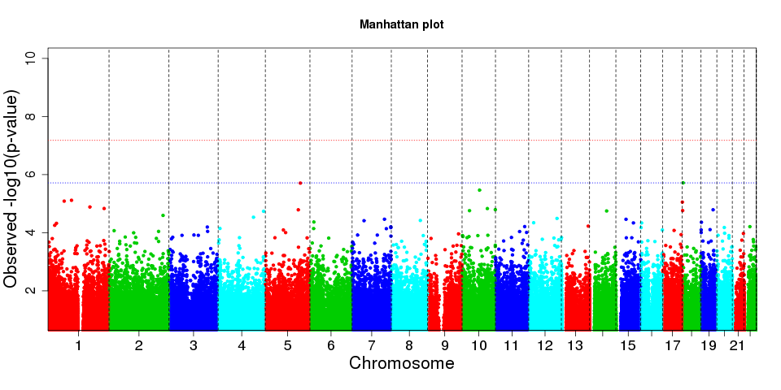
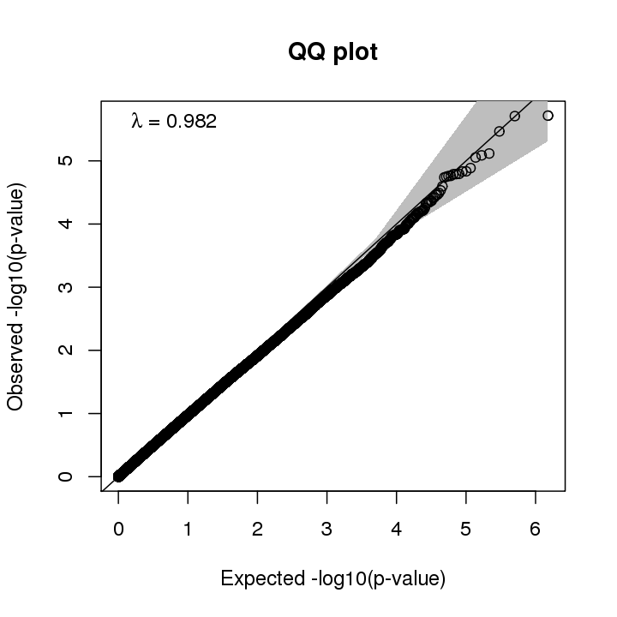
Figure S2: The Manhattan plot (top) and QQ-plot (bottom) shows the epigenome wide association study results in 10 year old samples. Here DNA methylation has been used as outcome and exclusive breastfeeding duration as exposure adjusted by confounding factors and cell type proportion. In the Manhattan plot, the blue dotted line represents FDR < 0.05 and red dotted line represents Bonferroni threshold.

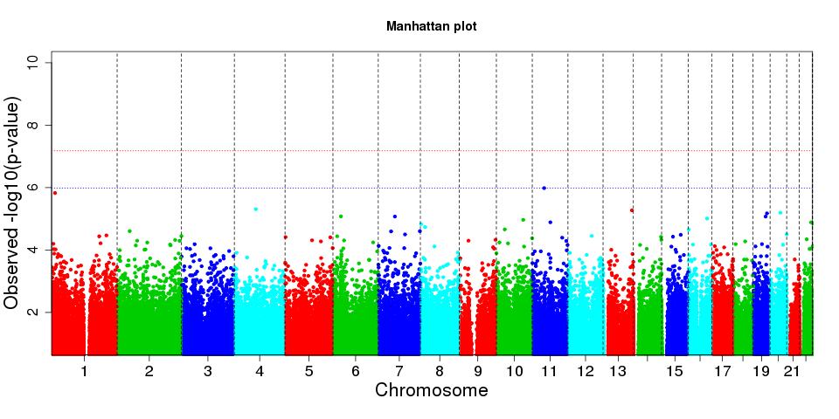
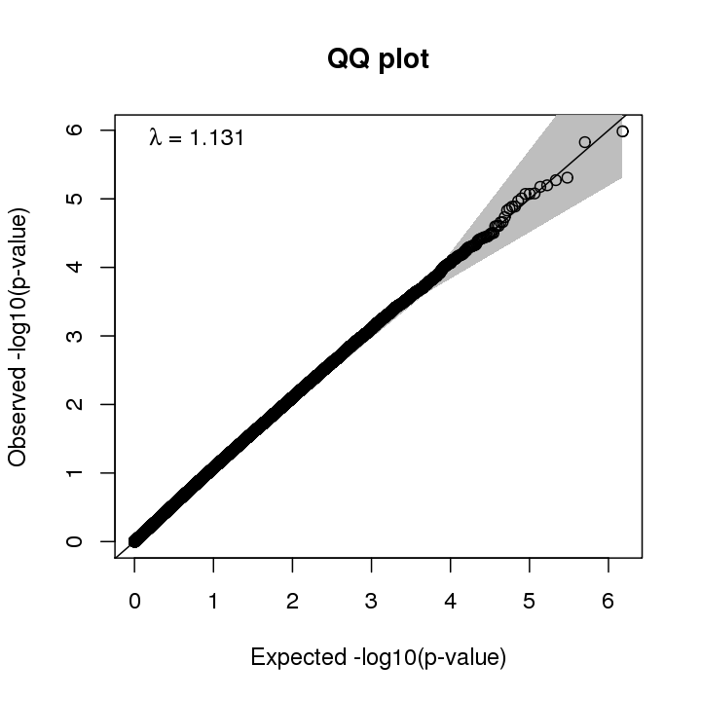
Figure S3: The Manhattan plot (top) and QQ-plot (bottom) shows the epigenome wide association study results in 10 year old samples. Here DNA methylation has been used as outcome and total breastfeeding duration as exposure adjusted by confounding factors and cell type proportion. In the Manhattan plot, the blue dotted line represents FDR < 0.05 and red dotted line represents Bonferroni threshold.

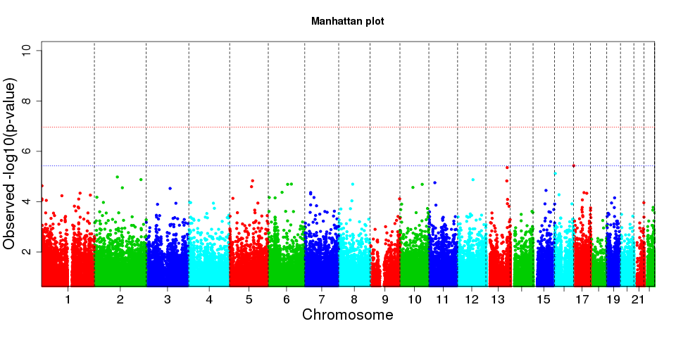
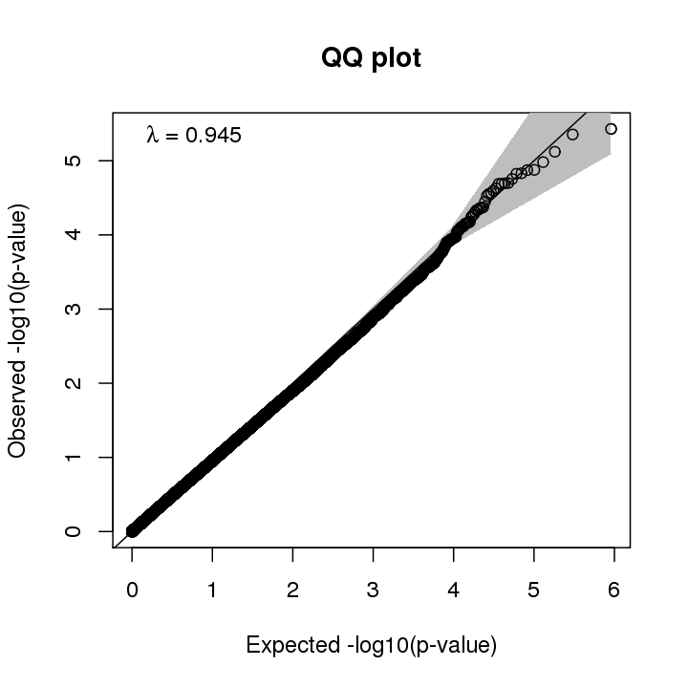
Figure S4: The Manhattan plot (top) and QQ-plot (bottom) shows the epigenome wide association study results in 18 year old samples. Here DNA methylation has been used as outcome and exclusive breastfeeding duration as exposure adjusted by confounding factors and cell type proportion. In the Manhattan plot, the blue dotted line represents FDR < 0.05 and red dotted line represents Bonferroni threshold.

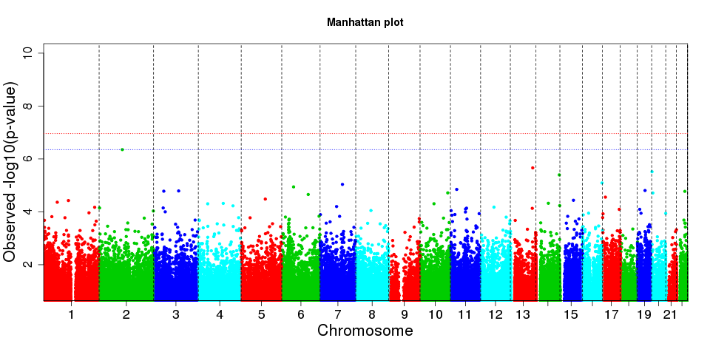
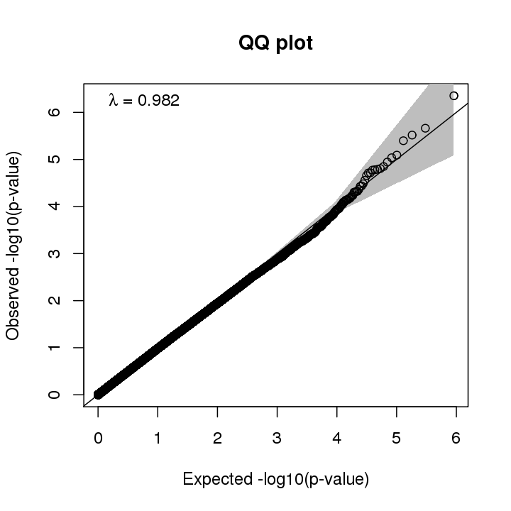
Figure S5: The Manhattan plot (top) and QQ-plot (bottom) shows the epigenome wide association study results in 18 year old samples. Here DNA methylation has been used as outcome and total breastfeeding duration as exposure adjusted by confounding factors and cell type proportion. In the Manhattan plot, the blue dotted line represents FDR < 0.05 and red dotted line represents Bonferroni threshold.

