Additional file 1

DNA methylation instability by BRAF-mediated TET silencing and lifestyle-exposure divides colon cancer pathways

Faiza Noreen^{1,2}, Taya Küng¹, Luigi Tornillo³, Hannah Parker⁴, Miguel Silva^{5,} Stefan Weis¹, Giancarlo Marra⁴, Roland Rad⁵, Kaspar Truninger^{1,6*}, Primo Schär^{1*}

¹Department of Biomedicine, University of Basel, Basel, 4058, Switzerland;²Swiss Institute of Bioinformatics, Basel, 4053, Switzerland; ³Institute of Pathology, University Hospital Basel, Basel, 4056, Switzerland; ⁴Institute of Molecular Cancer Research, University of Zurich, Zurich, 8057, Switzerland; ⁵Department of Medicine II, Klinikum Rechts der Isar, Technische Universität München, 81675 Munich, Germany; ⁶Gastroenterologie Oberaargau, Langenthal, 4900, Switzerland

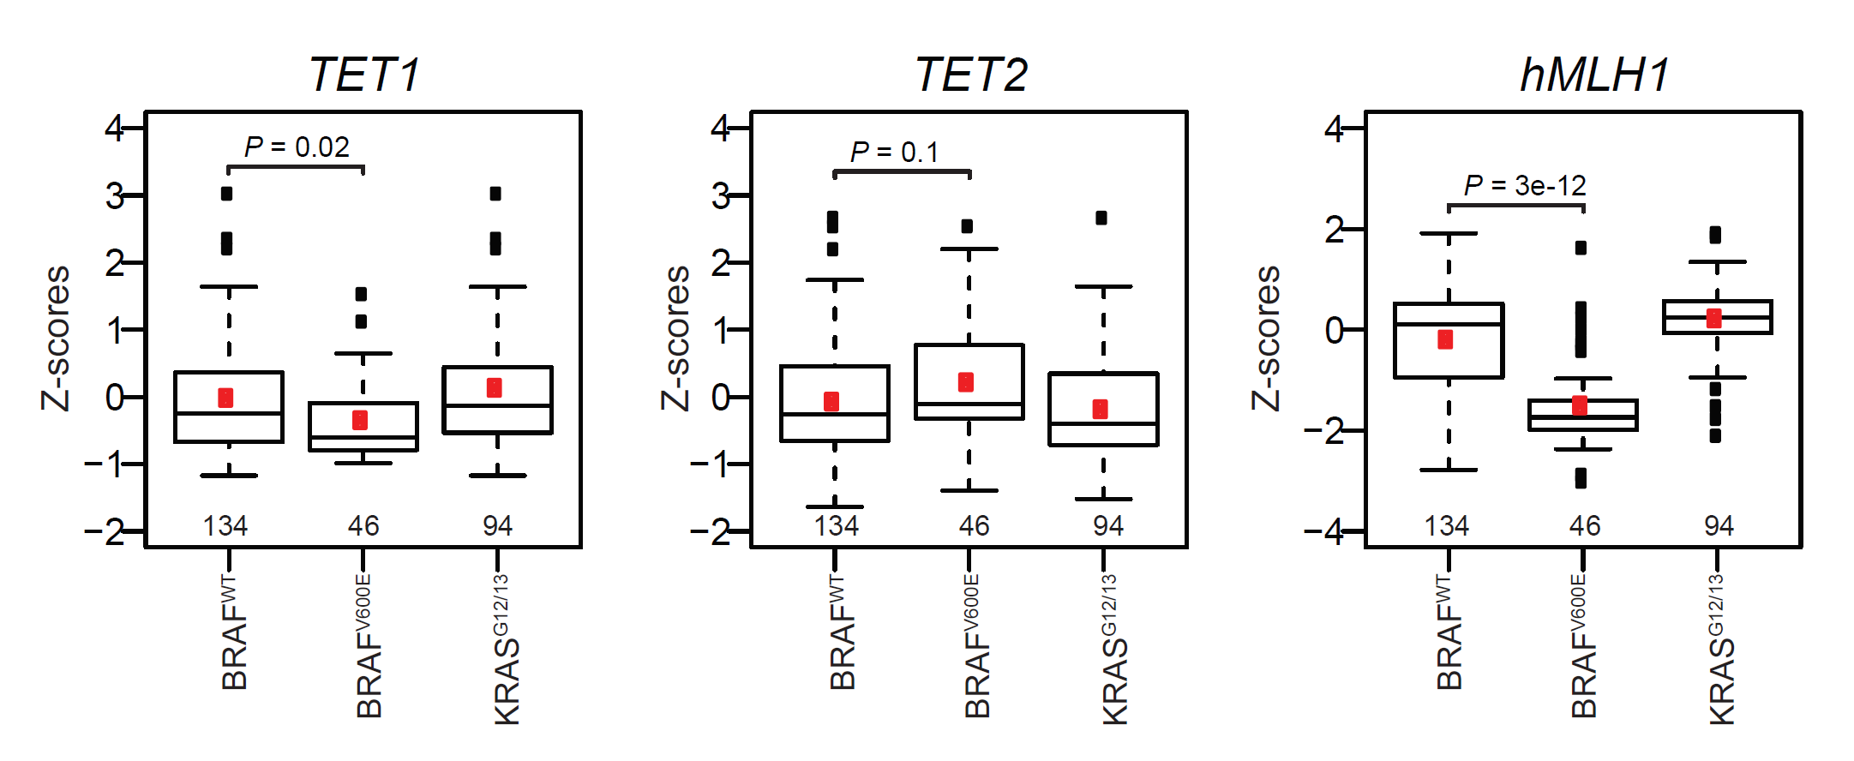
Figure S1. TCGA mRNA RNA-seq data showing TET1, TET2 and hMLH1 expression levels. The Z-scores were available for 274 female colon cancer samples (BRAF^{WT}/KRAS^{WT}; n = 134, BRAF^{V600E}; n= 46, KRAS^{G12/13}; n=94). The z-scores were calculated using cancer diploid for each gene as the reference population. Number of cancer samples in each category are shown at the bottom of each plot.

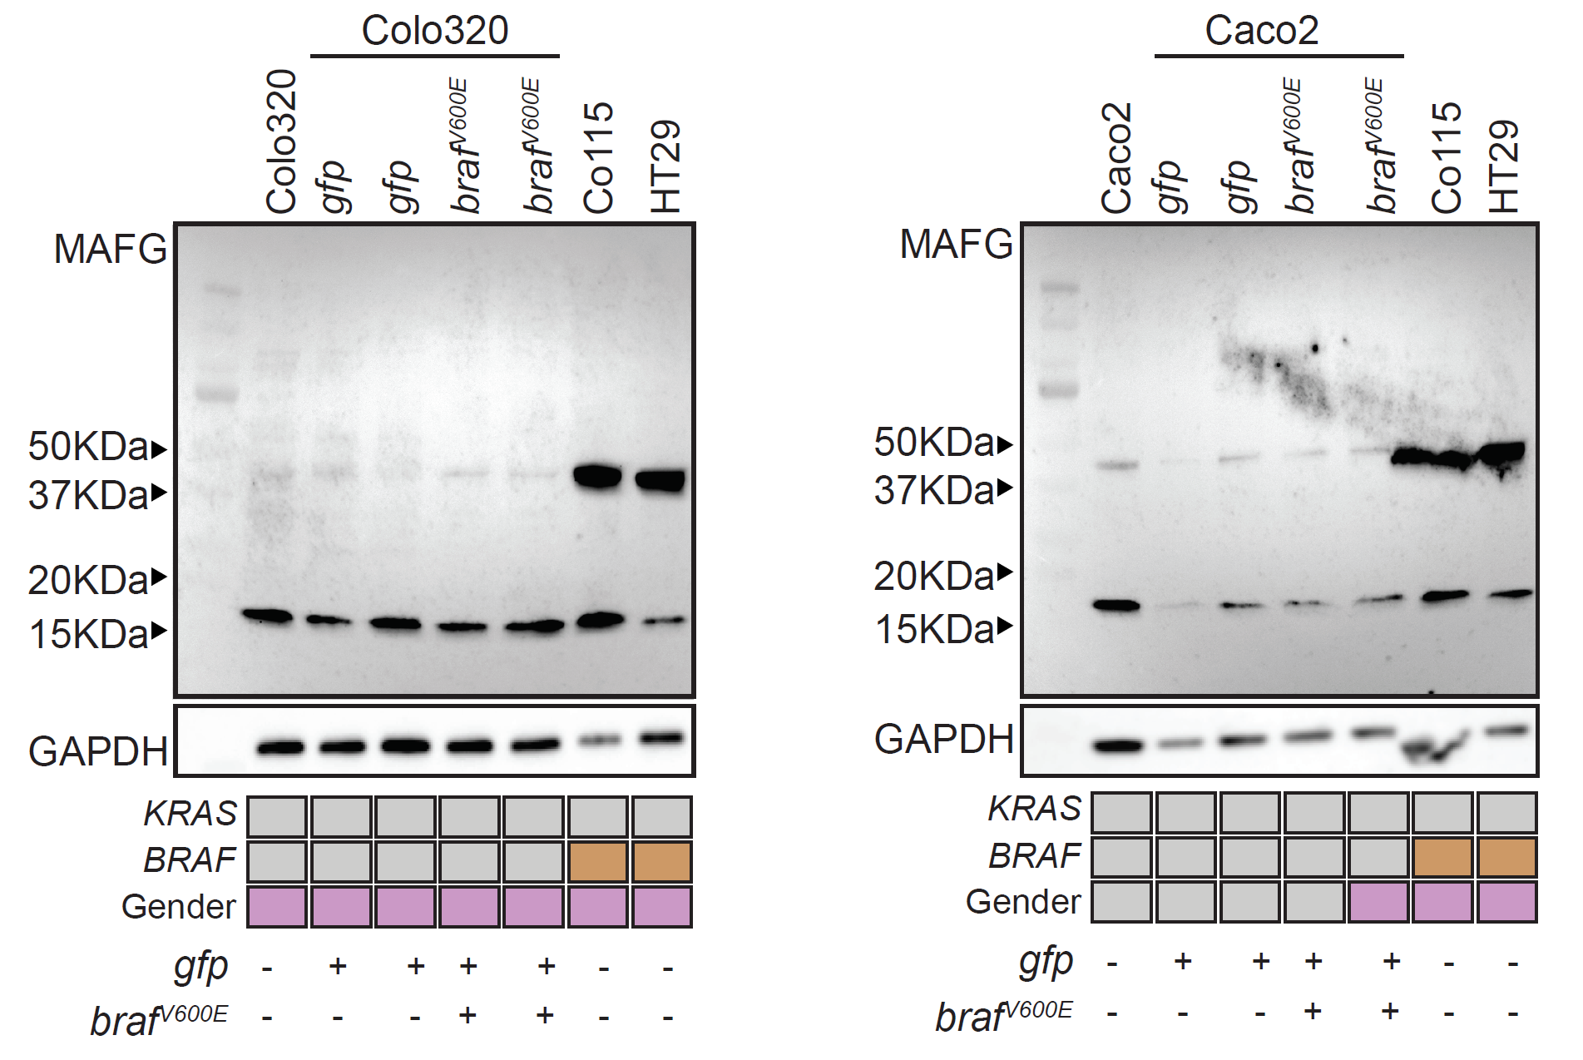
Figure S2. Western blot showing MAFG levels in un-transduced Colo320 and Caco2, ectopically expressing BRAF^{V600E} (braf^{V600E}) or GFP (gfp) transduced cells and cell lines constitutively expressing BRAF^{V600E} (Co115 and HT29). In addition to the expected size of the protein (18KDa), the antibody detected a higher band (~42KDa). At both 18 and 42KDa, no increase in MAFG levels was found in braf^{V600E} versus gfp. GAPDH was used as control.

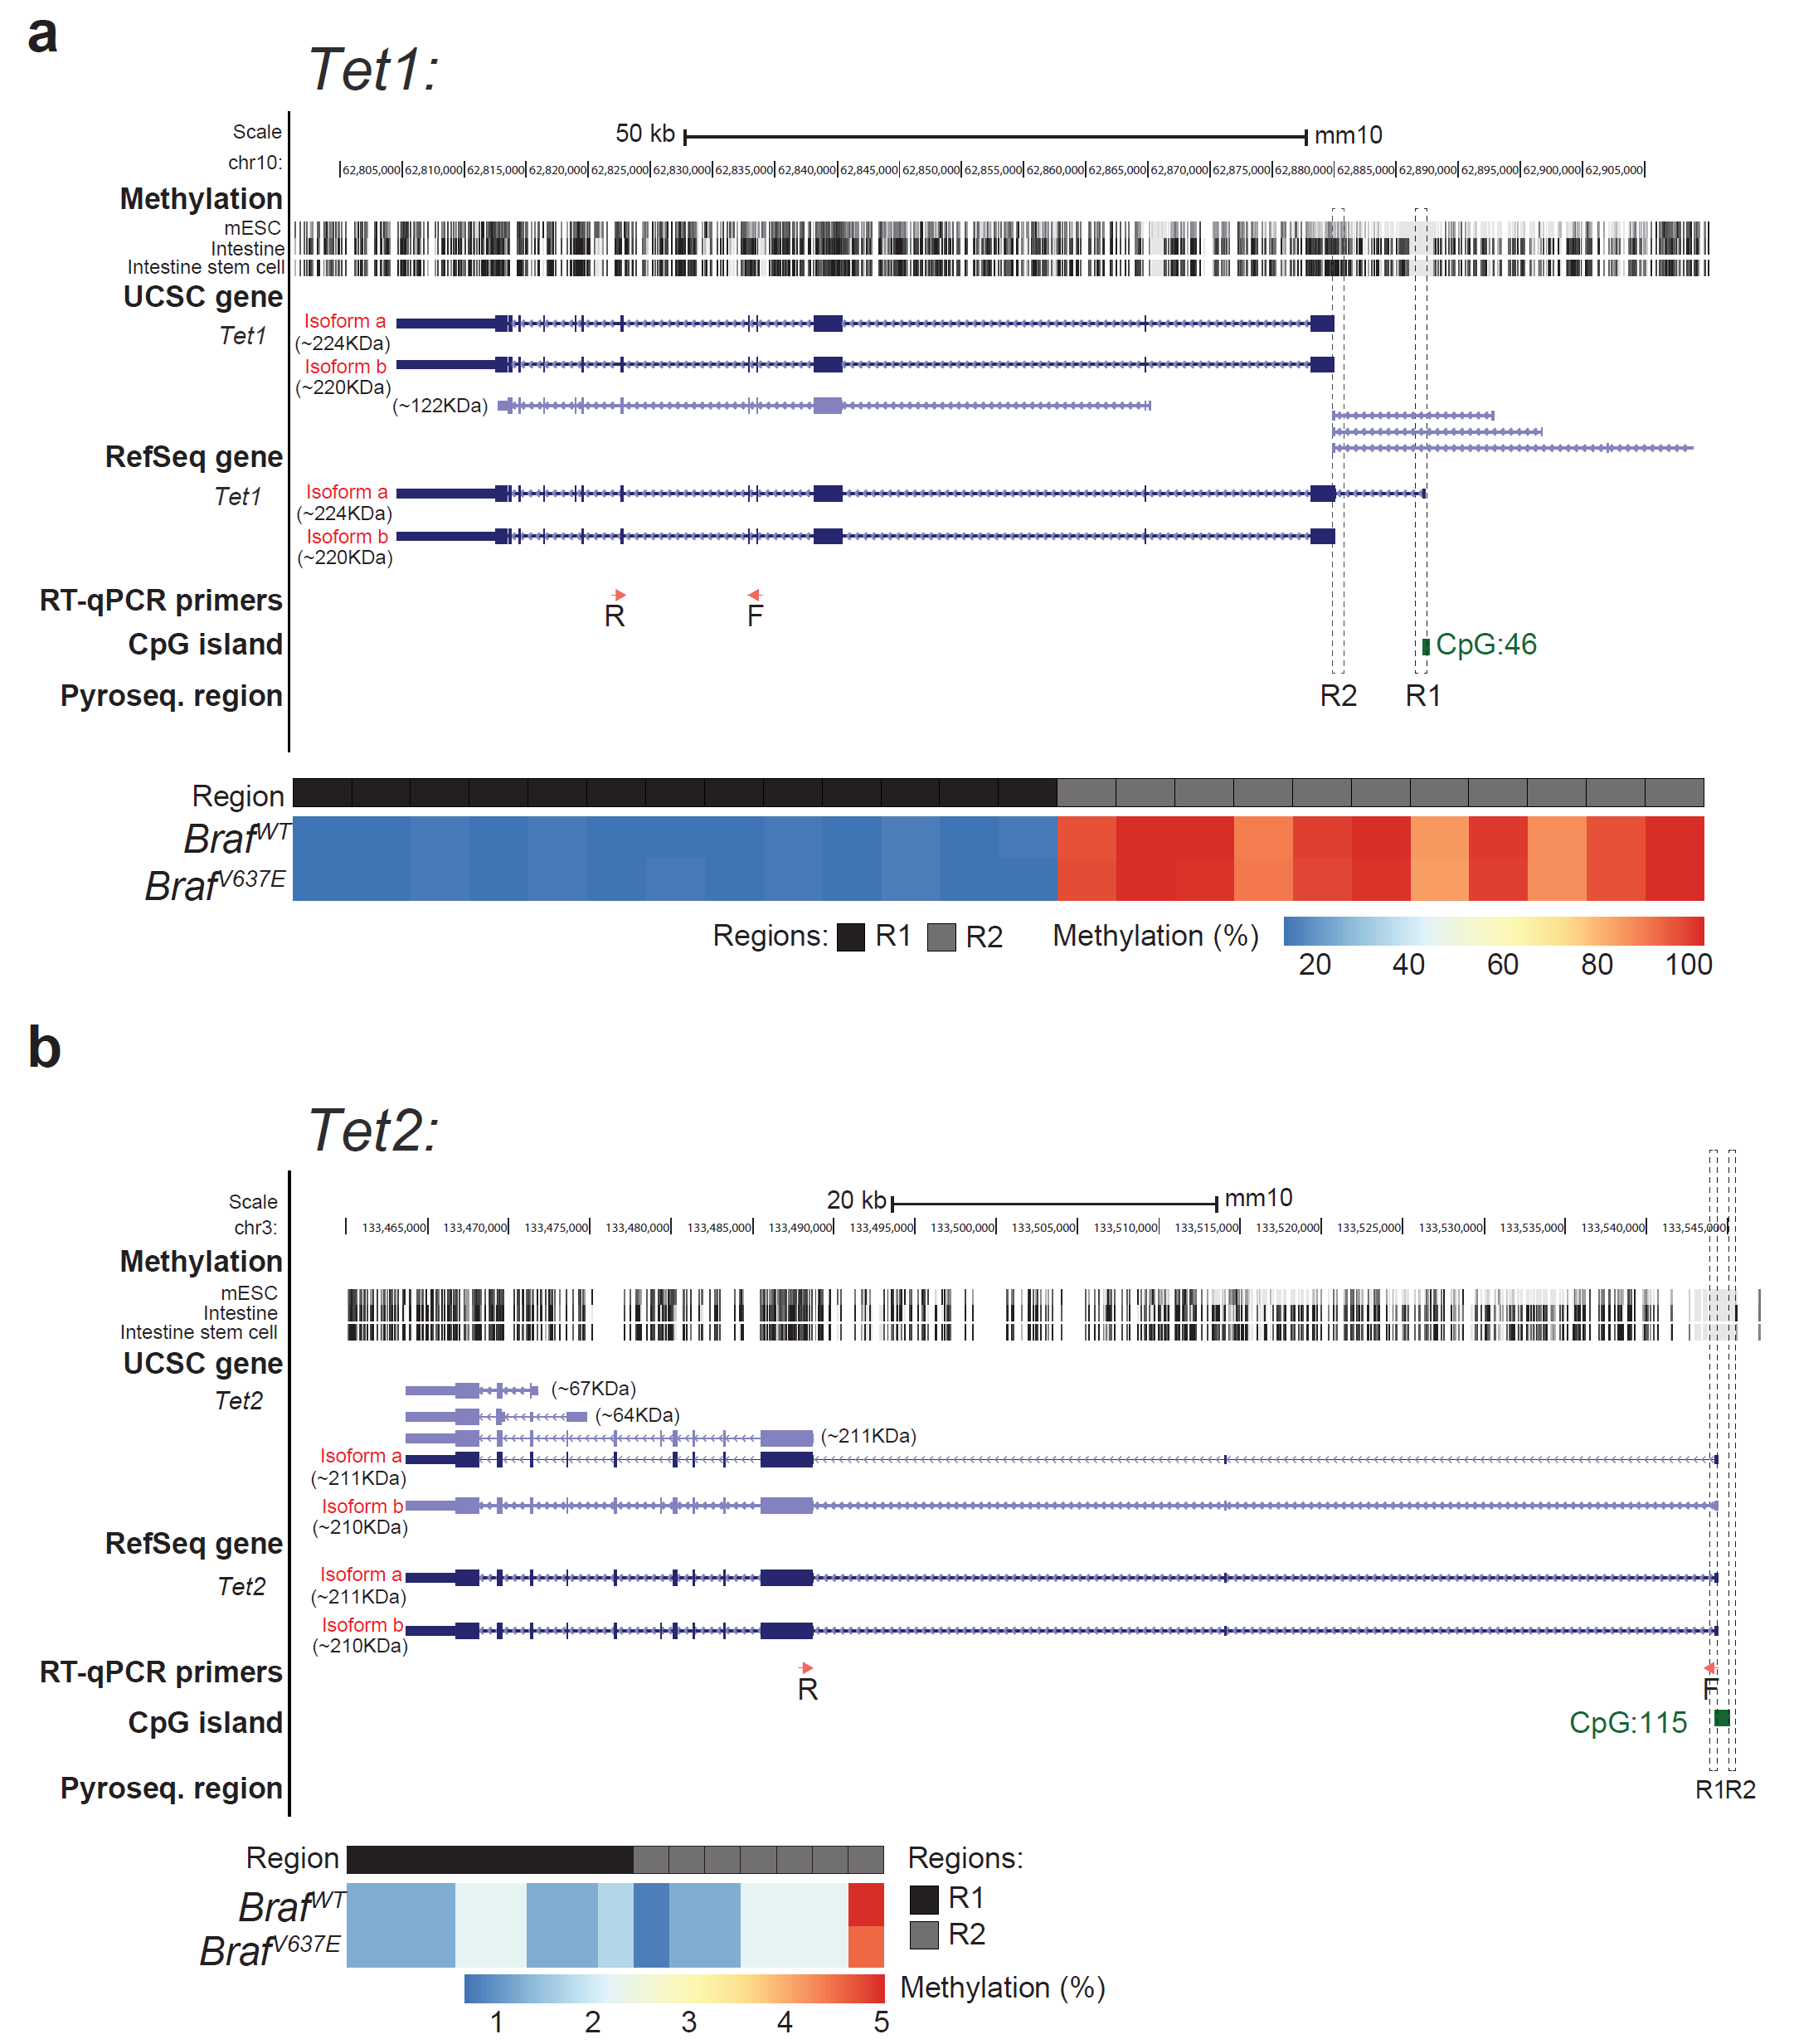
Figure S3. DNA methylation at mouse Tet1 and Tet2 promoter-associated CGI in conditional Braf^{-V637} knock-in mice. (a), Snapshot of mouse (mm10) Tet1 gene in the UCSC browser showing the UCSC and Refseq transcript tracks. In darkblue are the transcript that have been reviewed or validated by either the RefSeq, SwissProt or CCDS staff gene track and in light blue are the other RefSeq transcripts. Location of forward (F) and reverse (R) primers used for RT-qPCR are depicted in red arrows. Region used for the detection of methylation by pyrosequencing (R1and R2) is highlighted with dashed block. Sequence of primers are shown in Supplemental Table 2. Methylation data from mouse embryonic stem cells (mESC), intestine, intestinal stem cell was used from Smith’s lab provided at UCSC browser. Further details of each track can be found at https://genome-.ucsc.edu. Below; Heatmaps showing DNA methylation levels (percentage methylation) at Tet1 region1(R1) and 2 (R2) in intestinal tissue of wild type BRAF (BRAF^{WT}, n = 5) and mutated knock-in BRAF (Braf^{-V637}, n = 12) mice. (b), Snapshot of mouse (mm10) Tet2 gene in the UCSC browser. Figure display is the same as in panel a.

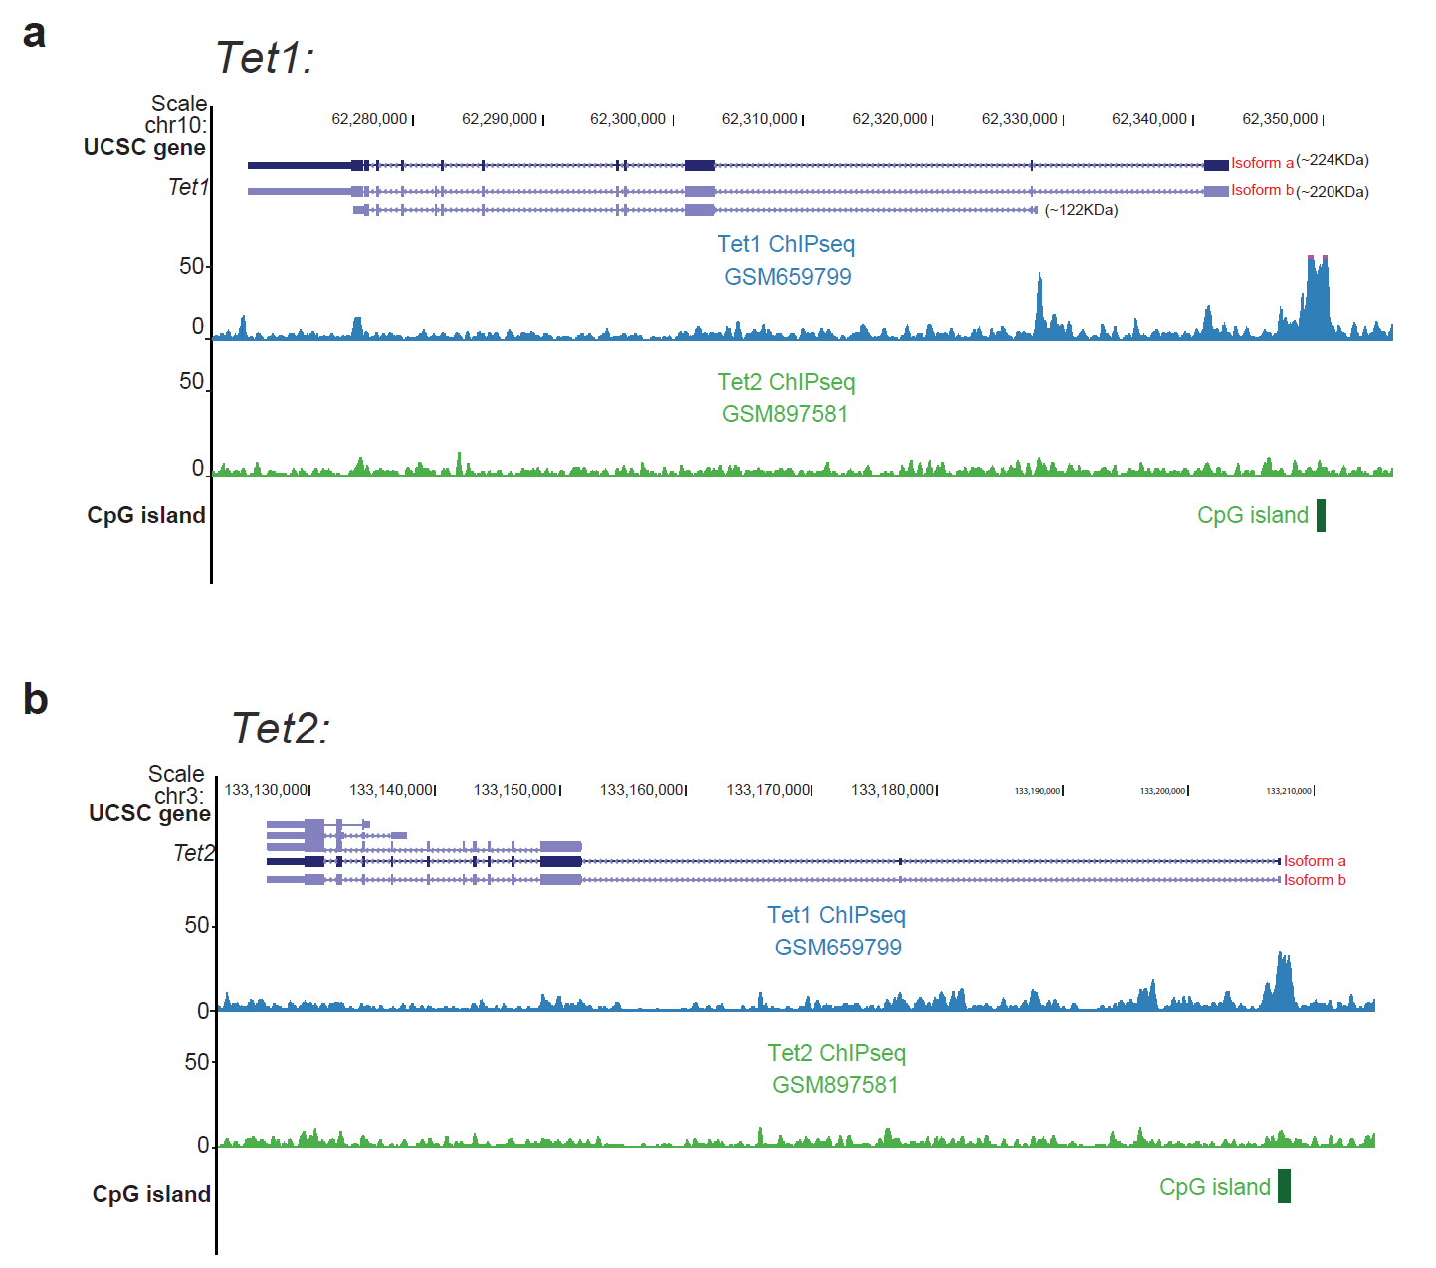

Figure S4. The UCSC browser view showing Tet1 binding on its own promoter and on Tet2 promoter. Snapshot of mouse (mm9) Tet1 (a) and Tet2 (b) gene in the UCSC browser showing the UCSC and transcript tracks. In darkblue are the transcript that have been reviewed or validated by either the RefSeq, SwissProt or CCDS staff gene track and in light blue are the other transcripts. Tet1 ChIPseq data from mESC (GSM659799) and Tet2 ChIPseq data from mouse bone marrow (GSM897581) are shown in blue and green, respectively.

Table S1. Quantitative RT-PCR primer sequences.
Gene | Forward Primer (5’-3’) | Reverse Primer (5’-3’)
Human
BRAF | TGATTTTGGTCTAGCTACAGT | TGAATAAGGTAACTGTCCAG
BRAFV600E | TGATTTTGGTCTAGCTACAGA | TGAATAAGGTAACTGTCCAG
TET1 | GCGCGAGTTGGAAAGTTT | GCTCAGTCACACAAGGTTTTGG
TET2 | CCAATAGGACATGATCCAGG | TCTGGATGAGCTCTCTCAGG
hMLH1 | GCTATCAAAGAGATGATTGAGAACTG | TATCCAGATCTTCTTTCCTGATCC
IGFBP7 | CACTGGTGCCCAGGTGTACT | TTGGATGCATGGCACTCATA
NEGR1 | TCATTCCCAGATGTGAGGAAAGTAA | GGTCACGGTGCCAGATTTAATT
FSTL1 | GACCACGATGTGGAAACGCT | AGCTCATCACGGTTGGACTG
FOXE3 | CAGACATGTTCGACAACGGC | CTGTCGACGCTGAACAGAC
SLIT1 | CATTGGTGCCAACCCCCTAT | GTCTCGACCCTTATAGCCGC
FAM78A | GACTCCAGGGAGAGTCTGCG | GCTGGACATGCCCTGCTC
SLC6A4 | ACGAGCTTCGTTTCGGGATT | GTAGGCCCCTCCAAAAGTCAG
KCNK13 | GTCGTTTCCACCATAGGGTTTG | ATGATGGTGATCAGGCGCTC
RAB31 | CTTCTCGGGGACACTGGGG | CTGCAGCTGAGCCTCGATAG
GREM1 | CACTCTCGGTCCCGCTGA | CTGTGCGGCTCATACTGTCA
DKK3 | CACCCTCAATGAGATGTTCC | ATTTCCAACCTTCGTGTCTG
ACTB | AGCCTCGCCTTTGCCGA | CTGGTGCCTGGGGCG
GAPDH | GGAGCGAGATCCCTCCAAAAT | GGCTGTTGTCATACTTCTCATGG
Mouse
Tet1 | ACACACCTTGGGGCAGGACCA | TCTGATCACCCACTTGGCGACC
Tet2 | ATATTGATGCGGAGGCGAGG | AATGAATCCAGCAGCACCGT
Mlh1 | TTAGTGAGCGGTGCCATGAG | ACAGCTCTTCACTGAGCTTGG
Actb | ACTATTGGCAACGAGCGGTT | ACACTTCATGATGGAATTGAATGTAGT
Gapdh | GTGTTCCTACCCCCAATGTGT | ATTGTCATACCAGGAAATGAGCTT
Tbp | CACAGGAGCCAAGAGTGAAGAAC | CTACTGAACTGCTGGTGGGTC

Table S2. Pyrosequencing primer sequences.
Gene | Primer | Sequence (5’-3’)
Human
TET1
 | Forward1 | GAGGTTTGTTTTGGGGAGATA
 | Reverse1 | GCCCCCGCCCGCCCCAACTCCAAACCTAC
 | Forward-nested1 | TGTTTTGGGGAGATATAGTTG
 | Sequencing-R1 | GGGGGTTGATTTGG
 | Sequencing-R2 | GGGTTTTGATTGTGTTGG
 | Forward2 | AGGGTTGGTGTAGGTTTGGAGTT
 | Reverse2 | GCCCCCGCCCGACACTTACCCTCCCCCA
 | Forward-nested2 | GTAGGTTTGGAGTTGGGGGT
 | Sequencing-R3 | TGTTTTGGGAATGTGATT
 | Sequencing-R4 | TTGTTTTAGGGGTGGGTT
 | Sequencing-R5 | GAGATAAATAATGTTTT
 | Sequencing-R6 | TTTGGGGTTTTGATT
TET2
 | Forward | GAAGTGGTGGTGGAGTGTAG
 | Reverse | GCCCCCGCCCGCAATAAAAACCTAAACTACCCTCAC
 | Forward-nested | GAGTGTAGATTAGTAAAAAGTTTTAAAGGG
 | Sequencing-R1 | GGGAAATTTTAGATGTTA
 | Sequencing-R2 | TTTAGGGGTGGAGATT
 | Sequencing-R3 | TTAGTTTTGGTTTTTATTT
hMLH1
 | Forward | TGTATTGGTATATAAAGTTTTTTTTATTTTAGT
 | Reverse | GCCCCCGCCCGCTCCTCCTCTCCCCTTA
 | Forward-nested | GAGTAGTTTTTTTTTTAGGAGTGAAGG
 | Sequencing-R1 | TAGGAGTGAAGGAGGTTA
 | Sequencing-R2 | ATAGATTAGGTATAGGGTTTTAT
 | Sequencing-R3 | GTTATAAGAGTAGGGTTA
Mouse
mTet1
 | Forward1 | TGATGTTAAGTTTGGAGGTTTTTAT
 | Reverse1 | GCCCCCGCCCGACCCTAAAATCCAAAAACAATTT
 | Forward-nested1 | AGGGTTAATTAAATTTTTTGGGGAG
 | Sequencing-R1 | GAGTATTGTTAGTTATT
 | Forward2 | AAGGAGTTTGGGTTTTGAAAAAG
 | Reverse2 | GCCCCCGCCCGCATCCTTACATCTTTACTTACTCTACA
 | Forward-nested2 | TTTGGGTTTTGAAAAAGAATTTGG
 | Sequencing-R2 | TTGAAAAAGAATTTGGTTT
mTet2
 | Forward1 | GGGAGATTGGAAAGGGATTAT
 | Reverse1 | GCCCCCGCCCGAAAACAAAATAACTACCCTATAAAATT
 | Forward-nested1 | GAGGAAAGAAAGAGAGAGAGAG
 | Sequencing-R1 | AGAGAGAGAGAGATAGG
 | Forward2 | GGGAGAGTTAGAGGGGTTTGG
 | Reverse2 | GCCCCCGCCCGCTTAAACATTAAAAACTACTAACTTAATTC
 | Forward-nested2 | GTTTAGGTTTATTTTTTGTTTATTTTGG
 | Sequencing-R2 | ATTTTTTGTTTATTTTGGTTA
Universal primer |  | Biotin-GCCCCCGCCCG
Sequence underlined represents the 11-base tag.

