Supplementary table 1: Primer pairs for real-time PCR
Genes | Sequences(5’-3’)
CFD | Sense | CAGCTGCAAGGGTGACTCC
 | Antisense | CAGGACGCTGTCGATCCAG
MBL2 | Sense | GTGATGGCACCAAGGGAGAA
 | Antisense | TCACCATCCGGACTTTTTCCA
C2 | Sense | GGGGACAAGGTCCGCTATC
 | Antisense | GAAGTCATAAGAGTAGGGTTGGC
C5 | Sense | ATTCGCTTGACCAGTTGGTAG
 | Antisense | CCAGATGGGAGATTAAGCACAAA
C8G | Sense | CCGACTACCAGAGTTTCGCT
 | Antisense | CAGAAGCCGTACTTGGGGAAG
MASP2 | Sense | TCCAGGGGAGTATGCCAATGA
 | Antisense | TCCAGGTCGAAGTGGGTGAA
C4B | Sense | ATGAAGAACACGACCTGCCA
 | Antisense | TTCCTCCGACCCTCAAACAG
C3 | Sense | TACTACACGCTGATCGGTGC
 | Antisense | GCTTTTTACCACCAGCGAGC
C1S | Sense | TTTGGCATGGGTTTATGCTGA
 | Antisense | GGGTGAAGTAGAGGTGAATCCC

Supplementary table 2: Primer pairs for ChIP-QPCR
Genes | Sequences(5’-3’)
VIM | Sense | CCTGAGGAATCGGCTATGGG
 | Antisense | CTTCTACGTGCAGTGCCGA
CTNNB1 | Sense | AAGAATACGCTGGCCCTGAA
 | Antisense | AACACATAGATGCAGGCGGA

Supplementary Figures

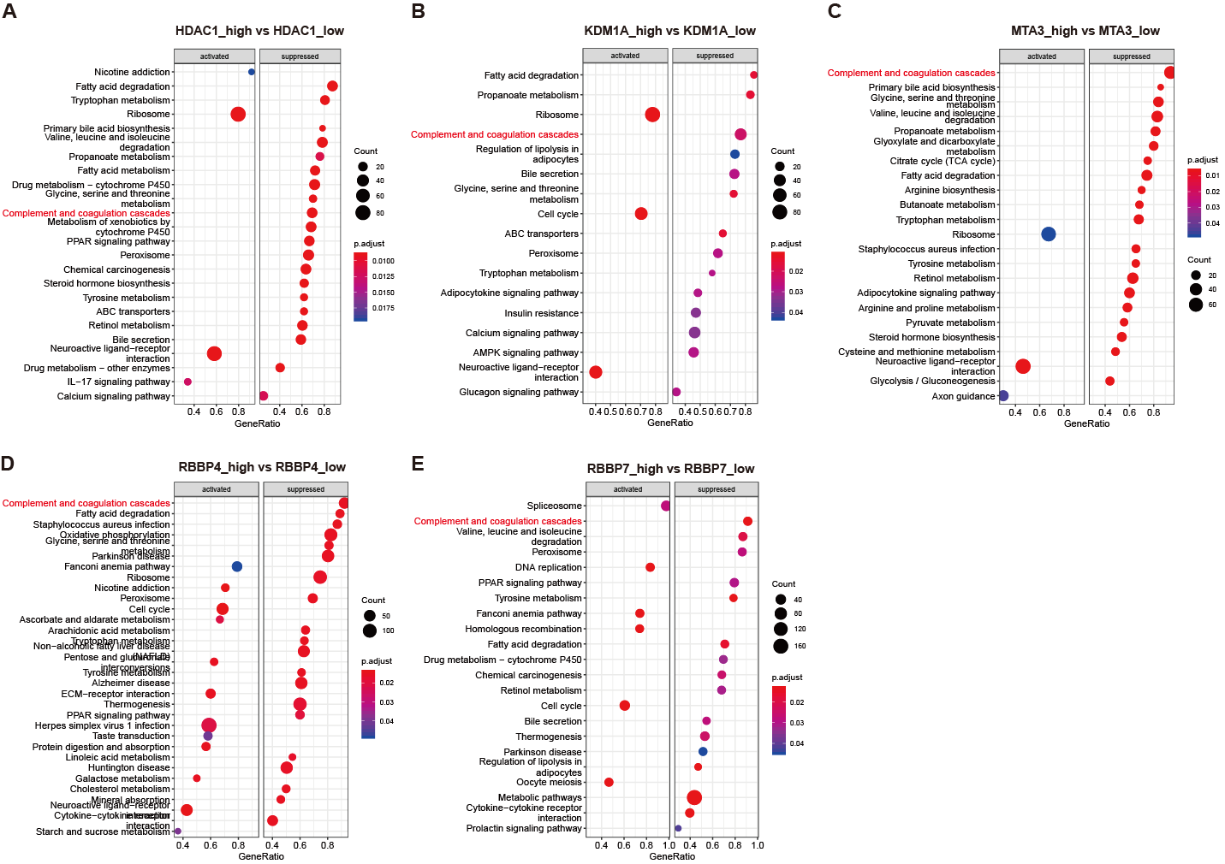
Supplementary Figure S1. The CHD4/NuRD complex regulates complement gene expression. Gene Set Enrichment Analysis (GSEA) analysis was performed to identify the pathways altered in high_expression HCC samples compared to low_expression samples for subunits HDAC1, KDM1A, MTA3, RBBP4 and RBBP7 respectively.

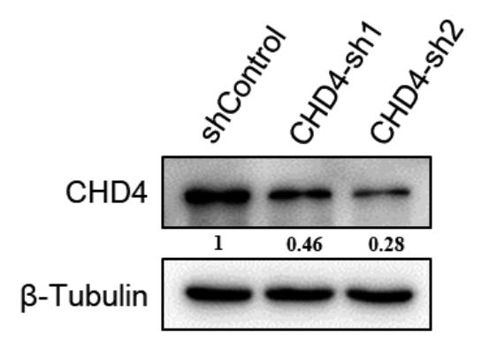
Supplementary Figure S2. CHD4 knockdown efficiency was measured in Hep3B cells using western blotting analyses. β-Tubulin was used as loading control.

