Supplementary information

Novel HDAC inhibitor MAKV-8 and imatinib synergistically kill chronic myeloid leukemia cells via inhibition of BCR-ABL/MYC-signaling: effect on imatinib resistance and stem cells

Manon Lernoux¹, Michael Schnekenburger¹, Hélène Losson¹, Koen Vermeulen², Hyunggu Hahn³, Déborah Gérard¹, Jin-Young Lee³, Aloran Mazumder³, Muneer Ahamed², Christo Christov⁴, Dong-Wook Kim⁵, Mario Dicato¹, Guy Bormans², Byung-Woo Han^{3*}, Marc Diederich^{3*}

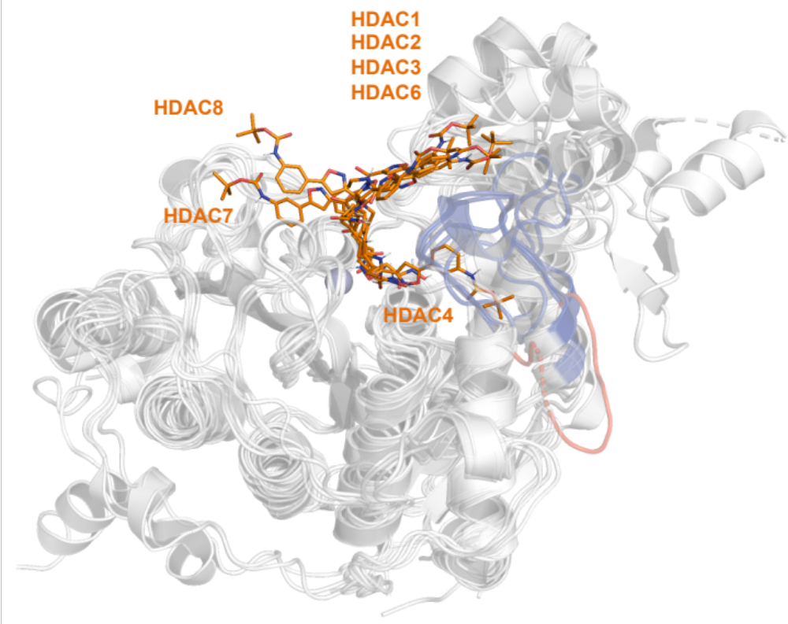
Figure S1: Docking of MAKV-8 into human HDAC isoenzymes.
Docking poses of MAKV-8 molecule, represented as stick model (orange), on the crystal structure of the indicated HDAC isoenzymes that are superposed (white; PDB codes: 4BKX, 4LY1, 4A69, 2VQM, 5EDU, 3C10, and 3EW8 for HDAC1, HDAC2, HDAC3, HDAC4, HDAC6, HDAC7 and HDAC8, respectively). Nitrogen and oxygen are colored in blue and red, respectively.
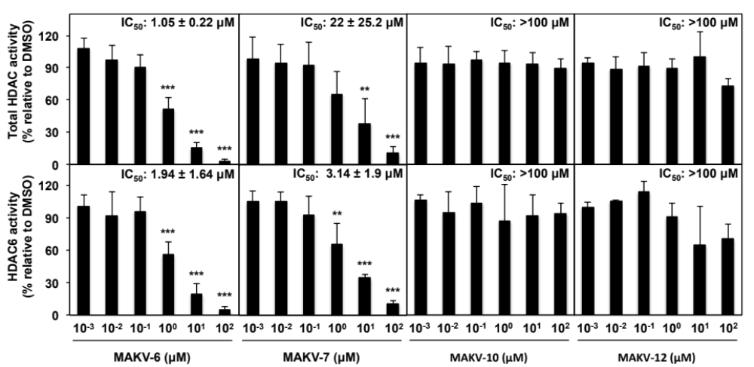
Figure S2: Effect of MAKV-8 derived compounds on in vitro HDAC6 and total HDAC activities.
In vitro HDAC activity assays were conducted with increasing concentrations of MAKV-8 derived compounds. Relative activities of total HDAC and HDAC6 were determined by comparison to the vehicle DMSO and correspond to the mean ± SD of three independent experiments for MAKV-6 and MAKV-7, or two independent experiments for MAKV-10 and MAKV-12.

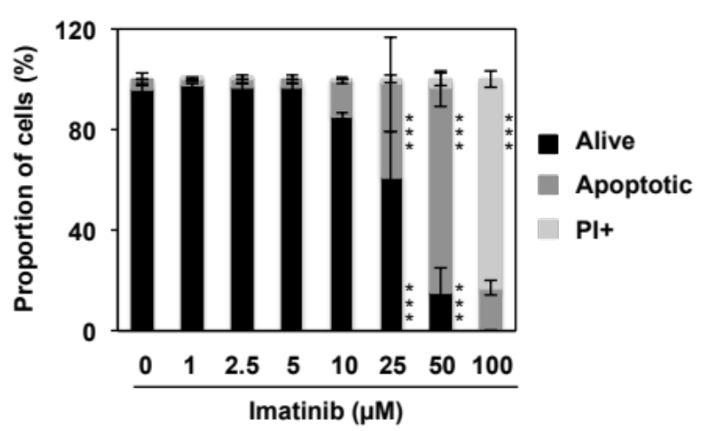
Figure S3: Effect of imatinib treatment on KBM-5R cell death.
KBM-5R cells were treated with increasing concentrations of imatinib and nuclear morphology was studied after 48 hours of treatment.

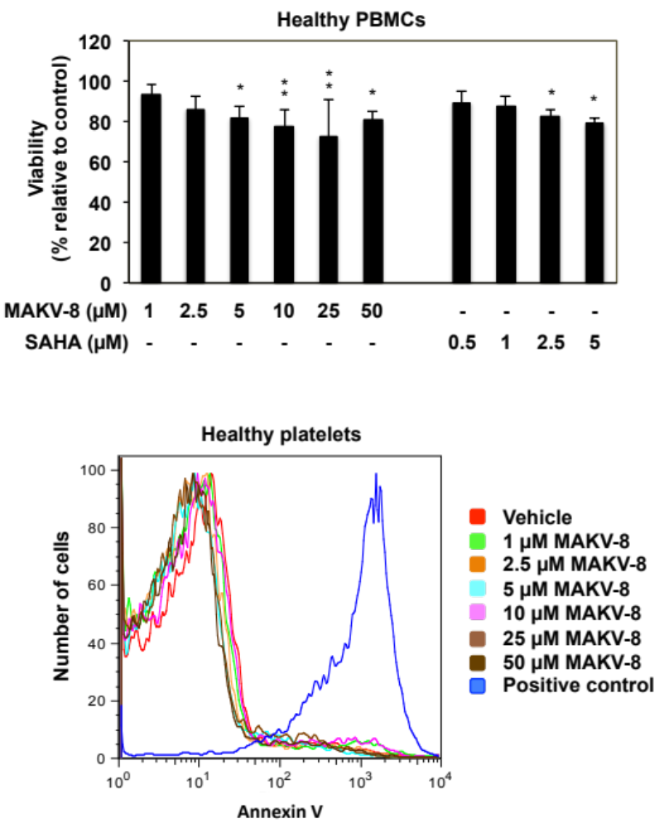
Figure S4: Effect of pan-HDACi MAKV-8 and SAHA on healthy model viability.
PBMCs (upper panel) and platelets (lower panel) were treated with the indicated concentrations of MAKV-8 or SAHA for 48 hours. Cell viability was assessed based on the Trypan Blue exclusion method for PBMCs and by flow cytometry after Annexin V staining for platelets.

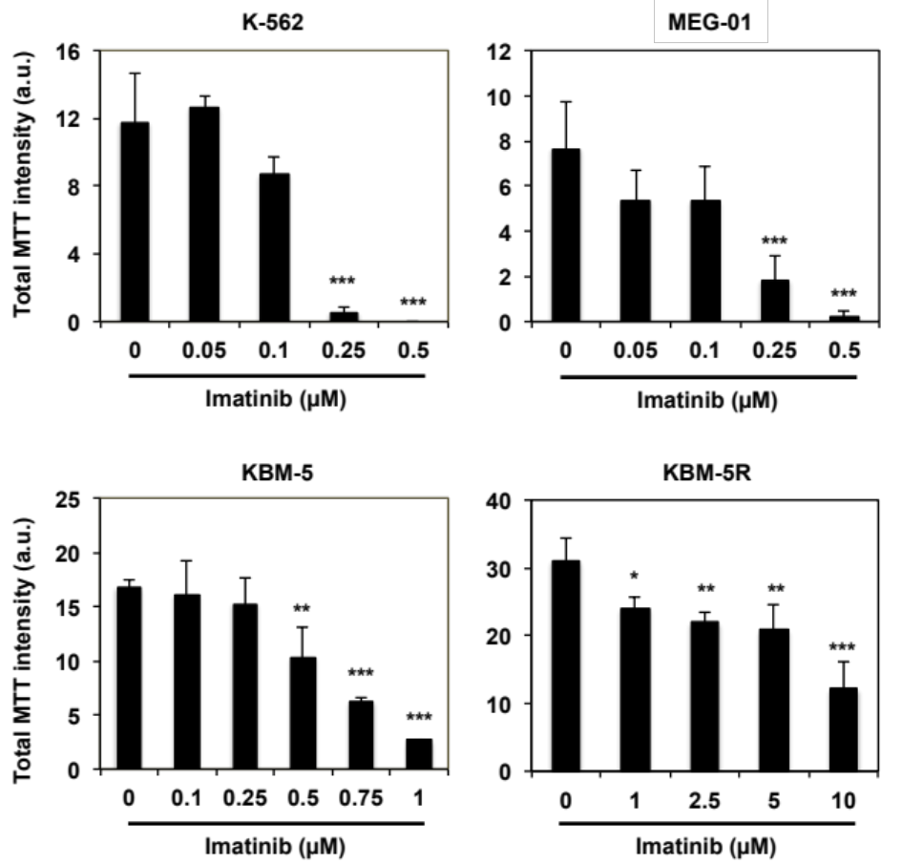
Figure S5: Effect of imatinib treatment on replicative ability of imatinib-sensitive and -resistant CML cells.
Imatinib-sensitive and -resistant CML cells were grown in semisolid methylcellulose medium in presence of increasing concentrations of imatinib for 10 days and colony formation was then scored after addition of MTT. Quantifications of total MTT intensity correspond the mean ± SD of three independent experiments.

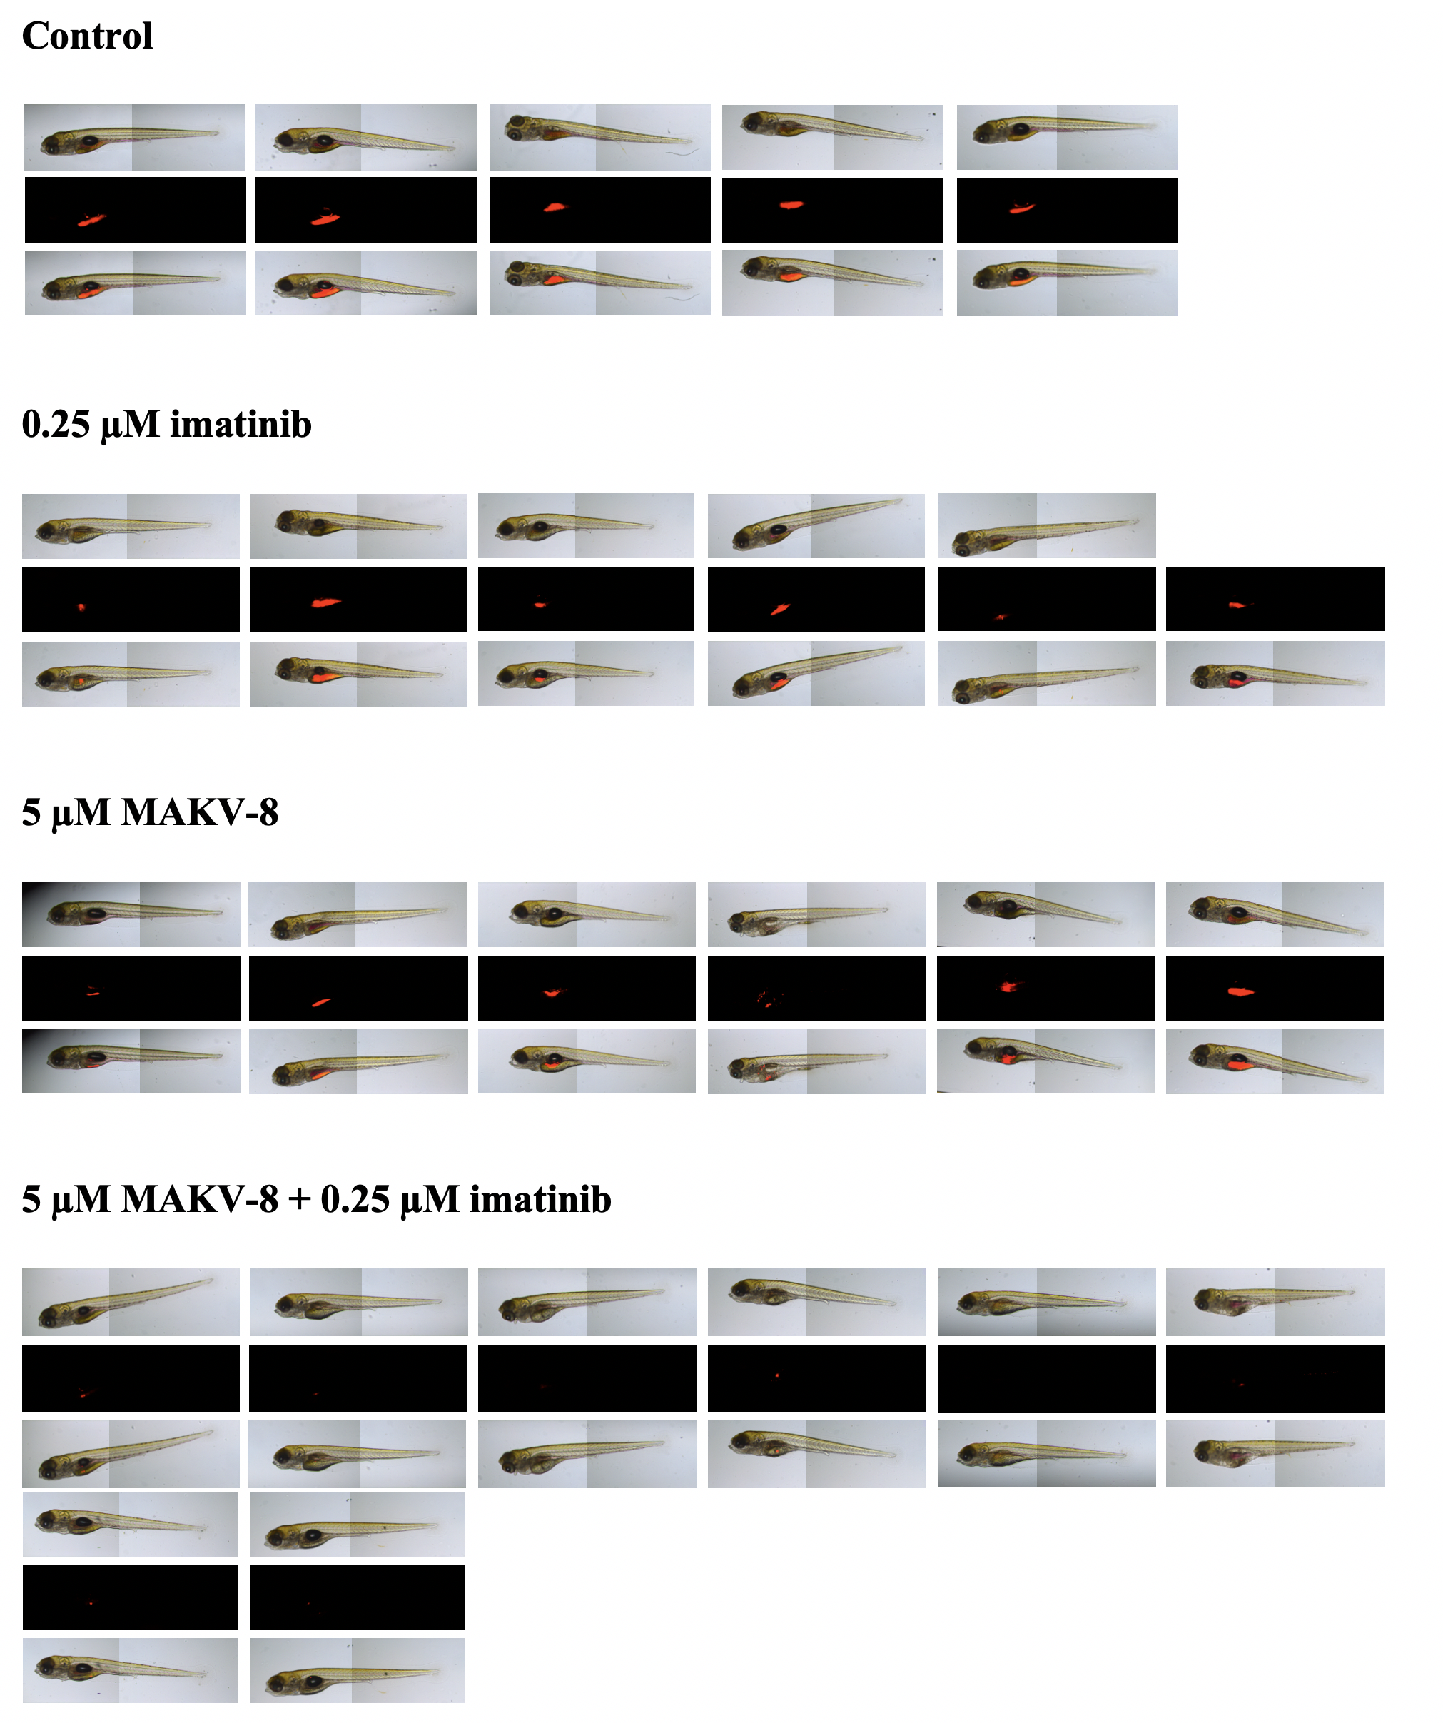
Figure S6: Panel of zebrafish pictures.
K-562 cells were treated as indicated in the figure for 24 hours, labeled with fluorescent dye and then injected in the zebrafish yolk sac. All zebrafish pictures for each condition are shown. Upper, middle and lower pictures represent bright field, red fluorescence and merge, respectively.
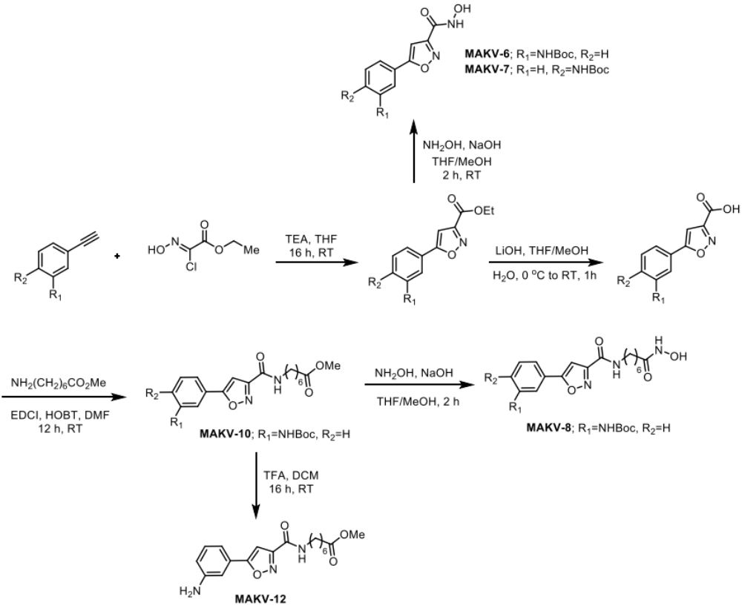
Figure S7: Reaction scheme showing the synthesis of MAKV-6, -7, -8, -10 and -12.

