SUPPLEMENTARY FIGURES
Supplementary Figure 1. Pearson correlations between serum CRP, the DNAm CRP score and the genetic score in the Lothian Birth Cohort 1936 and Generation Scotland. 95% confidence intervals are presented in square brackets.
LBC1936=Lothian Birth Cohort 1936; GS=Generation Scotland; CRP=C-reactive protein; DNAm=DNA methylation.
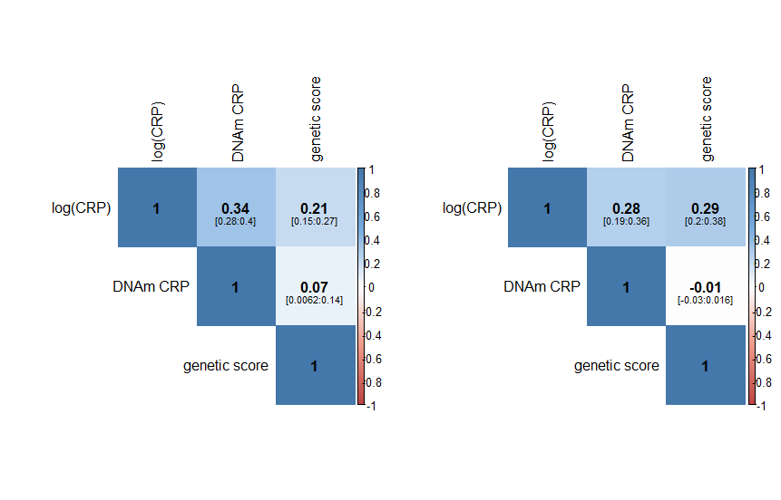
GS
LBC1936

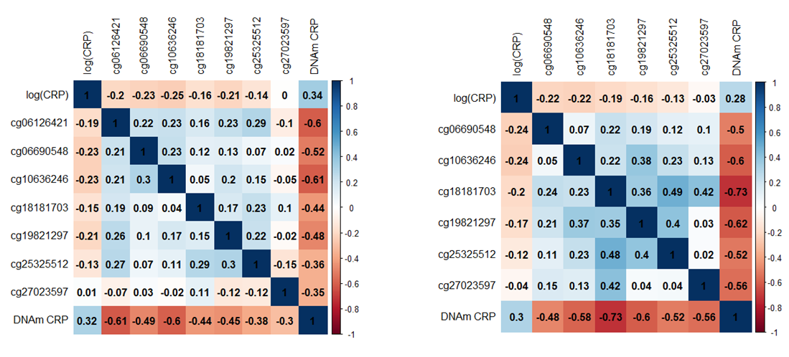
Supplementary Figure 2. Plots of the correlations between individual CpGs comprising the DNAm CRP score and serum CRP in the Lothian Birth Cohort 1936 and Generation Scotland. Pearson correlations are presented in the upper diagonal and Spearman correlations are presented in the lower diagonal.
GS
LBC1936=Lothian Birth Cohort 1936; GS=Generation Scotland; CRP=C-reactive protein; DNAm=DNA methylation.
LBC1936
GS

Supplementary Figure 3. Inter-wave Pearson correlations DNAm CRP score and serum CRP in the Lothian Birth Cohort 1936. 95% confidence intervals are presented in square brackets.
CRP=C-reactive protein; W=wave; DNAm=DNA methylation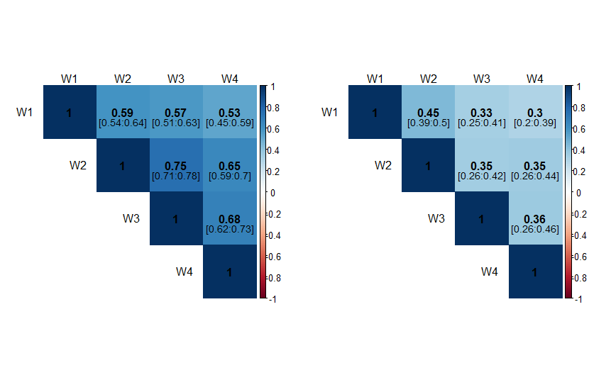
DNAm CRP
Serum CRP

