Supplementary

Table 1 Body composition of ARIES participants age 7 and 17
 | Age 7 |  |  | Age 17
 | n | Mean (SD) |  | n | Mean (SD)
BMIz | 870 | 0.15(1.03) |  | 749 | 0.36(1.12)
 | n | % |  | n | %
Healthy weight | 753 | 87.25 |  | 597 | 80.68
Overweight/obese | 110 | 12.75 |  | 143 | 19.32
Total | 863 |  |  | 740
Proportion (%) of study members in healthy weight or overweight/obese and mean BMIz and standard deviation (SD). n, sample size; %, column percentage.

Table 2 Linear associations between CpG sites (age 7) and RT.
Exposure | n | CpG name | Chr | Nearest gene | Model | Coefficient | SE | p value
With cell counts
RT | 116 | cg01379158 | 17 | NT5M | SVA | 0.0078 | 0.0025 | 0.0022
Without cell counts
RT | 125 | cg01379158 | 12 | NT5M | SVA | 0.0065 | 0.0025 | 0.0107
RT | 125 | cg11531579 | 12 | CHFR | SVA | 0.0056 | 0.0028 | 0.0493
Models are adjusted for age, sex, and surrogate variables, both with or without adjustment for cell counts. Estimates represent beta coefficients. n, sample size; SE, standard error; SVA, surrogate variable analysis.

Table 3 Summary statistics of CpG methylation (age 7) at the identified differentially methylated loci (age 7) by phenotype (healthy weight not healthy weight) at ages 7 and 17
 |  | N | Mean | SD | Median | Min | Max |  | N | Mean | SD | Median | Min | Max
 | Age 7 | cg01379158 |  |  |  |  |  |  | Age 7 | cg11531579
No RWG | Healthy weight | 74 | 0.069 | 0.017 | 0.068 | 0.033 | 0.125 |  | 74 | 0.035 | 0.011 | 0.033 | 0.016 | 0.084
No RWG | OWOB | 10 | 0.075 | 0.021 | 0.071 | 0.042 | 0.106 |  | 10 | 0.039 | 0.011 | 0.041 | 0.024 | 0.054
RWG | Healthy weight | 35 | 0.078 | 0.025 | 0.076 | 0.033 | 0.149 |  | 35 | 0.045 | 0.02 | 0.039 | 0.02 | 0.118
RWG | OWOB | 6 | 0.091 | 0.019 | 0.09 | 0.064 | 0.114 |  | 6 | 0.057 | 0.013 | 0.059 | 0.042 | 0.075
 | Total | 125 | 0.073 | 0.021 | 0.073 | 0.033 | 0.149 |  | 125 | 0.04 | 0.015 | 0.035 | 0.016 | 0.118
 | p value | 0.017 |  |  |  |  |  |  | < 0.001
 | Age 17 | cg01379158 |  |  |  |  |  |  | Age 17 | cg11531579
No RWG | Healthy weight | 54 | 0.069 | 0.017 | 0.069 | 0.039 | 0.103 |  | 54 | 0.036 | 0.012 | 0.033 | 0.023 | 0.084
No RWG | OWOB | 19 | 0.068 | 0.018 | 0.067 | 0.033 | 0.106 |  | 19 | 0.036 | 0.01 | 0.035 | 0.016 | 0.054
RWG | Healthy weight | 28 | 0.076 | 0.026 | 0.074 | 0.033 | 0.149 |  | 28 | 0.041 | 0.014 | 0.037 | 0.02 | 0.086
RWG | OWOB | 9 | 0.085 | 0.021 | 0.08 | 0.056 | 0.118 |  | 9 | 0.059 | 0.027 | 0.057 | 0.025 | 0.118
 | Total | 110 | 0.072 | 0.02 | 0.071 | 0.033 | 0.149 |  | 110 | 0.039 | 0.015 | 0.035 | 0.016 | 0.118
 | p value | 0.0801 |  |  |  |  |  |  | < 0.001
Values represent beta values. RWG, rapid weight gain; n, total in each group; SD, standard deviation; min, minimum; max, maximum. P value from ANOVA. Bold represents the high-risk phenotype of RWG in infancy and subsequent OWOB, which has higher DNAm levels (relative to the other categories).

A. 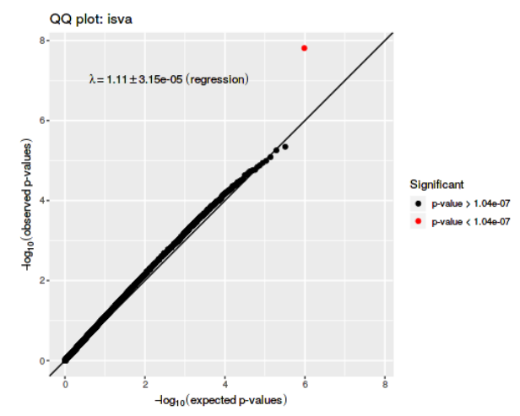 | B. 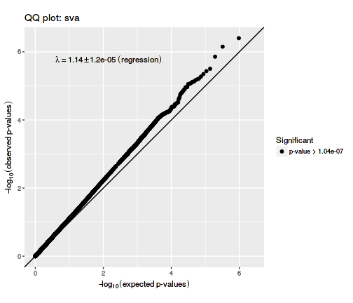
C.  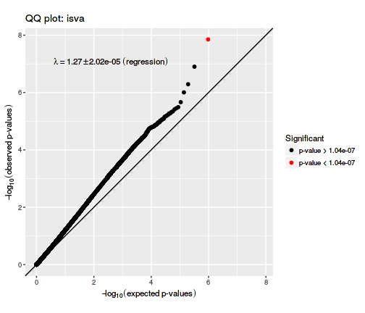 | D. 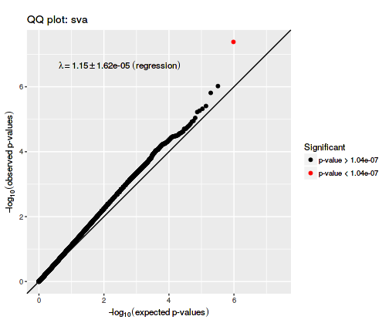
Figure I Q-Q plots for RWG models (SVA, ISVA) both with (A, B) and without (C,D) adjustment for cell counts.
The Q-Q plots present the distribution of the p value for the association between CpG site methylation and RWG. The straight line is the expected distribution under the null hypothesis.

Age 7, RWG
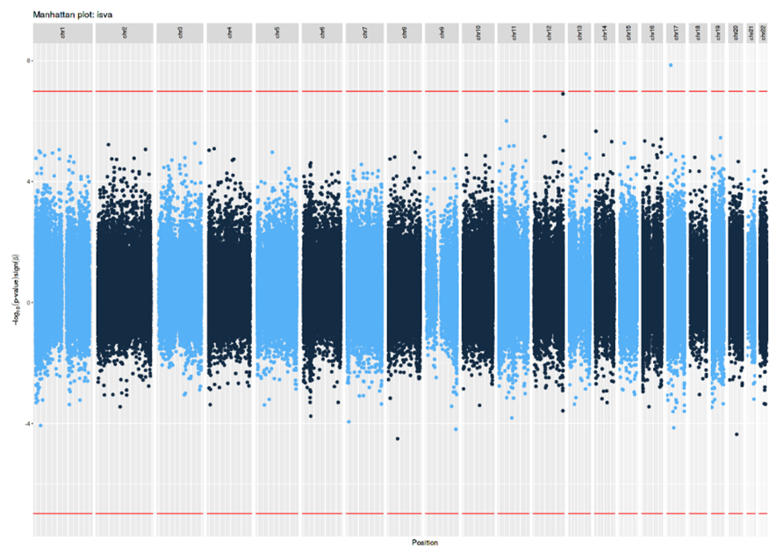
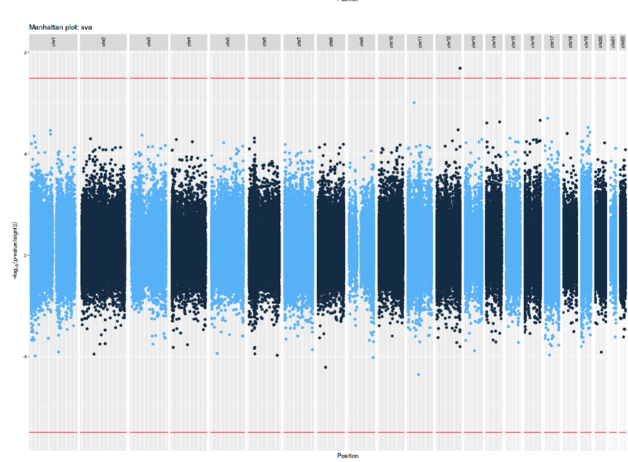
Age 7, RT
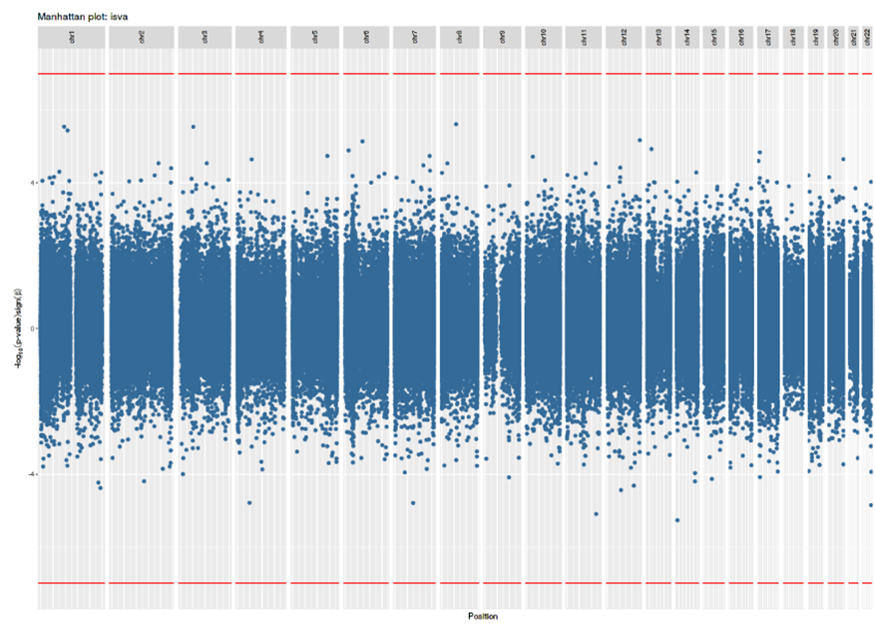
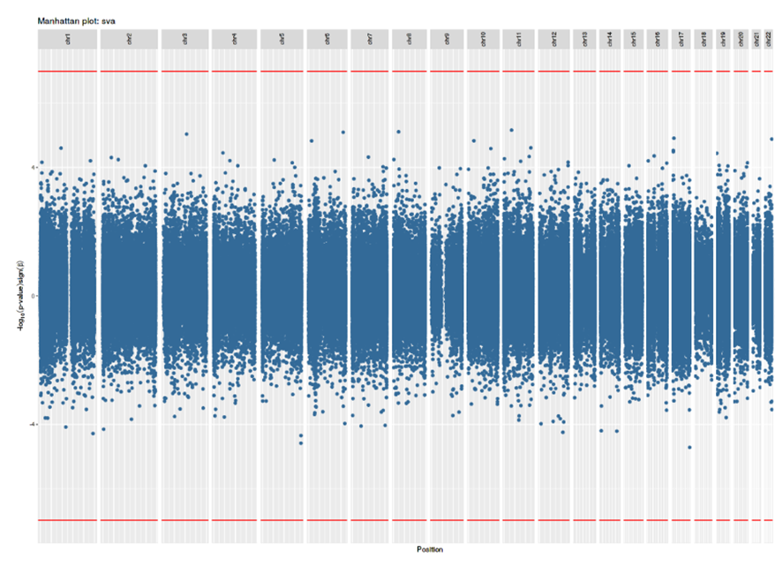
Figure 2 Bi-directional Manhattan plots of the EWAS analysis of RWG and RT for the ISVA and SVA models without cell counts.
The x-axis represents the chromosomes and the y-axis shows the –log10(P). The red line indicates the Bonferroni-corrected epigenome-wide threshold (p<1.04x10⁻⁷). Positively associated loci are displayed in the positive y-axis and negatively associated loci are displayed in the negative y-axis.

