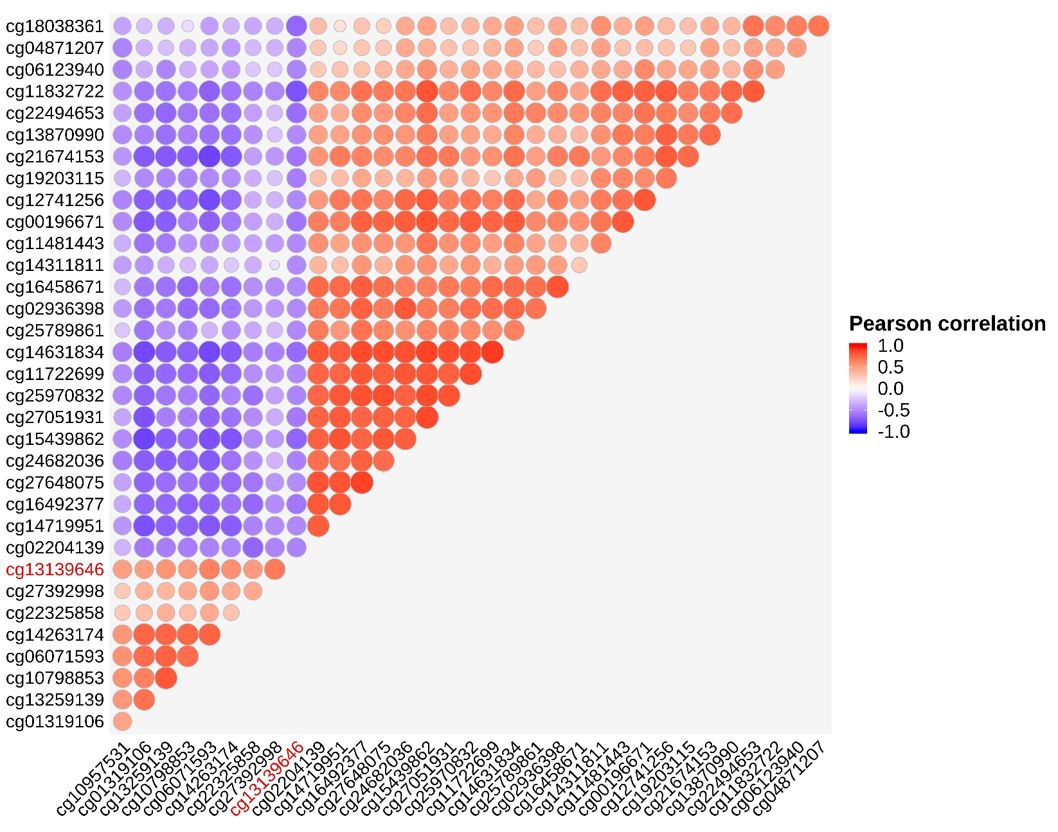
Additional File 4: Co-methylation analysis (Pearson’s correlation based on M values) with respect to cg13139646 (red text).

