Additional file 5: Figure S1

Difference between the observed mAge at the end of the intervention and the assumed expected mAge difference
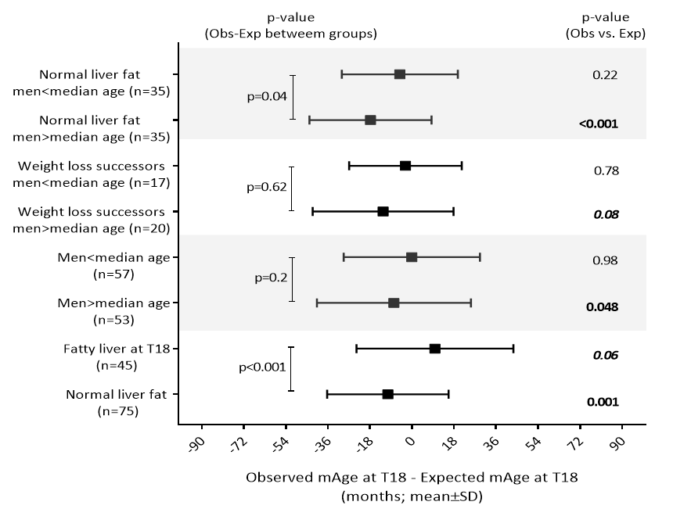
Data presented as mean±SDs for the difference between mAge at T18 and the expected mAge at T18. Between groups differences were tested using independent samples T test or Mann-Whitney test. Paired test was used for observed (Obs) vs. expected (Exp) mAge, both by T18.

