- 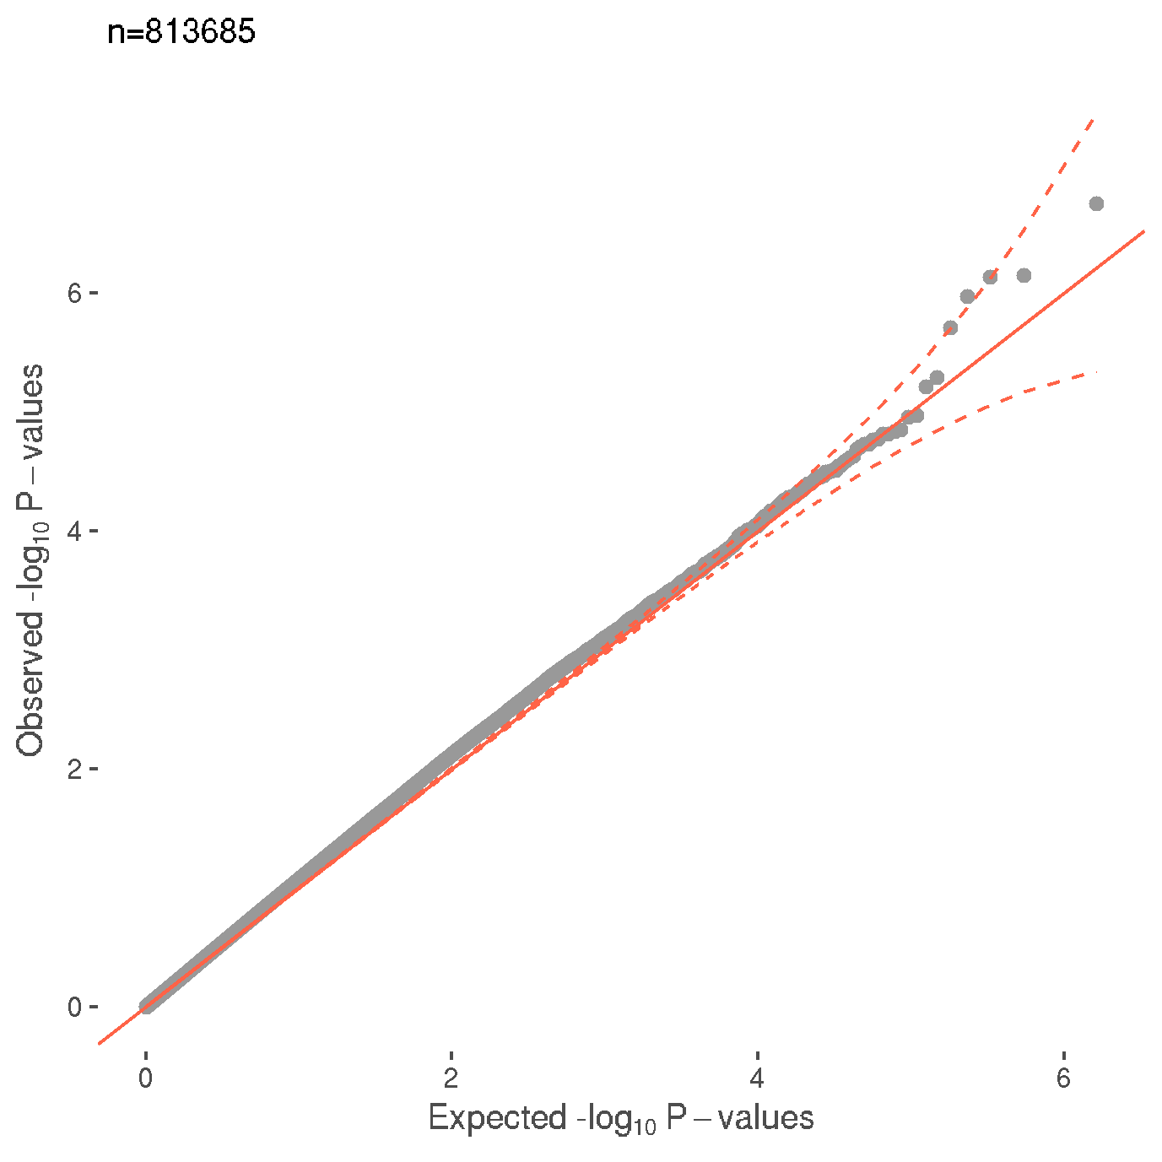b)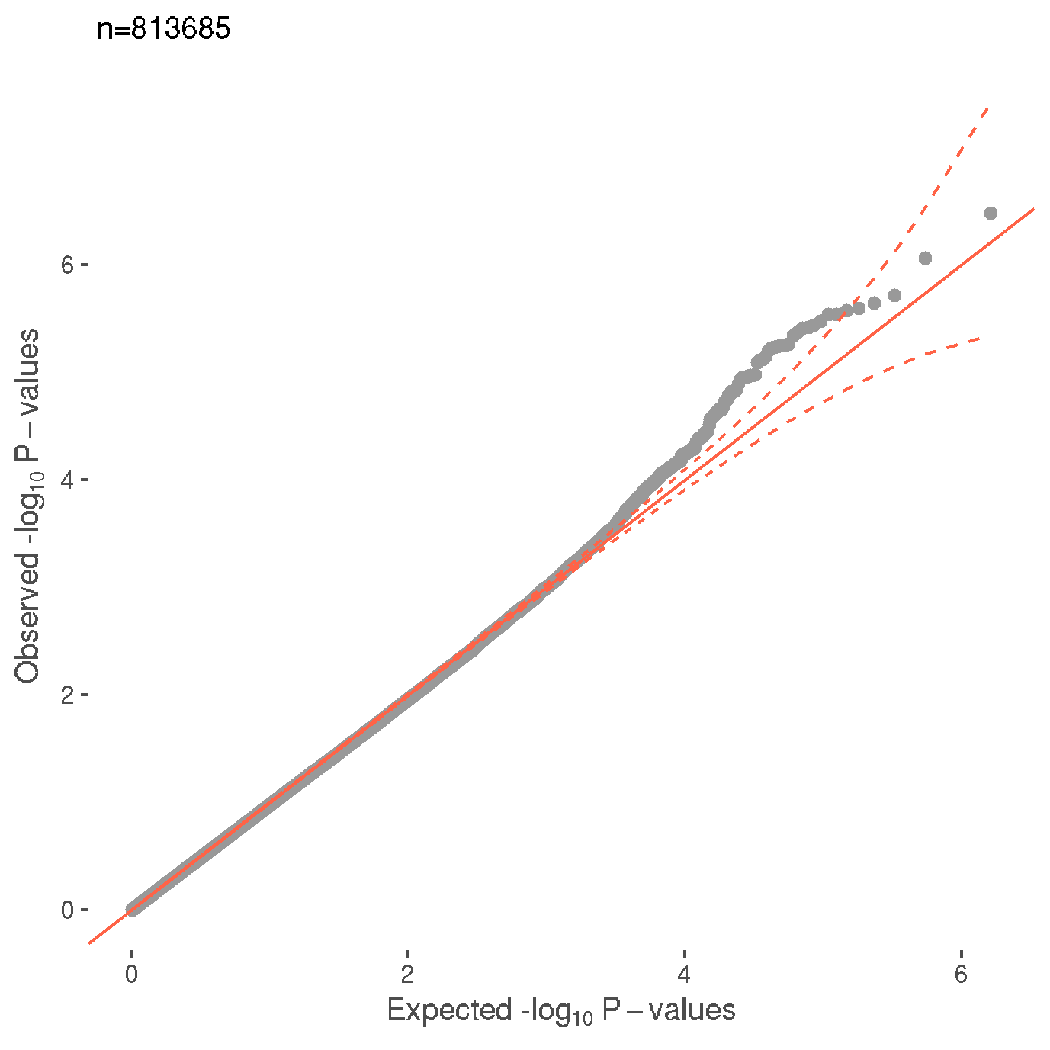

c)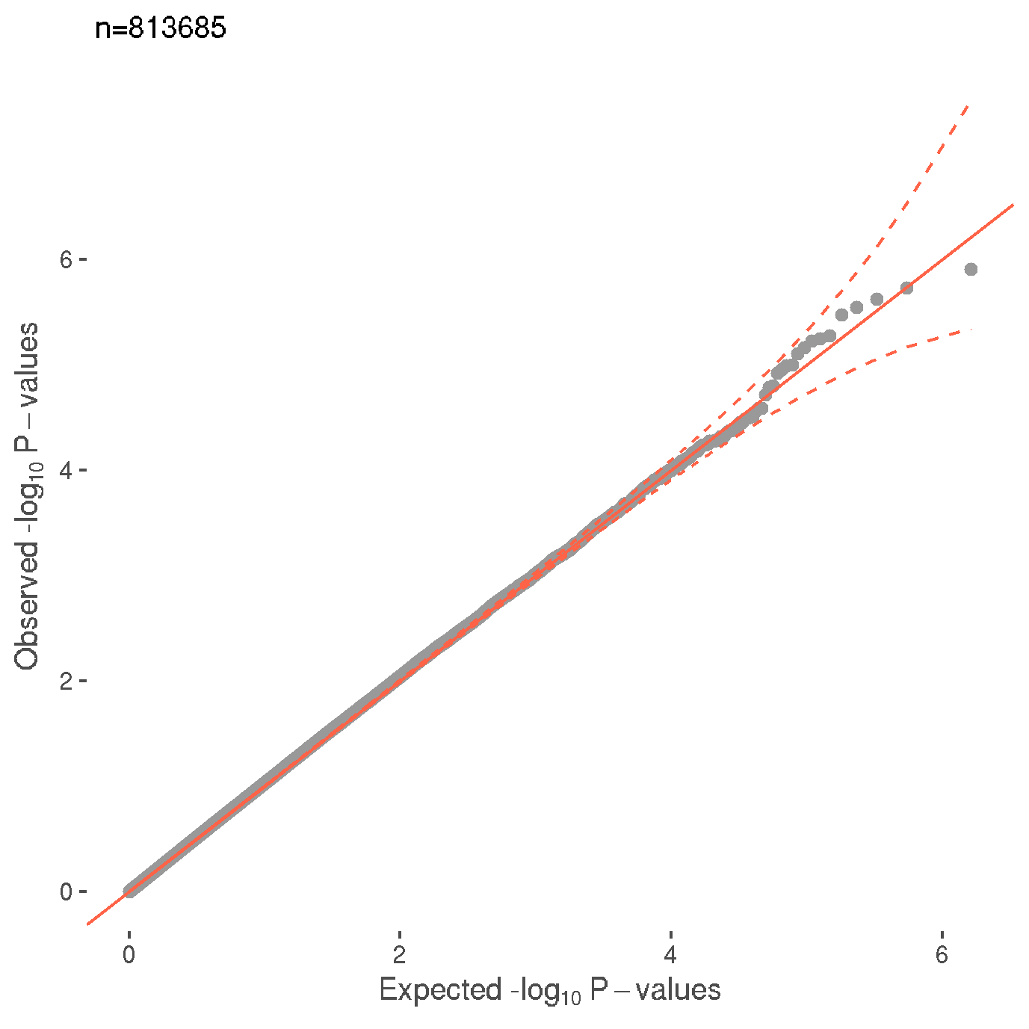d)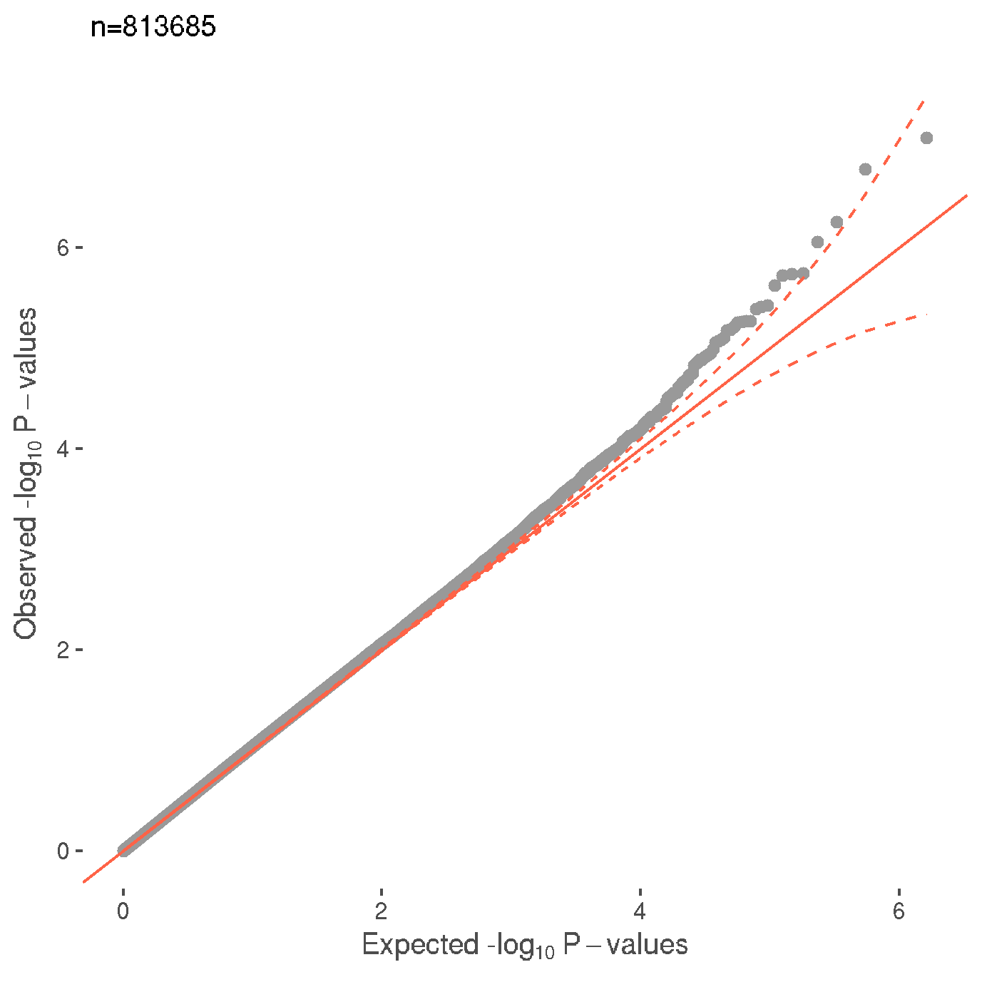

e)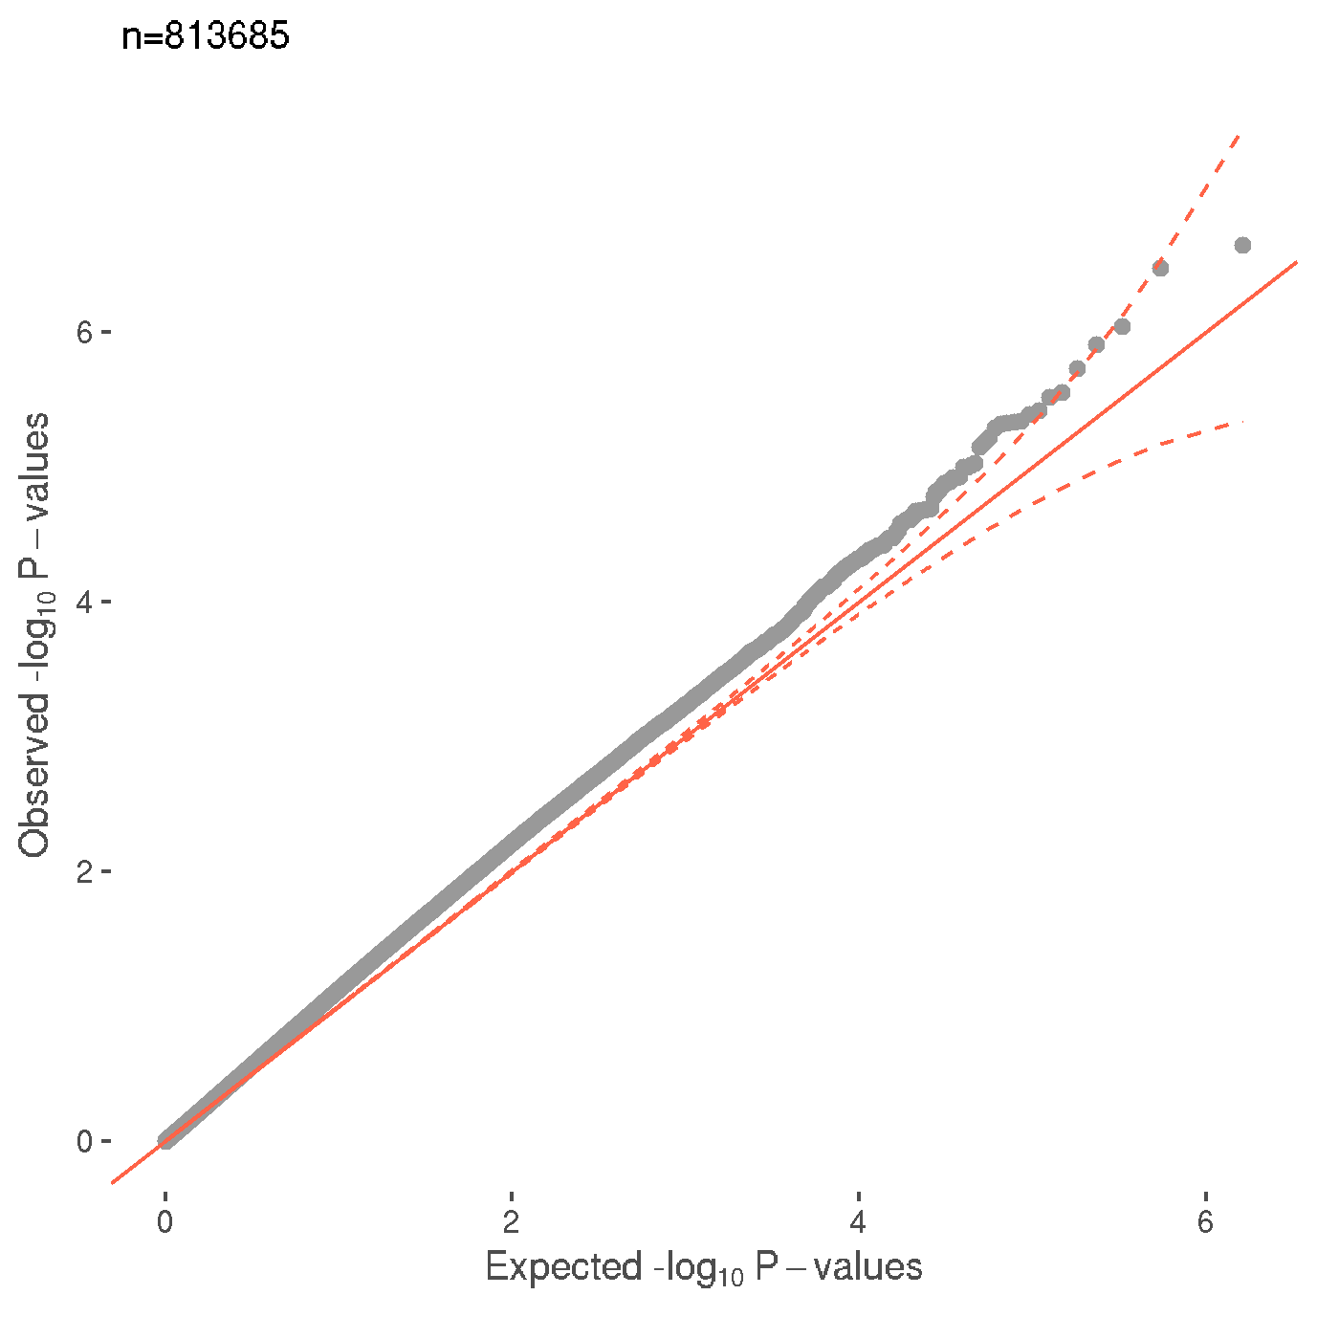f)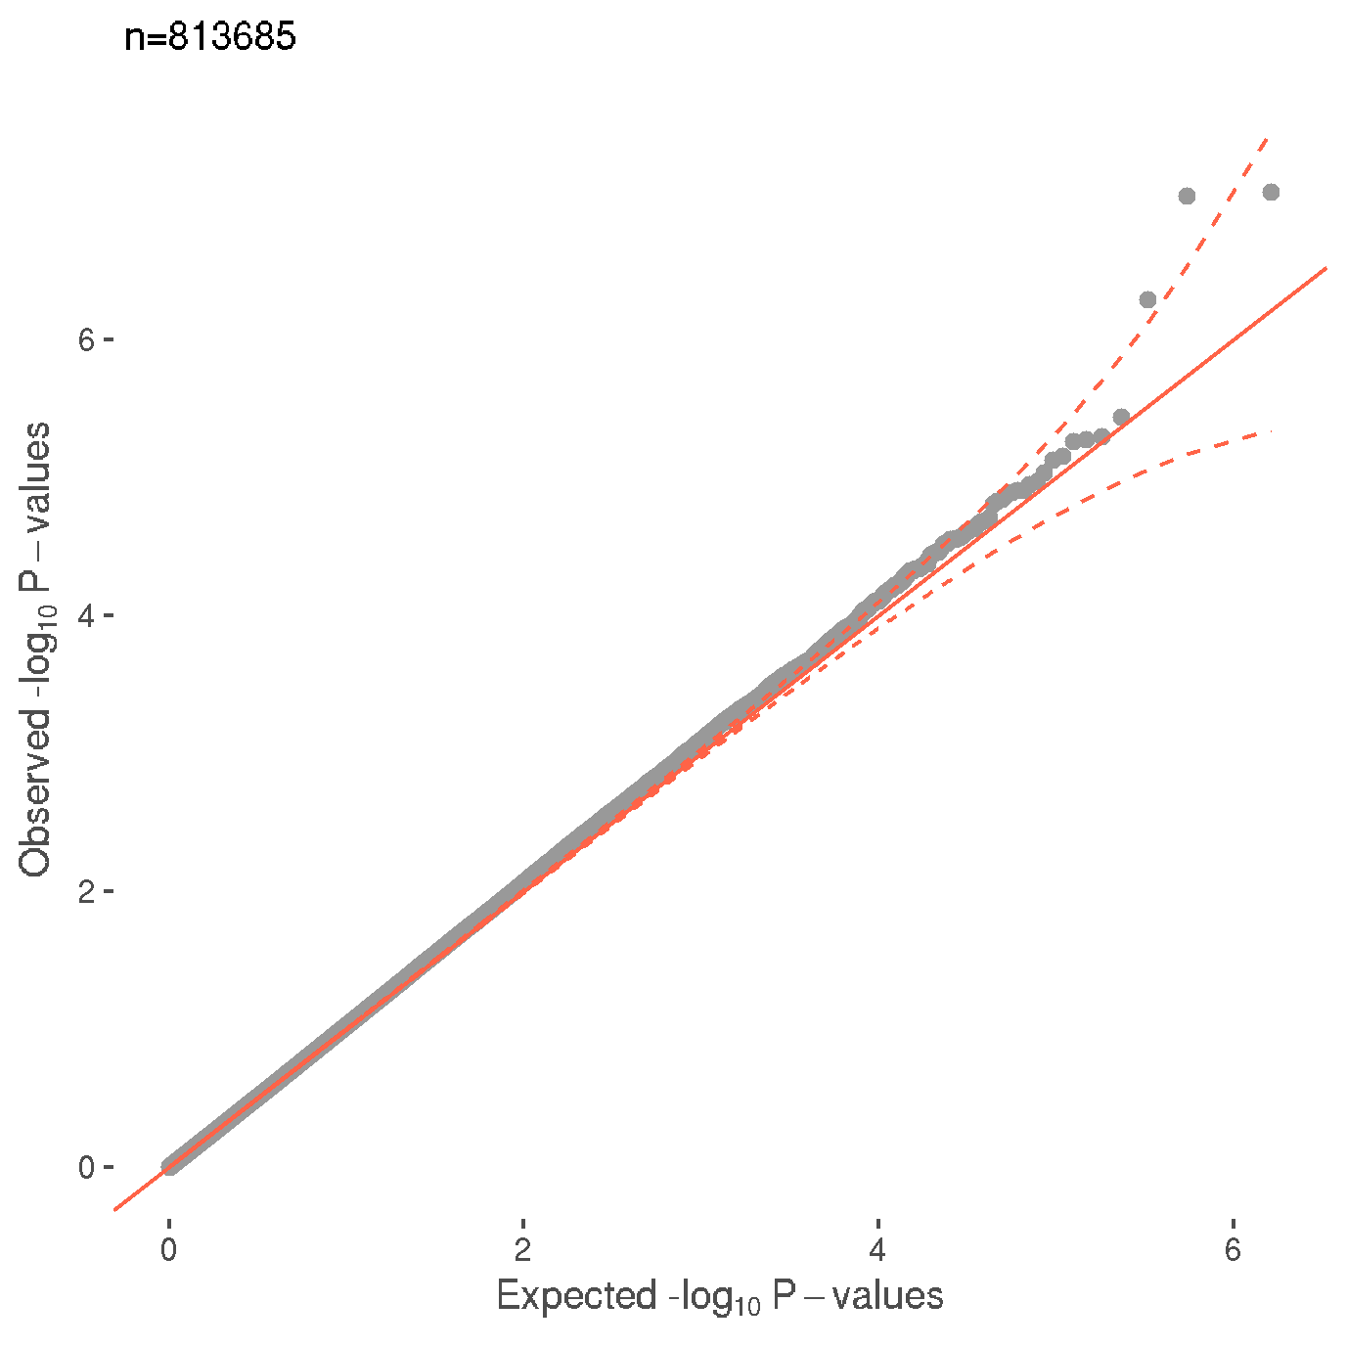
g)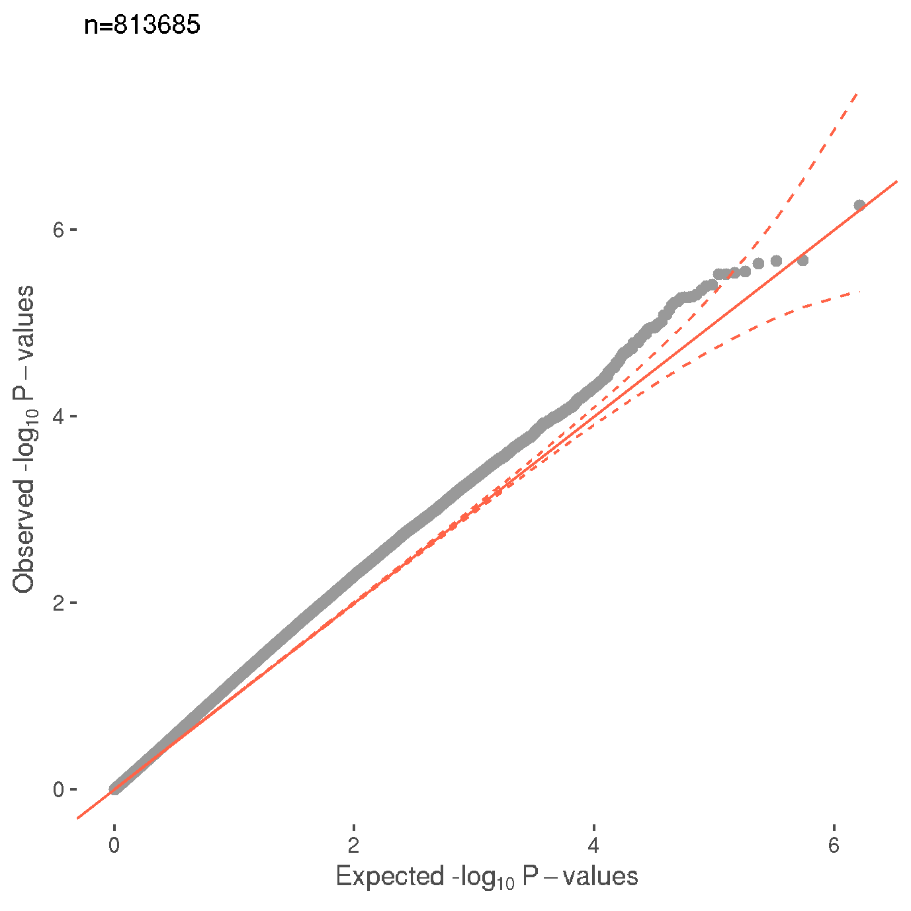h)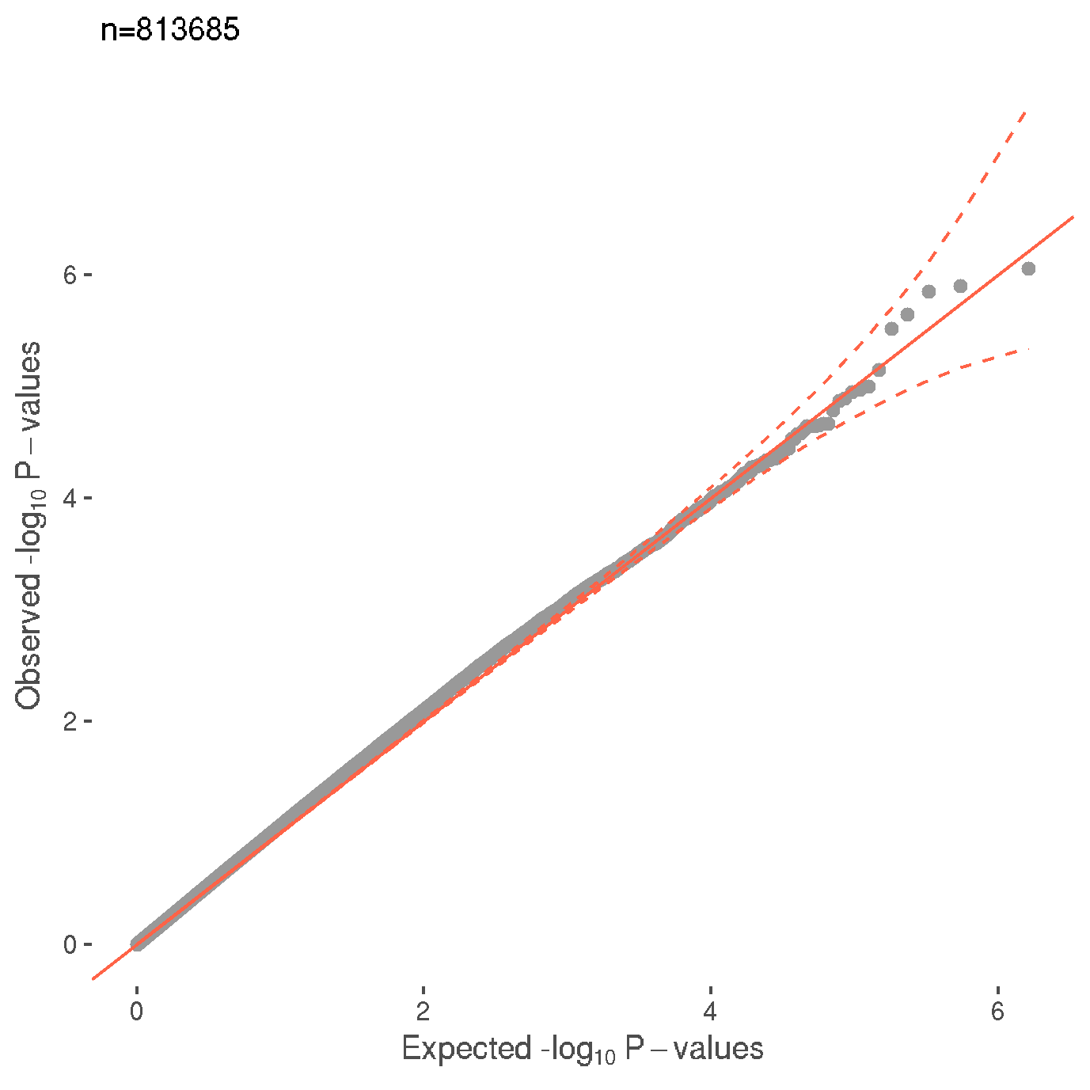
i)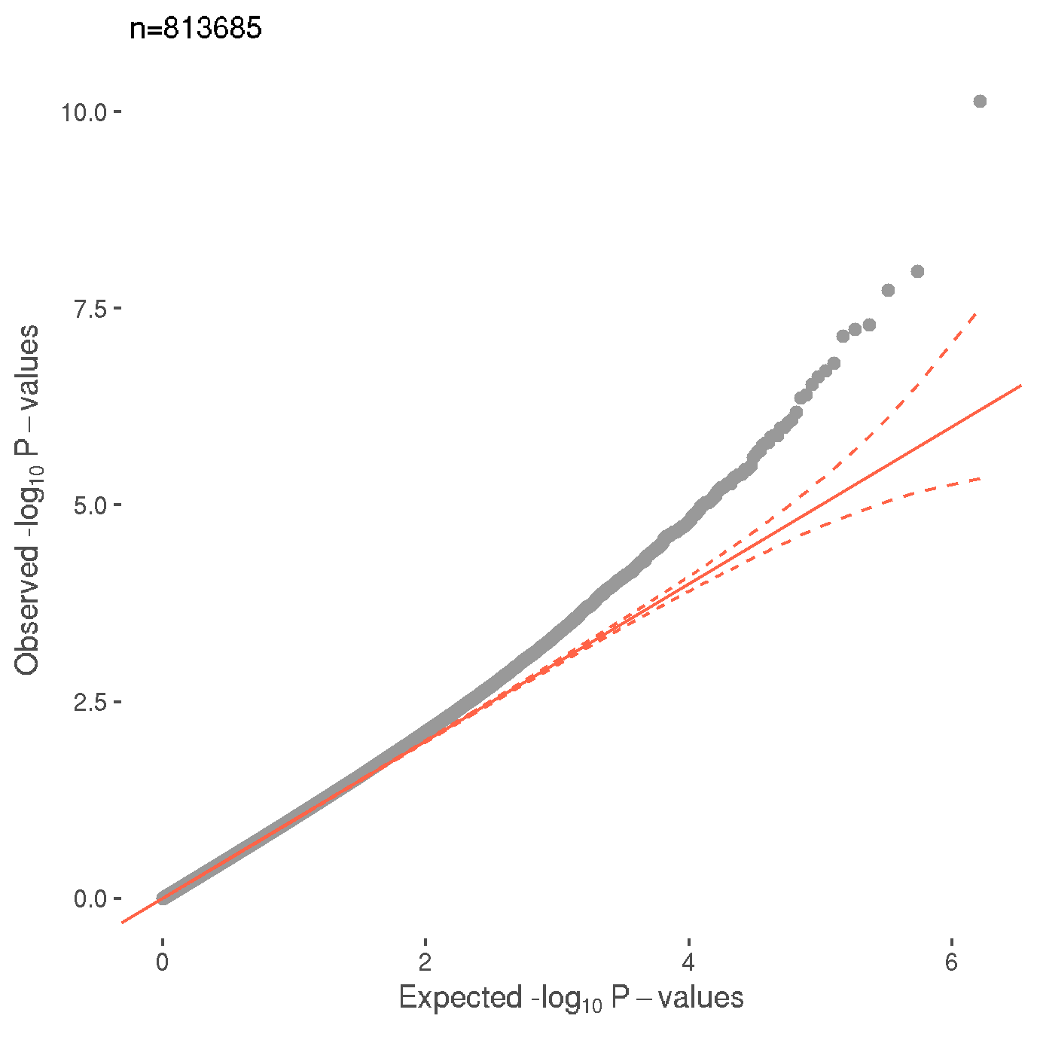j)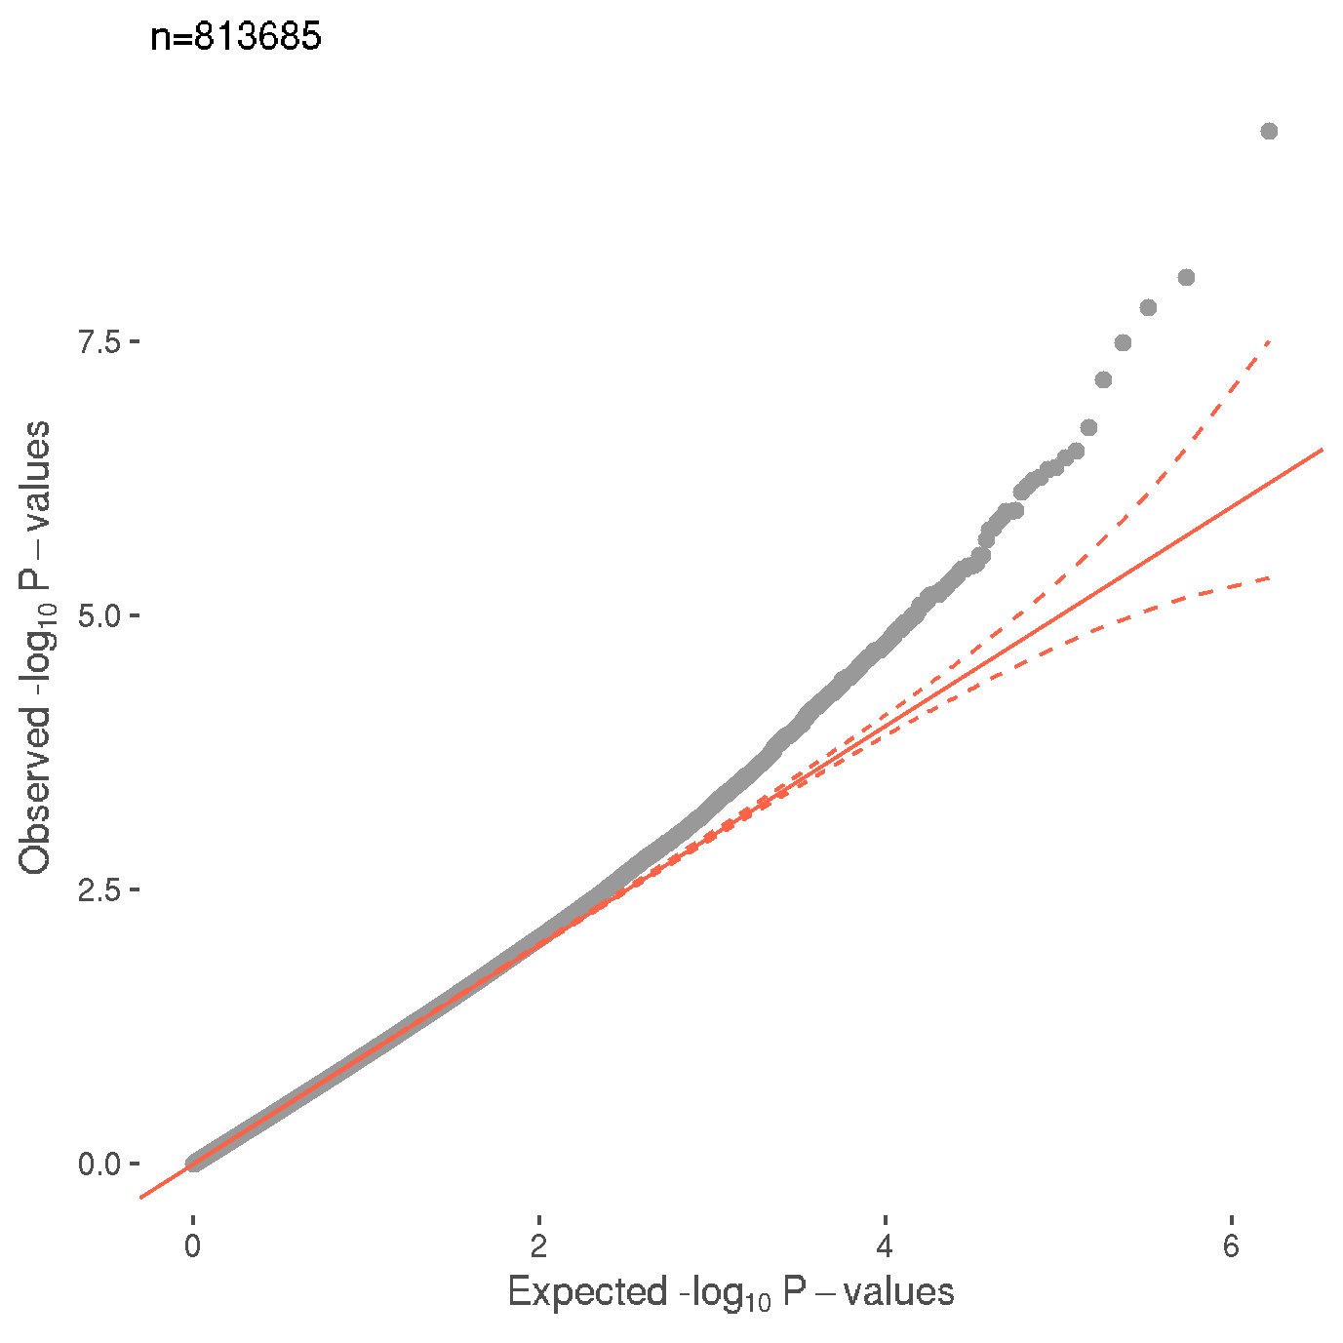
Supplementary figure 1.
Quantile-quantile plot (QQ-plot) displaying the observed and expected Benjamini-Hochberg adjusted –log₁₀ p-values for all group comparisons.
a) Healthy control versus Prenatal depressive symptoms
b) History and prenatal depressive symptoms versus Prenatal depressive symptoms only
c) History and prenatal depressive symptoms versus Healthy control
d) Prenatal depressive symptoms only versus Healthy control
e) Anxiety and prenatal depressive symptoms versus Prenatal depressive symptoms only
f) Anxiety and prenatal depressive symptoms versus Healthy control
g) Prenatal depressive symptoms only versus Healthy control
h) Healthy control versus Prenatal depressive symptoms without SSRI
i) Healthy control versus Prenatal depressive symptoms with SSRI
j) Prenatal depressive symptoms without SSRI versus Prenatal depressive symptoms with SSRI

