Combined prenatal Lactobacillus reuteri and ω-3 supplementation synergistically modulates DNA methylation in neonatal T helper cells
Johanna Huoman PhD¹, David Martínez-Enguita MSc², Elin Olsson MSc², Jan Ernerudh MD PhD³, Lennart Nilsson MD PhD⁴, Karel Duchén MD PhD⁴, Mika Gustafsson PhD^{2*} and Maria C Jenmalm PhD^{1*}
¹ Division of Inflammation and Infection, Department of Biomedical and Clinical Sciences, Linköping University, Linköping, Sweden
² Department of Physics, Chemistry and Biology, Linköping University, Linköping, Sweden
³ Department of Clinical Immunology and Transfusion Medicine, Department of Biomedical and Clinical Sciences, Linköping University, Linköping, Sweden
⁴ Allergy Center, Department of Biomedical and Clinical Sciences, Linköping University, Linköping, Sweden

*shared senior authorship

SUPPLEMENTARY APPENDIX
Including Figures S1-S12 and Tables S3, S6-S11. Tables S1-S2, S4-S5 are supplied in separate files.

RESULTS – SUPPLEMENTARY FIGURES AND TABLES
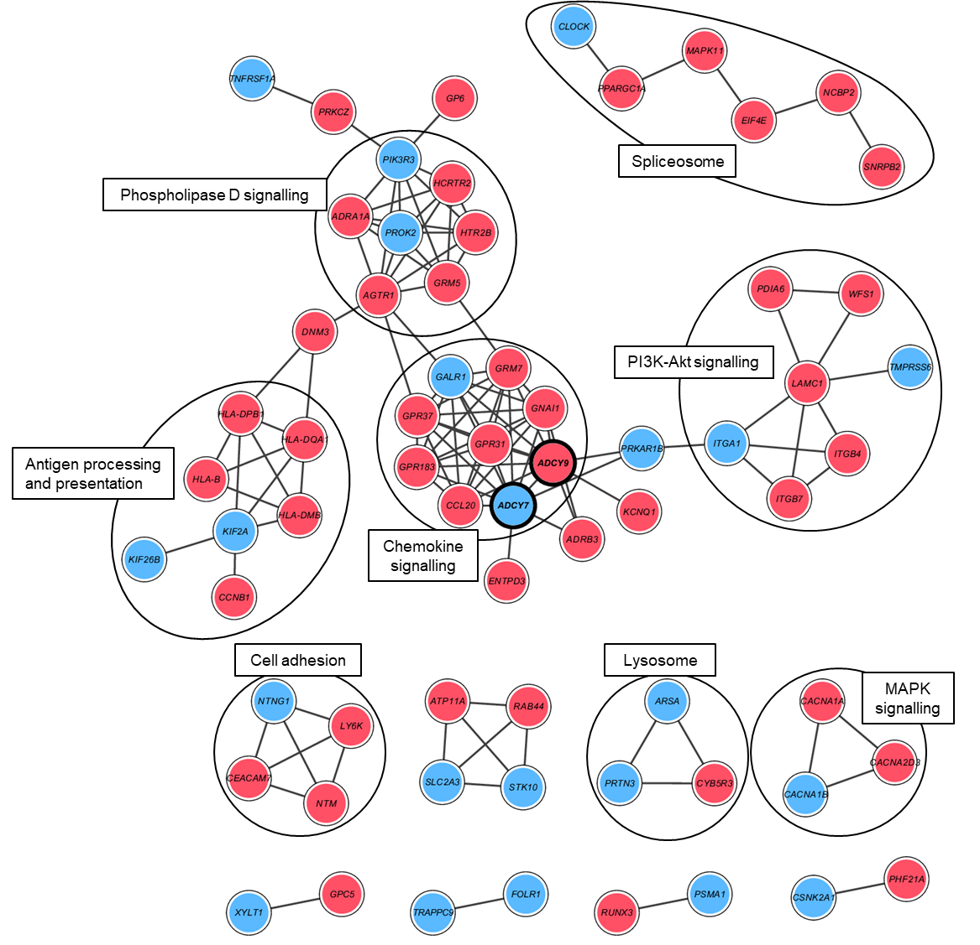
Figure S1.
LP vs. PP
Figure S1. Visualisation of the consensus module created with the DMGs from the differential methylation comparison between the single treated L.reuteri/placebo (LP) and the double placebo (PP) group. Nodes represent genes and connecting lines represent protein-protein interactions (STRING combined score > 0.7) within the network. Red nodes illustrate hypermethylated genes, whereas blue nodes indicate hypomethylated genes. Black lines enclose biologically relevant clusters identified by bioinformatic pathway enrichment analyses. DMGs – differentially methylated genes, L – Lactobacillus reuteri, P – placebo.
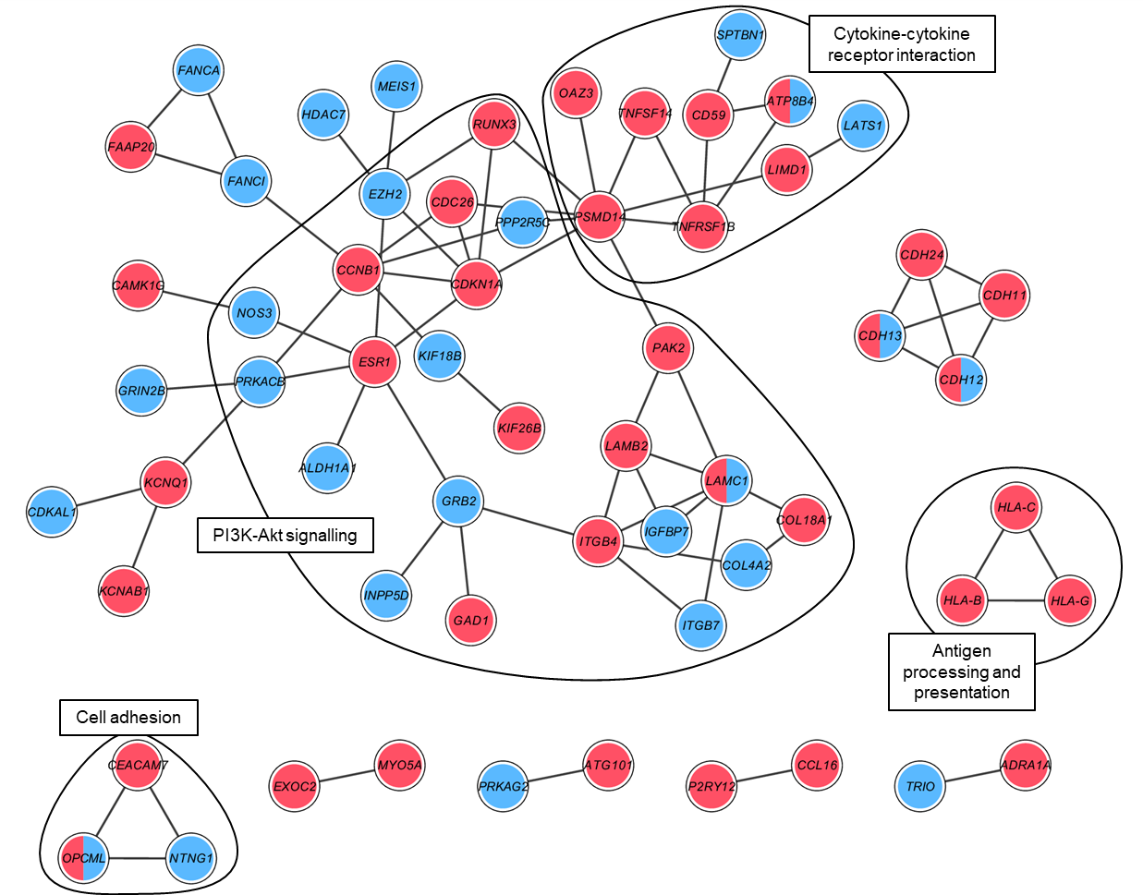
Figure S2.
Pω vs. PP

Figure S2. Visualisation of the consensus module created with the DMGs from the differential methylation comparison between the single treated placebo/ω-3 (Pω) and the double placebo (PP) group. Nodes represent genes and connecting lines represent protein-protein interactions (STRING combined score > 0.7) within the network. Red nodes illustrate hypermethylated genes, blue nodes indicate hypomethylated genes and both colours denote mixed methylation patterns. Black lines enclose biologically relevant clusters identified by bioinformatic pathway enrichment analyses. DMGs – differentially methylated genes, ω – ω-3 fatty acids, P – placebo.

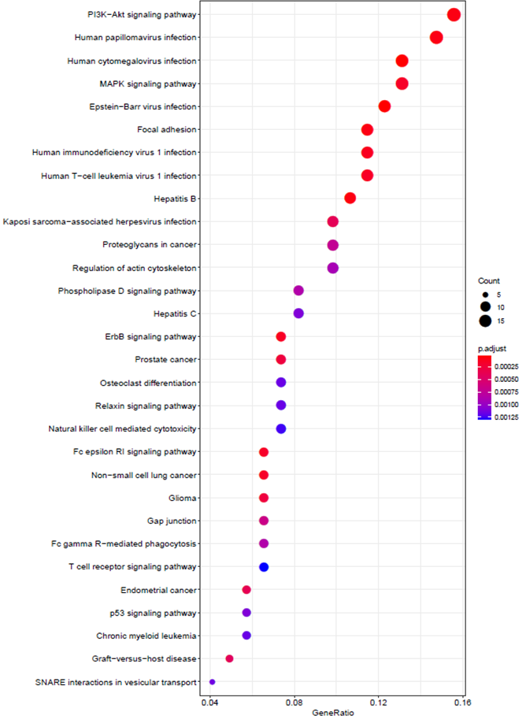
Figure S3.
Lω vs. PP
Figure S3. A dot plot illustrating the enriched pathways obtained by including all module genes from the comparison between the double treated L.reuteri/ω-3 (Lω) and the double placebo (PP) group. The x-axis represents the gene ratio, the dot size corresponds to the gene count, and the red-purple gradient dot colour represents adjusted enrichment P-values for the top 30 corresponding pathways designated on the left-hand side of the graph. L – Lactobacillus reuteri, ω – ω-3 fatty acids, P – placebo.

Figure S4
LP vs. PP
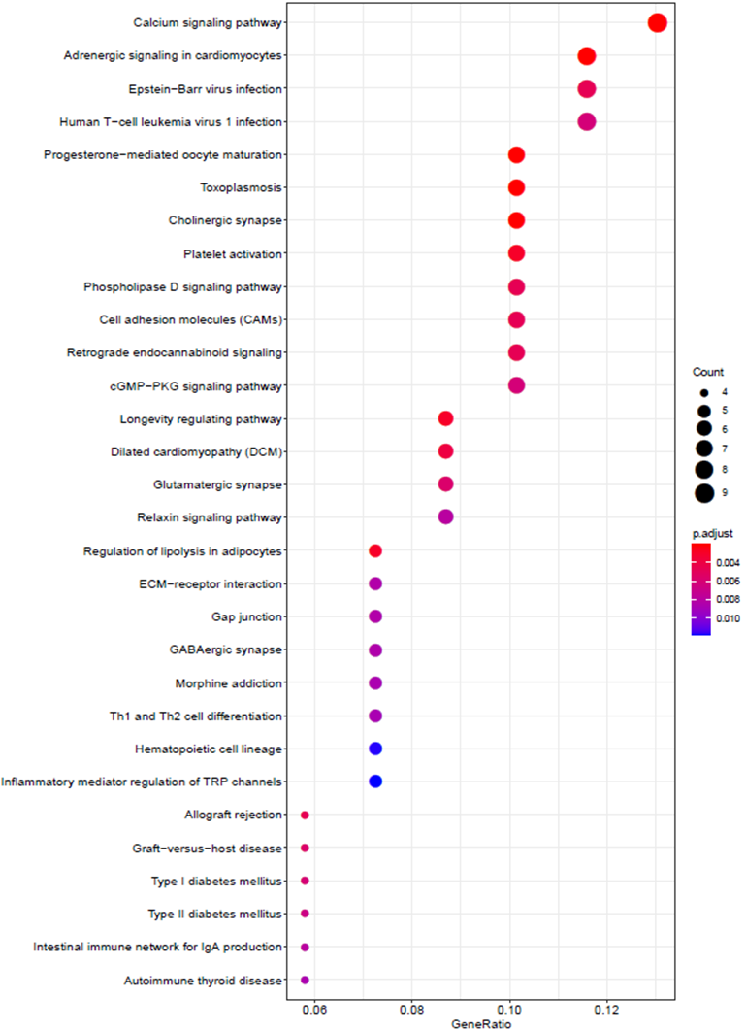
Figure S4. A dot plot illustrating the enriched pathways obtained by including all module genes from the comparison between the single treated L.reuteri/placebo (LP) and the double placebo (PP) group. The x-axis represents the gene ratio, the dot size corresponds to the gene count, and the red-purple gradient dot colour represents adjusted enrichment P-values for the top 30 corresponding pathways designated on the left-hand side of the graph. L – Lactobacillus reuteri, ω – ω-3 fatty acids, P – placebo.

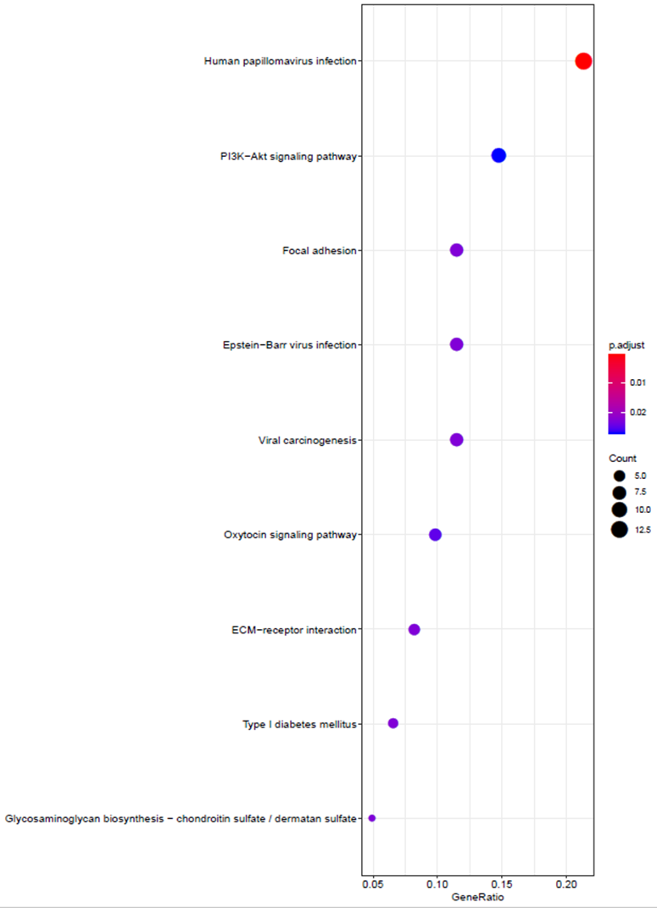
Figure S5.
Pω vs. PP
Figure S5. A dot plot illustrating the enriched pathways obtained by including all module genes from the comparison between the single treated placebo/ω-3 (Pω) and the double placebo (PP) group. The x-axis represents the gene ratio, the dot size corresponds to the gene count, and the red-purple gradient dot colour represents adjusted enrichment P-values for the corresponding pathways designated on the left-hand side of the graph. L – Lactobacillus reuteri, ω – ω-3 fatty acids, P – placebo.
Figure S6.
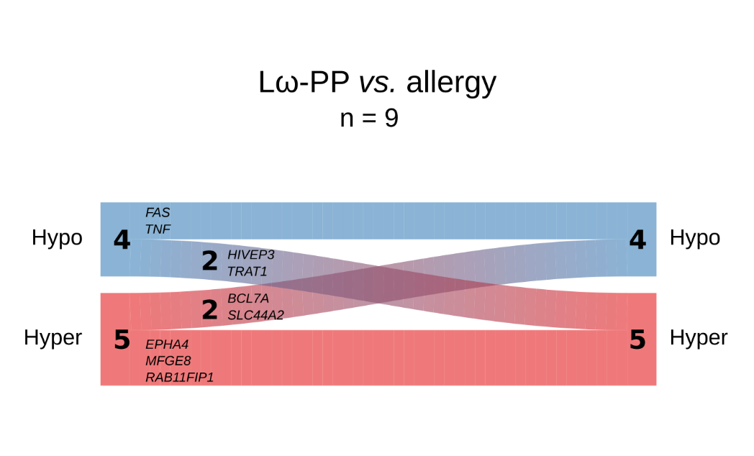

Figure S6. River plot illustrating the methylation status for overlapping genes being shared between the double-treated Lω group and the independent allergy data set. Genes are represented as flows of size proportional to number of genes within their methylation status in a particular set, and differences between sets are shown as connections between flows. The respective gene names are denoted next to each flow. Red represents hypermethylation and blue hypomethylation. The number of genes in the respective flows are denoted in the graph. L – Lactobacillus reuteri, ω – ω-3 fatty acids, P – placebo
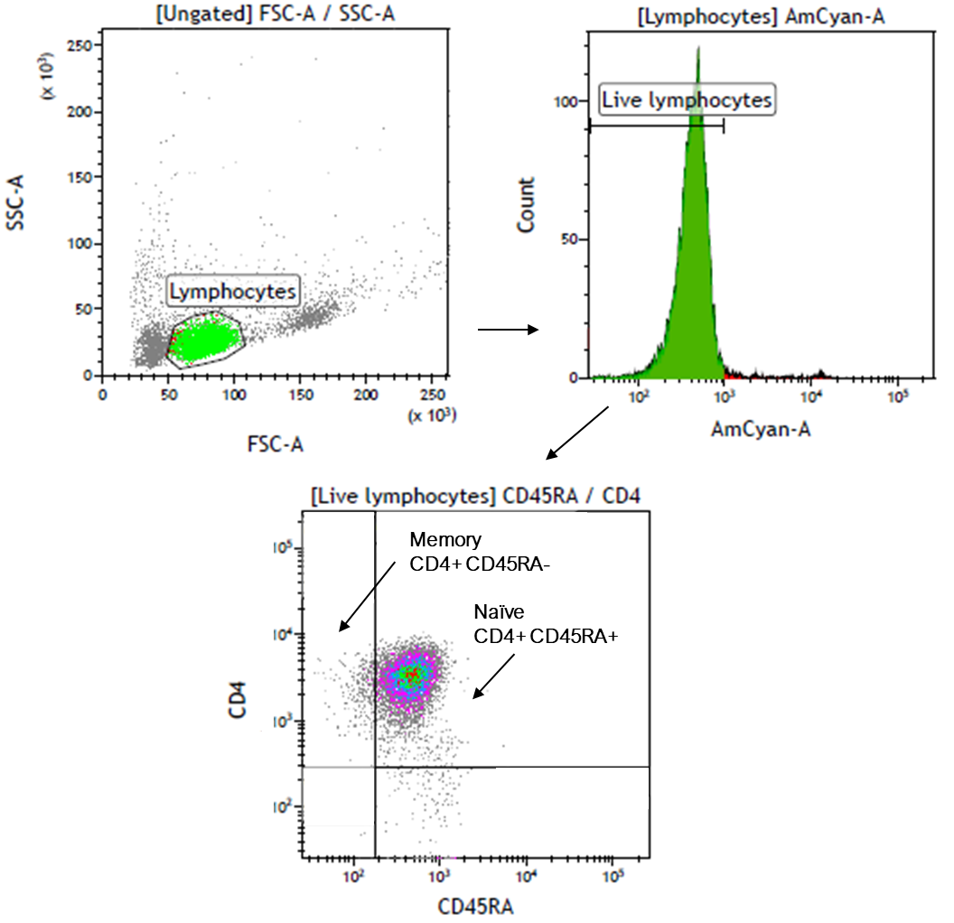
Figure S7.

Figure S7. Gating strategy for analysis of CD45RA+/- expression in CD4+ cells from cord blood mononuclear cells. Lymphocytes were defined using the FSC and SSC features. Thereafter, live cells within the lymphocyte population were determined using Aqua LIVE/DEAD (AmCyan-A) staining, and further gated to distinguish naïve (CD4+/CD45RA+) from memory (CD4+CD45RA-) cells. FSC – forward scatter, SSC – side scatter.
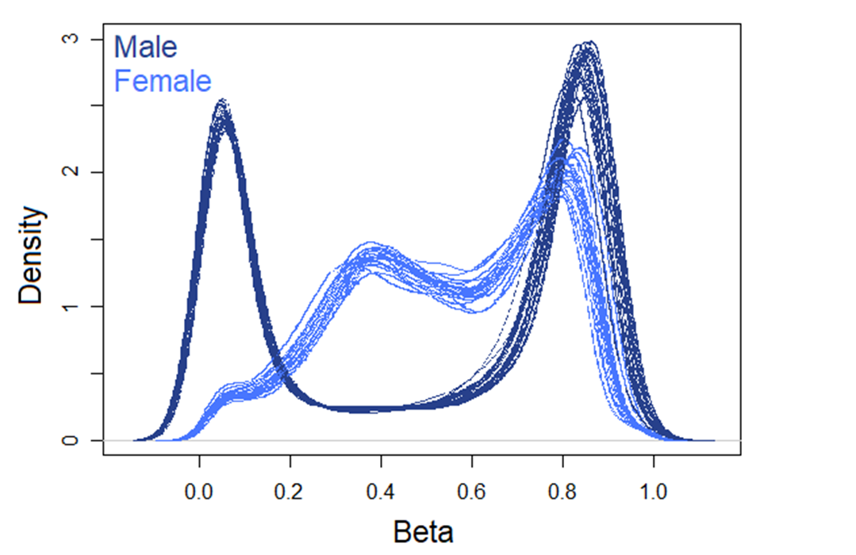
Figure S8.
Figure S8. Graphical representation of the density of the beta value distribution on the X chromosomes of males and females in raw DNA methylation data. Male samples are illustrated in dark blue, females in light blue.

Figure S9.
b
a
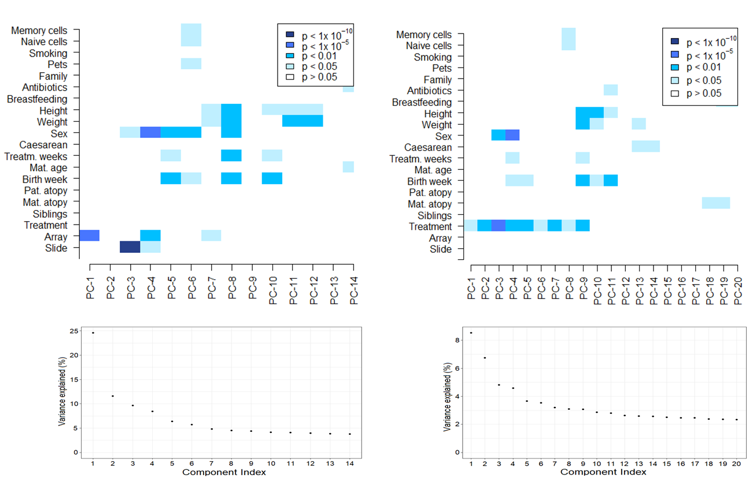
Figure S9. Graphical representations of Singular value decomposition (SVD) analyses for identification of major components of variation using the ChAMP package. Analyses on the filtered and BMIQ normalised data are displayed in panel a, and panel b shows the data upon correction for technical variables (array and slide). The lower panels present the % variance explained by each of the illustrated components in the SVD analyses. BMIQ – Beta Mixture Quantile.
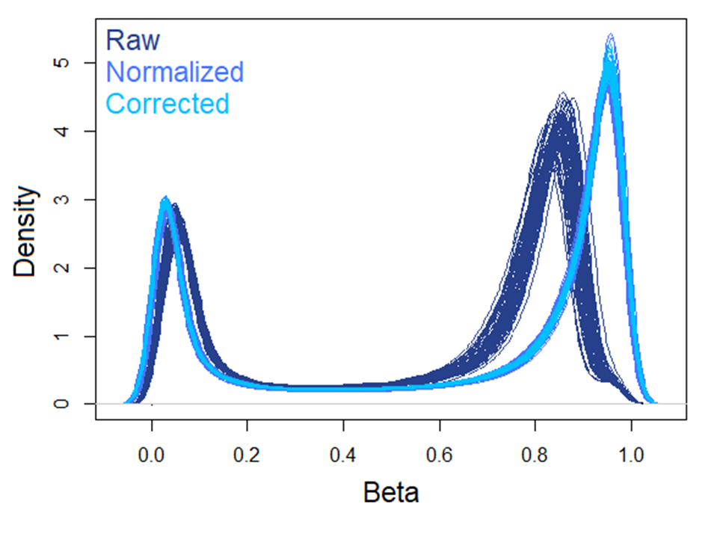
Figure S10.
Figure S10. Graphical representation of the density of the beta value distribution on the autosomal chromosomes prior to and after normalisation and correction. Raw DNA methylation data are depicted in dark blue, BMIQ-normalised data in light blue and batch corrected data (using the ChAMP package in both cases) are illustrated in coral blue.

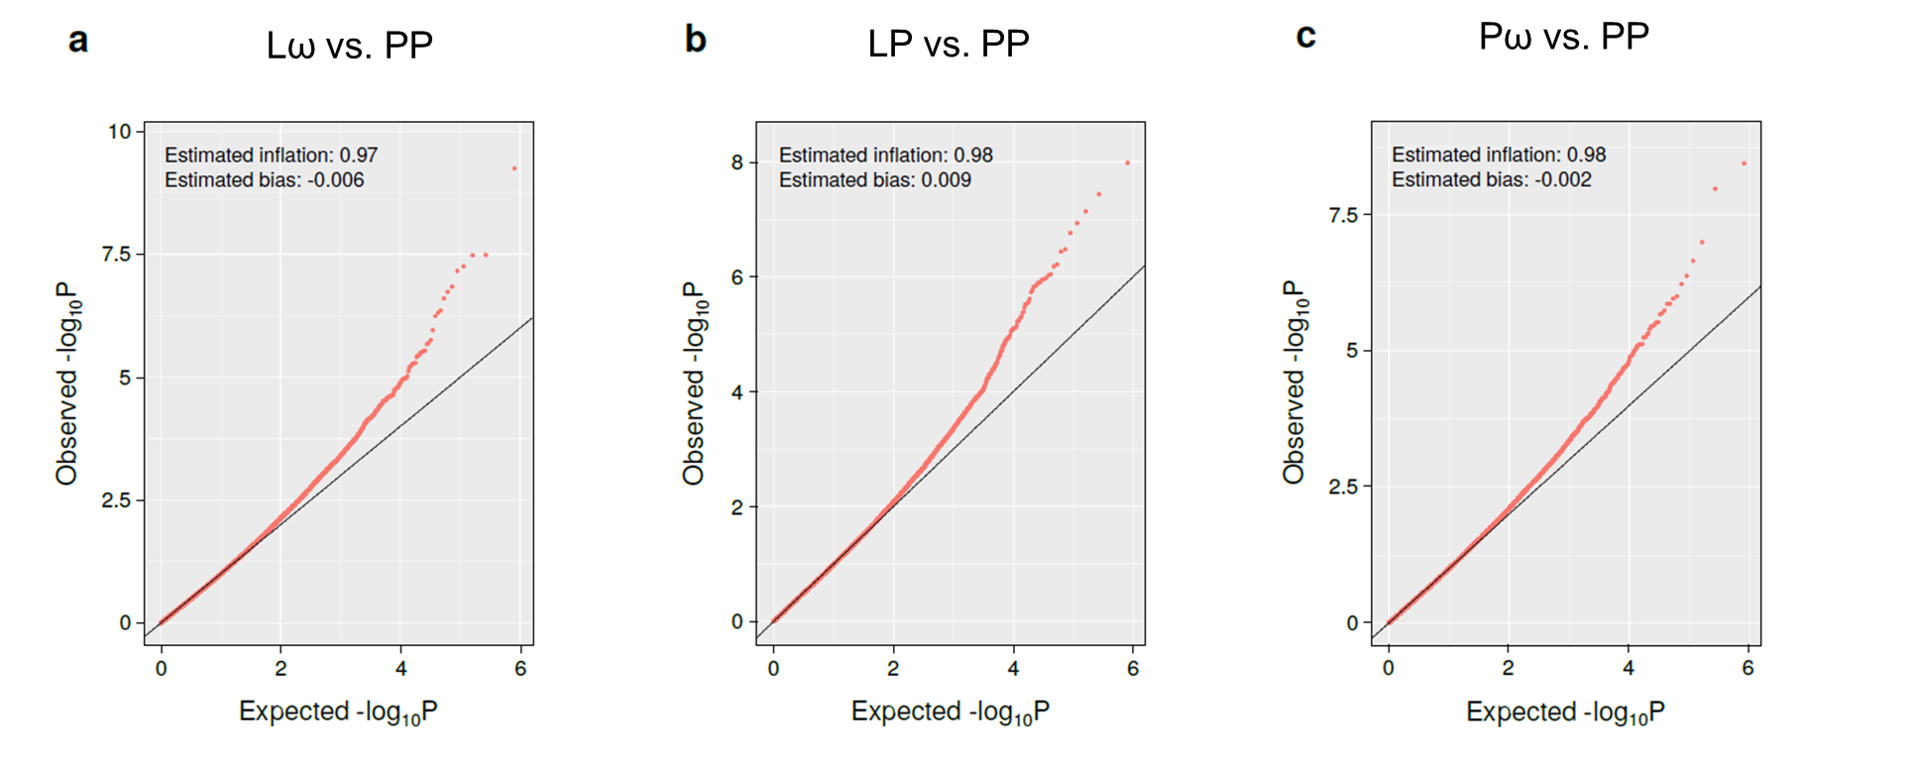
Figure S11

Figure S11. Plots illustrating the observed vs. expected –log10 of the obtained p-values from each of the three differential DNA methylation comparisons, with accompanying estimated values of genomic inflation and bias. Calculations were performed using the R package BACON. L – Lactobacillus reuteri, ω – ω-3 fatty acids, P – placebo.

Figure S12.
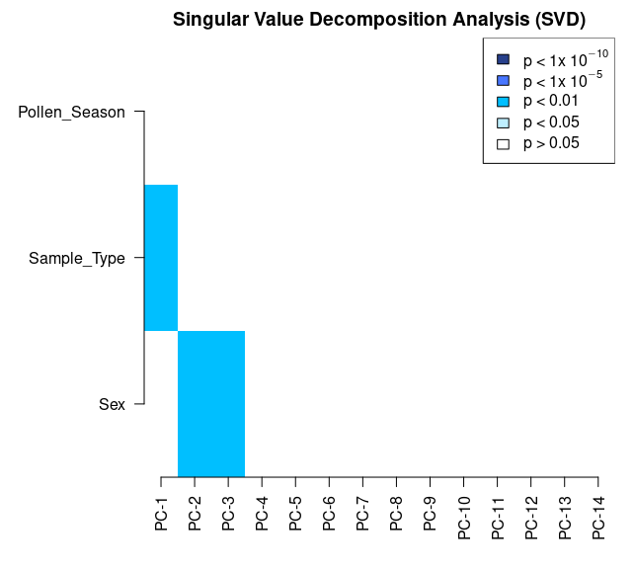
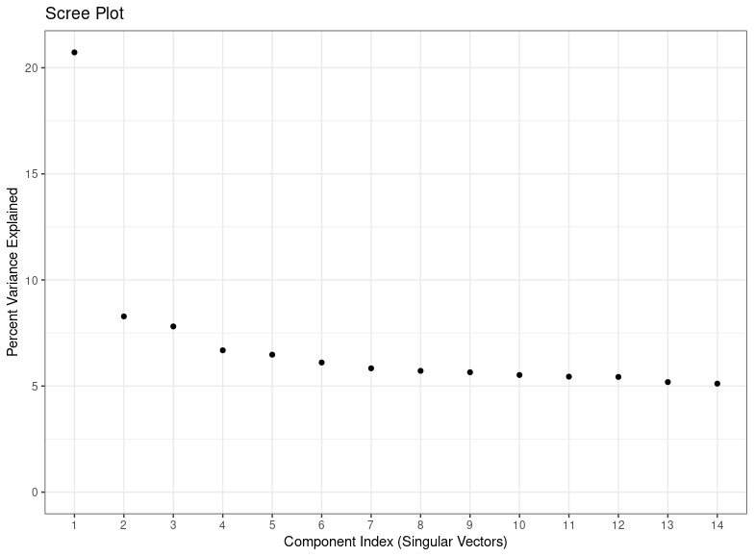

Figure S12. Graphical representation of Singular value decomposition (SVD) analyses for identification of major components of variation using the ChAMP package in the independent allergy data set. Analyses on the pre-processed, filtered and BMIQ normalised data are displayed in panel A, showing the major components of variation in the data. Panel B shows the Scree plot illustrating corresponding percent variance explained for each principal component. BMIQ – Beta Mixture Quantile.

Table S1. Table of extracted differentially methylated CpGs (DMCs) with corresponding mean methylation difference (MMD) from the three treatment comparisons (Lω, LP and Pω vs. PP, respectively). DMCs were defined as having a MMD of > ±5% along with an FDR-corrected p-value of <0.1. L – Lactobacillus reuteri, ω – ω-3 fatty acids, P – placebo. Supplied in a separate file.
Table S2. Table of differentially methylated genes (DMGs) with corresponding direction of methylation from the three treatment comparisons (Lω, LP and Pω). DMGs were defined as genes with at least one DMC, and the direction of methylation depended on the direction of methylation for all DMCs in the gene. Hypomethylation is defined as > -5% mean methylation difference (MMD), hypermethylation as > +5% MMD and mixed methylation genes contained DMCs of both directions. L – Lactobacillus reuteri, ω – ω-3 fatty acids, P – placebo. Supplied in a separate file.
Table S4. Table of pathways obtained from pathway enrichment analyses on DMCs from the Lω vs. PP comparison. Analyses were conducted using clusterProfiler R package and the KEGG PATHWAY database. Pathways with an adjusted p-value of 0.1 or lower were considered significantly relevant.
Table S5. Table of pathways obtained from pathway enrichment analyses on DMCs from the LP vs. PP comparison. Analyses were conducted using clusterProfiler R package and the KEGG PATHWAY database. Pathways with an adjusted p-value of 0.1 or lower were considered significantly relevant.

Table S3. Table of differentially methylated genes that were shared between the three treatment groups (Lω, LP and Pω). L – Lactobacillus reuteri, ω – ω-3 fatty acids, P – placebo.
Shared differentially
methylated genes
(n=72)
FCRLB | SLC45A4
PTPRN2 | NBL1
RPS6KA2 | ZFR
RFPL2 | HIVEP2
SYT17 | NAV2
UNC45A | CSGALNACT1
ZSCAN12P1 | KDM5B
PHF21A | B3GNT1
KIF26B | KCNG2
C1QL3 | SCGB1A1
C17orf54 | ZNF253
KRTAP12-3 | MYOF
MAGI2 | CEACAM7
CRISPLD2 | CCDC162P
ZSCAN12L1 | GRIK4
WNK4 | MCTP1
SLC1A7 | SYNPO2
NTNG1 | OTX2-AS1
AGPAT3 | IQGAP1
SLC35F3 | REM2
PKNOX2 | SORCS2
MICAL3 | ITGB7
LGR6 | RFTN1
OLFM1 | DEFB115
C6orf123 | ABI1
MIR548N | DGKG
CDH13 | RUNX3
MX2 | PLA2G4C
ZNF710 | LOC101929241
LAMC1 | CDC42BPA
FAM38A | NPHP1
CRTAC1 | SORCS1
MIB2 | MRGPRF
S100P | CRX
CD164 | HLA-B
C10orf93 | GP6

Table S6. A table of module genes from the Lω comparison, displaying Entrez-ID, direction of methylation (hypo-, hyper- or mixed methylation), the number of connecting genes within network module and absolute mean methylation difference. L – Lactobacillus reuteri, MMD – mean methylation difference, ω – ω-3 fatty acids, P – placebo.
Module genes from the Lω comparison
Gene symbol | Entrez | Direction of  methylation | Degree of  connectivity | Absolute MMD
FYN | 2534 | Hyper | 16 | 0,071
GNB5 | 10681 | Hyper | 14 | 0,082
SNAP23 | 8773 | Hyper | 13 | 0,055
LAMC1 | 3915 | Hyper | 12 | 0,095
IL6 | 3569 | Hypo | 10 | 0,051
RAF1 | 5894 | Hyper | 10 | 0,055
ADCY9 | 115 | Mixed | 9 | 0,074
CUL1 | 8454 | Hyper | 9 | 0,056
TNF | 7124 | Hypo | 9 | 0,053
AP1M1 | 8907 | Hyper | 8 | 0,063
CREB1 | 1385 | Hypo | 8 | 0,052
GRB2 | 2885 | Hyper | 8 | 0,059
HMOX2 | 3163 | Hyper | 8 | 0,059
LPAR1 | 1902 | Hyper | 8 | 0,074
PAK1 | 5058 | Hyper | 8 | 0,053
PRKACB | 5567 | Hypo | 8 | 0,055
SEC22B | 9554 | Hypo | 8 | 0,058
CD47 | 961 | Hypo | 7 | 0,068
CDC23 | 8697 | Hypo | 7 | 0,060
ITGB5 | 3693 | Hyper | 7 | 0,079
KCNAB2 | 8514 | Hyper | 7 | 0,090
MAP2K7 | 5609 | Hyper | 7 | 0,057
PAK2 | 5062 | Hyper | 7 | 0,060
PRTN3 | 5657 | Hypo | 7 | 0,176
SDCBP | 6386 | Hypo | 7 | 0,052
SLC2A3 | 6515 | Hypo | 7 | 0,069
SLC44A2 | 57153 | Hyper | 7 | 0,051
STK10 | 6793 | Hypo | 7 | 0,086
ADA2 | 51816 | Hypo | 6 | 0,062
AKT3 | 10000 | Hyper | 6 | 0,051
CDKN1A | 1026 | Hyper | 6 | 0,095
CPPED1 | 55313 | Hyper | 6 | 0,052
CYB5R3 | 1727 | Hyper | 6 | 0,061
HTR2B | 3357 | Hyper | 6 | 0,054
IST1 | 9798 | Hyper | 6 | 0,052
MAN2B1 | 4125 | Hypo | 6 | 0,063
MFGE8 | 4240 | Hyper | 6 | 0,104
PRKCA | 5578 | Hyper | 6 | 0,066
SYK | 6850 | Hyper | 6 | 0,055
ADRB3 | 155 | Hyper | 5 | 0,089
ATM | 472 | Hypo | 5 | 0,057
CALCR | 799 | Hypo | 5 | 0,053
EPHB3 | 2049 | Hyper | 5 | 0,062
FAM20C | 56975 | Hyper | 5 | 0,069
FAS | 355 | Hypo | 5 | 0,059
FSHR | 2492 | Hyper | 5 | 0,051
GPR27 | 2850 | Hyper | 5 | 0,138
ITGA8 | 8516 | Hypo | 5 | 0,062
ITGB7 | 3695 | Hypo | 5 | 0,051
LTB4R2 | 56413 | Hyper | 5 | 0,072
NPFFR2 | 10886 | Hypo | 5 | 0,053
PDIA6 | 10130 | Hyper | 5 | 0,079
PROK2 | 60675 | Hyper | 5 | 0,108
RCHY1 | 25898 | Hyper | 5 | 0,058
RING1 | 6015 | Hyper | 5 | 0,053
UBE2I | 7329 | Hyper | 5 | 0,061
WFS1 | 7466 | Hyper | 5 | 0,052
AGRN | 375790 | Hypo | 4 | 0,059
ARFGAP3 | 26286 | Hyper | 4 | 0,052
ASB10 | 136371 | Hyper | 4 | 0,054
CCL16 | 6360 | Hyper | 4 | 0,069
CEACAM7 | 1087 | Hyper | 4 | 0,068
ERBB4 | 2066 | Hyper | 4 | 0,054
FBXL7 | 23194 | Hyper | 4 | 0,056
GPR31 | 2853 | Hyper | 4 | 0,056
HLA-DRB1 | 3123 | Hyper | 4 | 0,222
KIF16B | 55614 | Hyper | 4 | 0,076
KIF25 | 3834 | Hypo | 4 | 0,063
KIF26B | 55083 | Hyper | 4 | 0,063
MDGA1 | 266727 | Hyper | 4 | 0,109
NTNG1 | 22854 | Hypo | 4 | 0,074
OPCML | 4978 | Hypo | 4 | 0,132
PGR | 5241 | Hyper | 4 | 0,050
PSCA | 8000 | Hyper | 4 | 0,052
RB1 | 5925 | Hyper | 4 | 0,100
RUNX1 | 861 | Hypo | 4 | 0,054
TP73 | 7161 | Hyper | 4 | 0,056
ACTN4 | 81 | Hyper | 3 | 0,055
AXIN1 | 8312 | Hyper | 3 | 0,080
CASP9 | 842 | Hypo | 3 | 0,065
EED | 8726 | Hypo | 3 | 0,067
ERCC4 | 2072 | Hyper | 3 | 0,051
HLA-B | 3106 | Hyper | 3 | 0,262
ITGAE | 3682 | Hyper | 3 | 0,059
MRPS2 | 51116 | Hyper | 3 | 0,054
MUC17 | 140453 | Hyper | 3 | 0,055
RPS25 | 6230 | Hyper | 3 | 0,051
AKAP9 | 10142 | Hyper | 2 | 0,062
ATG5 | 9474 | Hypo | 2 | 0,053
BET1L | 51272 | Hyper | 2 | 0,069
CRNKL1 | 51340 | Hyper | 2 | 0,056
DAB1 | 1600 | Hyper | 2 | 0,066
DDB2 | 1643 | Hyper | 2 | 0,052
EPHA4 | 2043 | Hyper | 2 | 0,092
EPS15L1 | 58513 | Hyper | 2 | 0,076
GLI2 | 2736 | Hyper | 2 | 0,060
GP6 | 51206 | Hyper | 2 | 0,060
HLA-DOB | 3112 | Hyper | 2 | 0,058
HNRNPM | 4670 | Hyper | 2 | 0,083
HTR3A | 3359 | Hypo | 2 | 0,086
LDLRAP1 | 26119 | Hyper | 2 | 0,057
MRPL28 | 10573 | Hyper | 2 | 0,157
MRPL51 | 51258 | Hyper | 2 | 0,065
PDGFRA | 5156 | Hyper | 2 | 0,052
PHF21A | 51317 | Hyper | 2 | 0,067
RELB | 5971 | Hyper | 2 | 0,104
RHOH | 399 | Hyper | 2 | 0,110
RHOJ | 57381 | Hyper | 2 | 0,055
RHOT1 | 55288 | Hyper | 2 | 0,064
RUNX3 | 864 | Hyper | 2 | 0,163
SALL4 | 57167 | Hyper | 2 | 0,063
SGIP1 | 84251 | Hypo | 2 | 0,069
STX19 | 415117 | Hypo | 2 | 0,051
STX2 | 2054 | Hypo | 2 | 0,061
TRPC6 | 7225 | Hyper | 2 | 0,077
WDR33 | 55339 | Hyper | 2 | 0,113
AGO2 | 27161 | Hyper | 1 | 0,054
ASAP1 | 50807 | Hyper | 1 | 0,052
ASAP2 | 8853 | Hyper | 1 | 0,050
ATG101 | 60673 | Hyper | 1 | 0,076
ATG4C | 84938 | Hyper | 1 | 0,052
BCL7A | 605 | Hyper | 1 | 0,058
BRD7 | 29117 | Mixed | 1 | 0,072
CACNA1A | 773 | Hyper | 1 | 0,066
CDH12 | 1010 | Hypo | 1 | 0,073
CDH13 | 1012 | Hyper | 1 | 0,087
CHSY1 | 22856 | Hypo | 1 | 0,093
CLOCK | 9575 | Hypo | 1 | 0,055
CSGALNACT1 | 55790 | Hypo | 1 | 0,091
EEF1A2 | 1917 | Hyper | 1 | 0,054
EIF3E | 3646 | Hypo | 1 | 0,068
ELL | 8178 | Hyper | 1 | 0,081
FGFR2 | 2263 | Hyper | 1 | 0,174
GALNT13 | 114805 | Mixed | 1 | 0,055
GALNT7 | 51809 | Hyper | 1 | 0,053
GALNT9 | 50614 | Hypo | 1 | 0,060
HOXB6 | 3216 | Hypo | 1 | 0,073
HOXC4 | 3221 | Hyper | 1 | 0,068
IDI1 | 3422 | Hypo | 1 | 0,075
INSIG1 | 3638 | Hyper | 1 | 0,072
MAP4K3 | 8491 | Hypo | 1 | 0,058
MEIS1 | 4211 | Hypo | 1 | 0,058
MYO5A | 4644 | Hyper | 1 | 0,060
NPAS2 | 4862 | Hyper | 1 | 0,061
NSUN2 | 54888 | Hypo | 1 | 0,079
POLR1B | 84172 | Hyper | 1 | 0,055
PPP2R2C | 5522 | Hypo | 1 | 0,065
SCNN1A | 6337 | Hyper | 1 | 0,054
TANK | 10010 | Hypo | 1 | 0,071
TMPRSS6 | 164656 | Hypo | 1 | 0,062
TNIK | 23043 | Hypo | 1 | 0,061
TRAT1 | 50852 | Hypo | 1 | 0,051
WNT3A | 89780 | Hyper | 1 | 0,062
ALDH1A1 | 216 | Hypo | 0 | 0,050
C9orf47 | 286223 | Hyper | 0 | 0,074
DSE | 29940 | Hyper | 0 | 0,059
EXOC6B | 23233 | Hypo | 0 | 0,063
HIVEP3 | 59269 | Hypo | 0 | 0,050
INPP5A | 3632 | Hyper | 0 | 0,164
LOR | 4014 | Hypo | 0 | 0,097
LOX | 4015 | Hypo | 0 | 0,097
LTF | 4057 | Hyper | 0 | 0,062
MKLN1 | 4289 | Hypo | 0 | 0,053
OS9 | 10956 | Hyper | 0 | 0,060
PIP5K1B | 8395 | Hyper | 0 | 0,060
PRICKLE1 | 144165 | Hyper | 0 | 0,063
RAB11FIP1 | 80223 | Hyper | 0 | 0,077
RARRES2 | 5919 | Hyper | 0 | 0,054
RTN4 | 57142 | Hyper | 0 | 0,057
SKA2 | 348235 | Hyper | 0 | 0,068

Table S7. A table of module genes from the LP comparison, displaying Entrez-ID, direction of methylation (hypo-, hyper- or mixed methylation), the number of connecting genes within network module and absolute mean methylation difference. L – Lactobacillus reuteri, MMD – mean methylation difference, P – placebo.
Module genes from the LP comparison
Gene symbol | Entrez | Direction of  methylation | Degree of  connectivity | Absolute MMD
ADCY7 | 113 | Hypo | 11 | 0,079
ADCY9 | 115 | Hyper | 11 | 0,058
AGTR1 | 185 | Hyper | 9 | 0,054
GALR1 | 2587 | Hypo | 9 | 0,069
GNAI1 | 2770 | Hyper | 9 | 0,080
GPR37 | 2861 | Hyper | 9 | 0,053
GRM7 | 2917 | Hyper | 9 | 0,058
CCL20 | 6364 | Hyper | 8 | 0,067
GPR183 | 1880 | Hyper | 8 | 0,051
GPR31 | 2853 | Hyper | 8 | 0,059
PIK3R3 | 8503 | Hypo | 8 | 0,051
GRM5 | 2915 | Hyper | 7 | 0,061
ADRA1A | 148 | Hyper | 6 | 0,052
HCRTR2 | 3062 | Hyper | 6 | 0,065
HTR2B | 3357 | Hyper | 6 | 0,074
LAMC1 | 3915 | Hyper | 6 | 0,063
PROK2 | 60675 | Hypo | 6 | 0,052
HLA-DPB1 | 3115 | Hyper | 5 | 0,062
HLA-DQA1 | 3117 | Hyper | 5 | 0,359
KIF2A | 3796 | Hypo | 5 | 0,052
HLA-DMB | 3109 | Hyper | 4 | 0,064
ITGA1 | 3672 | Hypo | 4 | 0,053
ADRB3 | 155 | Hyper | 3 | 0,100
ATP11A | 23250 | Hyper | 3 | 0,057
CEACAM7 | 1087 | Hyper | 3 | 0,063
DNM3 | 26052 | Hyper | 3 | 0,056
HLA-B | 3106 | Hyper | 3 | 0,064
ITGB4 | 3691 | Hyper | 3 | 0,055
ITGB7 | 3695 | Hyper | 3 | 0,057
LY6K | 54742 | Hyper | 3 | 0,052
NTM | 50863 | Hyper | 3 | 0,053
NTNG1 | 22854 | Hypo | 3 | 0,063
PRKAR1B | 5575 | Hypo | 3 | 0,061
RAB44 | 401258 | Hyper | 3 | 0,060
SLC2A3 | 6515 | Hypo | 3 | 0,068
STK10 | 6793 | Hypo | 3 | 0,065
ARSA | 410 | Hypo | 2 | 0,058
CACNA1A | 773 | Hyper | 2 | 0,080
CACNA1B | 774 | Hypo | 2 | 0,051
CACNA2D3 | 55799 | Hyper | 2 | 0,053
CYB5R3 | 1727 | Hyper | 2 | 0,069
EIF4E | 1977 | Hyper | 2 | 0,077
MAPK11 | 5600 | Hyper | 2 | 0,052
NCBP2 | 22916 | Hyper | 2 | 0,054
PDIA6 | 10130 | Hyper | 2 | 0,057
PPARGC1A | 10891 | Hyper | 2 | 0,052
PRKCZ | 5590 | Hyper | 2 | 0,071
PRTN3 | 5657 | Hypo | 2 | 0,129
WFS1 | 7466 | Hyper | 2 | 0,051
CCNB1 | 891 | Hyper | 1 | 0,068
CLOCK | 9575 | Hypo | 1 | 0,059
CSNK2A1 | 1457 | Hypo | 1 | 0,067
ENTPD3 | 956 | Hyper | 1 | 0,058
FOLR1 | 2348 | Hypo | 1 | 0,051
GP6 | 51206 | Hyper | 1 | 0,066
GPC5 | 2262 | Hyper | 1 | 0,064
KCNQ1 | 3784 | Hyper | 1 | 0,057
KIF26B | 55083 | Hypo | 1 | 0,069
PHF21A | 51317 | Hyper | 1 | 0,073
PSMA1 | 5682 | Hypo | 1 | 0,062
RUNX3 | 864 | Hyper | 1 | 0,128
SNRPB2 | 6629 | Hyper | 1 | 0,051
TMPRSS6 | 164656 | Hypo | 1 | 0,067
TNFRSF1A | 7132 | Hypo | 1 | 0,068
TRAPPC9 | 83696 | Hypo | 1 | 0,127
XYLT1 | 64131 | Hypo | 1 | 0,052
ADAM22 | 53616 | Hyper | 0 | 0,059
ASAP1 | 50807 | Hyper | 0 | 0,050
C2CD5 | 9847 | Hypo | 0 | 0,064
CBFA2T3 | 863 | Hypo | 0 | 0,060
CD1A | 909 | Hypo | 0 | 0,076
CDH13 | 1012 | Hyper | 0 | 0,091
CLDN15 | 24146 | Hypo | 0 | 0,061
CPS1 | 1373 | Hyper | 0 | 0,054
CSGALNACT1 | 55790 | Mixed | 0 | 0,133
CTTNBP2 | 83992 | Hyper | 0 | 0,066
CUX1 | 1523 | Hyper | 0 | 0,105
DSC3 | 1825 | Hyper | 0 | 0,068
GALNT7 | 51809 | Hyper | 0 | 0,099
GALNT9 | 50614 | Hyper | 0 | 0,051
GALNTL6 | 442117 | Hypo | 0 | 0,052
HOXA5 | 3202 | Hypo | 0 | 0,061
IDO1 | 3620 | Hyper | 0 | 0,051
INSIG1 | 3638 | Hyper | 0 | 0,060
KDM2B | 84678 | Hypo | 0 | 0,058
KRT84 | 3890 | Hypo | 0 | 0,085
MKLN1 | 4289 | Hyper | 0 | 0,060
MRPL48 | 51642 | Hyper | 0 | 0,066
PARP1 | 142 | Hypo | 0 | 0,067
PRSS3 | 5646 | Hyper | 0 | 0,057
RAD51B | 5890 | Hyper | 0 | 0,070
RB1CC1 | 9821 | Hypo | 0 | 0,056
RCHY1 | 25898 | Hyper | 0 | 0,051
RHOH | 399 | Hyper | 0 | 0,098
ROR2 | 4920 | Hyper | 0 | 0,080
RTN4 | 57142 | Hypo | 0 | 0,055
THEMIS | 387357 | Hyper | 0 | 0,051
TRPC6 | 7225 | Hyper | 0 | 0,074
USH2A | 7399 | Hyper | 0 | 0,053
WWTR1 | 25937 | Hyper | 0 | 0,060

Table S8. A table of module genes from the Pω comparison, displaying Entrez-ID, direction of methylation (hypo-, hyper- or mixed methylation), the number of connecting genes within network module and absolute mean methylation difference. ω – ω-3 fatty acids, MMD – mean methylation difference, P – placebo.
Module genes from the Pω comparison
Gene symbol | Entrez | Direction of  methylation | Degree of  connectivity | Absolute MMD
PSMD14 | 10213 | Hyper | 9 | 0,052
CCNB1 | 891 | Hyper | 6 | 0,057
CDKN1A | 1026 | Hyper | 6 | 0,134
ESR1 | 2099 | Hyper | 6 | 0,057
LAMC1 | 3915 | Mixed | 6 | 0,089
EZH2 | 2146 | Hypo | 5 | 0,056
ITGB4 | 3691 | Hyper | 5 | 0,053
GRB2 | 2885 | Hypo | 4 | 0,053
LAMB2 | 3913 | Hyper | 4 | 0,072
PRKACB | 5567 | Hypo | 4 | 0,054
TNFRSF1B | 7133 | Hyper | 4 | 0,078
CD59 | 966 | Hyper | 3 | 0,085
CDC26 | 246184 | Hyper | 3 | 0,054
CDH11 | 1009 | Hyper | 3 | 0,054
CDH12 | 1010 | Mixed | 3 | 0,074
CDH13 | 1012 | Mixed | 3 | 0,084
CDH24 | 64403 | Hyper | 3 | 0,051
FANCI | 55215 | Hypo | 3 | 0,051
KCNQ1 | 3784 | Hyper | 3 | 0,056
PAK2 | 5062 | Hyper | 3 | 0,059
RUNX3 | 864 | Hyper | 3 | 0,168
ATP8B4 | 79895 | Mixed | 2 | 0,130
CEACAM7 | 1087 | Hyper | 2 | 0,072
COL18A1 | 80781 | Hyper | 2 | 0,086
COL4A2 | 1284 | Hypo | 2 | 0,090
FAAP20 | 199990 | Hyper | 2 | 0,056
FANCA | 2175 | Hypo | 2 | 0,056
HLA-B | 3106 | Hyper | 2 | 0,077
HLA-C | 3107 | Hyper | 2 | 0,087
HLA-G | 3135 | Hyper | 2 | 0,054
IGFBP7 | 3490 | Hypo | 2 | 0,050
ITGB7 | 3695 | Hypo | 2 | 0,063
KIF18B | 146909 | Hypo | 2 | 0,052
LIMD1 | 8994 | Hyper | 2 | 0,086
NOS3 | 4846 | Hypo | 2 | 0,059
NTNG1 | 22854 | Hypo | 2 | 0,059
OPCML | 4978 | Mixed | 2 | 0,134
PPP2R5C | 5527 | Hypo | 2 | 0,054
TNFSF14 | 8740 | Hyper | 2 | 0,122
ADRA1A | 148 | Hyper | 1 | 0,050
ALDH1A1 | 216 | Hypo | 1 | 0,052
ATG101 | 60673 | Hyper | 1 | 0,101
CAMK1G | 57172 | Hyper | 1 | 0,120
CCL16 | 6360 | Hyper | 1 | 0,094
CDKAL1 | 54901 | Hypo | 1 | 0,059
EXOC2 | 55770 | Hyper | 1 | 0,050
GAD1 | 2571 | Hyper | 1 | 0,068
GRIN2B | 2904 | Hypo | 1 | 0,055
HDAC7 | 51564 | Hypo | 1 | 0,050
INPP5D | 3635 | Hypo | 1 | 0,055
KCNAB1 | 7881 | Hyper | 1 | 0,052
KIF26B | 55083 | Hyper | 1 | 0,058
LATS1 | 9113 | Hypo | 1 | 0,067
MEIS1 | 4211 | Hypo | 1 | 0,057
MYO5A | 4644 | Hyper | 1 | 0,082
OAZ3 | 51686 | Hyper | 1 | 0,055
P2RY12 | 64805 | Hyper | 1 | 0,061
PRKAG2 | 51422 | Hypo | 1 | 0,070
SPTBN1 | 6711 | Hypo | 1 | 0,063
TRIO | 7204 | Hypo | 1 | 0,068
ADGRV1 | 84059 | Hyper | 0 | 0,053
APC2 | 10297 | Hyper | 0 | 0,061
BIVM-ERCC5 | 100533467 | Hyper | 0 | 0,059
C9orf47 | 286223 | Hyper | 0 | 0,087
CACNG1 | 786 | Hyper | 0 | 0,053
CBFA2T3 | 863 | Hypo | 0 | 0,080
CELSR1 | 9620 | Hyper | 0 | 0,103
CHST11 | 50515 | Hypo | 0 | 0,074
COX6A2 | 1339 | Hypo | 0 | 0,073
CPA1 | 1357 | Hyper | 0 | 0,062
CSGALNACT1 | 55790 | Hypo | 0 | 0,102
CXXC1 | 30827 | Hyper | 0 | 0,056
CYP51A1 | 1595 | Hypo | 0 | 0,052
DSC3 | 1825 | Hyper | 0 | 0,065
ENTPD3 | 956 | Hyper | 0 | 0,066
GALNT13 | 114805 | Hypo | 0 | 0,065
GALNTL6 | 442117 | Hyper | 0 | 0,139
GULP1 | 51454 | Hypo | 0 | 0,051
MAEA | 10296 | Hypo | 0 | 0,081
OS9 | 10956 | Hyper | 0 | 0,059
PDHX | 8050 | Hyper | 0 | 0,067
PHF21A | 51317 | Hyper | 0 | 0,062
PIGQ | 9091 | Hyper | 0 | 0,090
ROR2 | 4920 | Hyper | 0 | 0,093
RPL27A | 6157 | Hyper | 0 | 0,064
SPG7 | 6687 | Hypo | 0 | 0,078
XYLT1 | 64131 | Hypo | 0 | 0,067

Table S9. Lists of shared DMGs from the network analyses, and their corresponding direction of methylation. DMGs were defined as genes with at least one DMC, and the direction of methylation depended on the direction of methylation for all DMCs in the gene. Hypomethylation is defined as > -5% mean methylation difference (MMD), hypermethylation as > +5% MMD and mixed methylation genes contained DMPs of both directions. DMG – differentially methylated gene, DMC – differentially methylated CpG, L – Lactobacillus reuteri, MMD – mean methylation difference, ω – ω-3 fatty acids, P – placebo.
 | Group comparison
Gene symbol | Lω-PP | LP-PP | Pω-PP
CDH13 | Hyper | Hyper | Mixed
CEACAM7 | Hyper | Hyper | Hyper
CSGALNACT1 | Hypo | Mixed | Hypo
HLA-B | Hyper | Hyper | Hyper
ITGB7 | Hypo | Hyper | Hypo
KIF26B | Hyper | Hypo | Hyper
LAMC1 | Hyper | Hyper | Mixed
NTNG1 | Hypo | Hypo | Hypo
PHF21A | Hyper | Hyper | Hyper
RUNX3 | Hyper | Hyper | Hyper
 | Group comparison
Gene symbol | Lω-PP | LP-PP
ADCY9 | Mixed | Hyper
ADRB3 | Hyper | Hyper
ASAP1 | Hyper | Hyper
CACNA1A | Hyper | Hyper
CLOCK | Hypo | Hypo
CYB5R3 | Hyper | Hyper
GALNT7 | Hyper | Hyper
GALNT9 | Hypo | Hyper
GP6 | Hyper | Hyper
GPR31 | Hyper | Hyper
HTR2B | Hyper | Hyper
INSIG1 | Hyper | Hyper
MKLN1 | Hypo | Hyper
PDIA6 | Hyper | Hyper
PROK2 | Hyper | Hypo
PRTN3 | Hypo | Hypo
RCHY1 | Hyper | Hyper
RHOH | Hyper | Hyper
RTN4 | Hyper | Hypo
SLC2A3 | Hypo | Hypo
STK10 | Hypo | Hypo
TMPRSS6 | Hypo | Hypo
TRPC6 | Hyper | Hyper
WFS1 | Hyper | Hyper
 | Group comparison
Gene symbol | Lω-PP | Pω-PP
ALDH1A1 | Hypo | Hypo
ATG101 | Hyper | Hyper
C9orf47 | Hyper | Hyper
CCL16 | Hyper | Hyper
CDH12 | Hypo | Mixed
CDKN1A | Hyper | Hyper
GALNT13 | Mixed | Hypo
GRB2 | Hyper | Hypo
MEIS1 | Hypo | Hypo
MYO5A | Hyper | Hyper
OPCML | Hypo | Mixed
OS9 | Hyper | Hyper
PAK2 | Hyper | Hyper
PRKACB | Hypo | Hypo
 | Group comparison
Gene symbol | LP-PP | Pω-PP
ADRA1A | Hyper | Hyper
CBFA2T3 | Hypo | Hypo
CCNB1 | Hyper | Hyper
DSC3 | Hyper | Hyper
ENTPD3 | Hyper | Hyper
GALNTL6 | Hypo | Hyper
ITGB4 | Hyper | Hyper
KCNQ1 | Hyper | Hyper
ROR2 | Hyper | Hyper
XYLT1 | Hypo | Hypo

Table S10. A table of genes overlapping between comparisons of DMCs in differential DNA methylation analyses (Lω, LP and Pω) to the publicly available allergy data set.
Genes overlapping between
All comparisons (Lω, LP and Pω) |  | Lω vs. LP |  | Lω vs. Pω |  | LP vs. Pω
cg14060519 | MYOF | cg14060519 | MYOF | cg12133451 | NA | cg14060519 | MYOF
cg05733780 | C6orf123 | cg15205559 | NA | cg14060519 | MYOF | cg27474175 | ZFAND6
cg10473311 | PTPRN2 | cg16786808 | EPHA4 | cg05830791 | NA | cg05733780 | C6orf123
 |  | cg05733780 | C6orf123 | cg26394940 | C22orf26 | cg10473311 | PTPRN2
 |  | cg10473311 | PTPRN2 | cg05733780 | C6orf123 | cg11953088 | NA
 |  | cg00330059 | ODZ3 | cg10473311 | PTPRN2 | cg17740434 | MIR548N
 |  | cg02390801 | CCDC33 | cg05482498 | NA | cg26466508 | FILIP1
 |  | cg03035115 | NA | cg07327178 | NA
 |  | cg06804823 | NA | cg09230756 | NA
 |  | cg11479811 | PP14571 | cg14743812 | NA
 |  | cg27306802 | MEGF6 | cg14950193 | C7orf63
 |  |  |  | cg19421526 | CRTAC1
 |  |  |  | cg19735538 | C6orf227
 |  |  |  | cg27307810 | LOC154822
CpG position identifiers and gene names are reported (when applicable). NA – not applicable.

Table S11. Cell type proportions in the included CD4+ T cell samples, as determined using the Houseman method.
Intervention group | Lω | LP | Pω | PP
CD8+ T cells | 1 (0-3) | 2 (1-4) | 2 (1-3) | 2 (1-3)
CD4+ T cells | 96 (94-98) | 94 (93-96) | 95 (92-98) | 96 (94-97)
NK cells | 0 (0-0) | 0 (0-0) | 0 (0-0) | 0 (0-0)
B cells | 0 (0-0) | 1 (0-1) | 0 (0-0) | 0 (0-0)
Monocytes | 0 (0-0) | 0 (0-0) | 0 (0-0) | 0 (0-0)
Granulocytes | 1 (1-3) | 3 (2-3) | 2 (1-4) | 2 (1-3)

The proportions of each cell type are expressed as medians with interquartile
ranges in brackets. L – Lactobacillus reuteri, ω – ω-3 fatty acids, P – placebo.

