Supplementary Figure 1 – Analysis plan

Supplementary Figure 2 - Heatmap of differentially methylated CpG sites identified among smokers, vapers and non-smokers

Supplementary Figure 3 - Dose-response assessment of differentially methylated CpG sites between a) vapers vs. non-smokers b) smokers vs. non-smokers by duration of exposure

Supplementary Figure 4 – Enrichment of known smoking related CpG sites in SEE-Cigs

A) B)
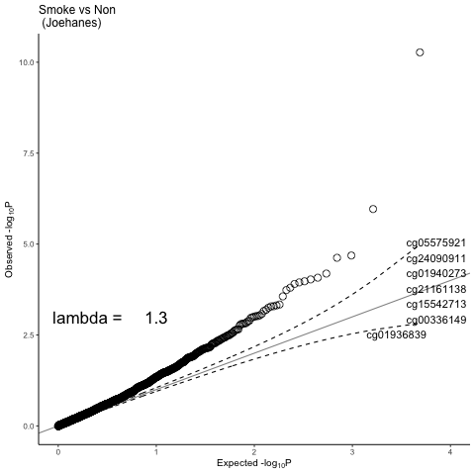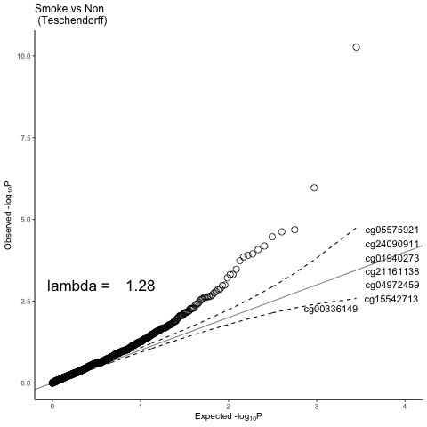
C) D)
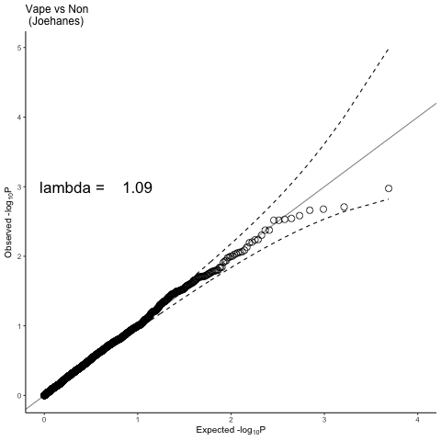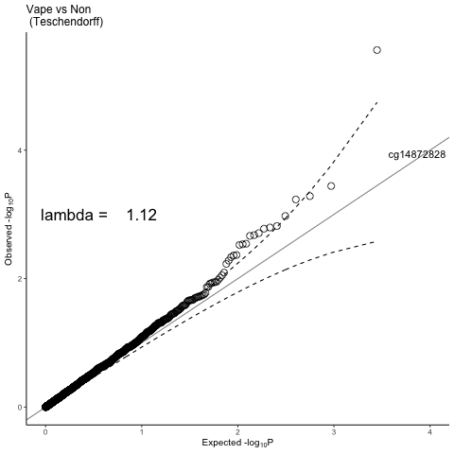

- CpG sites from Joehanes et al (1) in EWAS of smokers vs non-smokers in SEE-Cigs
- CpG sites from Teschendorff et al (2) in EWAS of smokers vs non-smokers in SEE-Cigs
- CpG sites from Joehanes et al (1) in EWAS of vapers vs non-smokers in SEE-Cigs
- CpG sites from Teschendorff et al (2)in EWAS of vapers vs non-smokers in SEE-Cigs

Supplementary Figure 5 - Comparing the discriminative performance of a DNAm score for e-cigarette use with a DNAm score for smoking in independent samples

- Performance of a DNAm score for smoking in discriminating smokers (1) from non-smokers (0) in SEE-Cigs (n= 32 smokers and n= 32 non-smokers)
- Performance of a DNAm score for e-cigarette use in discriminating vapers (1) from non-smokers (0) in SEE-Cigs (n= 32 vapers and n= 32 non-smokers)
- Performance of a DNAm score for smoking in discriminating smokers (1) from non-smokers (0) in ALSPAC (n= 47 smokers and n= 262 non-smokers)
- Performance of a DNAm score for e-cigarette use in discriminating vapers (1) from non-smokers (0) in ALSPAC (n= 14 vapers and n= 262 non-smokers)

Supplementary Figure 6 - Comparing the performance of a DNAm score for e-cigarette use with a DNAm score for smoking in discriminating lung tumour from normal adjacent tissue

- Performance of a DNAm score for smoking in discriminating lung adenocarcinoma (LUAD) tumour (T) from adjacent normal (N) in TCGA (n= 27 matched pairs)
- Performance of a DNAm score for e-cigarette use in discriminating lung adenocarcinoma (LUAD) tumour (T) from adjacent normal (N) in TCGA (n= 27 matched pairs)
- Performance of a DNAm score for smoking in discriminating lung squamous cell carcinoma (LUSC) tumour (T) from adjacent normal (N) in TCGA (n= 40 matched pairs)
- Performance of a DNAm score for e-cigarette use in discriminating lung squamous cell carcinoma (LUSC) tumour (T) from adjacent normal (N) in TCGA (n= 40 matched pairs)

Supplementary Figure 7 – Assessing the discriminative performance of AHRR (cg05575921) methylation

- Performance of AHRR (cg05575921) methylation in discriminating smokers (1) from non-smokers (0) in SEE-Cigs (n= 32 smokers and n= 32 non-smokers)
- Performance of AHRR (cg05575921) methylation in discriminating smokers (1) from non-smokers (0) in ALSPAC (n= 47 smokers and n= 262 non-smokers)
- Performance of AHRR (cg05575921) methylation in discriminating lung adenocarcinoma (LUAD) tumour (T) from adjacent normal (N) in TCGA (n= 27 matched pairs)
- Performance of AHRR (cg05575921) methylation in discriminating lung squamous cell carcinoma (LUSC) tumour (T) from adjacent normal (N) in TCGA (n= 40 matched pairs)

1. R. Joehanes et al., Epigenetic Signatures of Cigarette Smoking. Circ Cardiovasc Genet 9, 436-447 (2016).
2. A. E. Teschendorff et al., Correlation of Smoking-Associated DNA Methylation Changes in Buccal Cells With DNA Methylation Changes in Epithelial Cancer. JAMA Oncol 1, 476-485 (2015).

