ADDITIONAL MATERIAL
Title: Prenatal metal exposure, cord blood DNA methylation and persistence in childhood: an epigenome-wide association study of twelve metals

Authors: Anne K. Bozack, Sheryl L. Rifas-Shiman, Brent A. Coull, Andrea A. Baccarelli, Robert O. Wright, Chitra Amarasiriwardena, Diane R. Gold, Emily Oken, Marie-France Hivert, Andres Cardenas

Additional Figure 1: Flowchart of participant enrollment and study inclusion

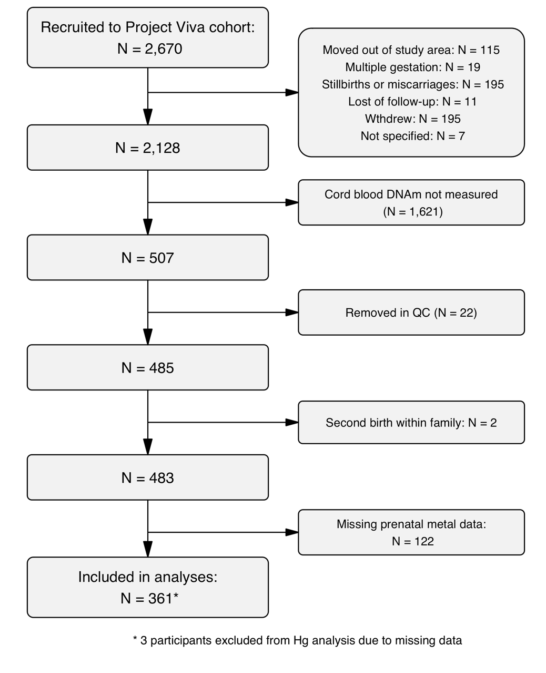

Additional Figure 2: Spearman correlations between prenatal first trimester metals measured in red blood cells (N = 361). * p < 0.05.
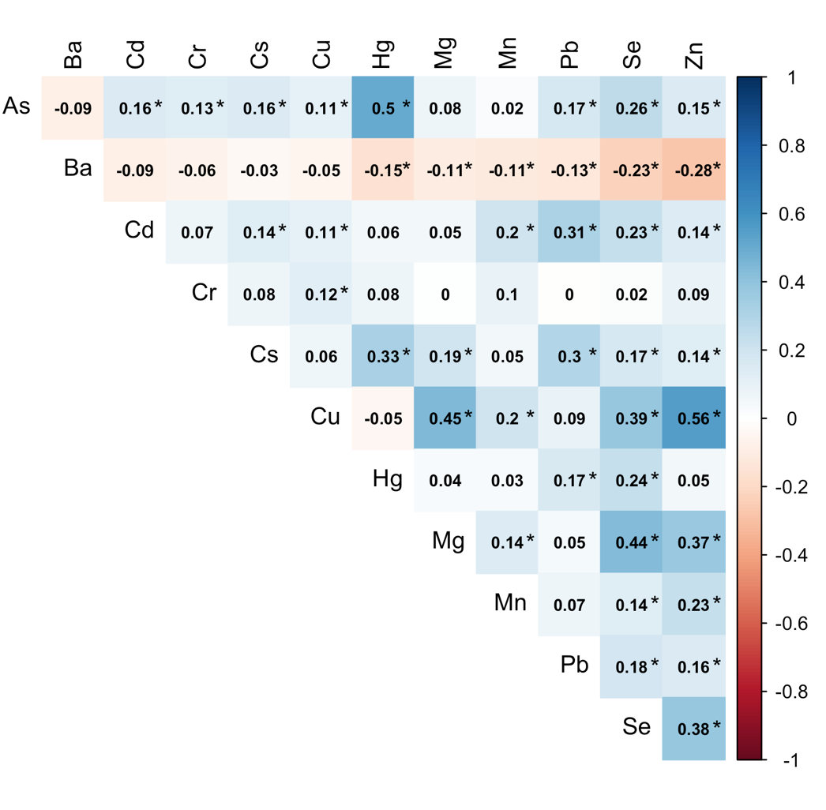

Additional Table 1: Associations between prenatal metal exposure and cell type abundance percentages in cord blood. Results from linear models for log₂-transformed metal concentrations adjusted for infant sex, race/ethnicity, gestational age, nulliparous, maternal age at enrollment, pre-pregnancy BMI, education, smoking, and household income. Significant associations (p < 0.05) are bolded.
 | B cells |  | CD4+ T cells |  | CD8+ T cells |  | Granulocytes |  | Monocytes |  | NK cells |  | Nucleated RBCs
Metal | B | p | B | p | B | p | B | p | B | p | B | p | B | p
As | 0.16 | 0.16 | -0.04 | 0.88 | 0.02 | 0.86 | -0.26 | 0.54 | 0.20 | 0.10 | 0.01 | 0.91 | -0.06 | 0.87
Ba | -0.17 | 0.18 | -0.20 | 0.46 | -0.16 | 0.26 | 0.75 | 0.10 | -0.16 | 0.23 | -0.02 | 0.84 | -0.05 | 0.90
Cd | 0.08 | 0.56 | 0.63 | 0.05 | 0.03 | 0.87 | -0.40 | 0.45 | 0.08 | 0.58 | -0.13 | 0.29 | -0.34 | 0.41
Cr | -0.19 | 0.25 | 0.13 | 0.72 | -0.16 | 0.37 | 0.47 | 0.42 | -0.03 | 0.85 | -0.18 | 0.20 | -0.02 | 0.97
Cs | -0.02 | 0.97 | -0.03 | 0.97 | 0.01 | 0.99 | -0.57 | 0.64 | 0.49 | 0.16 | 0.20 | 0.50 | -0.12 | 0.90
Cu | -0.67 | 0.35 | 3.25 | 0.037 | -0.90 | 0.27 | -1.18 | 0.65 | -1.22 | 0.10 | -0.43 | 0.49 | 0.47 | 0.82
Hg | -0.05 | 0.64 | -0.33 | 0.19 | 0.01 | 0.96 | 0.49 | 0.23 | 0.23 | 0.05 | 0.04 | 0.65 | -0.36 | 0.28
Mg | -0.23 | 0.70 | -0.75 | 0.57 | -0.33 | 0.62 | 2.10 | 0.33 | -0.74 | 0.23 | -0.29 | 0.58 | -0.10 | 0.95
Mn | 0.02 | 0.91 | -0.16 | 0.73 | 0.35 | 0.13 | -0.41 | 0.58 | 0.10 | 0.66 | -0.07 | 0.70 | 0.22 | 0.71
Pb | 0.18 | 0.55 | 0.95 | 0.14 | -0.46 | 0.16 | -1.91 | 0.07 | 0.09 | 0.78 | 0.27 | 0.28 | 0.77 | 0.36
Se | 0.01 | 0.99 | 1.15 | 0.37 | 0.46 | 0.49 | -1.50 | 0.48 | -0.37 | 0.55 | 0.31 | 0.55 | -0.46 | 0.79
Zn | 0.21 | 0.75 | 2.08 | 0.15 | -0.84 | 0.26 | 1.04 | 0.66 | -1.05 | 0.12 | -0.51 | 0.37 | -1.76 | 0.35
NK = natural killer; RBCs = red blood cells

Additional Table 2: Genomic inflation factors (λ) for associations between prenatal metal exposure and cord blood DNAm. Models of individual log₂-transformed prenatal metal concentrations adjusted for infant sex, race/ethnicity, gestational age, nulliparous, maternal age at enrollment, pre-pregnancy BMI, education, smoking, household income, and estimated cord blood cell type proportions.
 | All infants (N = 361) | Female (N = 169) | Male (N = 192)
 | λ | λ | λ
As | 1.04 | 0.95 | 1.01
Ba | 1.01 | 0.80 | 0.86
Cd | 0.91 | 0.95 | 0.97
Cr | 1.01 | 0.84 | 0.92
Cs | 1.02 | 0.78 | 1.09
Cu | 1.84 | 1.05 | 1.92
Hg ª | 0.80 | 0.71 | 0.79
Mg | 1.07 | 0.87 | 1.60
Mn | 0.74 | 0.89 | 0.84
Pb | 0.91 | 1.11 | 0.88
Se | 0.87 | 0.72 | 1.01
Zn | 1.48 | 1.04 | 1.10
a. All infants: N = 358; female: N = 167; male: N = 191. λ = genomic inflation factor.

Additional Figure 3: Q-Q plots for epigenome-wide associations between prenatal metal exposure and differential methylation in cord blood. DMPs identified using limma models of log₂-transformed prenatal metal concentrations adjusted for infant sex, race/ethnicity, gestational age, nulliparous, maternal age at enrollment, pre-pregnancy BMI, education, smoking, household income, and estimated cord blood cell type proportions.
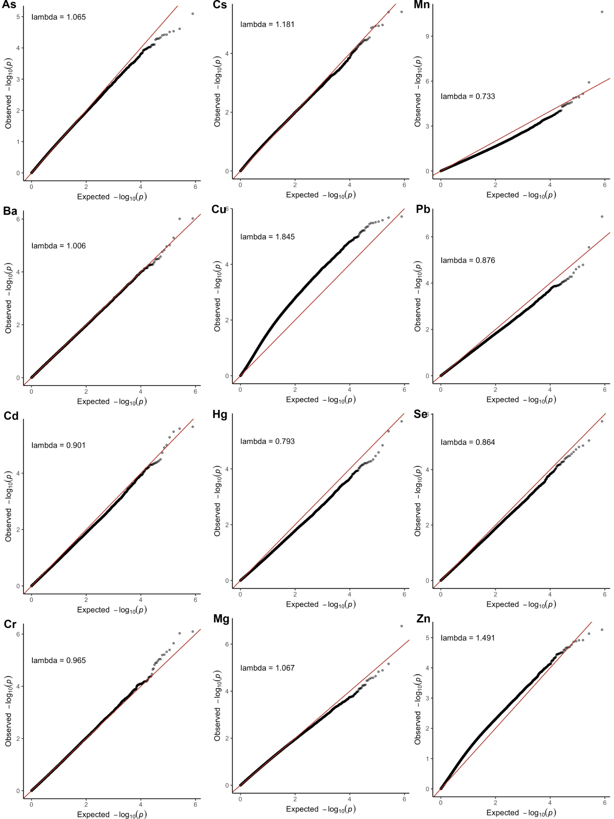
Additional Table 3: Lookup of cord blood CpGs previously reported to be associated with second-trimester maternal RBC Pb (N = 268; FDR < 0.05) (Wu et al. 2017) and Hg (N = 321; p_{Bonferroni} < 0.05 and FDR < 0.05 for DMPs and DMRs, respectively) in Project Viva. In current study, p-values from models of individual log₂-transformed prenatal metal concentration adjusted for infant sex (if not stratified), race/ethnicity, gestational age, nulliparous, maternal age at enrollment, pre-pregnancy BMI, education, smoking, household income, and estimated cord blood cell type proportions. Mean difference in % methylation determined using the same adjusted models for Beta-values for interpretation of results.
Associations with Pb |  |  |  | Wu et al. |  | Present study
CpG | Chr | Position | Gene | Mean difference in % methylationª | p-value | Mean difference in % methylationª | p-value
All infants
cg02272457 | chr6 | 42,427,790 | – | -0.1 | 1.2×10⁻⁶ | -0.1 | 0.11
cg20324491 | chr7 | 149,128,397 | – | -0.5 | 8.3×10^{–8} | -1.9 | 0.15
cg22112000 | chr7 | 5,647,182 | – | -0.1 | 1.1×10⁻⁷ | -0.9 | 0.046
cg10773601 | chr19 | 51,226,046 | CLEC11A | -1.4 | 2.3×10⁻⁷ | -0.8 | 0.08
Male infants
cg22512536 | chr5 | 154,134,507 | LARP1 | 0.1 | 2.2×10⁻⁷ | 0.1 | 0.07
cg08964024 | chr12 | 14,923,326 | – | 0.1 | 2.2×10⁻⁸ | 0.1 | 0.06
Female infants
cg04295372 | chr1 | 101,184,332 | VCAM1 | 1.6 | 3.9×10⁻⁶ | 0.4 | 0.66
cg09356083 | chr1 | 2,430,057 | PLCH2 | -0.6 | 6.9×10⁻⁷ | -0.2 | 0.48
cg20816789 | chr1 | 27,462,916 | SLC9A1 | -0.8 | 3.8×10⁻⁷ | 0.2 | 0.50
cg22446399 | chr2 | 27,326,580 | CGREF1 | -0.5 | 4.2×10⁻⁶ | -0.5 | 0.09
cg27403609 | chr2 | 11,101,403 | – | -1.2 | 3.4×10⁻⁴ | -0.6 | 0.14
cg07248017 | chr4 | 8,230,689 | SH3TC1 | -1.0 | 1.2×10⁻⁶ | 0.0 | 0.96
cg06239355 | chr5 | 32,714,010 | NPR3 | 0.1 | 1.5×10⁻⁷ | 0.0 | 0.71
cg15601915 | chr5 | 1,065,775 | SLC12A7 | -0.9 | 1.6×10⁻⁶ | -0.5 | 0.27
cg17599748 | chr6 | 31,589,597 | SNORA38 | -1.4 | 1.1×10⁻⁶ | -0.1 | 0.88
cg08673909 | chr7 | 1,329,592 | – | -0.2 | 6.3×10⁻⁶ | -0.1 | 0.48
cg10090217 | chr7 | 45,151,583 | TBRG4 | -0.1 | 5.0×10⁻⁶ | 0.0 | 0.96
cg16565528 | chr8 | 91,010,920 | – | 1.8 | 7.9×10⁻⁷ | 0.3 | 0.54
cg03152353 | chr9 | 139,417,194 | NOTCH1 | -1.1 | 4.6×10⁻⁷ | -0.1 | 0.90
cg13817920 | chr9 | 96,587,843 | – | -0.6 | 4.4×10⁻⁵ | -0.1 | 0.61
cg13791644 | chr10 | 119,794,366 | RAB11FIP2 | 1.0 | 1.3×10⁻⁵ | 0.2 | 0.58
cg18454045 | chr10 | 88,391,658 | – | -1.3 | 2.8×10⁻⁷ | -0.8 | 0.17
cg11127561 | chr11 | 125,462,151 | STT3A | 0.1 | 4.6×10⁻⁵ | 0.1 | 0.11
cg17971003 | chr11 | 107,582,804 | SLN | 1.0 | 1.7×10⁻⁶ | 0.9 | 0.044
cg24637308 | chr11 | 6,592,297 | DNHD1 | -4.3 | 1.1×10⁻⁶ | -2.0 | 0.10
cg05959994 | chr13 | 114,253,916 | TFDP1 | -0.2 | 1.9×10⁻⁸ | -0.3 | 2.30×10⁻⁴
cg11203293 | chr13 | 25,777,762 | – | -2.3 | 3.4×10⁻⁷ | -0.6 | 0.45
cg04545835 | chr14 | 102,675,570 | WDR20 | -0.4 | 4.0×10⁻⁵ | -0.2 | 0.15
cg08131309 | chr15 | 40,399,131 | BMF | -1.6 | 6.2×10⁻⁷ | -1.3 | 0.15
cg04730825 | chr16 | 16,116,191 | ABCC1 | -1.7 | 3.8×10⁻⁶ | 0.2 | 0.66
cg26686608 | chr16 | 88,705,716 | IL17C | 1.2 | 1.7×10⁻⁶ | 1.1 | 0.06
cg00461015 | chr17 | 42,295,635 | UBTF | -0.1 | 1.7×10⁻⁵ | -0.1 | 0.13
cg04571282 | chr17 | 44,108,753 | KIAA1267 | -0.2 | 4.8×10⁻⁶ | -0.3 | 1.11×10⁻⁴
cg11252953 | chr17 | 80,358,829 | C17orf101 | 0.8 | 8.7×10⁻⁷ | 0.2 | 0.70
cg15922057 | chr17 | 25,784,714 | – | -1.2 | 8.9×10⁻⁶ | -0.1 | 0.85
cg06753949 | chr19 | 15,334,309 | – | -0.2 | 7.8×10⁻⁶ | 0.0 | 0.53
cg07780528 | chr19 | 35,630,334 | FXYD1 | -0.8 | 2.0×10⁻⁶ | -0.5 | 0.21
cg11610754 | chr19 | 18,722,595 | TMEM59L | 0.1 | 3.1×10⁻⁶ | 0.1 | 0.39
cg18598117 | chr19 | 941,126 | ARID3A | -1.5 | 2.8×10⁻⁵ | -0.3 | 0.90
cg22217660 | chr19 | 50,765,301 | MYH14 | -0.7 | 1.2×10⁻⁵ | 0.3 | 0.27
cg03373781 | chr20 | 30,582,113 | XKR7 | -1.1 | 2.3×10⁻⁷ | 0.0 | 0.90
cg07341934 | chr20 | 57,463,711 | GNAS | -1.5 | 2.2×10⁻⁶ | 0.3 | 0.69
cg21307155 | chr20 | 3,216,740 | SLC4A11 | -0.8 | 8.1×10⁻⁸ | -0.5 | 0.28
cg17174023 | chr22 | 50,987,453 | KLHDC7B | -1.0 | 3.1×10⁻⁵ | -0.8 | 0.13
Associations with Hg |  |  |  | Cardenas et al. |  | Present study
All infants
CpG | Chr | Position | Gene | Mean difference in % methylationª | p-value | Mean difference in % methylationª | p-value
cg13340705 | 18 | 30,091,235 | WBP11P1 | 0.3 | 5.3×10⁻⁷ |  | 0.88
Male infants
cg13416866 | 9 | 140,175,679 | TOR4A | 1.3 | 3.5×10⁻⁸ | 0.5 | 0.028
cg07404485^{b} | 7 | 94,953,653 | PON1 | -2.2 | 7.2×10⁻⁴ | -0.8 | 0.10
cg05342682 | 7 | 94,953,680 | PON1 | -1.8 | 8.0×10⁻³ | -0.4 | 0.32
cg04155289 | 7 | 94,953,770 | PON1 | -1.7 | 3.3×10⁻³ | -0.5 | 0.20
cg19678392 | 7 | 94,953,810 | PON1 | -2.9 | 8.5×10⁻⁴ | -1.1 | 0.06
cg21856205 | 7 | 94,953,877 | PON1 | -1.6 | 9.9×10⁻⁴ | -0.5 | 0.16
cg17330251 | 7 | 94,953,956 | PON1 | -3.7 | 1.6×10⁻³ | -1.6 | 0.05
cg01874867 | 7 | 94,954,059 | PON1 | -3.8 | 8.2×10⁻⁴ | -0.5 | 0.06
cg20119798 | 7 | 94,954,144 | PON1 | -2.7 | 2.5×10⁻⁵ | -0.8 | 0.15
cg04871131 | 7 | 94,954,202 | PON1 | -1.0 | 1.5×10⁻⁴ | -0.6 | 0.026
a. Change in % methylation for each doubling of maternal Pb or Hg concentrations. b. CpGs located in the second-trimester Hg-associated DMR chr7:94,953,653-94,954,202.

Additional Table 4: Overlapping differentially methylated regions (DMRs) identified in sex-stratified analyses (Sidak p < 0.05). DMRs identified using comb-p adjusted for infant sex (if not stratified), race/ethnicity, gestational age, nulliparous, maternal age at enrollment, pre-pregnancy BMI, education, smoking, household income, and estimated cord blood cell type proportions.
Analysis | Chr | Start | End | Gene(s) | Length | Number of probes
Cd, all infants | 2 | 200,468,626 | 200,468,832 |  | 207 | 3
Cd, female |  | 200,468,626 | 200,468,728 |  | 103 | 2
Cs, all infants; Cs, male | 3 | 141,087,187 | 141,087,363 | ZBTB38 | 177 | 5
Cs, all infants; Cs, male | 6 | 28,601,269 | 28,601,519 |  | 251 | 11
Hg, all infants | 6 | 30,039,374 | 30,039,548 | RNF39 | 175 | 12
Hg, male |  | 30,039,142 | 30,039,548 | RNF39 | 407 | 15
Cs, all infants | 6 | 30,881,316 | 30,881,842 | VARS2;GTF2H4 | 527 | 21
Cs, male |  | 30,881,464 | 30,881,766 | VARS2;GTF2H4 | 303 | 15
Cs, male | 6 | 31,650,735 | 31,651,362 |  | 628 | 21
Hg, male |  | 31,650,786 | 31,651,291 |  | 506 | 18
Cs, all infants | 6 | 32,847,441 | 32,847,845 | PPP1R2P1 | 405 | 17
Cs, male |  | 32,847,762 | 32,847,845 | PPP1R2P1 | 84 | 7
Cr, all infants; Cr, female | 8 | 13,373,033 | 13,373,141 |  | 109 | 3
Cs, all infants | 8 | 43,131,260 | 43,131,656 |  | 397 | 5
Cs, male |  | 43,131,260 | 43,132,507 |  | 1248 | 8
Hg, all infants; Hg, male | 8 | 143,859,669 | 143,859,990 | LYNX1 | 322 | 7
Se, all infants; Ba, female | 8 | 144,635,260 | 144,635,610 | GSDMD | 351 | 9
Se, female |  | 144,635,260 | 144,636,113 | GSDMD | 854 | 12
As, all infants; As, male | 12 | 9,217,390 | 9,217,859 | LOC144571 | 470 | 9
Cs, all infants; Cs, female | 12 | 44,152,509 | 44,152,940 | IRAK4;PUS7L | 432 | 11
Cu, all infants; Cu, male | 12 | 54,673,867 | 546,74,009 | CBX5;HNRNPA1;HNRPA1L-2 | 143 | 4
Cs, all infants; Cs, male | 15 | 69,325,271 | 69,325,560 | MIR548H4;NOX5 | 290 | 5
Cs, all infants | 17 | 17,603,531 | 17,603,837 | RAI1 | 307 | 4
Cs, male |  | 17,603,531 | 17,604,146 | RAI1 | 616 | 5
Cu, all infants |  | 57,427,426 | 57,427,942 | GNAS;GNASAS | 517 | 17
Cu, female |  | 57,427,443 | 57,427,942 | GNAS;GNASAS | 500 | 16
Mg, all infants |  | 57,427,170 | 57,427,973 | GNAS;GNASAS | 804 | 24
Mg, female |  | 57,427,443 | 57,427,762 | GNAS;GNASAS | 320 | 13
Mg, male | 19 | 57,742,112 | 57,742,423 | AURKC | 312 | 7
Se, male |  | 57,742,255 | 57,742,423 | AURKC | 169 | 6
Cu, all infants |  | 57,427,426 | 57,427,942 | GNAS;GNASAS | 517 | 17
Cu, female |  | 57,427,443 | 57,427,942 | GNAS;GNASAS | 500 | 16
Mg, all infants |  | 57,427,170 | 57,427,973 | GNAS;GNASAS | 804 | 24
Mg, female |  | 57,427,443 | 57,427,762 | GNAS;GNASAS | 320 | 13

