Supplementary Figure S1
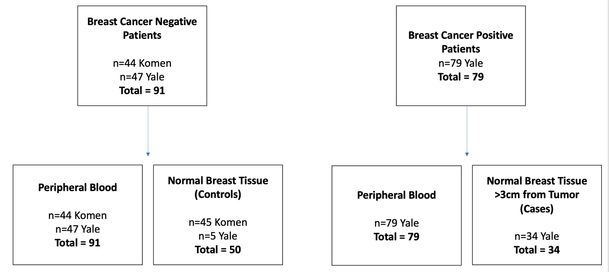
Supplementary Figure S1: Consort diagram of breast tissue and peripheral blood samples.

Supplementary Figure S2
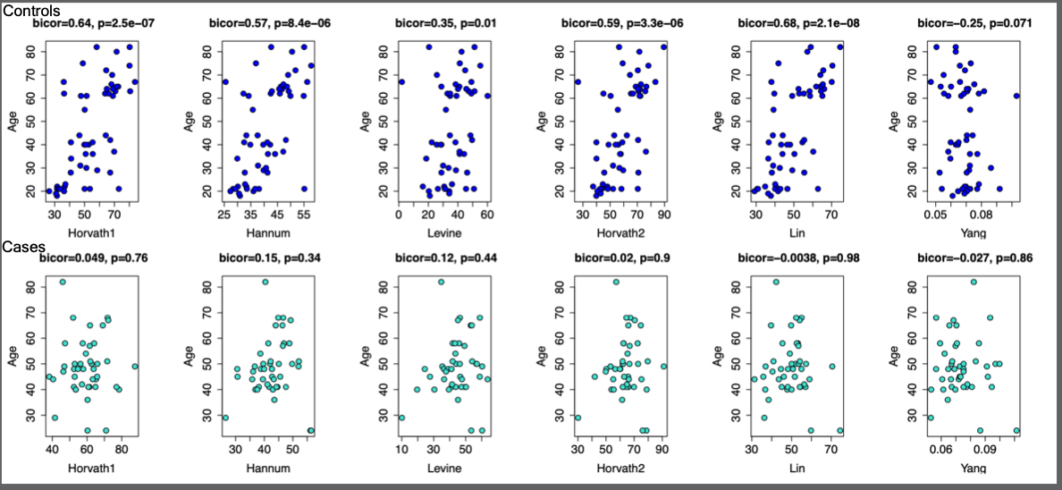
Supplementary Figure S2: Correlations between age and six epigenetic clocks in controls (top row) and cases (bottom row) in breast tissue.

Supplementary Figure S3

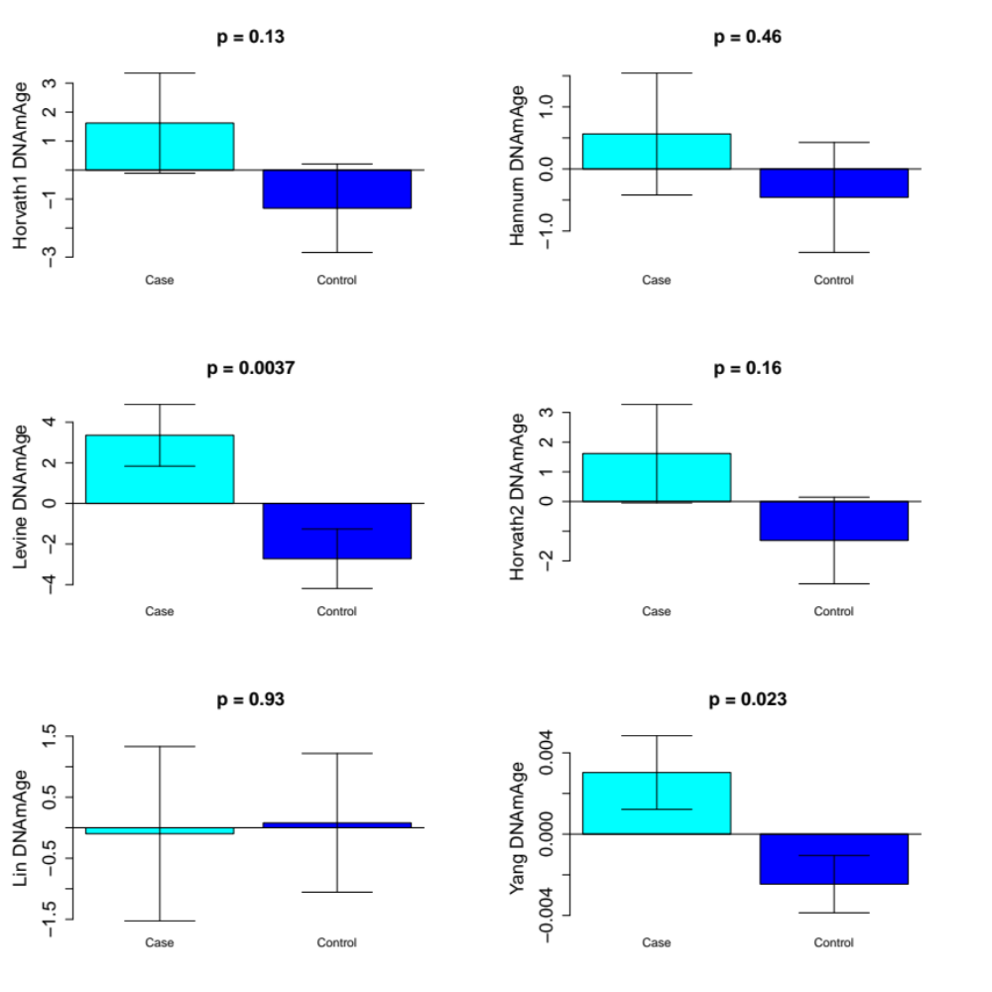
Supplementary Figure S3: Epigenetic clock accelerations in cases (normal breast tissue >3cm away from breast tumor in breast cancer patients) and controls (normal breast tissue from healthy individuals) adjusted for confounders (race, smoking, BMI)

Supplementary Figure S4:
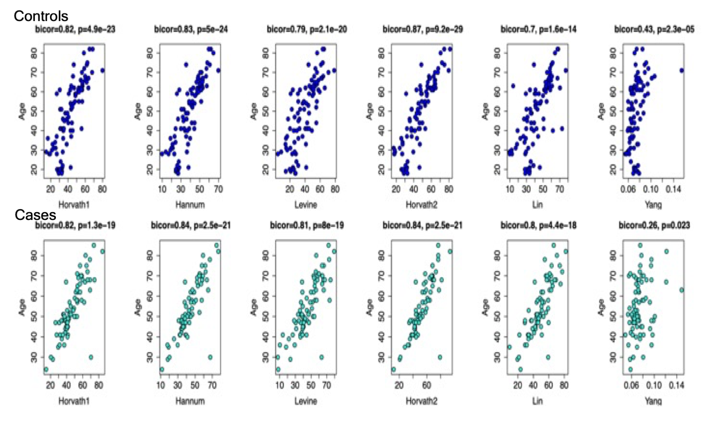

Supplementary Figure S4: Correlations between age and epigenetic clocks in controls (top row) and cases (bottom row) in peripheral blood.

Supplementary Figure S5

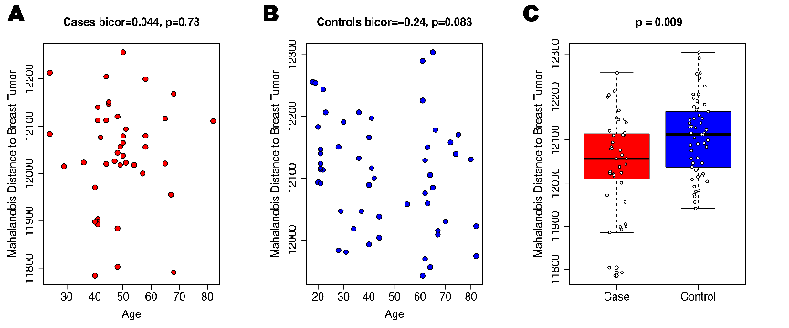
Supplementary Figure S5: Using the CpGs in the Levine clock that are associated with polycomb related genes, we estimated Mahalanobis distance using DNA methylation levels from breast tumor samples as a reference. We then tested whether samples became more tumor like (lower distance) with age in cases (A) and controls (B). When comparing cases to controls, we found that cases had a DNA methylation profile with a lower Mahalanobis distance suggesting they were more breast tumor like (C).

