SUPPLEMENTARY MATERIAL

Supplementary methods
- Targeted bisulfite sequencing
The next generation sequencing-based targeted bisulfite sequencing includes the following steps: Primers (Table S7) were designed using primer3 (http://primer3.ut.ee/) based on the genomic position of CpG sites from public available datasets. A two-step PCR approach was performed for each bisulfite-converted DNA sample, with a multiplexed PCR amplification followed by an index PCR. Paired-end sequencing (2 × 150 bp) was performed on the Illumina HiSeq platform (Illumina, San Diego, CA, USA). After quality control and filtering, paired reads were merged using FLASH, then were mapped to the reference genome of the human GRCh37/hg19 using blast + . Methylation level of each CpG sites were calculated as methylated reads counts divided by total read counts.
2. Droplet Digital PCR
The QX200™ Droplet Digital™ PCR System (Bio-Rad) was used to measure the methylation levels in cfDNA. Primers and probes were designed using ABI Primer Express software (version 3.0.1) and synthesized by Sangon Biotech (Shanghai). The ddPCR reaction mixture consisted of 10 μl ddPCR Supermix for Probes (No dUTP, Cat#1863024), and approximately 5-6 μl bisulfite-converted DNA template, primers (0.9 μM) and probes (0.25 μM), and RNase-Free water, in a final volume of 21 μl. The following cycling conditions were used: 95 ℃ for 10 min, followed by 40 cycles at 94 ℃ for 10 s and 60 ℃ for 60 s (at ramp rate 2 ℃/s), and finally 98 ℃ for 10 min. After thermo cycling, the 96-well plate was loaded into a QX200 droplet reader for droplet amplitude reading. Data from the QX200 Droplet Reader was analyzed in QuantaSoft version 1.7.4 (Bio-Rad). With a methylated DNA control, a unmethylated DNA control, a RNase-Free water control, and a non-template control (NTC) in the 96-well plate, the threshold was determined for distinguishing between positive and negative droplets. Samples with a total number of droplets less than 8000 are excluded. Methylation level = methylated copies / (methylated copies + non-methylated copies).

Supplemental Figures

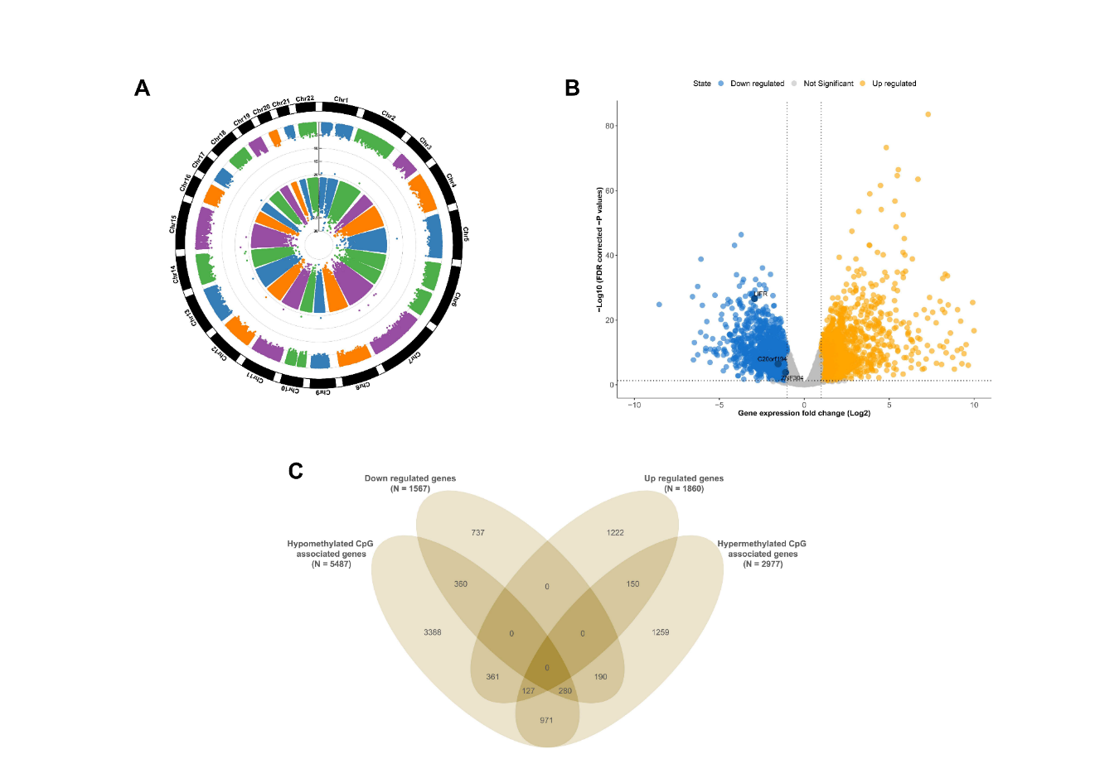

Fig. S1. Integrative analysis of DNA methylation and gene expression.
(A) Differential analysis of DNA methylation in TCGA 45 paired CRC samples. Manhattan plot shows the chromosome (chr) and positional (pos) information of each CpG sites. Dots in inner ring represents log₁₀ FDR, dots in outer ring represents log₁₀ |Δβ|. (B) Differential analysis of gene expression in TCGA 36 paired CRC samples. A volcano plot showing the -log₁₀FDR against the log₂ fold change for each gene. (C) Integrative analysis of DNA methylation and gene expression. A four-way Venn diagram shows intersection of genes containing differential methylated CpG sites and differential regulated genes.

Fig. S2. Correlation analysis of selected CpG sites in relation to gene expression and methylation of neighbor CpG sites in C20orf194.
(A) Correlation analysis between methylation levels of selected CpG sites at C20orf194 and relative gene expression. Visualization of the TCGA data for C20orf194 in CRC was using MEXPRESS. The samples are ordered by their expression value. The direction of correlation between C20orf194 expression and methylation is confirmed by the Pearson correlation coefficients. (B) Regional plot of co-methylation patterns at the C20orf194 gene in TCGA CRC tissues. The upper plot shows the results (-log₁₀FDR) of differential methylation between 395 CRC samples and 45 normal samples. The middle panel shows annotation tracks. The lower panel shows Spearman correlation analysis between CpG sites in the genomic region of C20orf194.

Fig. S3. Correlation analysis of selected CpG sites in relation to gene expression and methylation of neighbor CpG sites in LIFR.
(A) Correlation analysis between methylation levels of selected CpG sites at LIFR and relative gene expression. Visualization of the TCGA data for LIFR in CRC was using MEXPRESS. The samples are ordered by their expression value. The direction of correlation between LIFR expression and methylation is confirmed by the Pearson correlation coefficients. (B) Regional plot of co-methylation patterns at the LIFR gene in TCGA CRC tissues. The upper plot shows the results (-log10FDR) of differential methylation between 395 CRC samples and 45 normal samples. The middle panel shows annotation tracks. The lower panel shows Spearman correlation analysis between CpG sites in the genomic region of LIFR.

Fig. S4. Correlation analysis of selected CpG sites in relation to gene expression and methylation of neighbor CpG sites in ZNF304.
(A) Correlation analysis between methylation levels of selected CpG sites at ZNF304 and relative gene expression. Visualization of the TCGA data for ZNF304 in CRC was using MEXPRESS. The samples are ordered by their expression value. The direction of correlation between ZNF304 expression and methylation is confirmed by the Pearson correlation coefficients. (B) Regional plot of co-methylation patterns at the ZNF304 gene in TCGA CRC tissues. The upper plot shows the results (-log₁₀FDR) of differential methylation between 395 CRC samples and 45 normal samples. The middle panel shows annotation tracks. The lower panel shows Spearman correlation analysis between CpG sites in the genomic region of ZNF304.
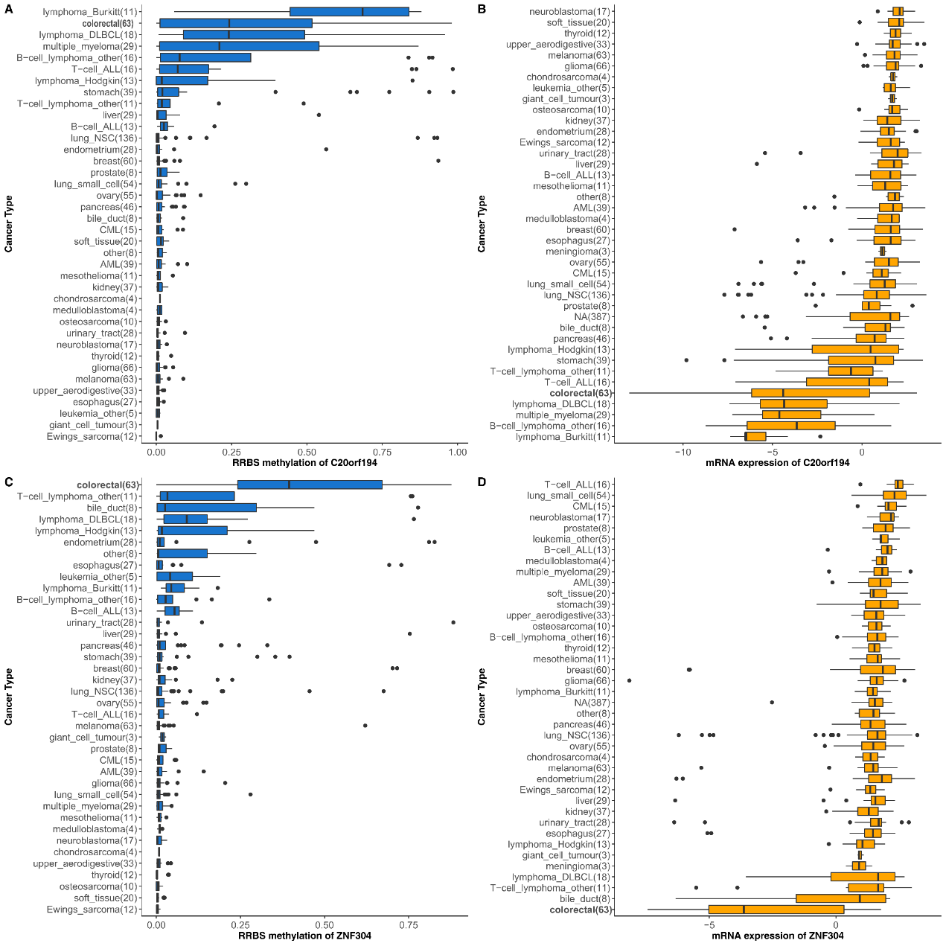

Fig. S5. Methylation and expression levels of C20orf194 and ZNF304 in Cancer Cell Line Encyclopedia.
Relative DNA methylation and mRNA expression levels were extracted from Cancer Cell Line Encyclopedia. Data were sorted by average value of each group. (A) Methylation (RRBS) of C20orf194. (B) mRNA expression (RNA-seq) of C20orf194. (C) Methylation (RRBS) of ZNF304. (D) mRNA expression (RNA-seq) of ZNF304.
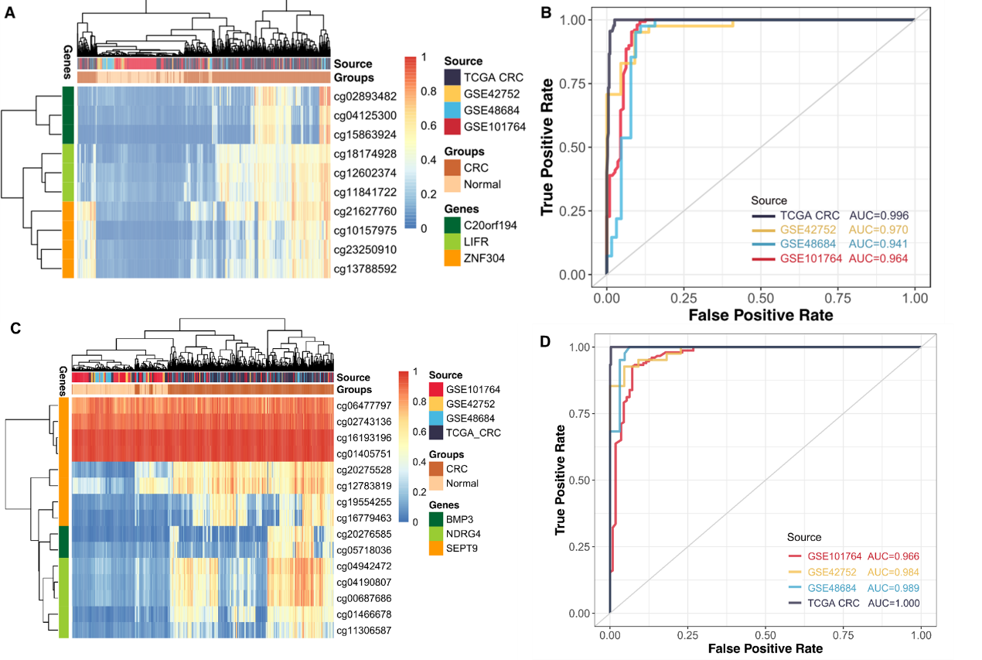

Fig. S6. Validation of 10 CRC-specific methylation CpG sites of our study and 15 CpG sites of three commercial biomarkers.
Unsupervised hierarchical clustering of (A) 10 CRC-specific methylation CpG sites of our study and (C) 15 CpG sites of three commercial biomarkers for the diagnosis of CRC in four datasets of TCGA CRC, GSE42752, GSE48684, and GSE101764. ROC curves of random forest model using (B) 10 CRC-specific methylation CpG sites of our study and (D) 15 CpG sites of three commercial biomarkers in four datasets.

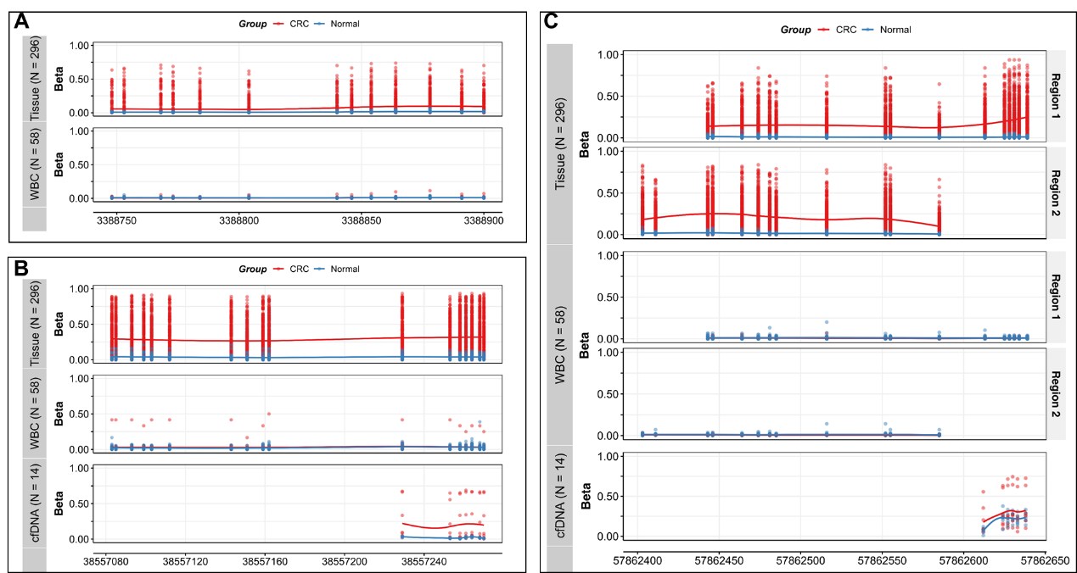

Fig. S7. Methylation profiles of (A) C20orf194, (B) LIFR and (C) ZNF304 in an inhouse study using targeted bisulfite sequencing analysis.
The panel shows the methylation profiles of 272 CRC tissues and 23 normal tissues, white blood cell samples from CRC patients (N = 29) and healthy controls (N = 29), cell-free DNA samples from CRC patients (N = 9) and healthy controls (N = 5). Each dot represents one CpG site for each individual.

Fig. S8. Receiver operating characteristic curve analyses of 8 CpG sites for discriminating colorectal cancer tissues and adjacent normal tissues in the inhouse study.
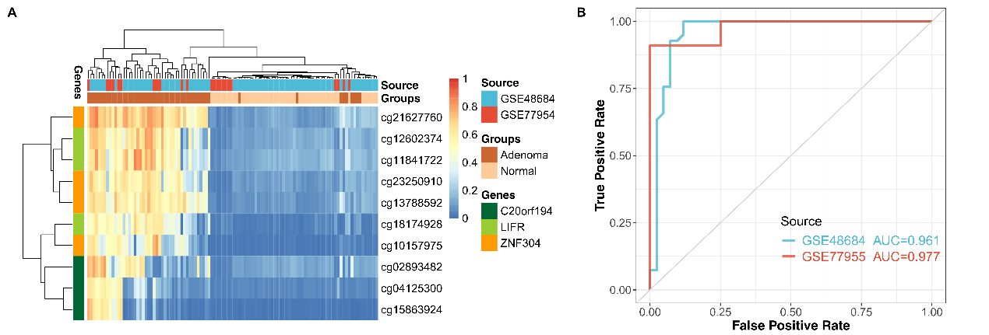

Fig. S9. Validation of 10 CRC-specific methylation CpG sites of our study in tissues of colorectal adenomas and normal tissues.
(A) Unsupervised hierarchical clustering of 10 CRC-specific methylation CpG sites of our study in in 2 GEO datasets (GSE48684 and GSE77955) including 54 colorectal adenomas and 52 normal samples. (B) ROC curves of random forest model using 10 CRC-specific methylation CpG sites of our study for distinguishing tissues of colorectal adenomas from normal tissues.

Supplemental Tables

Table S1. Datasets used for discovery and validation of CRC-specific methylation markers
Dataset | Source | Cancer type | Assay | Sample type | Number of samples
Discovery cohort (N = 5805)
 | TCGA | CRC | Infinium 450K | Tissue | Normal = 45, Tumor = 395
 | TCGA | BLCA | Infinium 450K | Tissue | Normal = 21, Tumor = 412
 | TCGA | BRCA | Infinium 450K | Tissue | Normal = 98, Tumor = 785
 | TCGA | ESCA | Infinium 450K | Tissue | Normal = 16, Tumor = 185
 | TCGA | GBM | Infinium 450K | Tissue | Normal = 2, Tumor = 140
 | TCGA | HNSC | Infinium 450K | Tissue | Normal = 50, Tumor = 528
 | TCGA | KIRC | Infinium 450K | Tissue | Normal = 160, Tumor = 319
 | TCGA | LIHC | Infinium 450K | Tissue | Normal = 50, Tumor = 377
 | TCGA | LUAD | Infinium 450K | Tissue | Normal = 32, Tumor = 458
 | TCGA | LUSC | Infinium 450K | Tissue | Normal = 43, Tumor = 372
 | TCGA | UCEC | Infinium 450K | Tissue | Normal = 46, Tumor = 431
 | GSE40279 & GSE69270 | Healthy | Infinium 450K | Blood leukocytes | Normal = 840
Validation cohort 1 (N = 2045)
 | GSE42752 & GSE48684& GSE101764 | CRC | Infinium 450K | Tissue | Normal = 231, Tumor = 198
 | GSE111933 | BLCA | Infinium 450K | Tissue | Normal = 46, Tumor = 46
 | GSE66695 & GSE69914 | BRCA | Infinium 450K | Tissue | Normal = 132, Tumor = 385
 | GSE52826 & GSE79366 | ESCA | Infinium 450K | Tissue | Normal = 10, Tumor = 16
 | GSE36278 & GSE60274 & GSE123678 | GBM | Infinium 450K | Tissue | Normal = 19, Tumor = 210
 | GSE38266 | HNSC | Infinium 450K | Tissue | Normal = 0, Tumor = 42
 | GSE61441 | KIRC | Infinium 450K | Tissue | Normal = 46, Tumor = 46
 | GSE54503 | LIHC | Infinium 450K | Tissue | Normal = 66, Tumor = 66
 | GSE39279 | LUAD | Infinium 450K | Tissue | Normal = 0, Tumor = 322
 | GSE39279 | LUSC | Infinium 450K | Tissue | Normal = 0, Tumor = 122
 | GSE67116 & GSE93589 | UCEC | Infinium 450K | Tissue | Normal = 0, Tumor = 42
Validation cohort 2 (N = 1457)
 | CCLE | 38 cancer types | RRBS | Cell lines | Tumor = 1457
Validation cohort 3 (N = 353)
 | Inhouse study | CRC | Targeted bisulfite sequencing | Tissue | Normal = 23, Tumor = 272
 | Inhouse study | CRC | Targeted bisulfite sequencing | WBC | Normal = 29, Tumor = 29
cfDNA pilot cohort (N = 14) *
 | Inhouse study | CRC | Targeted bisulfite sequencing | cfDNA | Normal = 5, Tumor = 9
cfDNA validation cohort (N = 155) *
 | Inhouse study | CRC | Droplet Digital PCR | cfDNA | Normal =60, Tumor = 95
* Nine cfDNA samples from colorectal cancer were overlapped between targeted bisulfite sequencing array and Droplet Digital PCR.

Table S2. Genomic information of 10 CRC-specific methylation CpG sites of our study and 15 CpG sites from three commercial biomarkers
CpG | Gene Symbol | Gene description | Chromosome | Genomic Coordinate | Strand | Relation to Island | UCSC RefGene Group
Our study
cg04125300 | C20orf194 | chromosome 20 open reading frame 194 | 20 | 3388262 | - | Island | TSS200
cg15863924 | C20orf194 | chromosome 20 open reading frame 194 | 20 | 3388269 | - | Island | TSS200
cg02893482 | C20orf194 | chromosome 20 open reading frame 194 | 20 | 3388900 | + | Island | TSS1500
cg18174928 | LIFR | LIF receptor alpha | 5 | 38557085 | + | Island | TSS1500
cg12602374 | LIFR | LIF receptor alpha | 5 | 38557162 | + | Island | TSS1500
cg11841722 | LIFR | LIF receptor alpha | 5 | 38557253 | - | Island | TSS1500
cg23250910 | ZNF304 | zinc finger protein 304 | 19 | 57862410 | - | N_Shore | TSS1500
cg10157975 | ZNF304 | zinc finger protein 304 | 19 | 57862442 | + | Island | TSS1500
cg13788592 | ZNF304 | zinc finger protein 304 | 19 | 57862612 | - | Island | TSS200
cg21627760 | ZNF304 | zinc finger protein 304 | 19 | 57862638 | + | Island | TSS200
Commercial biomarkers *
cg20276585 | BMP3 | Bone Morphogenetic Protein 3 | 4 | 81952330 | + | Island | 1stExon
cg05718036 | BMP3 | Bone Morphogenetic Protein 3 | 4 | 81952593 | + | Island | 1stExon
cg04190807 | NDRG4 | N-myc downregulated gene 4 | 16 | 58497230 | - | Island | TSS1500
cg00687686 | NDRG4 | N-myc downregulated gene 4 | 16 | 58497236 | - | Island | TSS1500
cg04942472 | NDRG4 | N-myc downregulated gene 4 | 16 | 58497239 | - | Island | TSS1500
cg01466678 | NDRG4 | N-myc downregulated gene 4 | 16 | 58497395 | + | Island | TSS1500
cg11306587 | NDRG4 | N-myc downregulated gene 4 | 16 | 58497714 | + | Island | TSS1500
cg19554255 | SEPT9 | Septin 9 | 17 | 75369051 | - | Island | TSS1500
cg16779463 | SEPT9 | Septin 9 | 17 | 75369055 | - | Island | TSS1500
cg20275528 | SEPT9 | Septin 9 | 17 | 75369484 | - | Island | 5'UTR
cg12783819 | SEPT9 | Septin 9 | 17 | 75369657 | - | Island | 5'UTR
cg16193196 | SEPT9 | Septin 9 | 17 | 75398290 | + | Island | 5'UTR
cg01405751 | SEPT9 | Septin 9 | 17 | 75398380 | + | Island | 5'UTR
cg06477797 | SEPT9 | Septin 9 | 17 | 75398526 | + | Island | 5'UTR
cg02743136 | SEPT9 | Septin 9 | 17 | 75398583 | + | S_Shore | Body
* CpG sites which were covered by primer sequence of three assays and other published articles were extracted. If primer sequence did not cover a CpG, two surrounding CpG sites were used.

Table S3. Differential methylation analysis of 10 CRC-specific methylation CpG sites of our study and 15 CpG sites of three commercial biomarkers in CRC samples and normal samples
CpG | TCGA |  |  |  | GSE42752 |  |  |  | GSE48684 |  |  |  | GSE101764
CpG | CRC | Normal | Δβ | P | CRC | Normal | Δβ | P | CRC | Normal | Δβ | P | CRC | Normal | Δβ | P
Our study
cg04125300 | 0.229 | 0.033 | 0.195 | 3.92E-47 | 0.24 | 0.071 | 0.169 | 3.33E-03 | 0.229 | 0.051 | 0.177 | 1.37E-07 | 0.22 | 0.069 | 0.151 | 4.45E-11
cg15863924 | 0.202 | 0.016 | 0.186 | 4.36E-36 | 0.218 | 0.033 | 0.186 | 4.73E-03 | 0.2 | 0.016 | 0.183 | 6.85E-07 | 0.182 | 0.023 | 0.159 | 1.24E-09
cg02893482 | 0.264 | 0.048 | 0.215 | 7.39E-45 | 0.249 | 0.113 | 0.136 | 9.87E-03 | 0.353 | 0.122 | 0.231 | 3.43E-08 | 0.214 | 0.066 | 0.149 | 4.23E-12
cg18174928 | 0.353 | 0.024 | 0.328 | 2.60E-113 | 0.337 | 0.084 | 0.253 | 2.49E-06 | 0.289 | 0.032 | 0.257 | 2.11E-14 | 0.317 | 0.067 | 0.251 | 2.10E-23
cg12602374 | 0.394 | 0.055 | 0.339 | 7.79E-110 | 0.375 | 0.115 | 0.26 | 7.80E-06 | 0.473 | 0.129 | 0.344 | 6.04E-16 | 0.287 | 0.075 | 0.212 | 7.99E-22
cg11841722 | 0.375 | 0.072 | 0.303 | 4.06E-99 | 0.4 | 0.134 | 0.266 | 1.50E-06 | 0.483 | 0.147 | 0.336 | 6.99E-17 | 0.276 | 0.095 | 0.182 | 1.14E-21
cg23250910 | 0.338 | 0.048 | 0.29 | 9.88E-89 | 0.331 | 0.073 | 0.258 | 2.40E-06 | 0.36 | 0.103 | 0.257 | 3.08E-11 | 0.235 | 0.053 | 0.183 | 1.36E-23
cg10157975 | 0.331 | 0.02 | 0.311 | 4.95E-92 | 0.315 | 0.031 | 0.283 | 5.17E-06 | 0.191 | 0.02 | 0.171 | 4.74E-09 | 0.284 | 0.031 | 0.253 | 5.88E-25
cg13788592 | 0.369 | 0.048 | 0.321 | 3.98E-108 | 0.359 | 0.078 | 0.282 | 4.88E-07 | 0.396 | 0.091 | 0.305 | 2.13E-13 | 0.299 | 0.054 | 0.246 | 3.13E-31
cg21627760 | 0.475 | 0.082 | 0.393 | 8.34E-98 | 0.433 | 0.095 | 0.337 | 6.15E-08 | 0.462 | 0.118 | 0.343 | 6.14E-14 | 0.368 | 0.074 | 0.294 | 3.25E-33
Commercial biomarkers
cg20276585 | 0.239 | 0.015 | 0.224 | 2.21E-52 | 0.21 | 0.036 | 0.174 | 2.42E-03 | 0.231 | 0.018 | 0.213 | 3.17E-09 | 0.206 | 0.034 | 0.172 | 6.24E-13
cg05718036 | 0.265 | 0.061 | 0.204 | 1.02E-51 | 0.262 | 0.111 | 0.151 | 2.70E-03 | 0.389 | 0.135 | 0.255 | 5.91E-10 | 0.198 | 0.084 | 0.114 | 7.18E-11
cg04190807 | 0.481 | 0.1 | 0.382 | 6.50E-124 | 0.454 | 0.136 | 0.318 | 1.11E-07 | 0.574 | 0.179 | 0.395 | 4.94E-19 | 0.348 | 0.109 | 0.24 | 2.46E-24
cg00687686 | 0.474 | 0.096 | 0.378 | 4.48E-110 | 0.483 | 0.145 | 0.338 | 6.88E-08 | 0.558 | 0.193 | 0.365 | 3.61E-18 | 0.351 | 0.107 | 0.244 | 8.00E-24
cg04942472 | 0.505 | 0.111 | 0.393 | 2.42E-115 | 0.519 | 0.162 | 0.357 | 1.99E-08 | 0.605 | 0.218 | 0.387 | 1.90E-18 | 0.371 | 0.121 | 0.25 | 6.51E-24
cg01466678 | 0.4 | 0.026 | 0.374 | 6.36E-139 | 0.415 | 0.063 | 0.351 | 3.31E-09 | 0.333 | 0.022 | 0.311 | 3.33E-19 | 0.359 | 0.064 | 0.296 | 1.76E-30
cg11306587 | 0.291 | 0.043 | 0.247 | 6.05E-75 | 0.343 | 0.091 | 0.252 | 8.36E-06 | 0.237 | 0.047 | 0.191 | 8.04E-14 | 0.305 | 0.087 | 0.218 | 7.63E-22
cg19554255 | 0.372 | 0.056 | 0.316 | 1.25E-107 | 0.262 | 0.083 | 0.18 | 2.87E-05 | 0.404 | 0.101 | 0.303 | 4.64E-14 | 0.276 | 0.068 | 0.208 | 1.45E-23
cg16779463 | 0.366 | 0.02 | 0.346 | 3.73E-94 | 0.257 | 0.045 | 0.212 | 1.25E-04 | 0.253 | 0.026 | 0.227 | 4.05E-10 | 0.32 | 0.05 | 0.27 | 3.22E-22
cg20275528 | 0.598 | 0.121 | 0.478 | 4.86E-33 | 0.507 | 0.104 | 0.404 | 8.90E-14 | 0.494 | 0.1 | 0.394 | 5.06E-25 | 0.533 | 0.144 | 0.39 | 4.53E-59
cg12783819 | 0.632 | 0.28 | 0.353 | 2.77E-18 | 0.607 | 0.301 | 0.306 | 1.89E-10 | 0.548 | 0.267 | 0.28 | 4.47E-11 | 0.566 | 0.327 | 0.239 | 1.36E-28
cg16193196 | 0.976 | 0.977 | -0.001 | 4.96E-01 | 0.96 | 0.958 | 0.003 | 2.32E-01 | 0.962 | 0.962 | 0 | 9.13E-01 | 0.966 | 0.968 | -0.002 | 1.46E-01
cg01405751 | 0.977 | 0.976 | 0.001 | 8.09E-01 | 0.96 | 0.959 | 0.001 | 6.68E-01 | 0.96 | 0.961 | -0.001 | 6.89E-01 | 0.954 | 0.96 | -0.006 | 6.56E-04
cg06477797 | 0.869 | 0.883 | -0.015 | 7.99E-04 | 0.863 | 0.864 | -0.001 | 9.31E-01 | 0.927 | 0.927 | 0 | 9.89E-01 | 0.803 | 0.798 | 0.005 | 3.75E-01
cg02743136 | 0.929 | 0.915 | 0.014 | 6.59E-05 | 0.91 | 0.907 | 0.005 | 2.94E-01 | 0.914 | 0.919 | -0.005 | 3.11E-01 | 0.88 | 0.882 | -0.003 | 5.08E-01

Table S4. Prediction performance of 10 CRC-specific methylation CpG sites of our study and 15 CpG sites of three commercial biomarkers
CpG | Cut off value | AUC | TCGA CRC |  |  |  | GSE42752 |  |  |  | GSE48684 |  |  |  | GSE101764
CpG | Cut off value | AUC | TP | Sen | TN | Spe | TP | Sen | TN | Spe | TP | Sen | TN | Spe | TP | Sen | TN | Spe
Our study
cg04125300 | 0.098 | 0.638 | 199 | 0.504 | 45 | 1.000 | 10 | 0.455 | 37 | 0.902 | 29 | 0.453 | 41 | 1.000 | 48 | 0.429 | 140 | 0.940
cg15863924 | 0.072 | 0.651 | 153 | 0.387 | 45 | 1.000 | 10 | 0.455 | 40 | 0.976 | 24 | 0.375 | 41 | 1.000 | 38 | 0.339 | 148 | 0.993
cg02893482 | 0.142 | 0.680 | 183 | 0.463 | 45 | 1.000 | 11 | 0.500 | 36 | 0.878 | 38 | 0.594 | 38 | 0.927 | 46 | 0.411 | 149 | 1.000
cg18174928 | 0.196 | 0.806 | 300 | 0.759 | 45 | 1.000 | 16 | 0.727 | 41 | 1.000 | 39 | 0.609 | 41 | 1.000 | 73 | 0.652 | 149 | 1.000
cg12602374 | 0.172 | 0.843 | 312 | 0.790 | 45 | 1.000 | 16 | 0.727 | 40 | 0.976 | 48 | 0.750 | 40 | 0.976 | 72 | 0.643 | 149 | 1.000
cg11841722 | 0.200 | 0.839 | 307 | 0.777 | 45 | 1.000 | 18 | 0.818 | 39 | 0.951 | 54 | 0.844 | 40 | 0.976 | 70 | 0.625 | 149 | 1.000
cg23250910 | 0.143 | 0.853 | 300 | 0.759 | 44 | 0.978 | 17 | 0.773 | 40 | 0.976 | 42 | 0.656 | 36 | 0.878 | 78 | 0.696 | 149 | 1.000
cg10157975 | 0.086 | 0.836 | 306 | 0.775 | 44 | 0.978 | 17 | 0.773 | 39 | 0.951 | 36 | 0.563 | 41 | 1.000 | 86 | 0.768 | 149 | 1.000
cg13788592 | 0.129 | 0.871 | 328 | 0.830 | 44 | 0.978 | 19 | 0.864 | 39 | 0.951 | 45 | 0.703 | 36 | 0.878 | 92 | 0.821 | 148 | 0.993
cg21627760 | 0.234 | 0.876 | 328 | 0.830 | 45 | 1.000 | 18 | 0.818 | 40 | 0.976 | 43 | 0.672 | 41 | 1.000 | 88 | 0.786 | 149 | 1.000
Commercial biomarkers
cg20276585 | 0.064 | 0.674 | 203 | 0.514 | 45 | 1.000 | 11 | 0.500 | 38 | 0.927 | 34 | 0.531 | 41 | 1.000 | 51 | 0.455 | 146 | 0.980
cg05718036 | 0.130 | 0.698 | 195 | 0.494 | 45 | 1.000 | 12 | 0.545 | 35 | 0.854 | 57 | 0.891 | 25 | 0.610 | 48 | 0.429 | 148 | 0.993
cg04190807 | 0.197 | 0.884 | 333 | 0.843 | 45 | 1.000 | 20 | 0.909 | 39 | 0.951 | 55 | 0.859 | 34 | 0.829 | 77 | 0.688 | 147 | 0.987
cg00687686 | 0.223 | 0.887 | 310 | 0.785 | 45 | 1.000 | 19 | 0.864 | 39 | 0.951 | 56 | 0.875 | 36 | 0.878 | 73 | 0.652 | 148 | 0.993
cg04942472 | 0.287 | 0.893 | 302 | 0.765 | 45 | 1.000 | 18 | 0.818 | 41 | 1.000 | 49 | 0.766 | 40 | 0.976 | 66 | 0.589 | 149 | 1.000
cg01466678 | 0.197 | 0.914 | 329 | 0.833 | 45 | 1.000 | 20 | 0.909 | 41 | 1.000 | 47 | 0.734 | 41 | 1.000 | 84 | 0.750 | 148 | 0.993
cg11306587 | 0.146 | 0.800 | 271 | 0.686 | 45 | 1.000 | 16 | 0.727 | 40 | 0.976 | 42 | 0.656 | 41 | 1.000 | 75 | 0.670 | 147 | 0.987
cg19554255 | 0.120 | 0.910 | 322 | 0.815 | 44 | 0.978 | 17 | 0.773 | 41 | 1.000 | 52 | 0.813 | 39 | 0.951 | 79 | 0.705 | 147 | 0.987
cg16779463 | 0.084 | 0.818 | 288 | 0.729 | 44 | 0.978 | 14 | 0.636 | 41 | 1.000 | 35 | 0.547 | 40 | 0.976 | 80 | 0.714 | 145 | 0.973
cg20275528 | 0.415 | 0.972 | 373 | 0.944 | 45 | 1.000 | 15 | 0.682 | 41 | 1.000 | 45 | 0.703 | 41 | 1.000 | 97 | 0.866 | 145 | 0.973
cg12783819 | 0.478 | 0.911 | 350 | 0.886 | 40 | 0.889 | 20 | 0.909 | 35 | 0.854 | 43 | 0.672 | 36 | 0.878 | 89 | 0.795 | 125 | 0.839
cg16193196 | 0.974 | 0.669 | 300 | 0.759 | 9 | 0.200 | 1 | 0.045 | 40 | 0.976 | 7 | 0.109 | 38 | 0.927 | 36 | 0.321 | 107 | 0.718
cg01405751 | 0.975 | 0.705 | 314 | 0.795 | 8 | 0.178 | 1 | 0.045 | 40 | 0.976 | 4 | 0.063 | 41 | 1.000 | 1 | 0.009 | 141 | 0.946
cg06477797 | 0.846 | 0.627 | 315 | 0.797 | 3 | 0.067 | 18 | 0.818 | 10 | 0.244 | 64 | 1.000 | 0 | 0.000 | 30 | 0.268 | 141 | 0.946
cg02743136 | 0.930 | 0.711 | 246 | 0.623 | 39 | 0.867 | 3 | 0.136 | 36 | 0.878 | 21 | 0.328 | 34 | 0.829 | 3 | 0.027 | 145 | 0.973
TP, True positive; Sen, Sensitivity; TN, True negative; Spe, Specificity.

Table S5. Misclassification rate of 10 CRC-specific methylation CpG sites of our study and 15 CpG sites of three commercial biomarkers in GEO dataset
CpG | BLCA |  | BRCA |  | ESCA |  | GBM |  | HNSC |  | KIRC |  | LIHC |  | LUAD |  | LUSC |  | UCEC |  | Overall (N = 1616)
CpG | T | N | T | N | T | N | T | N | T | N | T | N | T | N | T | N | T | N | T | N | T | N | T&N
Our study
cg04125300 | 0.000 | 0.000 | 0.000 | 0.000 | 0.000 | 0.000 | 0.000 | 0.000 | 0.143 | NA | 0.000 | 0.000 | 0.106 | 0.000 | 0.050 | NA | 0.025 | NA | 0.000 | NA | 0.061 | 0.049 | 0.059
cg15863924 | 0.000 | 0.000 | 0.000 | 0.000 | 0.000 | 0.000 | 0.000 | 0.000 | 0.119 | NA | 0.000 | 0.000 | 0.091 | 0.000 | 0.019 | NA | 0.008 | NA | 0.000 | NA | 0.023 | 0.015 | 0.022
cg02893482 | 0.000 | 0.000 | 0.003 | 0.000 | 0.000 | 0.000 | 0.005 | 0.000 | 0.238 | NA | 0.000 | 0.000 | 0.045 | 0.000 | 0.161 | NA | 0.156 | NA | 0.024 | NA | 0.080 | 0.051 | 0.074
cg18174928 | 0.109 | 0.000 | 0.003 | 0.000 | 0.000 | 0.000 | 0.000 | 0.000 | 0.000 | NA | 0.000 | 0.000 | 0.061 | 0.000 | 0.003 | NA | 0.025 | NA | 0.000 | NA | 0.042 | 0.024 | 0.038
cg12602374 | 0.087 | 0.022 | 0.005 | 0.000 | 0.000 | 0.000 | 0.000 | 0.000 | 0.095 | NA | 0.000 | 0.000 | 0.106 | 0.000 | 0.019 | NA | 0.033 | NA | 0.000 | NA | 0.072 | 0.050 | 0.068
cg11841722 | 0.087 | 0.022 | 0.005 | 0.000 | 0.000 | 0.000 | 0.000 | 0.000 | 0.190 | NA | 0.000 | 0.000 | 0.167 | 0.000 | 0.019 | NA | 0.041 | NA | 0.000 | NA | 0.090 | 0.062 | 0.084
cg23250910 | 0.000 | 0.000 | 0.000 | 0.000 | 0.000 | 0.000 | 0.000 | 0.000 | 0.262 | NA | 0.022 | 0.000 | 0.015 | 0.000 | 0.031 | NA | 0.033 | NA | 0.071 | NA | 0.054 | 0.033 | 0.050
cg10157975 | 0.000 | 0.000 | 0.000 | 0.000 | 0.000 | 0.000 | 0.000 | 0.000 | 0.238 | NA | 0.022 | 0.000 | 0.015 | 0.000 | 0.022 | NA | 0.016 | NA | 0.024 | NA | 0.023 | 0.015 | 0.021
cg13788592 | 0.000 | 0.000 | 0.000 | 0.000 | 0.000 | 0.000 | 0.000 | 0.000 | 0.357 | NA | 0.022 | 0.000 | 0.015 | 0.000 | 0.043 | NA | 0.025 | NA | 0.095 | NA | 0.052 | 0.032 | 0.048
cg21627760 | 0.000 | 0.000 | 0.000 | 0.000 | 0.000 | 0.000 | 0.000 | 0.000 | 0.214 | NA | 0.022 | 0.000 | 0.015 | 0.000 | 0.034 | NA | 0.016 | NA | 0.095 | NA | 0.064 | 0.041 | 0.059
10 CpG | 0.109 | 0.022 | 0.062 | 0.068 | 0.000 | 0.000 | 0.000 | 0.000 | 0.452 | NA | 0.022 | 0.022 | 0.136 | 0.000 | 0.081 | NA | 0.098 | NA | 0.095 | NA | 0.077 | 0.034 | 0.069
Commercial biomarkers
cg20276585 | 0.000 | 0.022 | 0.364 | 0.030 | 0.688 | 0.000 | 0.448 | 0.000 | 0.524 | NA | 0.065 | 0.000 | 0.348 | 0.015 | 0.146 | NA | 0.115 | NA | 0.286 | NA | 0.097 | 0.025 | 0.083
cg05718036 | 0.065 | 0.065 | 0.392 | 0.068 | 0.750 | 0.000 | 0.786 | 0.000 | 0.524 | NA | 0.239 | 0.000 | 0.303 | 0.152 | 0.516 | NA | 0.549 | NA | 0.333 | NA | 0.191 | 0.085 | 0.170
cg04190807 | 0.022 | 0.000 | 0.208 | 0.008 | 0.000 | 0.000 | 0.114 | 0.000 | 0.214 | NA | 0.152 | 0.000 | 0.727 | 0.000 | 0.413 | NA | 0.107 | NA | 0.119 | NA | 0.172 | 0.097 | 0.157
cg00687686 | 0.022 | 0.000 | 0.182 | 0.000 | 0.000 | 0.000 | 0.095 | 0.000 | 0.238 | NA | 0.130 | 0.000 | 0.500 | 0.000 | 0.332 | NA | 0.074 | NA | 0.119 | NA | 0.171 | 0.101 | 0.157
cg04942472 | 0.022 | 0.000 | 0.130 | 0.008 | 0.000 | 0.000 | 0.071 | 0.000 | 0.048 | NA | 0.087 | 0.000 | 0.409 | 0.000 | 0.267 | NA | 0.057 | NA | 0.024 | NA | 0.186 | 0.115 | 0.172
cg01466678 | 0.000 | 0.000 | 0.075 | 0.000 | 0.000 | 0.000 | 0.038 | 0.000 | 0.095 | NA | 0.065 | 0.000 | 0.409 | 0.000 | 0.270 | NA | 0.041 | NA | 0.048 | NA | 0.081 | 0.023 | 0.069
cg11306587 | 0.022 | 0.000 | 0.060 | 0.000 | 0.000 | 0.000 | 0.014 | 0.000 | 0.167 | NA | 0.087 | 0.000 | 0.545 | 0.000 | 0.199 | NA | 0.016 | NA | 0.000 | NA | 0.096 | 0.054 | 0.087
cg19554255 | 0.935 | 0.500 | 0.143 | 0.015 | 0.688 | 0.000 | 0.048 | 0.105 | 0.786 | NA | 0.152 | 0.087 | 0.712 | 0.030 | 0.130 | NA | 0.328 | NA | 0.000 | NA | 0.141 | 0.075 | 0.128
cg16779463 | 0.935 | 0.370 | 0.135 | 0.030 | 0.688 | 0.000 | 0.033 | 0.000 | 0.595 | NA | 0.130 | 0.065 | 0.712 | 0.030 | 0.087 | NA | 0.262 | NA | 0.000 | NA | 0.113 | 0.046 | 0.100
cg20275528 | 0.891 | 0.087 | 0.184 | 0.008 | 0.688 | 0.000 | 0.000 | 0.000 | 0.310 | NA | 0.109 | 0.000 | 0.591 | 0.015 | 0.065 | NA | 0.230 | NA | 0.000 | NA | 0.156 | 0.063 | 0.137
cg12783819 | 0.870 | 0.043 | 0.249 | 0.000 | 0.688 | 0.100 | 0.005 | 0.000 | 0.286 | NA | 0.087 | 0.000 | 0.500 | 0.000 | 0.047 | NA | 0.262 | NA | 0.000 | NA | 0.207 | 0.088 | 0.183
cg16193196 | 0.087 | 0.087 | 0.078 | 0.068 | 0.750 | 0.100 | 0.352 | 0.368 | 0.000 | NA | 0.087 | 0.087 | 0.364 | 0.364 | 0.000 | NA | 0.000 | NA | 0.310 | NA | 0.949 | 0.963 | 0.952
cg01405751 | 0.022 | 0.022 | 0.008 | 0.000 | 0.625 | 0.200 | 0.114 | 0.368 | 0.000 | NA | 0.435 | 0.457 | 0.303 | 0.333 | 0.000 | NA | 0.000 | NA | 0.214 | NA | 0.943 | 0.960 | 0.946
cg06477797 | 0.196 | 0.239 | 0.810 | 0.614 | 0.688 | 0.400 | 0.729 | 0.947 | 0.500 | NA | 0.696 | 0.630 | 0.348 | 0.682 | 0.547 | NA | 0.328 | NA | 0.619 | NA | 0.858 | 0.849 | 0.856
cg02743136 | 0.043 | 0.000 | 0.117 | 0.030 | 0.563 | 0.100 | 0.100 | 0.053 | 0.048 | NA | 0.457 | 0.457 | 0.364 | 0.379 | 0.022 | NA | 0.008 | NA | 0.143 | NA | 0.883 | 0.897 | 0.885
15 CpG | 0.913 | 0.087 | 0.309 | 0.068 | 0.688 | 0.000 | 0.248 | 0.000 | 0.929 | NA | 0.217 | 0.000 | 0.833 | 0.167 | 0.705 | NA | 0.639 | NA | 0.143 | NA | 0.493 | 0.075 | 0.410
T, Tumor; N, Normal

Table S6. Confusion matrix of random forest model using 15 CpG sites from three commercial biomarkers in distinguishing CRC samples from normal samples
Validation dataset | TCGA |  |  |  | GSE42752 |  |  |  | GSE48684 |  |  |  | GSE101764
Class | True  CRC | True Normal | Totals |  | True  CRC | True Normal | Totals |  | True  CRC | True Normal | Totals |  | True  CRC | True Normal | Totals
Predict CRC | 388 | 0 | 388 |  | 22 | 12 | 34 |  | 64 | 26 | 90 |  | 104 | 13 | 117
Predict Normal | 7 | 45 | 52 |  | 0 | 29 | 29 |  | 0 | 15 | 15 |  | 8 | 136 | 144
Predict Correct | 388 | 45 | 433 |  | 22 | 29 | 51 |  | 64 | 15 | 79 |  | 104 | 136 | 240
Totals | 395 | 45 | 440 |  | 22 | 41 | 63 |  | 64 | 41 | 105 |  | 112 | 149 | 261
Accuracy (95% CI) | 0.984(0.968, 0.994) |  |  |  | 0.810(0.691, 0.898) |  |  |  | 0.752(0.659, 0.831) |  |  |  | 0.920(0.880, 0.950)
Sensitivity | 0.982 |  |  |  | 1.000 |  |  |  | 1.000 |  |  |  | 0.929
Specificity | 1.000 |  |  |  | 0.707 |  |  |  | 0.366 |  |  |  | 0.913
Kappa | 0.919 |  |  |  | 0.628 |  |  |  | 0.413 |  |  |  | 0.837
Mcnemar's Test P-Value | 2.33E-02 |  |  |  | 1.50E-03 |  |  |  | 9.44E-07 |  |  |  | 3.83E-01
Prevalence | 0.898 |  |  |  | 0.349 |  |  |  | 0.610 |  |  |  | 0.429
Detection Rate | 0.882 |  |  |  | 0.349 |  |  |  | 0.610 |  |  |  | 0.399
Detection Prevalence | 0.882 |  |  |  | 0.540 |  |  |  | 0.857 |  |  |  | 0.448
Balanced Accuracy | 0.991 |  |  |  | 0.854 |  |  |  | 0.683 |  |  |  | 0.921

Table S7. Sequences of primers and products of targeted bisulfite sequencing array and Droplet Digital PCR
Technique | Sample type | Gene |  | Primer | Primer Sequence (5'-3') | Product information
Technique | Sample type | Gene |  | Primer | Primer Sequence (5'-3') | Genomic Location | Product size (bp) | Strand | CpG
Targeted bisulfite sequencing array
 | Tissue & WBC | C20orf194 |  | forward | GATTTTAATAGTAAAGGTTAGGGGTTTT | chr20.3388942-3388727 | 216 | - | 13
 | Tissue & WBC | C20orf194 |  | reverse | CCAACRCACCTCCCCAATAC
 | Tissue & WBC | LIFR |  | forward | GAYGGTTTTGYGGGGAGGA | chr5.38557063-38557297 | 235 | + | 17
 | Tissue & WBC | LIFR |  | reverse | CCCCACACCCRACAAAAA
 | Tissue & WBC | ZNF304 |  | forward | AATTAGAATGTAYGGATYGGGTATAGG | chr19.57862403-57862672 | 270 | - | 16
 | Tissue & WBC | ZNF304 |  | reverse | AAATATCRTTTTCCCAATCTTTTCTC
 | Tissue & WBC | ZNF304 |  | forward | AYGTTAGAAGTTTYGTTTTTGTAGTTTAGAG | chr19.57862368-57862625 | 258 | - | 12
 | Tissue & WBC | ZNF304 |  | reverse | AAATACATACCCTTTAAAAACAACTATAACC
 | cfDNA | LIFR |  | forward | AAGAAAATTAGTTTTTGGGAGAG | chr5.38557184-38557291 | 108 | + | 7
 | cfDNA | LIFR |  | reverse | ACCCRACAAAAAAACCAAAA
 | cfDNA | ZNF304 |  | forward | AATGATAGTTTAGAAATTGGGYG | chr19.57862563-57862671 | 109 | + | 6
 | cfDNA | ZNF304 |  | reverse | CCAAAATACACRAACCRAACATAA
Droplet Digital PCR
 | cfDNA | LIFR | Reaction mixture1 | Methylated forward | GGGATTTTGCGAATTATTTAAATAG | chr5.38557220-38557285 | 66 | + | 7
 | cfDNA | LIFR | Reaction mixture1 | Methylated reverse | CAAAAAAACCAAAACGCGAA
 | cfDNA | LIFR | Reaction mixture1 | Methylated probe | FAM-ACGACGCCTCGAC-MGB
 | cfDNA | LIFR | Reaction mixture1 | Unmethylated forward | TGATTGTTGGGATTTTGTGA | chr5.38557212-38557291 | 80 | + | 0
 | cfDNA | LIFR | Reaction mixture1 | Unmethylated reverse | ACCCAACAAAAAAACCAAAAC
 | cfDNA | LIFR | Reaction mixture1 | Unmethylated probe | VIC-CAACACCTCAACCC-MGB
 | cfDNA | LIFR | Reaction mixture2 | Universal forward | TGTTGGGATTTTGYGAATTATTTA | chr5.38557216-38557286 | 71 | + | -
 | cfDNA | LIFR | Reaction mixture2 | Universal reverse | ACAAAAAAACCAAAACRCRAAC
 | cfDNA | LIFR | Reaction mixture2 | Methylated probe | FAM-ACGACGCCTCGAC-MGB
 | cfDNA | LIFR | Reaction mixture2 | Unmethylated probe | VIC-CAACACCTCAACCC-MGB
` | cfDNA | ZNF304 | Reaction mixture1 | Methylated forward | GTTGTAGGGGCGAGATTT | chr19.57862602-57862670 | 69 | + | 8
 | cfDNA | ZNF304 | Reaction mixture1 | Methylated reverse | CAAAATACACGAACCGAACATA
 | cfDNA | ZNF304 | Reaction mixture1 | Methylated probe | FAM-AATACGTCACGACGACGACGCCA-BHQ1
 | cfDNA | ZNF304 | Reaction mixture1 | Unmethylated forward | GTTGTTTTGGGTTGTAGGG | chr19.57862592-57862675 | 84 | + | 0
 | cfDNA | ZNF304 | Reaction mixture1 | Unmethylated reverse | ACAACCAAAATACACAAACCA
 | cfDNA | ZNF304 | Reaction mixture1 | Unmethylated probe | VIC-CATCACAACAACAACA-MGB
 | cfDNA | ZNF304 | Reaction mixture2 | Methylated forward | GTTGTAGGGGCGAGATTT | chr19.57862602-57862671 | 70 | + | 8
 | cfDNA | ZNF304 | Reaction mixture2 | Universal reverse | CCAAAATACACRAACCRAACATA
 | cfDNA | ZNF304 | Reaction mixture2 | Methylated probe | FAM-AATACGTCACGACGACGACGCCA-BHQ1
 | cfDNA | ZNF304 | Reaction mixture2 | Unmethylated forward | GTTGTTTTGGGTTGTAGGG | chr19.57862592-57862671 | 80 | + | 0
 | cfDNA | ZNF304 | Reaction mixture2 | Universal reverse | CCAAAATACACRAACCRAACATA
 | cfDNA | ZNF304 | Reaction mixture2 | Unmethylated probe | VIC-CATCACAACAACAACA-MGB

