Supplemental Table 1. Interaction and stratified analysis results for the association between marijuana use and GrimAge acceleration at examination years 15 and 20 by tobacco smoking status
 | Year 15 |  |  | Year 20 |  |  | GEE
 | Β_{marijuana} [95% CI] | P |  | Β_{marijuana} [95% CI] | P |  | Β_{marijuana} [95% CI] | P
Ever Marijuana Use | 0.01 [-0.72, 0.73] | 0.989 |  | -0.06 [-0.86, 0.74] | 0.883 |  | -0.03 [-0.80, 0.74] | 0.934
Never Smoker | 0.65 [0.10, 1.19] | 0.021 |  | 0.01 [-0.57, 0.58] | 0.980 |  | 0.37 [-0.06, 0.80] | 0.091
Former Smoker | 0.73 [-1.13, 2.59] | 0.439 |  | 0.53 [-1.42, 2.49] | 0.591 |  | 0.49 [-1.20, 2.18] | 0.567
Current Smoker | 0.67 [-1.06, 2.40] | 0.446 |  | 0.03 [-1.96, 2.02] | 0.977 |  | 0.29 [-1.36, 1.93] | 0.734
Cumulative Marijuana Use | -0.10 [-0.21, 0.02] | 0.093 |  | -0.07 [-0.17, 0.02] | 0.139 |  | -0.08 [-0.17, 0.02] | 0.117
Never Smoker | 0.30 [0.13, 0.47] | <0.001 |  | 0.20 [0.06, 0.33] | 0.004 |  | 0.23 [0.08, 0.38] | 0.002
Former Smoker | 0.47 [0.25, 0.70] | <0.001 |  | 0.34 [0.18, 0.49] | <0.001 |  | 0.38 [0.25, 0.51] | <0.001
Current Smoker | 0.11 [-0.08, 0.31] | 0.253 |  | 0.10 [-0.08, 0.29] | 0.272 |  | 0.11 [-0.04, 0.26] | 0.147
Recent Marijuana Use | 0.27 [-0.44, 0.98] | 0.458 |  | -0.67 [-1.45, 0.10] | 0.090 |  | -0.12 [-0.79, 0.56] | 0.735
Never Smoker | 1.36 [0.38, 2.33] | 0.007 |  | 1.83 [0.81, 2.85] | <0.001 |  | 1.55 [0.52, 2.58] | 0.003
Former Smoker | 2.29 [0.76, 3.82] | 0.004 |  | 2.59 [1.15, 4.03] | <0.001 |  | 2.42 [1.01, 3.84] | <0.001
Current Smoker | 1.96 [0.72, 3.19] | 0.002 |  | 0.45 [-1.09, 2.00] | 0.564 |  | 1.51 [0.48, 2.53] | 0.004
Recent Marijuana Use Quantity | -0.03 [-0.08, 0.01] | 0.151 |  | -0.01 [-0.06, 0.05] | 0.777 |  | -0.02 [-0.07, 0.02] | 0.348
Never Smoker | 0.10 [0.03, 0.18] | 0.004 |  | 0.08 [0.01, 0.14] | 0.021 |  | 0.09 [0.02, 0.16] | 0.013
Former Smoker | 0.22 [0.11, 0.33] | <0.001 |  | 0.19 [0.10, 0.28] | <0.001 |  | 0.20 [0.11, 0.28] | <0.001
Current Smoker | 0.05 [-0.02, 0.12] | 0.194 |  | 0.10 [-0.01, 0.20] | 0.078 |  | 0.07 [0.01, 0.13] | 0.032
Bolded values represent the beta coefficient [95% CI] and P for the joint association between marijuana use and tobacco smoking status.
Results are adjusted for sex, race, center, education, cumulative packs of cigarettes, BMI, physical activity, and alcohol consumption, with cumulative marijuana analyses further adjusted for ever marijuana use.
Supplemental Table 2. Interaction and stratified analysis results for the association between marijuana use and GrimAge acceleration at examination years 15 and 20 by race
 | Year 15 |  |  | Year 20 |  |  | GEE
 | Β_{marijuana} [95% CI] | P |  | Β_{marijuana} [95% CI] | P |  | Β_{marijuana} [95% CI] | P
Ever Marijuana Use | 0.84 [-0.12, 1.80] | 0.087 |  | 0.79 [-0.23, 1.80] | 0.128 |  | 0.77 [-0.00, 1.55] | 0.051
Black Participants | 0.31 [-0.50, 1.13] | 0.450 |  | -0.12 [-0.99, 0.76] | 0.795 |  | 0.16 [-0.51, 0.82] | 0.647
White Participants | 1.12 [0.44, 1.80] | 0.001 |  | 0.49 [-0.22, 1.20] | 0.178 |  | 0.81 [0.31, 1.31] | 0.002
Cumulative Marijuana Use | 0.27 [0.07, 0.46] | 0.009* |  | 0.07 [-0.09, 0.23] | 0.404 |  | 0.15 [-0.02, 0.32] | 0.082
Black Participants | 0.09 [-0.10, 0.28] | 0.349 |  | 0.16 [0.02, 0.31] | 0.027 |  | 0.14 [0.00, 0.28] | 0.058
White Participants | 0.36 [0.23, 0.48] | <0.001 |  | 0.20 [0.09, 0.30] | <0.001 |  | 0.26 [0.14, 0.38] | <0.001
Recent Marijuana Use | 0.71 [-0.53, 1.95] | 0.262 |  | 0.67 [-0.68, 2.02] | 0.331 |  | 0.68 [-0.52, 1.88] | 0.264
Black Participants | 1.49 [0.42, 2.55] | 0.006 |  | 1.18 [0.04, 2.33] | 0.043 |  | 1.42 [0.56, 2.29] | 0.001
White Participants | 2.19 [1.33, 3.04] | <0.001 |  | 1.68 [0.75, 2.62] | <0.001 |  | 1.94 [0.98, 2.91] | <0.001
Recent Marijuana Use Quantity | 0.12 [0.04, 0.20] | 0.004* |  | 0.01 [-0.08, 0.10] | 0.778 |  | 0.07 [-0.01, 0.15] | 0.078
Black Participants | 0.03 [-0.04, 0.10] | 0.344 |  | 0.10 [0.02, 0.17] | 0.014 |  | 0.06 [0.00, 0.13] | 0.061
White Participants | 0.16 [0.10, 0.21] | <0.001 |  | 0.10 [0.04, 0.16] | 0.001 |  | 0.13 [0.07, 0.19] | <0.001
* Interaction terms with P ≤ 0.05.
Bolded values represent the beta coefficient [95% CI] and P for the joint association between marijuana use and race.
Results are adjusted for sex, center, education, tobacco smoking status, cumulative packs of cigarettes, BMI, physical activity, and alcohol consumption, with cumulative marijuana analyses further adjusted for ever marijuana use.
Supplemental Table 3. Interaction and stratified analysis results for the association between marijuana use and GrimAge acceleration at examination years 15 and 20 by sex
 | Year 15 |  |  | Year 20 |  |  | GEE
 | Β_{marijuana} [95% CI] | P |  | Β_{marijuana} [95% CI] | P |  | Β_{marijuana} [95% CI] | P
Ever Marijuana Use | -0.32 [-1.27, 0.63] | 0.510 |  | -0.33 [-1.32, 0.67] | 0.521 |  | -0.31 [-1.08, 0.46] | 0.432
Male Participants | 1.05 [0.23, 1.86] | 0.012 |  | 0.30 [-0.52, 1.13] | 0.472 |  | 0.70 [0.08, 1.32] | 0.026
Female Participants | 0.37 [-0.28, 1.02] | 0.259 |  | -0.02 [-0.75, 0.71] | 0.957 |  | 0.19 [-0.36, 0.75] | 0.498
Cumulative Marijuana Use | 0.01 [-0.21, 0.23] | 0.943 |  | -0.02 [-0.20, 0.17] | 0.855 |  | 0.00 [-0.18, 0.18] | 0.964
Male Participants | 0.28 [0.15, 0.41] | <0.001 |  | 0.20 [0.09, 0.30] | <0.001 |  | 0.22 [0.11, 0.33] | <0.001
Female Participants | 0.21 [0.02, 0.40] | 0.034 |  | 0.13 [-0.04, 0.30] | 0.125 |  | 0.16 [0.01, 0.32] | 0.044
Recent Marijuana Use | -0.66 [-1.92, 0.60] | 0.303 |  | -1.82 [-3.21, -0.42] | 0.011* |  | -1.18 [-2.34, -0.01] | 0.048*
Male Participants | 2.33 [1.40, 3.26] | <0.001 |  | 2.16 [1.21, 3.10] | <0.001 |  | 2.30 [1.37, 3.23] | <0.001
Female Participants | 1.11 [0.15, 2.07] | 0.023 |  | 0.18 [-0.92, 1.29] | 0.743 |  | 0.70 [-0.11, 1.51] | 0.092
Recent Marijuana Use Quantity | -0.05 [-0.14, 0.04] | 0.270 |  | -0.01 [-0.11, 0.09] | 0.857 |  | -0.03 [-0.12, 0.06] | 0.506
Male Participants | 0.12 [0.07, 0.18] | <0.001 |  | 0.11 [0.05, 0.16] | <0.001 |  | 0.11 [0.06, 0.17] | <0.001
Female Participants | 0.03 [-0.03, 0.10] | 0.323 |  | 0.07 [-0.01, 0.16] | 0.101 |  | 0.06 [-0.02, 0.13] | 0.127
* Interaction terms with P ≤ 0.05.
Bolded values represent the beta coefficient [95% CI] and P for the joint association between marijuana use and sex.
Results are adjusted for race, center, education, tobacco smoking status, cumulative packs of cigarettes, BMI, physical activity, and alcohol consumption, with cumulative marijuana analyses further adjusted for ever marijuana use.

Supplemental Figure 1. Pairwise correlation of marijuana use, cumulative packs of cigarettes, and DNA methylation-based biomarkers of GrimAge at examination years 15 and 20

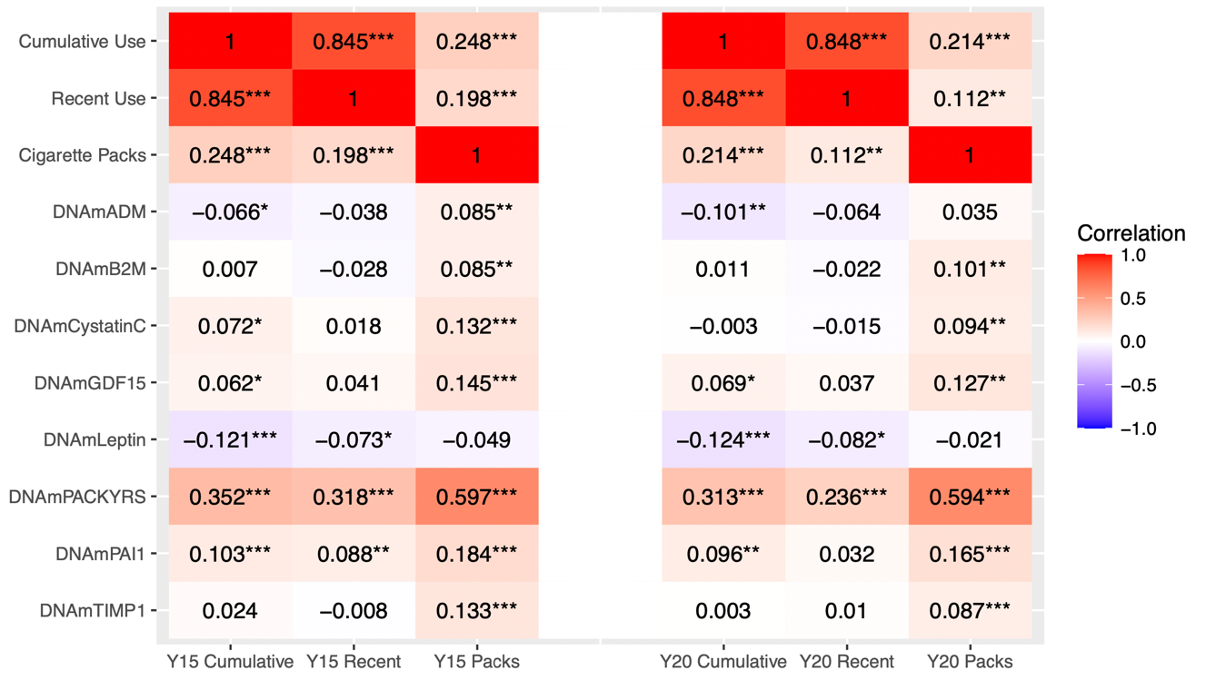

The columns represent marijuana-years, number of days of recent use, and cumulative packs of cigarettes for Y15 and Y20 and the rows represent the DNA methylation-based biomarkers of GrimAge with the Pearson correlation coefficient reported within each box, respectively. ***P<0.001, **P<0.01, *P<0.05.

DNAmADM, adrenomedullin; DNAmB2M, beta-2 microglobulin; DNAmCystatinC, cystatin C; DNAmGDF15, growth differentiation factor 15; DNAmLeptin, leptin; DNAmPACKYRS, smoking pack-years; DNAmPAI1, plasminogen activation inhibitor 1; DNAmTIMP1, tissue inhibitor metalloproteinase 1.

