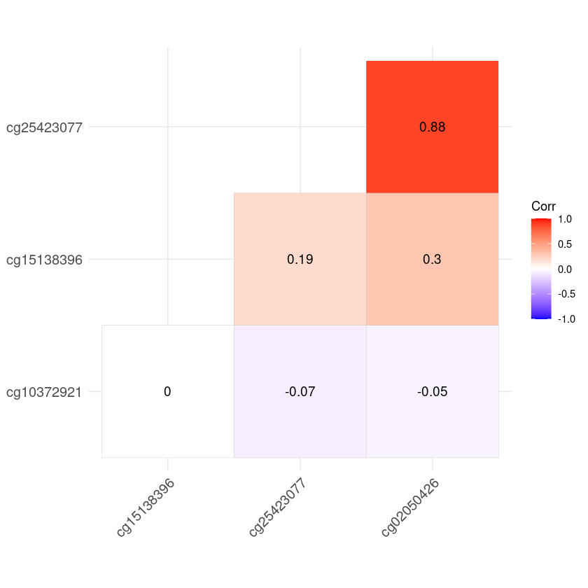
S-Fig 2. Pearson correlations among the four CpGs that mediated the difference in birthweight between newborns conceived naturally and those conceived by fresh embryo transfer.

