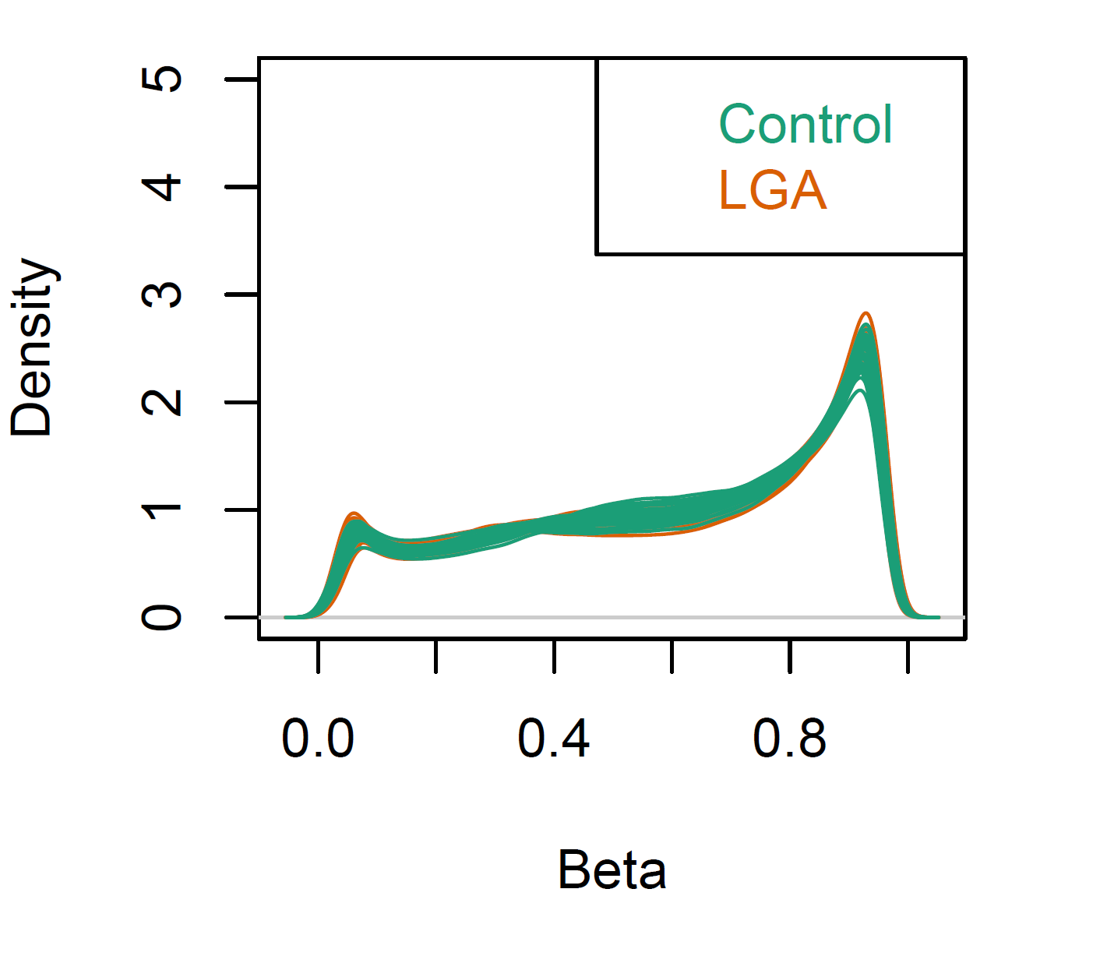

Figure S1. Density plots of beta values in LGA and OGA (control) groups in an epigenome-wide association study of placental DNA methylations. LGA, large-for-gestational age (birth weight>90th percentile); OGA, optimal-for-gestational-age (birth weight 25th-75th percentiles).

