Supplemental Results

Supplemental Figures
(A) Full sample (n=1058) | (B) Excluding self-reported smokers (n=971)
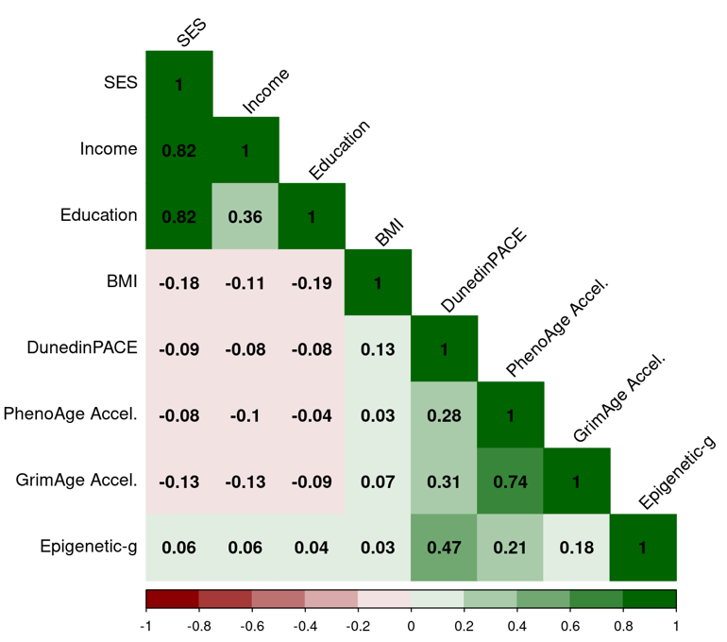 | 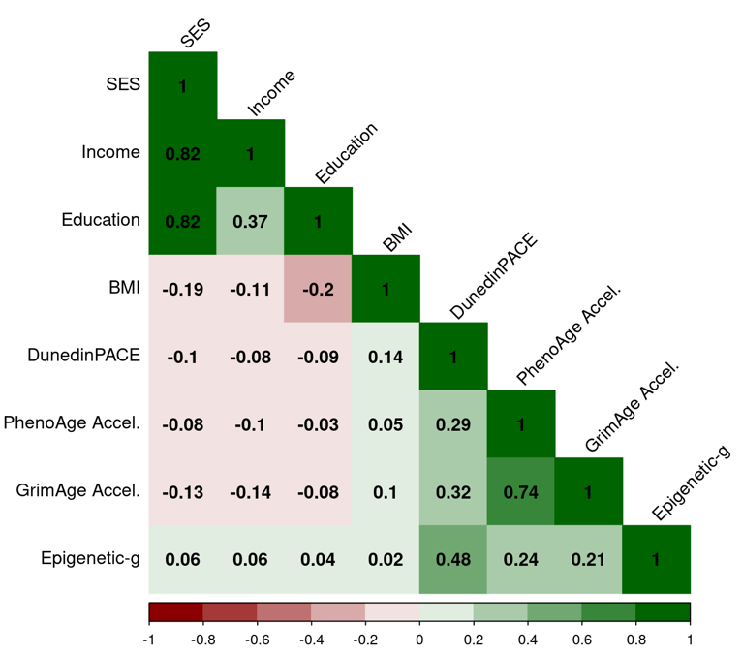
(C) DNAm algorithms residualized for body mass index (n= 876)
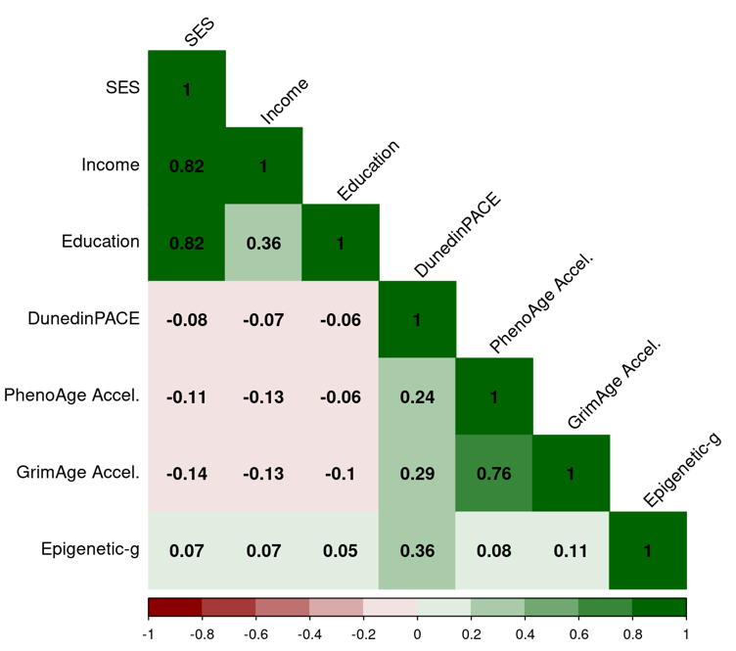
Supplementary Figure S1. Correlation matrix of of socioeconomic variables with buccal DNA-methylation (DNAm) algorithms in (A) full sample, (B) excluding self-reported smokers, and (C) residualizing DNAm algorithms for body mass index (BMI). In all plots DNAm measures were residualized for chronological age. BMI was age- and sex-normed.

