Supplementary information

1. Supplementary tables
Suppl. Table 1. Sample characteristics
 | Normal (19) |  | Adenoma (17) |  | Carcinoma (19)
Characteristic | Number | %from total | Number | %from total | Number | %from total
Sex
Male | 13 | 68,5 | 9 | 53 | 12 | 63
Female | 6 | 31,5 | 8 | 47 | 7 | 37
Age
Median | 66,5 | / | 67,5 | / | 75,5 | /
Interval | 50 - 83 | / | 50 - 82 | / | 56-95 | /
Location
Left | 11 | 57,9 | 10 | 59 | 11 | 57,9
Right | 5 | 26,3 | 6 | 35 | 5 | 26,3
Unknown | 3 | 15,8 | 1 | 6 | 3 | 15,8
Dysplasia
Low-grade | / | / | 15 | 88 | / | /
High-grade | / | / | 2 | 12 | / | /
Type
Tubulo-villous | / | / | 5 | 29 | / | /
Tubular | / | / | 12 | 71 | / | /
* This included paired samples from the same patient: 10 tumor-normal pairs and 1 adenoma-normal pair

Suppl. Table 2. Samples that passed quality control of the in-house generated methylation data
Tissue type | Concentration (ng/µL) | Gender | Age
Nl | 60,8 | Male | 83
LGA (Tb) | 33,6 | Female | 70
CRC | 187 | Female | 72
CRC | 155 | Male | 71
HGA (Tv) | 31,7 | Male | 64
Nl | 22,7 | Male | 63
CRC | 445 | Male | 76
LGA (Tv) | 21,5 | Female | 50
LGA (Tv) | 41,5 | Male | 70
CRC ¹ | 148 | Female | 62
LGA (Tb) | 41,4 | Female | 82
LGA (Tb) | 17,4 | Female | 68
CRC | 118 | Female | 71
LGA (Tb) | 23,2 | Male | 73
LGA (Tv) | 114 | Male | 66
LGA (Tb) | 31,8 | Male | 64
Nl ¹ | 63,2 | Female | 62
LGA (Tb) | 20 | Male | 73
LGA (Tb) | 23,4 | Male | 66
LGA (Tb) | 46,3 | Female | 77
CRC | 56,4 | Female | 72
LGA (Tb) | 29,8 | Male | 67
CRC | 29,1 | Male | 76
CRC ² | 298 | Male | 59
CRC | 155 | Female | 68
Nl ² | 46,2 | Male | 59
Nl | 61,3 | Male | 79

(Nl = normal adjacent, CRC= colorectal cancer, LGA = low grade adenoma, HGA = high grade adenoma, Tb = tubular, Tv= tubulovillous, ^{1,2...} = paired sample)
Suppl. Table 4: Location of DE DMPs in different groups within the genome
Due to the large number of rows, the table is uploaded in a separate file to facilitate access for readers.

Suppl. Table 3: Overview of the datasets used for discovery, double evidencing and validation.
Dataset ID | Adenoma | Carcinoma | Normal | QC Passed Sum | Cohort
EMD_01 | 3 | 2 | 3 | 4 | Validation
EMD_02 | 3 | 2 | 3 | 3 | Validation
EMD_03 | 3 | 3 | 2 | 4 | Validation
EMD_04 | 3 | 3 | 2 | 4 | Validation
EMD_05 | 4 | 2 | 2 | 4 | Validation
EMD_06 | 1 | 1 | 1 | 2 | Validation
EMD_07 | 0 | 4 | 4 | 6 | Validation
EMD_08 | 0 | 2 | 2 | 0 | Validation
E-MTAB-6450 | 16 | 0 | 0 | 16 | Discovery/DE
E-MTAB-7854 | 80 | 0 | 0 | 78 | Discovery/DE
GSE132804 | 0 | 0 | 206 | 206 | Discovery/DE
GSE151732 | 0 | 0 | 256 | 256 | Discovery/DE
GSE166212 | 10 | 32 | 6 | 47 | Discovery/DE
GSE199057 | 0 | 77 | 80 | 156 | Discovery/DE
Sum | 123 | 128 | 567 | 786
GSE106556 | 0 | 0 | 10 | 10 | DE
GSE129364 | 69 | 0 | 3 | 72 | DE
GSE132804 | 0 | 0 | 128 | 128 | DE
GSE139404 | 40 | 0 | 20 | 60 | DE
GSE66555 | 0 | 0 | 43 | 34 | DE
GSE68060 | 0 | 82 | 36 | 118 | DE
GSE77718 | 0 | 96 | 96 | 191 | DE
GSE77955 | 12 | 13 | 14 | 39 | DE
TCGA_READ + COAD) | 0 | 409 | 45 | 454 | DE
Sum | 121 | 600 | 395 | 1106
Legend: EMD = experimental methylation data, E-MTAB= data from array express, GSE= data from GEO. Green = EPIC array data, blue = 450K array data.

Suppl. Table 5: List of significantly enriched gene sets based on functional enrichment analysis of DMPs in adenoma versus carcinoma samples.
Due to the large number of rows, the table is uploaded in a separate file to facilitate access for readers.

Suppl. Table 6: Pathways in GSEA that contain the NEU1 gene
Description | GSEA | ID
Lysosome | KEGG | 4142
neutrophil activation involved in immune response | GO | GO:0002283
neutrophil mediated immunity | GO | GO:0002446
lysosomal membrane | GO | GO:0005765
vacuolar membrane | GO | GO:0005774
carbohydrate catabolic process | GO | GO:0016052
granulocyte activation | GO | GO:0036230
neutrophil activation | GO | GO:0042119
neutrophil degranulation | GO | GO:0043312
lytic vacuole membrane | GO | GO:0098852
carbohydrate derivative catabolic process | GO | GO:1901136
vacuolar lumen | GO | GO:0005775
specific granule | GO | GO:0042581
sphingolipid metabolic process | GO | GO:0006665
secretory granule lumen | GO | GO:0034774
Diseases of glycosylation | Reactome | R-HSA-3781865
Asparagine N-linked glycosylation | Reactome | R-HSA-446203
Neutrophil degranulation | Reactome | R-HSA-6798695

Suppl. Table 7: Overlap between COSMIC genes and significantly enriched genes from KEGG, GO & Reactome gene sets for adenoma versus carcinoma.
Due to the large number of rows, the table is uploaded in a separate file to facilitate access for readers.

2. Supplemental figures
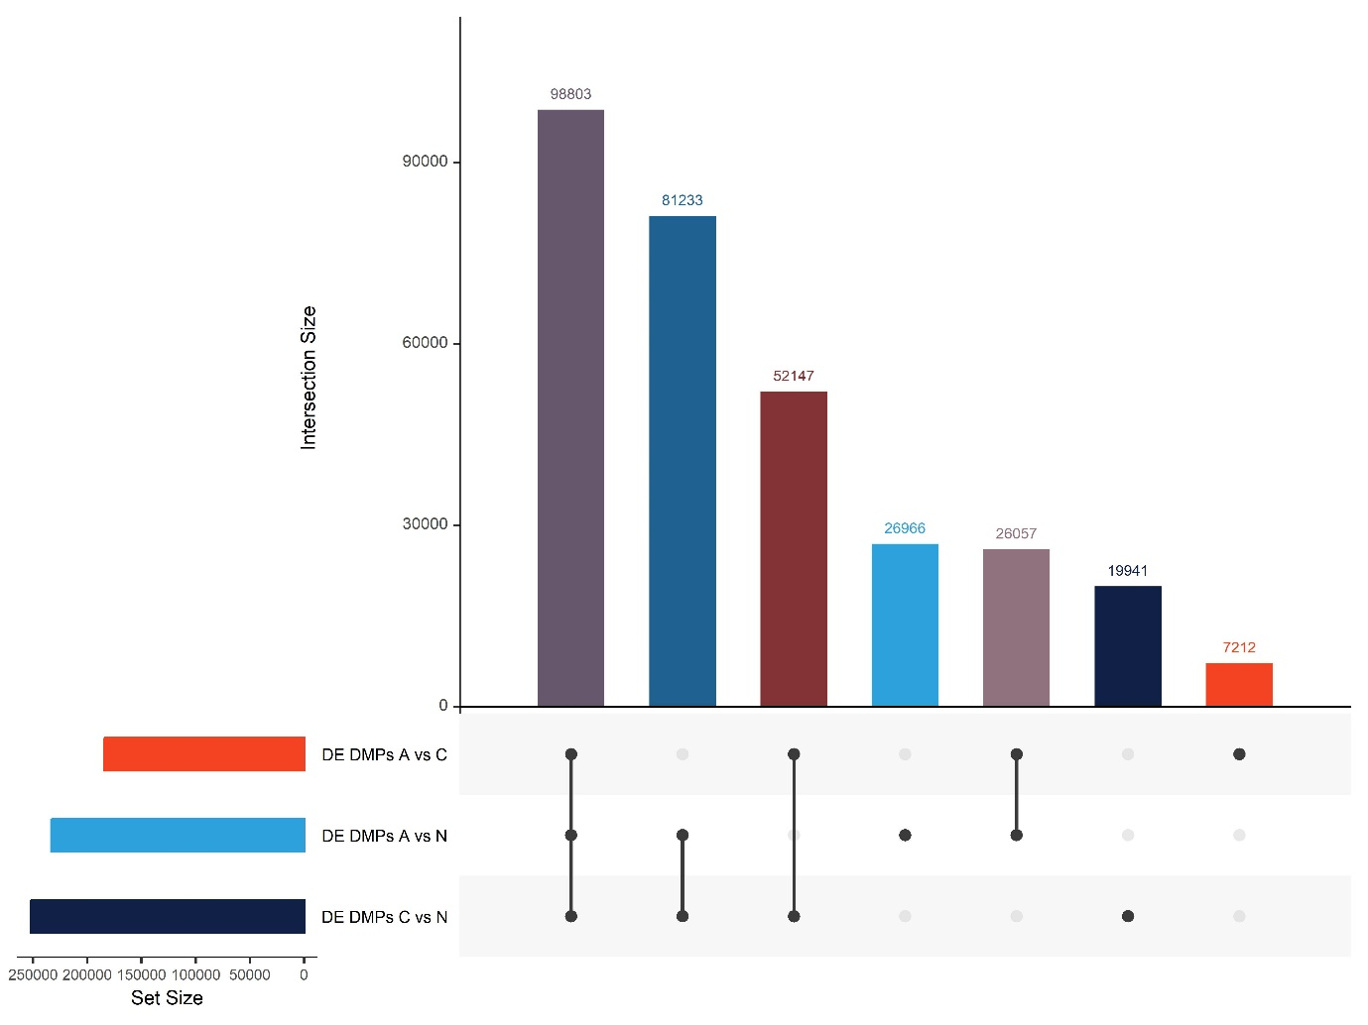
Suppl. Figure 1. Counts of unique and common DE-DMPs in the three different colorectal tissue types. The upset diagram shows the total number of DE DMPs found in the discovery analysis prior to filtering based on |Δβ|. Legend: A= adenoma, N= normal, C= carcinoma

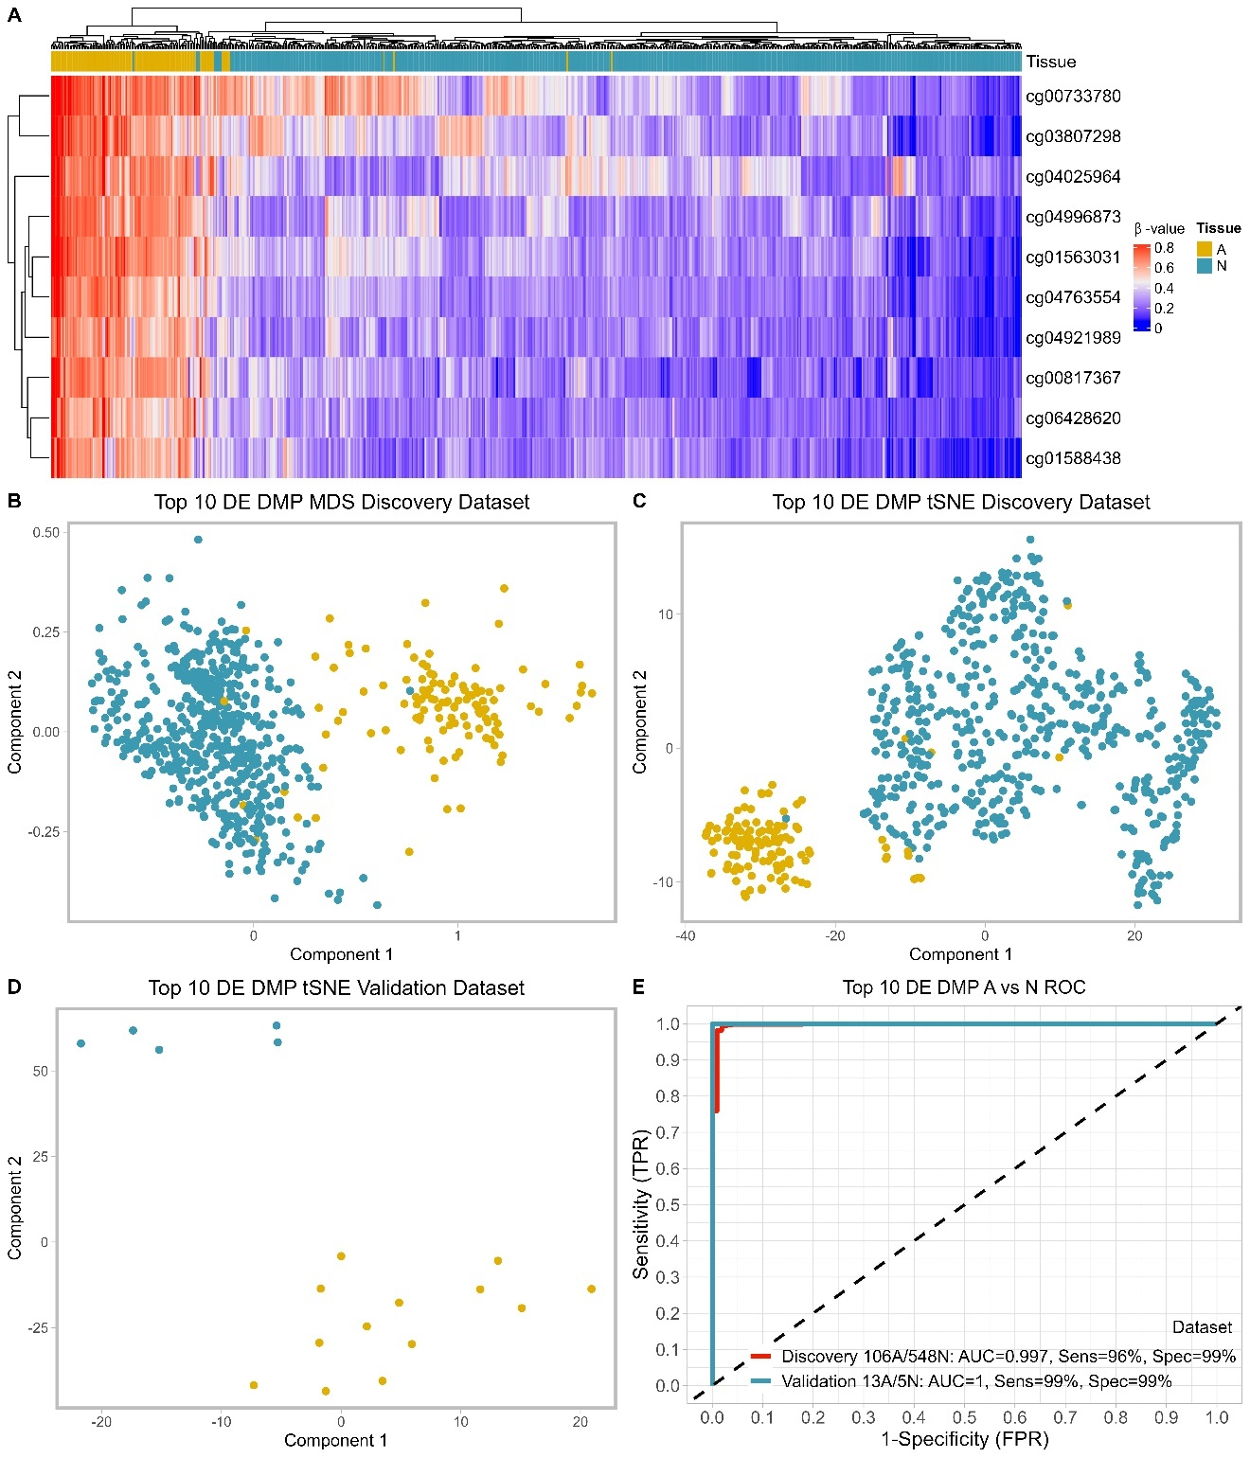
Suppl. Figure 2. The top 10 selected DE DMP markers were effective at classifying adenomas and normal tissues. A. Heatmap and hierarchal clustering analysis of the discovery EPIC dataset based on the top 10 identified DE DMP markers shows a block like structure with most of the markers being hypermethylated in adenomas and hypomethylated in normal tissues. B. MDS clustering of the discovery dataset using the 10 markers shows 2 distinct clusters. C. tSNE clustering of the discovery dataset using the 10 markers could also resolve the two tissue types. D. tSNE clustering of the validation dataset using the 10 markers shows a clear separation between adenomas and normal tissues. E. ROC curves for the final top 10 DE DMP classifier model for both discovery and validation datasets from EPIC arrays. Sensitivity and specificity, for distinguishing between adenomas and normal tissues, at various cut-off values for the datasets are plotted. The diagonal dotted line represents the line of no discrimination between tumor and normal tissues. DE DMP: double evidenced differentially methylated probes, ROC: receiver operating characteristic, MDS: multidimensional scaling, tSNE: t-distributed stochastic neighbor embedding, TPR: true positive rate, FPR: false positive rate, A: adenoma, N: normal tissue.

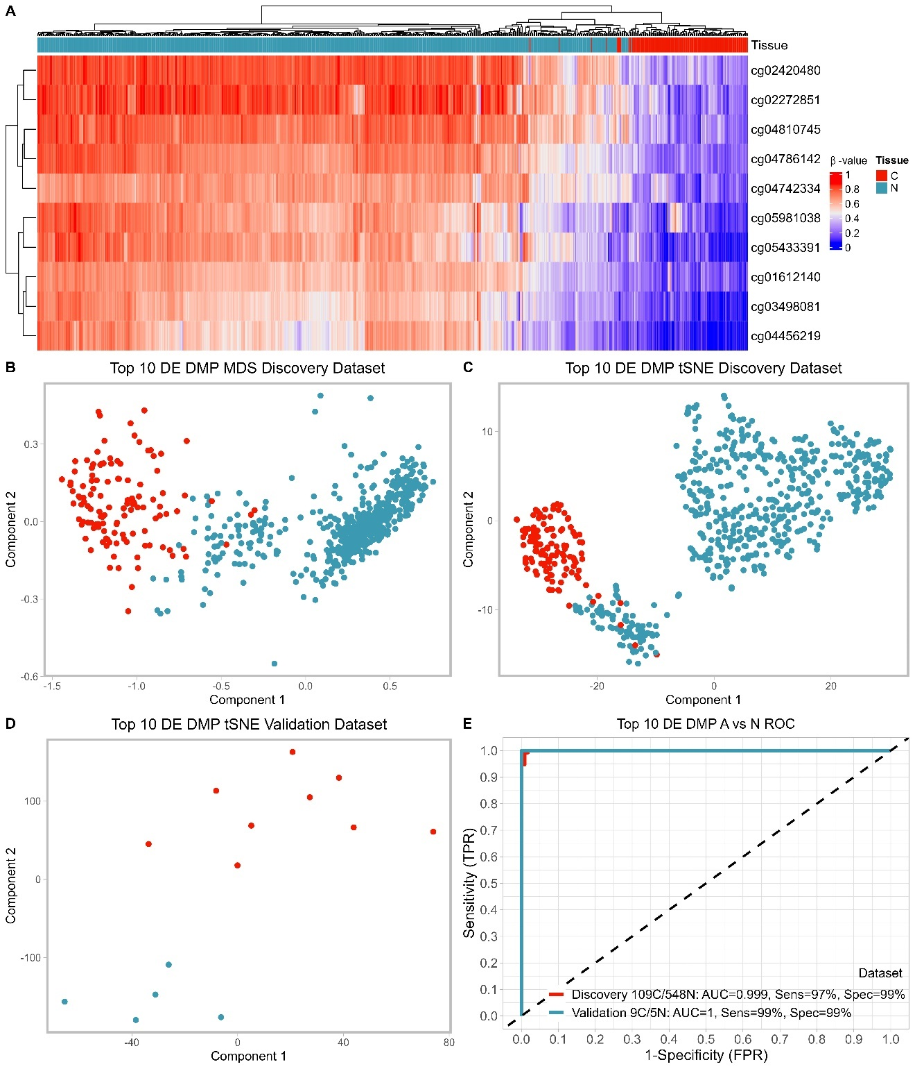
Suppl. Figure 3. The top 10 selected DE DMP markers were effective at classifying carcinomas and normal tissues. A. Heatmap and hierarchal clustering analysis of the discovery EPIC dataset based on the top 10 identified DE DMP markers shows a block like structure with most of the markers being hypomethylated in carcinomas and hypermethylated in normal tissues. B. MDS clustering of the discovery dataset using the 10 markers shows 2 distinct clusters. C. tSNE clustering of the discovery dataset using the 10 markers could also resolve the two tissue types. D. tSNE clustering of the validation dataset using the 10 markers shows a clear separation between carcinomas and normal tissues. E. ROC curves for the final top 10 DE DMP classifier model for both discovery and validation datasets from EPIC arrays. Sensitivity and specificity, for distinguishing between carcinomas and normal tissues, at various cut-off values for the datasets are plotted. The diagonal dotted line represents the line of no discrimination between tumor and normal tissues. DE DMP: double evidenced differentially methylated probes, ROC: receiver operating characteristic, MDS: multidimensional scaling, tSNE: t-distributed stochastic neighbor embedding, TPR: true positive rate, FPR: false positive rate, C: carcinoma, N: normal tissue.

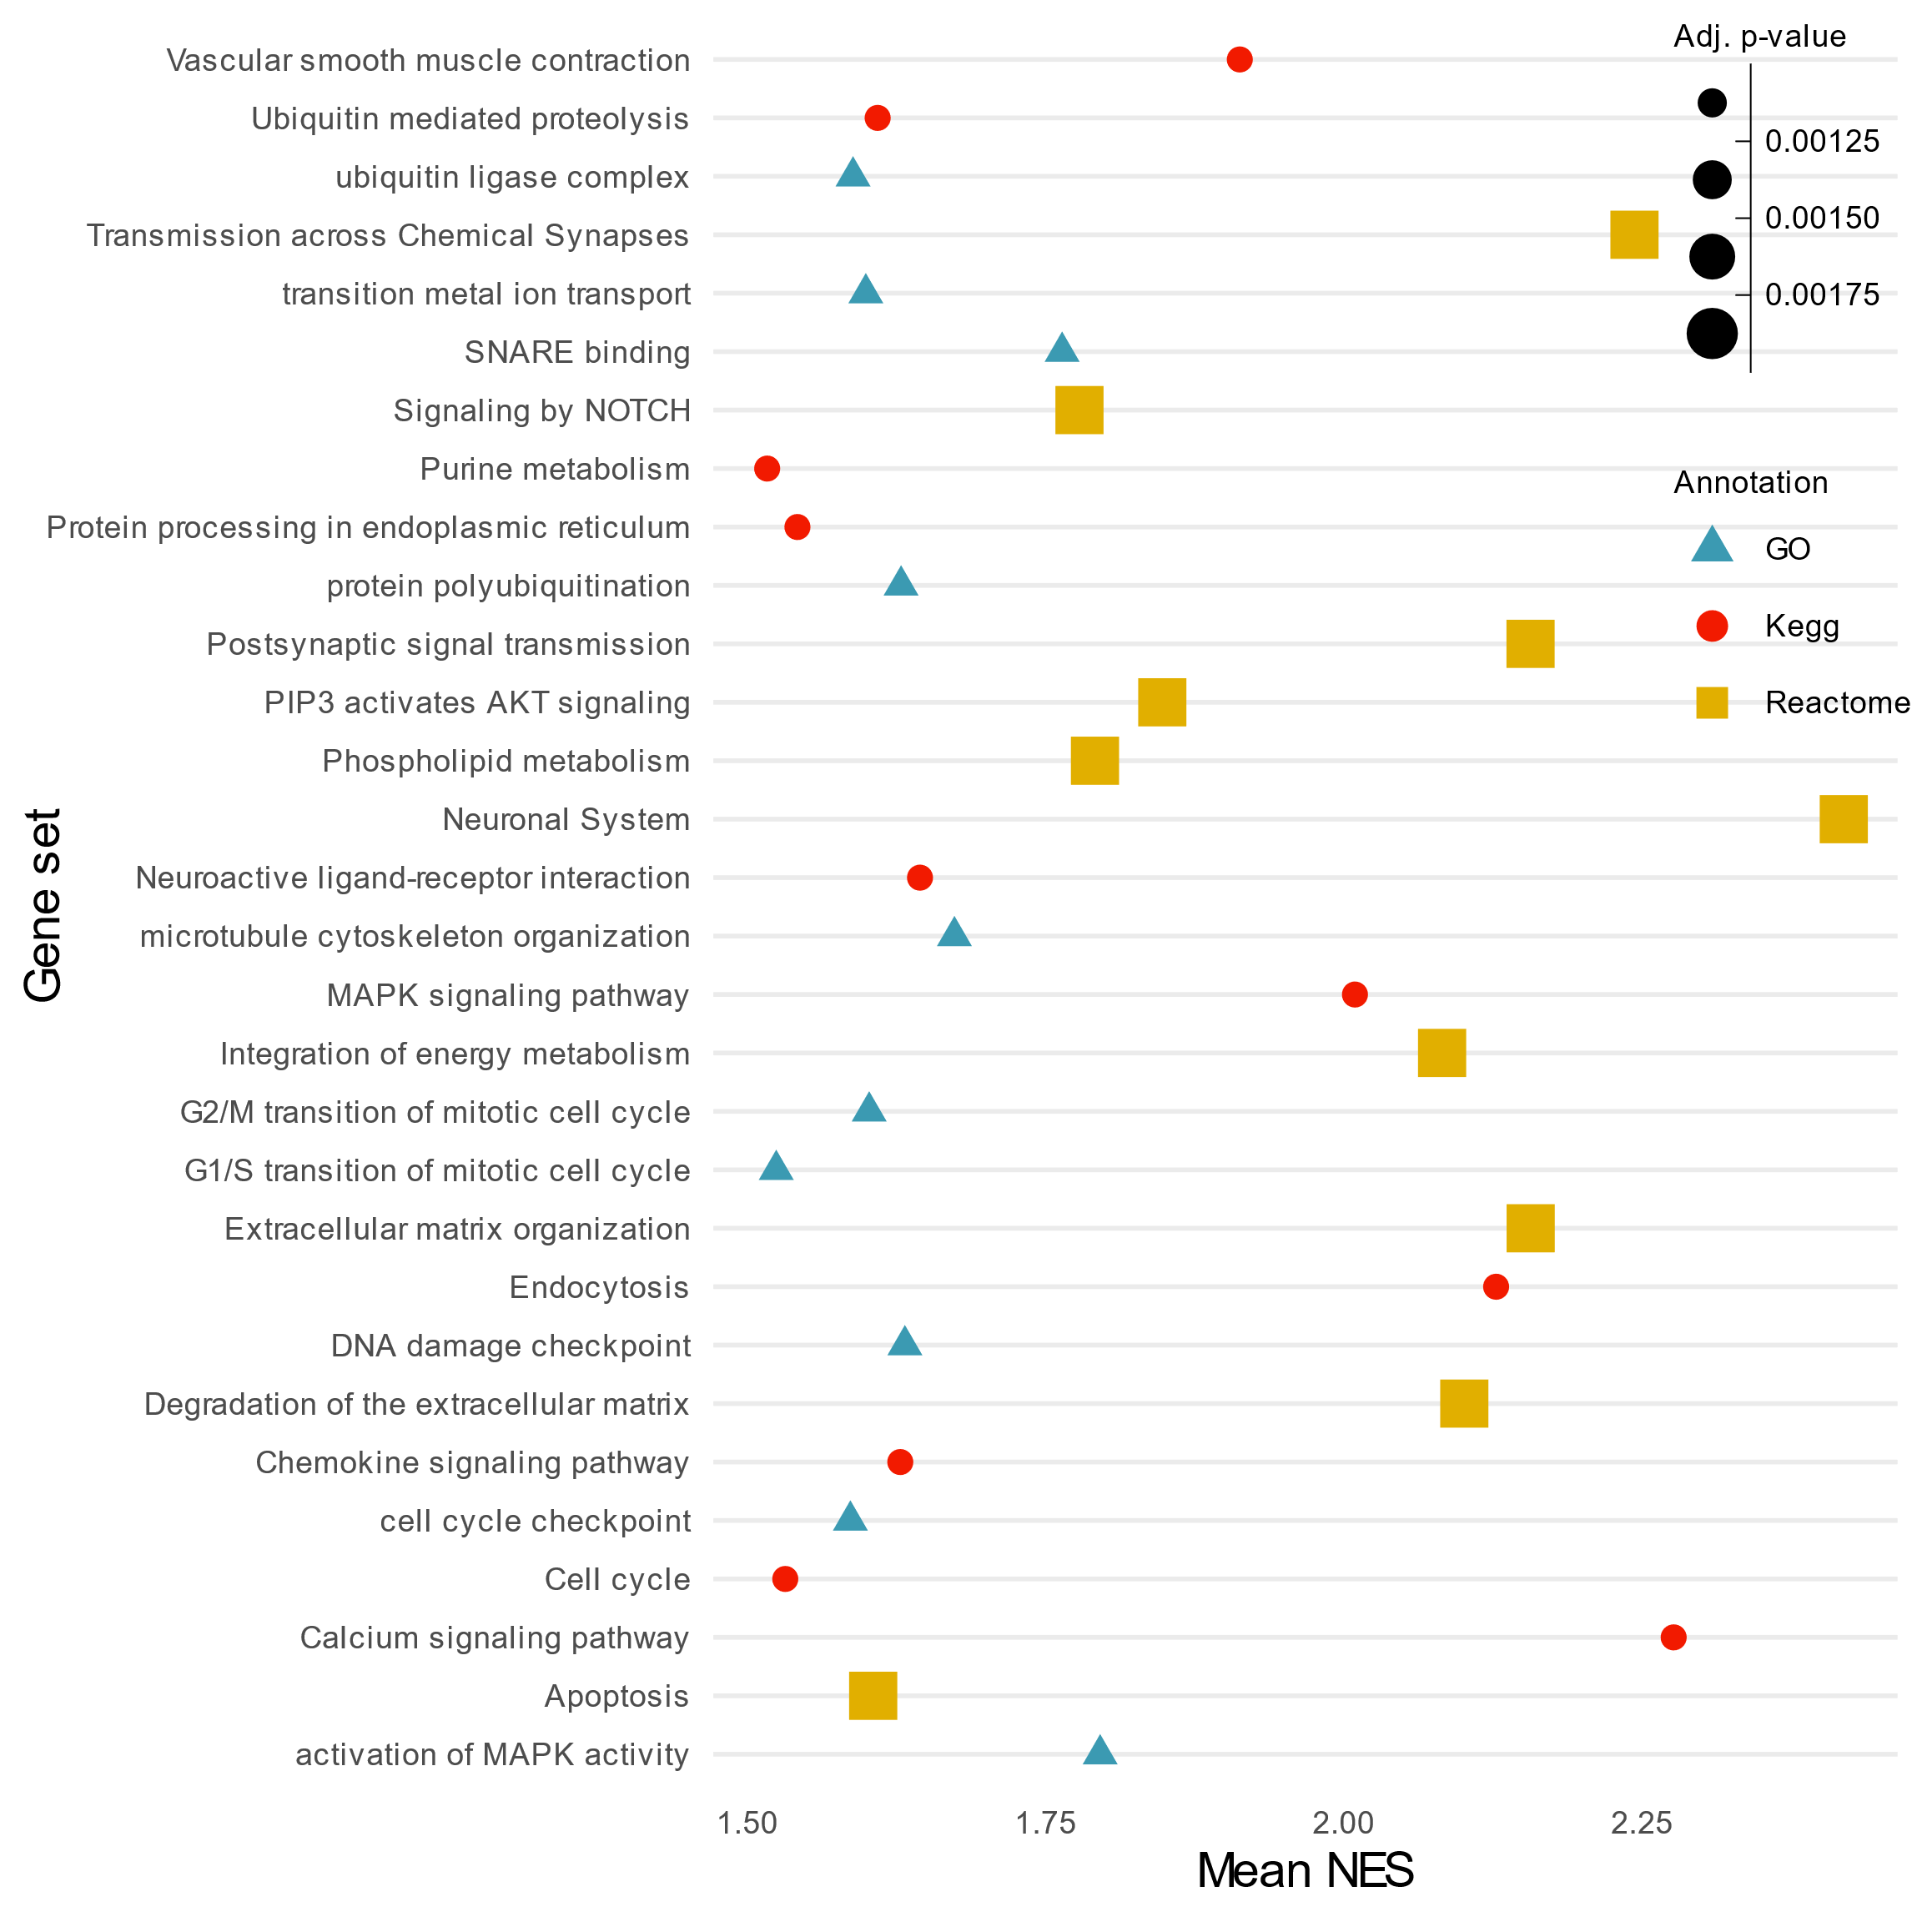
Suppl. Figure 4. Dot plot outlining the gene set enrichment analysis (GSEA) results based on the GO, KEGG, and Reactome gene sets. The top 10 most significantly enriched gene sets (FDR ≤ 0.05) in each category are shown. The dot size corresponds to the adjusted p-value of each gene set while the normalized enrichment score (NES) is shown on the x-axis.

