Additional file 6. Epigenome-wide association plot (-log10 p-values) for maternal 2h-post OGTT glucose levels.
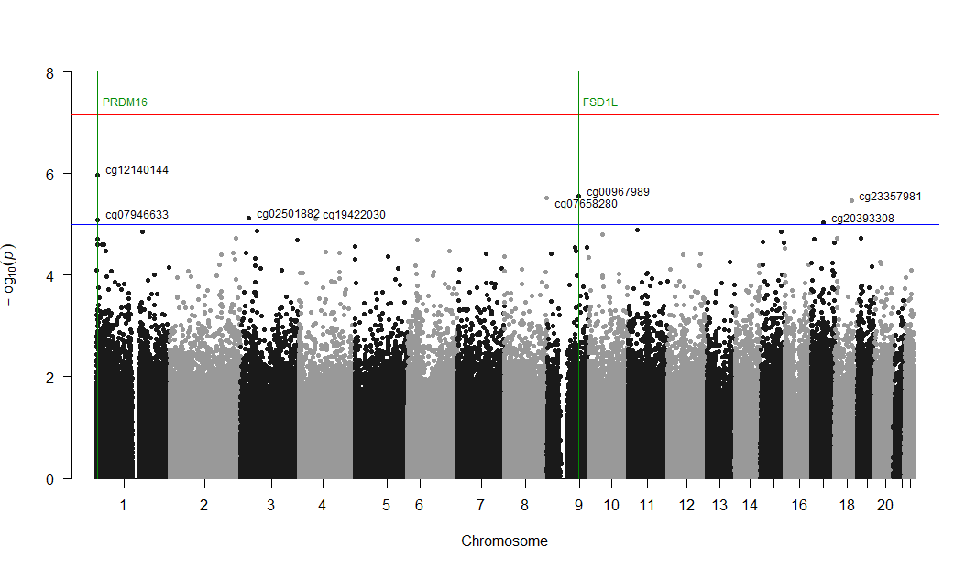
Manhattan plot for the EWAS of maternal 2h post-75g-OGTT glucose levels with DNAm measured longitudinally at birth and 5 years of age (red line: Bonferroni threshold= p-value<6.9 x10⁻⁸; blue line: Suggestive threshold= P<1.0 x10⁻⁵).

