Evaluation of Pediatric Epigenetic Clocks Across Multiple Tissues

Additional File 2
Supplementary Figures
Supplementary Figure 1 2
Supplementary Figure 2 3
Supplementary Figure 3 4
Supplementary Figure 4 5
Supplementary Figure 5 6
Supplementary Figure 6 7
Supplementary Figure 7 8
Supplementary Figure 8 9

Supplementary Figure 1. The distribution of CpGs across the genome for all 7 epigenetic clocks.
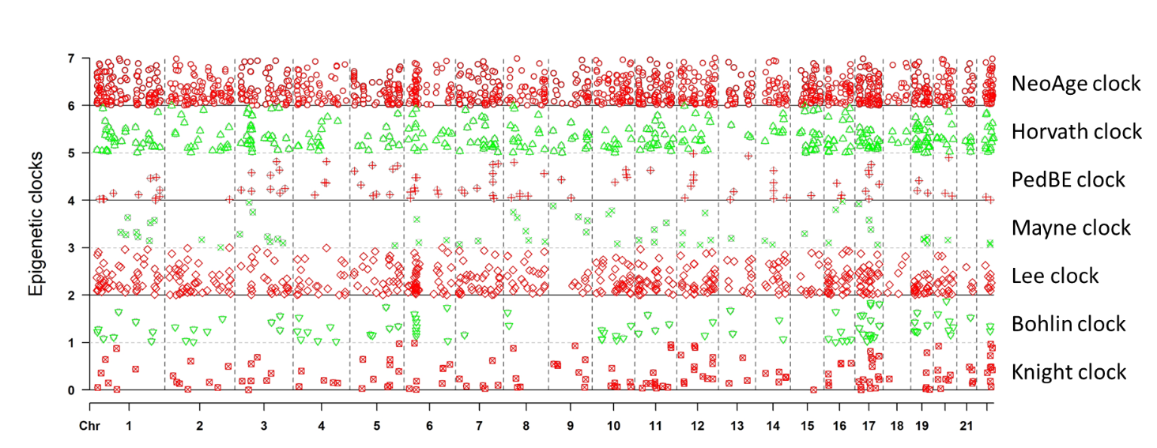

Supplementary Figure 2. Comparison of Knight clock and Bohlin clock for cord blood samples using 27K array across White and Black groups.
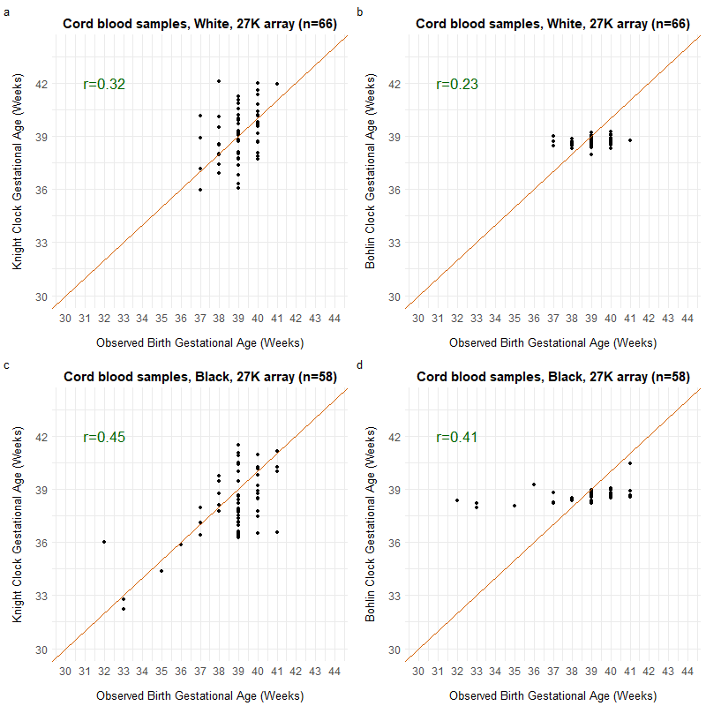

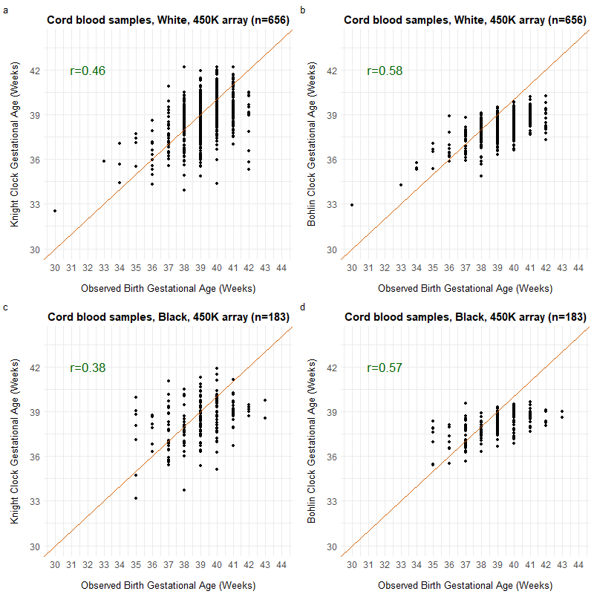
Supplementary Figure 3. Comparison of Knight clock and Bohlin clock for cord blood samples using 450K array across White and Black groups.

Supplementary Figure 4. Comparison of Knight clock and Bohlin clock for cord blood samples using EPIC array across White and Black groups.
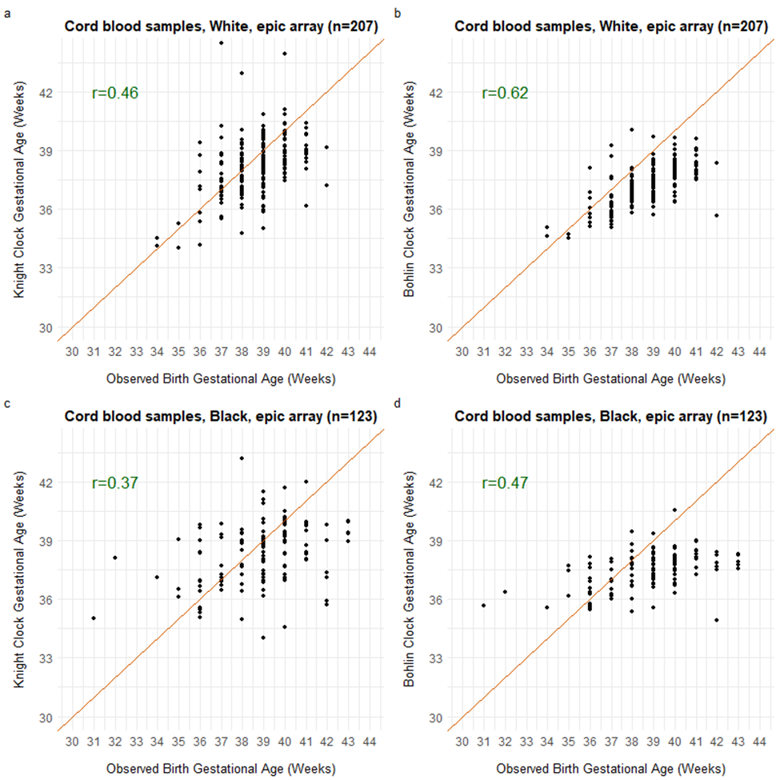

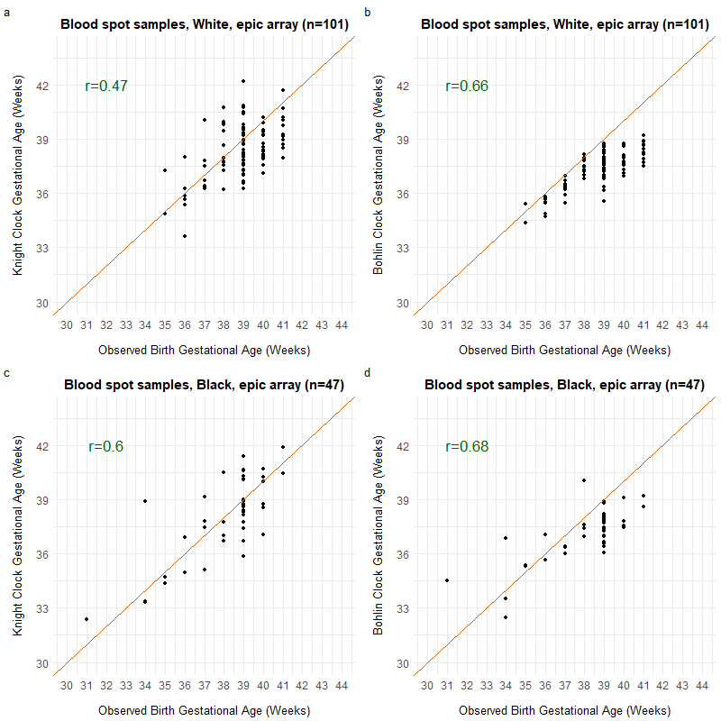
Supplementary Figure 5. Comparison of Knight clock and Bohlin clock for blood spot samples collected at birth for normal term infants using EPIC array across White and Black groups.

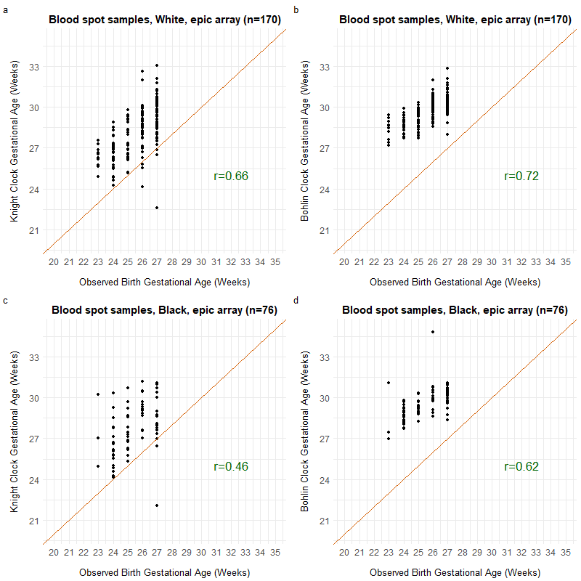
Supplementary Figure 6. Comparison of Knight clock and Bohlin clock for blood spot samples collected at birth for preterm infants using EPIC array across White and Black groups.

Supplementary Figure 7. Comparison of Lee clock and Mayne clock for placental samples collected at birth for preterm infants using EPIC array across White and Black groups.
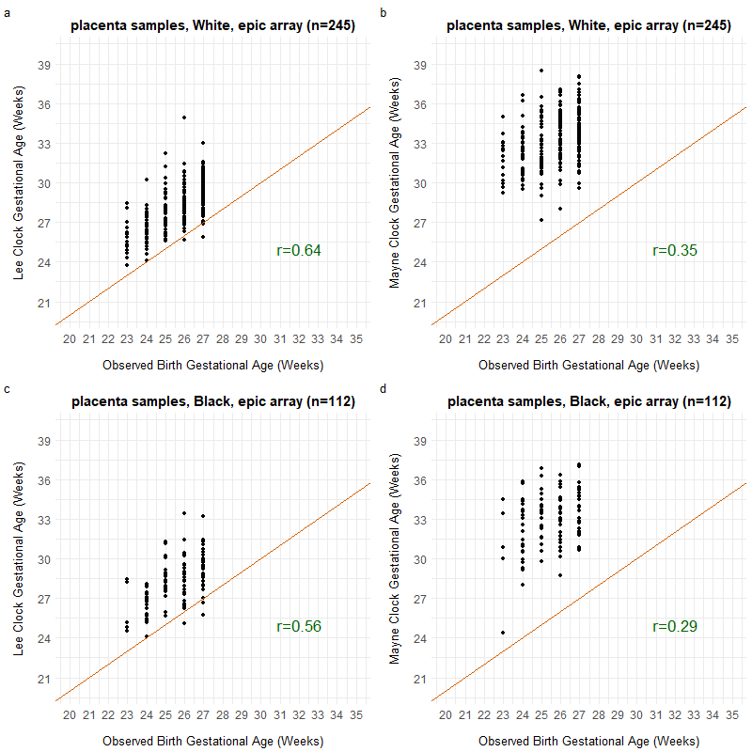

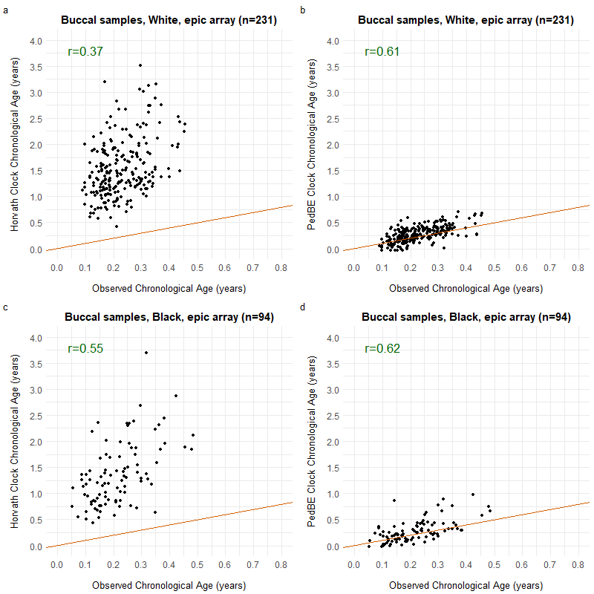
Supplementary Figure 8. Comparison of Horvath clock and PedBE clock for buccal samples collected within the first year after birth for preterm infants using EPIC array across White and Black groups.

