Supplementary Table 1. Enrichment Analysis p-values
Sleep measurement | Hypergeometric test p-value | Permutation p-value
Bedtime (Self-Report) | 0.007* | 0.036*
Bedtime (ACT) | 0.5 | 0.76
Bedtime (PSG) | 0.0003* | 0.005*
SOL (Self-Report) | 0.18 | 0.36
SOL (ACT) | 0.18 | 0.39
SOL (PSG) | 0.57 | 0.76
SOT (Self-Report) | 0.0001* | 0.003*
SOT (ACT) | 0.64 | 0.82
SOT (PSG) | 0.13 | 0.28
* Statistically Significant p < 0.05

Figure S1. Manhattan Plots of adjusted P-values
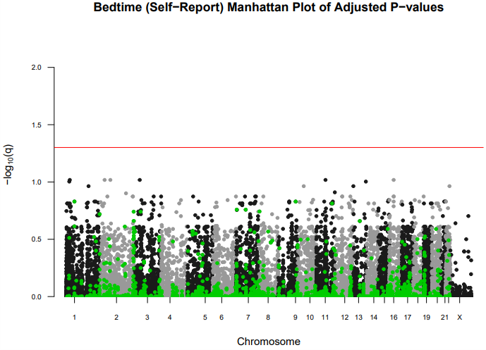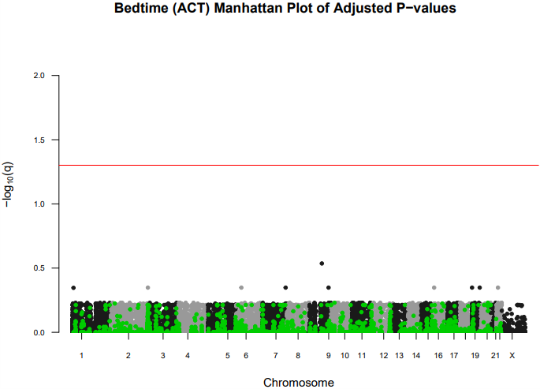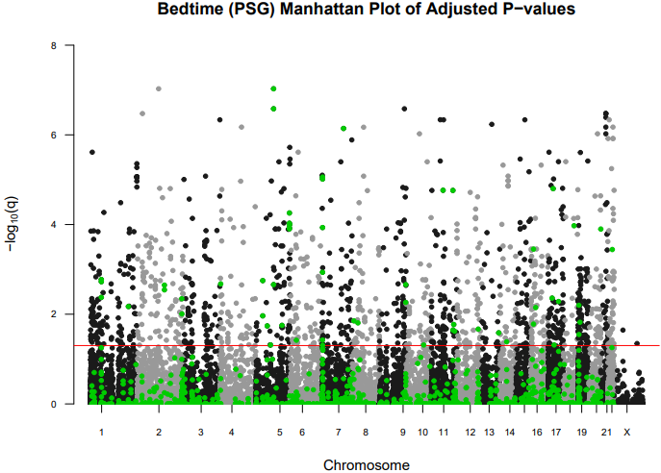

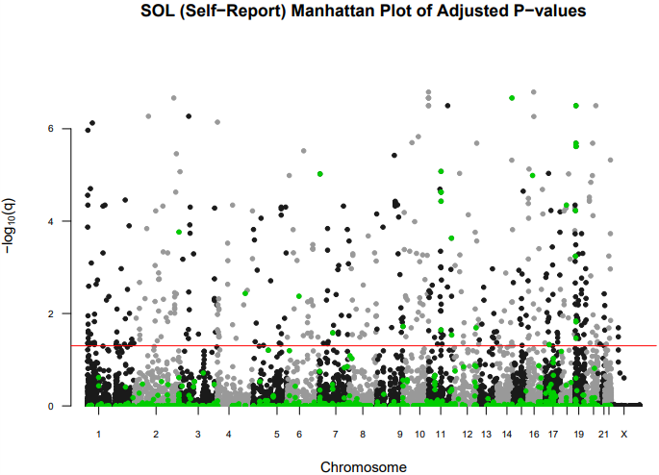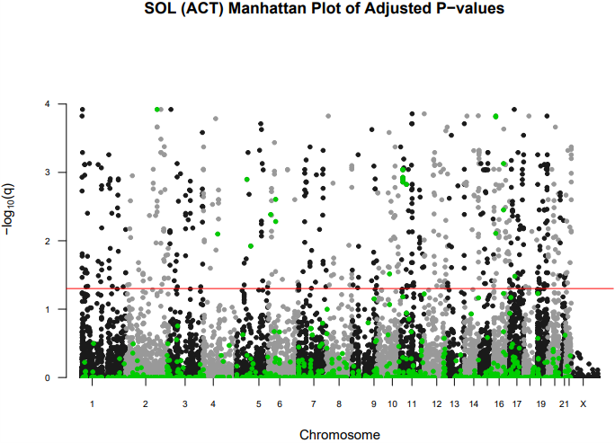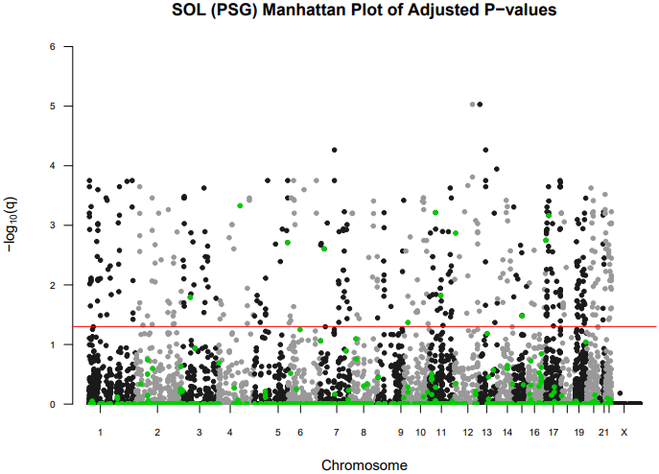

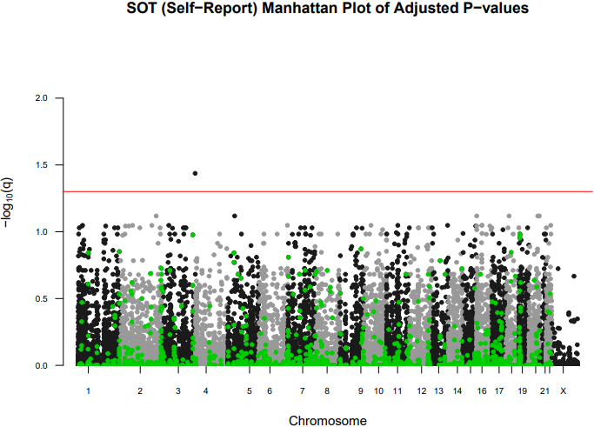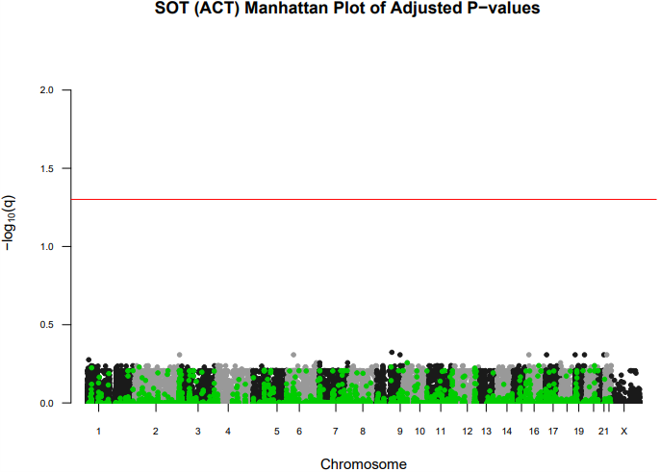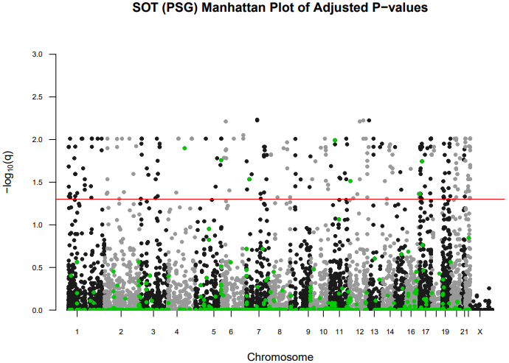
All represented sites fall either within genes or within specific proximities to genes: 1500 base pairs upstream or 500 base pairs downstream. The green dots specifically highlight the methylation sites that are within or near genes identified by previous genome-wide association studies (GWAS), while the remaining sites are associated with other genes. Red lines indicate a threshold where the q-value is less than 0.05. These q-values represent p-values that have been adjusted using the Benjamini and Hochberg method.

