Supplementary Figures

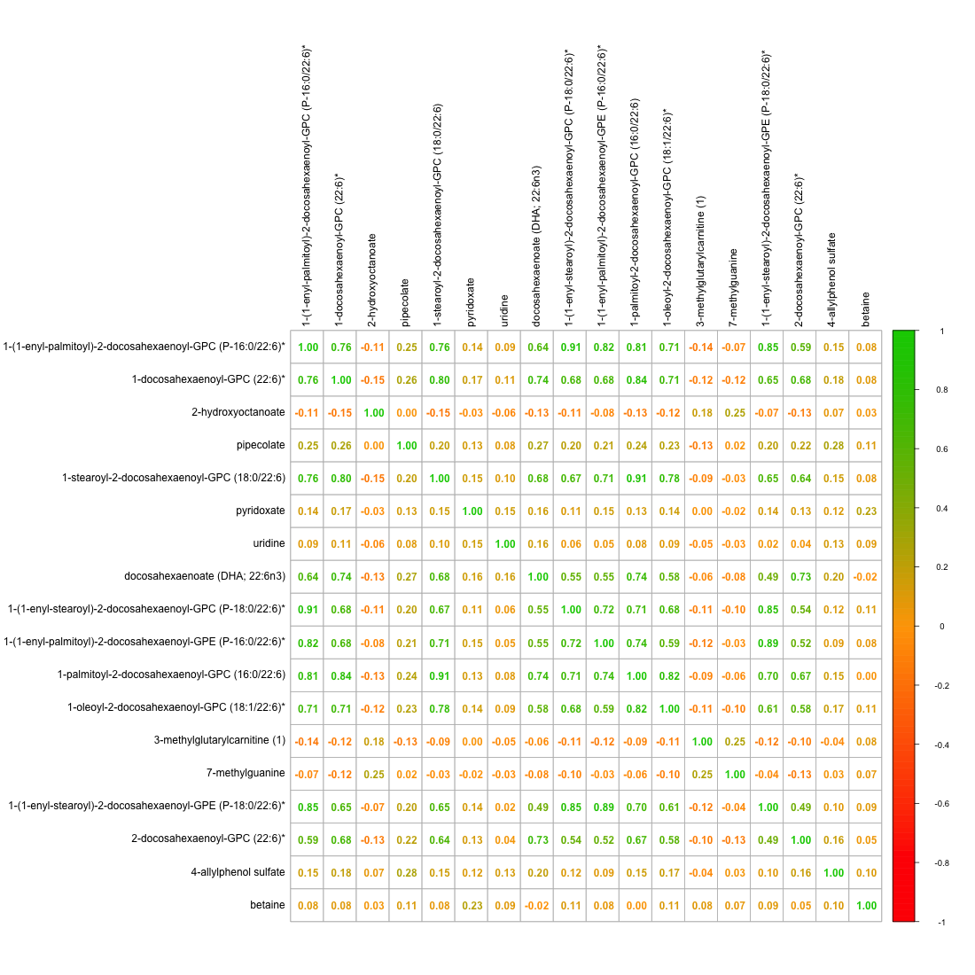
  - Supplementary Figure 1. Correlation matrix of the serum levels of the metabolomic biomarkers identified.

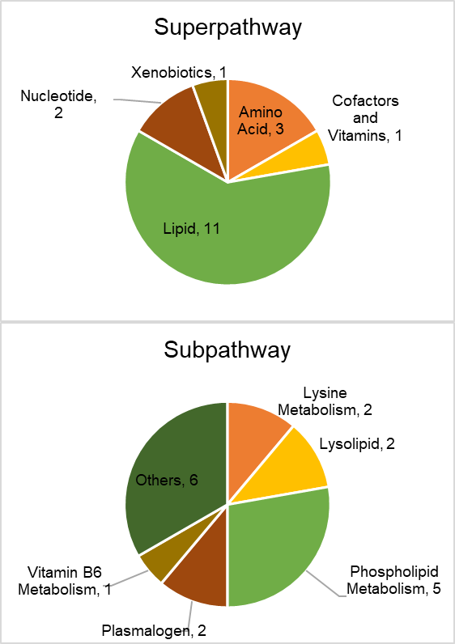
  - Supplementary Figure 2. Pathway annotations of the 18 metabolomic biomarker identified for folate and vitamins B6 and B12 (Bonferroni-adj. p < 0.05).

