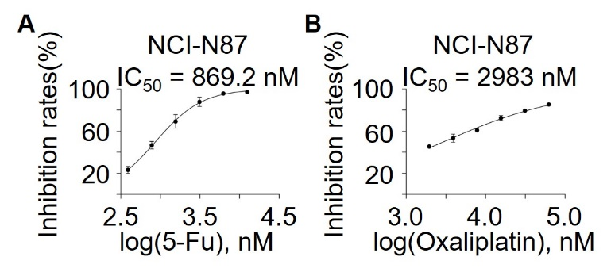
Supplementary Fig. 1
IC50 determination of genotoxic agents in N87 cells
A-B, Dose-response assay in NCI-N87 cells was used to determine the IC₅₀ of indicated genetoxic drug.

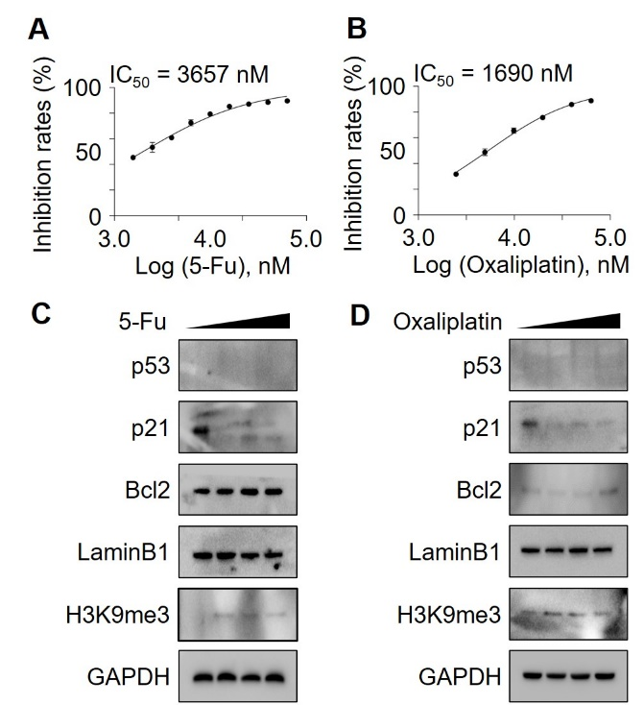
Supplementary Fig. 2
Low doses of genotoxic agents fail to active p53 signaling and trigger senescence in HGC27
A-B, Dose-response assay in HGC27 cells was used to determine the IC₅₀ of indicated genetoxic drug. C-D, HGC27 cells were treated with low dose of indicated genotoxic drug, followed by IB analysis as indicated.

