RNA Sequencing Coverage and Quality Statistics
1. RNA quantification and qualification
RNA integrity was assessed using the RNA Nano 6000 Assay Kit of the Bioanalyzer 2100 system (Agilent Technologies, CA, USA).
2. Library preparation for Transcriptome sequencing
Total RNA was used as input material for the RNA sample preparations. Briefly, mRNA was purified from total RNA using poly-T oligo-attached magnetic beads. Fragmentation was carried out using divalent cations under elevated temperature in First Strand Synthesis Reaction Buffer(5X). First strand cDNA was synthesized using random hexamer primer and M-MuLV Reverse Transcriptase, then use RNaseH to degrade the RNA. Second strand cDNA synthesis was subsequently performed using DNA Polymerase I and dNTP. After adenylation of 3’ ends of DNA fragments, Adaptor with hairpin loop structure were ligated to prepare for hybridization. In order to select cDNA fragments of preferentially 370~420 bp in length, the library fragments were purified with AMPure XP system (Beckman Coulter, Beverly, USA). Then PCR was performed with Phusion High-Fidelity DNA polymerase, Universal PCR primers and Index (X) Primer. At last, PCR products were purified (AMPure XP system) and library quality was assessed on the Agilent Bioanalyzer 2100 system.
3. Clustering and sequencing
The clustering of the index-coded samples was performed on a cBot Cluster Generation System using TruSeq PE Cluster Kit v3-cBot-HS (Illumia) according to the manufacturer’s instructions. After cluster generation, the library preparations were sequenced on an Illumina Hiseq-PE150 platform and 150 bp paired-end reads were generated.
4. Data Analysis and Quality control
Raw data (raw reads) of fastq format were firstly processed through in-house perl scripts. In this step, clean data (clean reads) were obtained by removing reads containing adapter, reads 1 containing N base and low quality reads from raw data. At the same time, Q20, Q30 and GC content the clean data were calculated. All the downstream analyses were based on the clean data with high quality.
5. Reads mapping to the reference genome
Reference genome and gene model annotation files were downloaded from genome website directly. Index of the reference genome was built using Hisat2 v2.0.5 and paired-end clean reads were aligned to the reference genome using Hisat2 v2.0.5. We selected Hisat2 as the mapping tool for that Hisat2 can generate a database of splice junctions based on the gene model annotation file and thus a better mapping result than other non-splice mapping tools.
6. Quantification of gene expression level
FeatureCounts v1.5.0-p3 was used to count the reads numbers mapped to each gene. And then FPKM of each gene was calculated based on the length of the gene and reads count mapped to this gene. FPKM, expected number of Fragments Per Kilobase of transcript sequence per Millions base pairs sequenced, considers the effect of sequencing depth and gene length for the reads count at the same time, and is currently the most commonly used method for estimating gene expression levels.

Supplementary Tables and Figures

Table S1 Primers of BSP and RT-qPCR for BTG1
Primer | Experiment | Sequence
BTG1 forward | RT-qPCR | CAAGGGATCGGGTTACCGTTGT
BTG1 reverse | RT-qPCR | AGCCATCCTCTCCAATTCTGTAGG
BTG1 forward | BSP | TTTTAGGGTGGAATAGAAATGGTT
BTG1 reverse | BSP | ACCCATTTAAAAACAACCCTACC
GAPDH forward | RT-qPCR | GCACCGTCAAGGCTGAGAAC
GAPDH reverse | RT-qPCR | TGGTGAAGACGCCAGTGGA

Table S2 siRNA sequence of BTG1
Primer | Sequence
siRNA-1forward | GGAGCUGCUGGCAGAACAUUATT
siRNA-1reverse | UAAUGUUCUGCCAGCAGCUCCTT
siRNA-2forward | GCAAAUGGUAGACAGCCGAAUTT
siRNA-2reverse | AUUCGGCUGUCUACCAUUUGCTT
siRNA-3forward | CCGUUGUAUUCGCAUCAACCATT
siRNA-3reverse | UGGUUGAUGCGAAUACAACGGTT
NC forward | UUCUCCGAACGUGUCACGUTT
NC reverse | ACGUGACACGUUCGGAGAATT

Table S3 Datasets information
Datasets | Platform | Samples information | Induction regimen | Time
GSE103424 | GPL18573 (Illumina NextSeq 500) | 36 newly diagnosed AML: 18 achieved CR, 18 achieved non-CR | “7+3” regimen | 2019
GSE164894 | GPL24676 (Illumina NovaSeq 6000) | 24 newly diagnosed AML：15 achieved CR，9 achieved non-CR | “7+3” regimen | 2021

Table S4 Clinical characteristics of AML patients detected with BTG1
Characteristics | Training cohort,  n=36  n (%)/Median (IQR) | Verification cohort, n=18  n (%)/Median (IQR) | P value
Sex |  |  | 0.784
Male | 23(63.9) | 12(66.7)
Female | 13(36.1) | 6(33.3)
Age, years | 51(42-57) | 51(40-55) | 0.638
WBC, ×10⁹/L | 15.98(2.99-52.14) | 30.66(11.57-43.79) | 0.377
Hemoglobin (g/L) | 76.5(63.7-105.3) | 73.0(59.0-86.0) | 0.391
PLT, ×10⁹/L | 33.0(15.3-51.3) | 34.0(15.0-59.0) | 0.676
Bone marrow blast cells, % | 67.7(40.5-87.5) | 68.5(45.3-88.0) | 0.407
FAB type |  |  | 0.783
M1 | 8(22.2) | 6(33.3)
M2 | 10(27.8) | 6(33.3)
M4 | 3(8.3) | 1(5.6)
M5 | 14(38.9) | 5(27.8)
Unknown | 1(2.7) | 0(0)
Molecular abnormality
FLT3-ITD mutation | 8(22.2) | 4(22.2) | 1.000
DNMT3A mutation | 2(5.6) | 2(11.1) | 0.854
TET2 mutation | 4(11.1) | 2(11.1) | 1.000
IDH1/2 mutation | 5(13.9) | 2(11.1) | 0.775
Complex karyotype | 1(2.7) | 1(5.6) | 0.610
Prognosis stratification |  |  | 0.802
Low-risk | 9(25.0) | 6(33.3)
Median-risk | 15(41.7) | 7(38.9)
High-risk | 12(33.3) | 5(27.8)

Table S5 Comparison of clinical characteristics between low and high BTG1 expression
Characteristics | Low expression,  n=40  n (%)/Median (IQR) | High expression, n=14  n (%)/Median (IQR) | P value
Sex |  |  | 0.547
Male | 25(62.5) | 10(71.4)
Female | 15(37.5) | 4(28.6)
Age, years | 53(42-58) | 44(36-55) | 0.163
WBC, ×10⁹/L | 25.98(2.99-47.14) | 38.66(11.57-52.29) | 0.438
Hemoglobin (g/L) | 78.5(65.5-108.2) | 68.0(59.0-94.0) | 0.342
PLT, ×10⁹/L | 29.0(13.5-55.5) | 34.0(15.0-62.0) | 0.578
Bone marrow blast cells, % | 65.5(38.5-85.0) | 72.5(48.0-88.0) | 0.481
FAB type |  |  | 0.928
M1 | 10(25.0) | 4(28.6)
M2 | 11(27.5) | 5(35.7)
M4 | 3(7.5) | 1(7.1)
M5 | 15(37.5) | 4(28.6)
Unknown | 1(2.5) | 0(0)
Molecular abnormality
FLT3-ITD mutation | 9(22.5) | 3(21.4) | 0.934
DNMT3A mutation | 2(5.0) | 2(14.3) | 0.583
TET2 mutation | 4(10.0) | 2(14.3) | 1.000
IDH1/2 mutation | 5(12.5) | 2(14.3) | 0.864
Complex karyotype | 1(2.5) | 1(7.1) | 1.000
Prognosis stratification |  |  | 0.963
Low-risk | 11(27.5) | 4(28.6)
Median-risk | 16(40.0) | 6(42.9)
High-risk | 13(32.5) | 4(28.6)
CR/CRi | 39(97.5) | 7(50.0) | <0.001
MRD negativity | 34(85.0) | 2(14.3) | <0.001
CR_{MRD negativity} | 34(87.2) | 2(28.6) | 0.003

Fig. S1 The close association of gene expression and methylation density in BTG1 (from MEXPRESS, the red arrow indicated the association with r=-0.503, P<0.001).

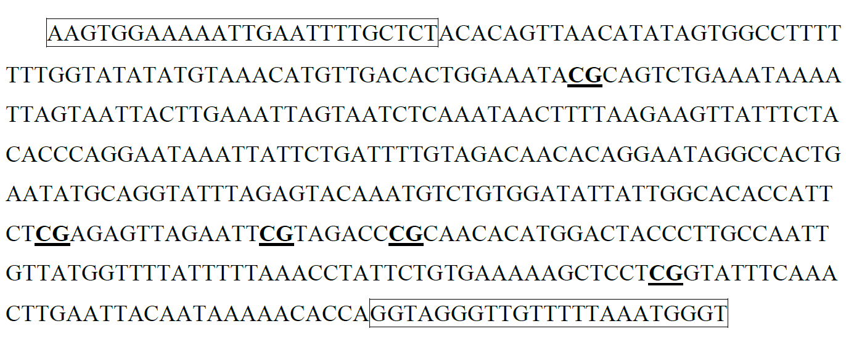
Fig. S2 The sequence on 3’UTR used for designing primer. This sequence is consisted of 416 bases and contains five CpG sites (bold and underline). The sequence within the box were the primer used for BSP of BTG1.

Fig. S3 The methylation density of promoter and gene expression of BTG1 in AML patients. (A) The insignificant association of the methylation density and gene expression of BTG1. (B) The comparison of methylation density of BTG1 promoter and 3’UTR in the same patient before and after treatment with decitabine + IA regimen (the black beads presented methylated sites, the white beads presented unmethylated sites).

