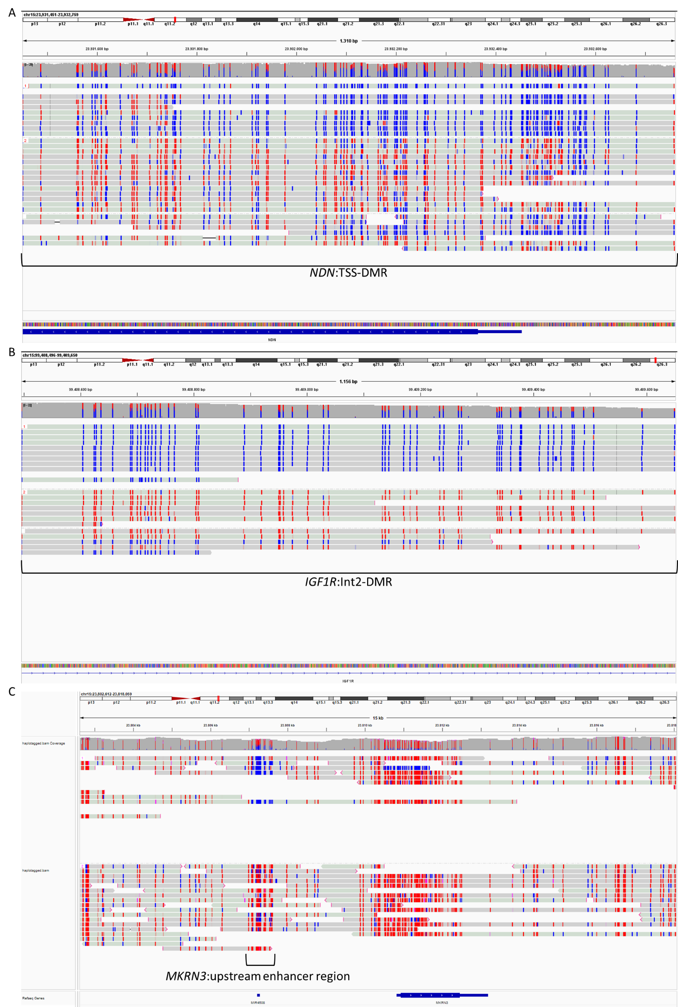Supp. Fig.1: DNA methylation quantification of three more DMRs on Chromosome 15 based on Nanopore sequencing data of the index patient. A: NDN:TSS-DMR (secondary DMR), B: IGF1R:Int2-DMR (primary DMR) and C: MKRN3:upstream enhancer region (Back 2020, secondary DMR).
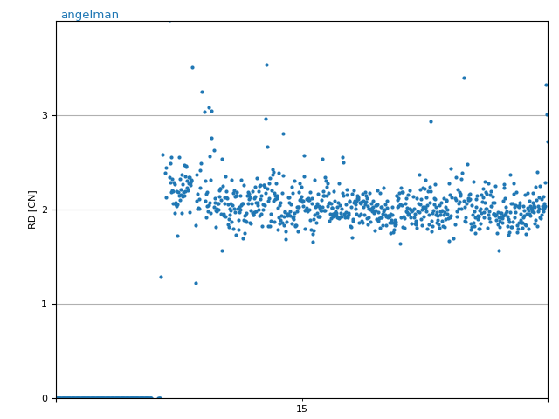
Chr.15q11.2-q13
Supp. Fig.2: Copy number analysis of chromosome 15. Manhattan plot was generated by CNVpytor with bin size of 100000. Vertical axis represents the relative copy number in log2 ratio, horizontal axis shows relative genome coordinate of chromosome 15 from the centromere to telomere of the long arm (from left to right).

Supp. Table 1: Summary of ClinVar entries with partial UBE3A duplications and completed by the present case
ClinVar entry | Genomic location (GRCh38) | Annotation | Size | Pathogenicity
VCV000155977.1 | chr15:  25339174-25339175 | NC_000015.10:g.25339175_  25339233dup | 59 bp | Pathogenic
VCV000144752.2 | chr15: ?_25337273-25342717_? | NC_000015.10:g.(?_25337273)_  (25342717_?)dup | 5,445 bp | VUS
VCV000148472.2 | chr15: ?_25365789-25375524_? | NC_000015.10:g.(?_25365789)_  (25375524_?)dup | 9,736 bp | VUS
VCV000149842.2 | chr15: ?_25334870-25351819_? | NC_000015.10:g.(?_25334870)_  (25351819_?)dup | 16,950 bp | Pathogenic
VCV000583426.1 | chr15: ?_25339117-25375783_? | NC_000015.9:g.(?_25584264)_  (25620930_?)dup | 36,667 bp | VUS
VCV000417431.1 | chr15: ?_25337249-25405506_? | NC_000015.9:g.(?_25582396)_  (25650653_?)dup | 68,258 bp | VUS
VCV000458664.6 | chr15: ?_25339117-25409127_? | NC_000015.9:g.(?_25584264)_  (25654274_?)dup | 70,011 bp | Pathogenic
this case | chr15:  25364087-25387427 | seq[GRCh38]  NC_000015.10:g. 25364087-25387427dup mat | 23,340 bp | Pathogenic

