Supporting Information

Extended methods
Cell culture, treatment, and transfection. HCC1806 (CRL-2335, Homo sapiens, breast cancer), MDA-MB-231 (CRM-HTB-26, Homo sapiens, breast cancer), Jurkat (Clone E6-1, TIB-152, Homo sapiens, Acute leukemia, T-lymphocyte), MRC5 (CCL-171, Homo sapiens, fetal lung, fibroblast) and WI-38 (CCL-75, Homo sapiens, fetal lung, fibroblast) cell lines were purchased from ATCC; B16-F10 WT line and KO line for HDAC6 were purchased from genOwa (Mus musculus, skin melanoma, a mixture of spindle-shaped and epithelial-like cells). HCC1806, MDA-MB-231, and Jurkat cells were cultured in RPMI1640 medium (Euroclone) supplemented with 1% L-Glutamine (Euroclone), 1% Penicillin-Streptomycin (Euroclone), and 10% Fetal Bovine Serum (FBS, Euroclone). B16-F10 and MCR5 cells were cultured in Dulbecco's modified eagle medium (DMEM; Euroclone) supplemented with 1% L-Glutamine (Euroclone), 1% Penicillin-Streptomycin (Euroclone) and 10% Fetal Bovine Serum (FBS, Euroclone). WI-38 cells were cultured in MEM medium (Euroclone) supplemented with 1% L-Glutamine (Euroclone), 1% Penicillin-Streptomycin (Euroclone), and 10% Fetal Bovine Serum (FBS, Euroclone). All cells were cultured at 37°C, 5% CO₂. Initially, dose-response proliferation curves were performed with ITF3756 (Italfarmaco S.p.A.) concentrations ranging from 250 nM to 5 µM. When required, cells were exposed to 1 µM ITF3756 for 16h. DMSO was used as a vehicle in a concentration ≤ 0.1%. For gene expression experiments, HEK293T cells (Sigma) were maintained in DMEM (Euroclone) supplemented with 10% FBS, 1% Pen-Strep and 1% Glutamine and transfected with 2 μg/ 10⁶ cells of each plasmid: hHDAC6-Flag-pcDNA3.1+(Aurogene), pcDNA3.1+ (Invitrogen), according to Lipofectamine3000 standard protocol (Invitrogen). For small RNA interference, RNA knockdown of HDAC6 and P300 expression in HCC1806 and MRC5 cells, Smart pool siRNAs and scramble controls were purchased from Dharmacon and transfected using DharmaFECT 1 reagent according to the manufacturer's instructions. For growth curves, cells were counted manually, in triplicate, using Trypan blue reagent (Euroclone) and disposable Bürker chambers at a Leica DMi1 optical microscope.
Crystal violet staining. After treatment, cells were fixed in fresh 2% paraformaldehyde (PFA) at room temperature (RT) for 20 minutes (min) and stained with 0.5% Crystal violet solution (methyl violet 10B or hexamethyl pararosaniline chloride, prepared in 20% methanol) at RT for 5 min, washed with phosphate-buffered saline (PBS) and dried for 30 min. Images were then acquired at 10X magnification using a Leica DMi1 optical microscope. Cells were incubated with 1% SDS for 15 min at RT, gently shaking at 150 rpm to wash out the crystal violet. The colorimetric signal/optical density was detected with VICTOR Nivo Multimode Microplate Reader (PerkinElmer) at 570 nm.
mRNA extraction and qRT-PCR. According to the manufacturer's instructions, RNA was extracted from approximately 1x10⁶ cells using Tri-Reagent (Sigma). cDNA synthesis for quantitative real-time PCR (qRT-PCR) was retrotranscribed with Omniscript RT Kit (Qiagen). All reactions were performed in RT² SYBR Green ROX qPCR Mastermix (Qiagen), using the QIAquant 96 5plex (230V) Device (Qiagen). The primers reported in Table 1 were used.
Gene | Primers sequences (5' 3')
HDAC6 (Homo sapiens) | Fw: ACCCCAGTGTCCTCTATTTCTC  Rv: CCTGGTTCCAAGGCACATTGA
P300 (Homo sapiens) | Fw: GCTTCAGACAAGTCTTGGCAT  Rv: ACTACCAGATCGCAGC
GAPDH (Homo sapiens) | Fw: GTCTCCTCTGACTTCAACAGCG  Rv: ACCACCCTGTTGCTGTAGCCAA
Hdac6 (Mus musculus) | Fw: TCCACCGGCCAAGATTCTTC  Rv: CAGCACACTTCTTTCCACCAC
P300 (Mus musculus) | Fw: TTCAGCCAAGCGGCCTAAA  Rv: CGCCACCATTGGTTAGTCCC
Akt1 (Mus musculus) | Fw: GGACTACTTGCACTCCGAGAAG  Rv: CATAGTGGCACCGTCCTTGATC
Itgb3 (Mus musculus) | Fw: GTGAGTGCGATGACTTCTCCTG  Rv: CAGGTGTCAGTGCGTGTAGTAC
Sox9 (Mus musculus) | Fw: CACACGTCAAGCGACCCATGAA  Rv: TCTTCTCGCTCTCGTTCAGCAG
Nf1 (Mus musculus) | Fw: CGGCTGCTTTGGAACAATCAGG  Rv: GTGTATCTGCCACAGGCTTGTG
Gene | Primers sequences (5' 3')
Tgfb2 (Mus musculus) | Fw: TTGTTGCCCTCCTACAGACTGG  Rv: GTAAAGAGGGCGAAGGCAGCAA
Casp7 (Mus musculus) | Fw: CCGTCCACAATGACTGCTCTTG  Rv: CCCGTAAATCAGGTCCTCTTCC
Smad3 (Mus musculus) | Fw: GCTTTGAGGCTGTCTACCAGCT  Rv: GTGAGGACCTTGACAAGCCACT
Gapdh (Mus musculus) | Fw: AACTTTGGCATTGTGGAAGG  Rv: ATGCAGGGATGATGTTCTGG
Table 1. The table reports the primer pairs used for qRT-PCR analysis—primers provided by Integrated DNA Technologies (IDT).
ELISA assays. Total HDAC and HAT activity were assayed on nuclear and cytoplasmic extracts obtained using the Nuclear Extraction Kit (ab113474, Abcam), following the manufacturer's instructions. Total HDAC activity was quantified using the HDAC Activity Assay Kit (colorimetric, ab1432, Abcam), and total HAT activity was quantified using the Histone Acetyltransferase Activity Assay Kit (colorimetric, ab65352, Abcam) according to the supplier's protocols. Absorbance was detected by VICTOR Nivo Multimode Microplate Reader (PerkinElmer) at 440 nm. According to the supplier's protocol, AcCoA content was measured using the Acetyl CoA Assay Kit (fluorometric, ab87546, Abcam). The fluorescent signal was detected by VICTOR Nivo Multimode Microplate Reader (PerkinElmer) at Ex/Em 535/587 nm.
Immunoprecipitation and capillary electrophoresis. Cells were lysed in 20 mM Tris-HCl (pH 7.4), 50 mM NaCl, 1% NP40/IGEPAL, 2 mM EDTA, 0.01% SDS, supplemented with protease/phosphatase inhibitor (PI/PhI) mix and 2 mM DTT and protein concentration was determined by a BCA kit (Pierce, Life Technologies). 500 μg of extract was immunoprecipitated by using 5 μg of anti-P300 (RbMAb, Abcam), anti-HDAC6 (MsMAb, Abcam), or anti-Flag (MsMAb, Abcam) and Dynabeads-Protein G magnetic beads system (Thermofisher Scientific). Samples were then eluted in Leammli buffer 2X. For capillary electrophoresis, samples lysed or eluted in Leammli buffer were loaded into the proper cartridge (2-40 kDa, 12- 230 kDa, 66-440 kDa Wes/Jess Separation Modules, ProteinSimple, Biotechne) following the supplier recommendations. H3K9Ac (1:50, RbMAb, Abcam), H3K27Ac (1:50, RbMAb, Abcam), H3K14Ac (1:50, RbMAb, Abcam), H4K16Ac (1:50, RbMAb, Abcam), P300 (1:100, RbMAb, Abcam), HDAC6 (1:50, MsMAb, Abcam), Flag (1:100, MsMAb, Abcam), Ubiquitin (1:50, MsMAb, Cell Signaling), Acetyl α-Tubulin K40 (1:500, RbMAb, Abcam), α-Tubulin (1:500, MsMAb, Abcam), β-Actin (1:500, RbMAb, Abcam), GAPDH (1:500, RbMAb, Abcam), were used as primary antibodies. Secondary antibodies were Anti-Mouse Secondary HRP and Anti-Rabbit Secondary HRP (ProteinSimple, Biotechne). The plate was then loaded into the Wes instrument and run using the "Compass for SW" program. For representative blots, images at different contrasts were exported to represent better the area measurements automatically calculated by the "Compass for SW" program.
Western blotting. For denaturing and reducing Wb, crude cell extracts prepared as indicated above, were heat-denatured and reduced in Laemmli buffer 1X supplemented with 1 mM DTT. After that, 4-20% acrylamide pre-cast gels (Bio-Rad, Hercules, CA, USA) were used to separate proteins by SDS-PAGE. After separation, proteins were transferred to a HyBond-ECL nitrocellulose filter (Bio-Rad, Hercules, CA, USA) and probed with antibodies raised against the following targets: PSMB6 (β6) and PSMA7 (α4) subunits of the 20S; PSMD4 (Rpn10), which is a 19S subunit, whose levels were previously reported to correlate with the 26S structural integrity; Ub; Ub:K48 chains; GAPDH (not shown). All antibodies were purchased from Protein-tech Group (Manchester, UK). Antibodies were diluted 1:3000 in 0.02% Tween-PBS fat-free milk and, after, incubated with a horseradish peroxidase-conjugated anti-rabbit or anti-mouse IgG antibody (Bio-Rad, Hercules, CA, USA), diluted 1:50.000 in 0.2% Tween-PBS fat-free milk. Remarkably, the dynamic linear range for internal controls (e.g., tubulin, actin, GAPDH) was previously calculated in our lab and used as a reference to address target proteins towards total protein normalization or normalization on classic internal controls. To obtain a good visualization of proteins, the micrograms loaded were found to fall off the linearity range of β-actin or GAPDH. Therefore, fold change in individual proteins was calculated by normalizing the protein band intensity to the total proteins loaded in each lane. To this aim, filters were stained with Ponceau S and gels by Coomassie Brilliant Blau (CBB; this last stain is not shown).

Protein extraction from mice tissue. Samples were cut into small pieces with a scalpel and transferred into tubes. To each tube, two 3 mm Tungsten Carbide Beads (Qiagen) and Leammli buffer supplemented with 100 nM Phenylmethanesulfonyl fluoride (PMSF, Merck), 100 µM Trichostatin A (TSA, Cabru-Cayman Chemical) and PI/PhI mix were added. Samples were loaded to TissueLyzer LT and shaken 3-6 times for 3 min at 50 Hz; after centrifugation, samples were heated at 95°C and sonicated to avoid DNA interference.
Immunofluorescence staining. Treated/untreated HCC1806 cells and WT and KO_HDAC6 B16F10 cells were cultured in LabTek II chamber slides (Nunc, Biosigma), fixed in 4% PFA (Merck) for 10 min, RT, and permeabilized with 0.1% Triton solution (Merck) for 30 min at RT. Samples were blocked in 5% BSA for 90 min, incubated overnight at 4°C with primary antibodies, and 1h at RT with secondary antibodies. Primary antibodies were: H3K9Ac (1:100, RbMAb, Abcam), H3K27Ac (1:100, RbMAb, Abcam), H3K14Ac (1:100, RbMAb, Abcam), H4K16Ac (1:100, RbMAb, Abcam), P300 (1:200, RbMAb, Abcam), HDAC6 (1:100, MsMAb, Abcam), Flag (1:200, MsMAb, Abcam), Acetyl α-Tubulin K40 (1:500, RbMAb, Abcam), α-Tubulin (1:500, MsMAb, Abcam). Alexa Fluor 546 goat anti-Ms (1:200, Thermo Fisher Scientific) and Alexa Fluor 488 goat anti-Rb (1:200, Thermo Fisher Scientific) were used as secondary antibodies. Nuclei were stained with DAPI (Cell Signaling) for 10 min at RT, and ProLong Glass Antifade Mountant (Thermo Fisher Scientific) was used to seal coverslips. Images were acquired using an Olympus IX83 research inverted microscope at 20X and 40X magnifications.
Proximity ligation assay (PLA). MCR5 cells were transfected with hHDAC6-Flag-pcDNA3.1+ (Aurogene) and treated with ITF3756 at 1 µM for 16h. Cells were then fixed with 4% PFA for 15 min, RT, permeabilized with 0.5% Triton X-100 for 20 min at RT, and blocked with 3% BSA–PBS 0.1% Tween for 1h at 37°C. After that, samples were incubated with P300 (1:200, RbMAb, Abcam) and Flag (1:200, MsMAb, Abcam) for 2h at 37°C and washed with PLA Buffer A (Sigma), and a classic PLA reaction was performed by using the SIGMA Duolink Kit, according to the manufacturer's instructions. After the PLA reaction, cells were incubated with secondary antibodies for 30 min at RT, washed again with PLA buffer A (Sigma), and stained with DAPI for 2 min at RT. Then, cells were washed twice with PLA Buffer B (Sigma) for 5 min at RT and once with Buffer B 0.01X (Sigma) for 1 min at RT. Images were acquired using 40X magnification on a Zeiss AxioImager M2 controlled by Micromanager.
Proteasome Assay. Cell pellets of Vehicle and ITF3756-treated cells were lysed in an osmotic buffer according to a standard procedure for isolating crude cell extracts, particularly enriched in intact proteasome assemblies. Briefly, cells were lysed in pre-chilled 250 mM Sucrose, 50 mM Tris-HCl, 5 mM MgCl₂, 1 mM DTT, 1 mM EDTA, 2 mM ATP, 15% glycerol pH 7.5, through freeze/thaw cycles. Cell extracts were then cleared by centrifugation (13.000 rpm, 10 min, 4°C), and protein concentration was determined by BCA assay. After that, 20 µg of proteins were loaded in a 96-well multi-well (black flat) in Tris-HCl 50 mM, 5 mM MgCl₂, 1 mM EDTA, 2 mM ATP, pH 7.5, 15% glycerol in the presence or absence of 1 µM epoxomicin, a potent and irreversible inhibitor of proteasome chymotrypsin-like activity (Boston Biochem, MA, USA). After 10 min of incubation at 37°C, 75 µM Succinyl-Leu-Leu-Val-Tyr-7-amino-4-methylcoumarin (Suc-LLVY-amc; Boston Biochem, MA, USA) was added, and the fluorescence released by proteasome cleavage recorded in a Varioskan Lux spectrofluorometer (λ_{exc.} = 340 nm; λ_{em.} = 440 nm). Slopes for individual samples were calculated by subtracting that observed in the presence of epoxomicin.

Assay for Transposase-Accessible Chromatin (ATAC) sample preparation. B16F10 KO_HDAC6 and WT cells and ITF3756 and DMSO treated Jurkat cells were cultured for 16h, then treated for 30 min at 37°C with 1X DNase buffer (200 units/mL in HBSS, 2.5 mM MgCl2, 0.5 mM CaCl2). 10⁵ cells were then cryopreserved in 50% FBS, 40% growth media, 10% DMSO, frozen, and sent to Active Motif (Carlsbad, CA, USA) for analysis. Briefly, cell pellets were resuspended in lysis buffer, pelleted, and tagmented using the enzyme and buffer provided in the Nextera Library Prep Kit (Illumina). Tagmented DNA was then purified using the MinElute PCR purification kit (Qiagen), amplified with 10 cycles of PCR, and purified using Agencourt AMPure SPRI beads (Beckman Coulter). The resulting material was quantified using the KAPA Library Quantification Kit for Illumina platforms (KAPA Biosystems) and sequenced with PE42 sequencing on the NextSeq 500 sequencer (Illumina).
ATAC sequencing and bioinformatics analysis. The paired-end 42 bp sequencing reads (PE42) generated by Illumina sequencing were mapped to the genome using the BWA algorithm with default settings ("bwa mem"). Only reads that passed the Illumina purity filter, aligned with no more than 2 mismatches, and mapped uniquely to the genome were used in the subsequent analysis. In addition, duplicate reads ("PCR duplicates") were removed. Genomic regions with high transposition/tagging events were determined using the MACS3 peak calling algorithm (Zhang et al., Genome Biology 2008, 9: R137). The chromosome number and a start and end coordinate defined the genomic regions identified by MACS3 (Intervals). To identify the density of transposition events along the genome, the genome was divided into 32 bp bins, and the number of fragments in each bin was determined. The tag number of all samples was reduced (by random sampling) to a similar number of tags as in the smallest sample. To compare peak metrics between 2 or more samples, overlapping intervals were grouped into Merged Regions, defined by the start coordinate of the most upstream interval and the end coordinate of the most downstream interval (= union of overlapping intervals; "merged peaks"). This interval defines the Merged Region in locations where only one sample has an Interval. Merged Regions are necessary because the locations and lengths of Intervals are rarely the same when comparing different samples.
Furthermore, this approach can obtain fragment density values even for samples where no peak was called. After defining the Intervals and Merged Regions, their genomic locations and their proximities to gene annotations and other genomic features were determined. In addition, average and peak (i.e., at "summit") fragment densities within Intervals and Merged Regions were compiled. The genome hg38 for human samples and mm10 for murine cells were exploited for the alignment procedures. MACS 3.0.0 algorithm was used for peak calling.
Chromatin immunoprecipitation (ChIP) sample preparation. ITF3756 and DMSO treated Jurkat cells, and B16F10 KO_HDAC6 and WT cells were cultured for 16h, then crosslinked with 1% formaldehyde solution (10 mM NaCl, 100 µM EDTA pH 8.0, 5 mM HEPES, pH7.9) and quenched with 120 mM Glycine. Samples were then treated with 0.5% Igepal supplemented with 1 mM PMSF, pelleted, snap frozen, and sent to Active Motif (Carlsbad, CA, USA) for H3K27Ac-ChIP-seq analysis. Pooled samples were used as input control. Illumina sequencing libraries were prepared from ChIPs and Input at Active Motif using their standard protocol, including ChIP reaction validation via quantitative PCR (qPCR). Chromatin was isolated by adding a lysis buffer and disrupted with a Dounce homogenizer. Lysates were sonicated, and the DNA sheared to an average length of 300–500 bp with an EpiShear probe sonicator (Active Motif, cat# 53051). Genomic DNA (Input) was prepared by treating aliquots of chromatin with RNase, proteinase K, and heat for de-crosslinking, followed by SPRI beads clean up (Beckman Coulter) and quantitation by Clariostar (BMG Labtech). Extrapolation to the original chromatin volume allowed the determination of the total chromatin yield. An aliquot of chromatin (30 µg) was precleared with protein A agarose beads (Invitrogen). Genomic DNA regions of interest were isolated using 4 µg of antibody against H3K27Ac (Active Motif, Cat #39133). Complexes were washed, eluted from the beads with SDS buffer, and subjected to RNase and proteinase K treatment. Crosslinks were reversed by incubation overnight at 65°C, and ChIP DNA was purified by phenol-chloroform extraction and ethanol precipitation. Illumina sequencing libraries were prepared from the ChIP and Input DNAs on an automated system (Apollo 342, Wafergen Biosystems/Takara). After a final PCR amplification step, the resulting DNA libraries were quantified and sequenced on the Illumina NextSeq 500 platform.
ChIP sequencing and bioinformatics analysis. ChIP samples were processed for sequencing, and the 75-nt single-end (SE75) sequence reads generated by Illumina sequencing were mapped to the genome using the BWA algorithm ("bwa aln/samse" with default settings). Only reads that passed the Illumina purity filter, aligned with no more than 2 mismatches, and mapped uniquely to the genome were used in the subsequent analysis. In addition, duplicate reads ("PCR duplicates") were removed. Since the 5´-ends of the aligned reads (= "tags") represent the end of ChIP/IP-fragments, the tags were extended in silico (using Active Motif software) at their 3´-ends to a length of 200 bp, which corresponds to the average fragment length in the size-selected library. To identify the density of fragments (extended tags) along the genome, the genome was divided into 32-nt bins, and the number of fragments in each bin was determined. The chromosome number and a start and end coordinate defined genomic regions with local enrichments in tag numbers (intervals). Active Motif's two main peak callers are MACS/MACS2 (29) and SICER (30). To compare peak metrics between 2 or more samples, overlapping intervals were grouped into Merged Regions, defined by the start coordinate of the most upstream interval and the end coordinate of the most downstream interval. After defining the Intervals and Merged Regions, their genomic locations, along with their proximities to gene annotations and other genomic features, were determined, and average and peak fragment densities within Intervals and Merged Regions were compiled. The genome hg38 for human samples and mm10 for murine cells were exploited for the alignment procedures. MACS 2.1.0 algorithm was used for peak calling.

Bioinformatics analysis of NGS studies. Volcano plots were computed using GraphPad Prism 8 to identify regions of interest in the ATAC-seq (Differentially accessible regions (DARs) vs differentially inaccessible regions) and the ChIP-seq (Upregulated H3K27Ac targeted regions vs Downregulated H3K27Ac targeted regions) applying the following threshold to identify statistically significant regions modulated by pharmacological treatment or KO_HDAC6: -0.5 ≤ shrunken LogFC ≤ 0.5 and p adjusted-value ≤ 0.05. After pairwise comparison, both for ATAC-seq and ChIP-seq (B16F10: KO/WT; Jurkat: ITF3756/DMSO) gene ontology on regions affected by HDAC6 down-modulation was performed using DAVID (https://david.ncifcrf.gov/) to determine statistically overrepresented biological processes (BP) of specific GO categories. Subsequently, among the statistically significant identified BP, the ones more relevant to the conducted study were exploited to generate graphs and biological networks. The biological networks were obtained by STRING (https://string-db.org/) only on common regions identified in ATAC-seq and ChIP-seq analyses. Data have been deposited in GEO under accession numbers GSE273644 and GSE273645.

RNA Library preparation, sequencing, and bioinformatics analysis. Sequencing libraries were prepared with the Illumina TruSeq Stranded RNA Library Prep, version 2, Protocol D, using 500 ng total RNA (Illumina). 4200 Tape Station assessed the quality of each library with a "DNA High sensitivity" assay (Agilent). Libraries were fluorometrically quantified using a Sensitivity dsDNA assay with a Qubit device (Life Technologies). The sequencing step was performed with NGS technologies using Illumina Genome Analyzer and the NextSeq 500/550 High Output v2.5 kit (150 cycles; Illumina), processed on Illumina NextSeq 500. FastQ files were generated via Illumina bcl2fastq2, version 2.17.1.14, Available online: http://support.illumina.com/downloads/bcl-2fastq-conversion-software-v217.html (accessed on 2 May 2018, starting from raw sequencing reads produced by Illumina NextSeq sequencer). The number of detected transcripts for coding and noncoding RNAs was evaluated separately for each sample. Gene and transcript intensities were computed using STAR/RSEM software using GRCh38 (Gencode release 27) as a reference and the "stranded" option. Differential expression analysis for mRNA was performed using the R package DESeq2. Coding and noncoding genes were differentially expressed and retained for further analysis with |log2(KO/WT)| ≥ 1 and a false discovery rate, FDR ≤ 0.1. We imposed a minimum |Log2FC| of 1 and an FDR lower than 0.1 as thresholds for differentially expressed genes. This choice is motivated by the decision to maximize the sensitivity of this analysis to perform a massive screening and identify candidate genes to be validated with a broader sample population with real-time analysis. Pathway Analysis: Gene enrichment analysis was performed on coding genes. A Gene Ontology (GO) analysis was conducted for biological processes, cellular components, and molecular function, while KEGG pathway analysis (Kyoto Encyclopedia of Genes and Genomes available online: https://www.genome.jp/kegg/pathway.html; accessed on 2 May 2018) was conducted for pathway analysis. For this investigation, we used the enrichR web tool (accessed on 10 December 2019).
Proteomics Studies. The proteome characterization of HDAC6-silenced and scrambled (treated with a non-targeting pool of siRNA) HCC1806 cells was performed using a standard shot-gun proteomics protocol. Briefly, cell pellets (n=2 biological replicates, n=2 technical replicates each) were lysed in pre-chilled urea denaturing buffer (8 M urea, 50 mM Tris-HCl, 150 mM NaCl) supplemented with proteases inhibitors cocktail, sonicated (3 bursts, 10 seconds each, at 30 Hz) and cleared by centrifugation (13.000 rpm, 10 min, 4°C). Protein concentration was determined by BCA assay, and 100 µg enrolled in the study. First, proteins were denatured with 5 mM di-thiothreitol (DTT; 45 min, room temperature), alkylated with 10 mM iodoacetamide (30 min in the dark at RT), and digested with mass-grade trypsin (Fisher Scientific, Waltham, MA, USA) at 1:50 (trypsin to protein ratio), over-night (room temperature). The reaction was quenched with 0.4% trifluoroacetic acid (TFA), and peptides were desalted and cleaned using C18 stage-tips (Fisher Scientific, Waltham, MA, USA) by following manufacturer's instructions, quantified by BCA peptide assay, dried in a Speed Vacuum concentrator and resuspended in 5% acetonitrile (ACN), 0.1% FA. For each sample, 1 µg of trypsin-generated peptides were analyzed by LC/MS-MS in an Orbitrap Exploris 240 (Thermo Fisher Scientific, Waltham, MA, USA) online with a nano ultra-high-pressure liquid chromatography system (Dionex, Ultimate 3000), analysis was done in Label-Free Quantification mode and Data Dependent Acquisition (DDA). Samples were analyzed using an 88 min LC-MS method. The mobile phase flow rate was 250 nL/min. Solvent A was 0.1% FA, whereas Solvent B was 90% acetonitrile/0.1% FA. The LC-MS/MS method used the following gradient profile: (min: % B) 0:2; 2:6.7; 62:34.4; 67:55.5; 72:100. Regarding the mass spectrometer settings: MS1 spectra were measured with a resolution of 120.000, an AGC target of 3 × 10⁶, and a mass range from 375 to 1650 m/z. RF lens was set at 80%. The top 15 most abundant precursors with charge states from 2 to 7 were triggered for MS/MS at a resolution of 15.000, customized AGC target (5x10⁴), and an isolation window of 2 m/z. Maximum ion time was set as automatic, and the normalized collision energy (HCD) was set at 30%. Raw files were then analyzed by Proteasome Discoverer (2.5), and proteins identified by Sequest-HT coupled with Percolator against a human UniProt database (UP000005640 – 9606, containing 82685 entries). A contaminant list was included in the analysis. Carbamidomethylation of cysteine was set as static modification, whereas acetylation and ubiquitination were set as variable modification at lysine residues with phosphorylation ad serine or threonine residues. FDR was set at 0.01, and targets were validated using a concatenated target-decoy strategy. Proteins discussed in the results were filtered for the following parameters: i) Identification with at least 2 peptides and 1 unique peptide; ii) Identification in at least 50% of samples belonging to the same experimental group.

Statistical analysis. Statistical analyses were performed using the GraphPad Prism program. Sample sizes (N) were reported in the corresponding figure legend. Students' t-tests, 1-way and 2-way ANOVA with adequate multiple comparison post hoc tests were used to analyze variables. A value of p ≤ 0.05 was deemed statistically significant. Data indicate the mean values of at least three independent experiments ± SD or SEM. A specific comment has been added for each analysis.

Supplementary Figures

Figure S1. ITF3756 shows a dose-dependent effect on cell proliferation. (A, B, C, D) Cell growth curve after ITF3756 treatment. The panels show the cell growth curves of HCC1806 (A), B16F10 WT (B), MDA231 (C), and 4T1 (D) cell lines after ITF3756 treatment at different concentrations (250 nM, 500 nM, 1 µM, 2 µM, and 5 µM) and along a time course from 24h to 72h. Error bars indicate SEM. Statistical analysis was performed by multiple comparison 2-way ANOVA, N=3; *p<0.05; **p<0.005; ***p<0.0005. (E, F). Crystal violet staining and relative densitometry after ITF3756 treatment. Representative images of crystal violet staining of HCC1806 (E, upper panel) and B16F10 WT (F, upper panel) cell lines after treatment with ITF3756 at concentrations equal to 250 nM, 500 nM, 1 µM, 2 µM, and 5 µM for 48h. Images were acquired with a 10X magnification-scale bar: 100 µm. Lower panels represent the densitometry (Mean Optical Intensity, MOI). Error bars indicate SEM. Statistical analysis was performed by multiple comparison 1-way ANOVA, N=3; *p<0.05; ***p<0.0005.

Figure S2. HDAC6 inactivation effect on murine melanoma cell proliferation. (A) Left panel: representative images of crystal violet staining performed after one replicative step. Right: densitometry shows the quantification of the Mean Optical Intensity (MOI) of the HDAC6_KO condition (purple bar) compared to the control (black bar). Error bars indicate SEM. Statistical analysis was performed by unpaired t-test, N=6; ***p<0.0005. (B) Left: representative images of crystal violet staining of B16F10 HDAC6_KO cell line after 24h treatment with ITF3756 at concentrations equal to 250 nM, 500 nM, 1 µM, 2 µM, and 5 µM. Images were acquired at 10X magnification-scale bar: 200 µm. The graph on the right represents the densitometry (Mean Optical Intensity, MOI) of the B16F10 HDAC6_KO cell line treated with ITF3756. Error bars indicate SEM. Statistical analysis was performed by multiple comparison 1-way ANOVA, N=3; **p<0.005.

Figure S3. The HDAC6 inhibitor ITF3756 modulates lysine acetylation in human breast cancer cells. (A, B) Immunofluorescence staining after ITF3756 treatment of HCC1806 cell line. Left: representative images showing the acetylation of H3K14 (A) and H4K16 (B) (green signal) after 16h treatment with ITF3756 1 µM. DAPI (blue signal) and α-Tubulin (red signal) were normalizers. Images were acquired at 20X magnification. Scale bar: 100 µm. Right: densitometric analysis of the Mean Fluorescent Intensity (MFI). Error bars indicate SEM. Statistical analysis was performed by paired t-test, N=3; *p<0.05. (C) Quantification of constitutive H3K4, H3K9, H3K14, H3K23, H3K27 and H4K16 acetylation on HCC1806 cell line. Left: the panel shows a representative image of a capillary electrophoresis experiment performed on the HCC1806 cell line treated with 1 µM ITF3756 for 16h. Right: the graph shows the mean protein level related to the signal of H3K4, H3K9, H3K14, H3K23, H3K27, and H4K16 acetylation in ITF3756-treated cells (green bars) compared to vehicle-treated cells (black bar). The β-Actin was used as a normalizer. Error bars indicate SEM. Statistical analysis was performed by paired t-test, N=3; *p<0.05; **p<0.005.

Figure S4. ITF3756 effects validation on lysine acetylation in different cell lines. (A-D) Quantification of H3K4, H3K9, H3K14, H3K23, H3K27 and H4K16 acetylation levels. Left: the panels show representative capillary electrophoresis experiments performed on MDA231 (A), 4T1 (B), Jurkat (C), and WI38 (D) cell lines after 16h treatment with 1 µM ITF3756 or vehicle (DMSO). Right: the graphs show the mean protein level related to the signal of H3K4, H3K9, H3K14, H3K23, H3K27, and H4K16 acetylation in ITF3756-treated cells (green bars) compared to vehicle-treated cells (black bar). The β-Actin was used as a normalizer. Error bars indicate SEM. Statistical analysis was performed by paired t-test, N≥3; *p<0.05; **p<0.005. (E, F) Quantification of α-Tubulin K40 acetylation in Jurkat (E) and WI38 cell lines (F). Error bars indicate SEM. Statistical analysis was performed by paired t-test, N≥3; ***p<0.0005.

Figure S5. CRISPR/Cas9 inactivation of HDAC6 increases lysine acetylation in B16F10 murine melanoma cells. (A, B) Immunofluorescence staining: B16F10 KO_HDAC6 vs WT. (A) Left: representative images showing the acetylation of H3K14 (A) and H4K16 (B) (green signal). DAPI (blue signal) and α-Tubulin (red signal) were normalizers. Images acquired at 40X magnification. Scale bar: 50 µm. Right: densitometric analysis of the Mean Fluorescent Intensity (MFI) of the KO_HDAC6 condition (green bar) compared to the control (black bar). Error bars indicate SEM. Statistical analysis was performed by unpaired t-test; N=3; *p<0.05. (C) Quantification of constitutive H3K4, H3K9, H3K14, H3K23, H3K27 and H4K16 acetylation in B16F10 WT and KO_HDAC6 cell lines. Left: the panel shows a representative image of a capillary electrophoresis experiment. Right: the graph shows the mean protein level related to the signal of H3K4, H3K9, H3K14, H3K23, H3K27, and H4K16 acetylation in KO_HDAC6 cells (green bars) compared to the control (black bar). The β-Actin was used as a normalizer. Error bars indicate SEM. Statistical analysis was performed by unpaired t-test, N=3; *p<0.05; **p<0.005; ***p<0.0005. (D) Quantification of H3K4, H3K9, H3K14, H3K23, H3K27 and H4K16 acetylation levels. Left: the panels show representative capillary electrophoresis experiments performed in the B16F10 cell line after 16h treatment with 1 µM ITF3756 or vehicle (DMSO). Right: the graphs show the mean protein level related to the signal of H3K4, H3K9, H3K14, H3K23, H3K27, and H4K16 acetylation in ITF3756-treated cells (green bars) compared to vehicle-treated cells (black bar). The β-Actin was used as a normalizer. Error bars indicate SEM. Statistical analysis was performed by paired t-test, N=3; *p<0.05; **p<0.005.

Figure S6. HDAC6 inactivation effect on lysine acetylation in vivo. (A, B) The graphs show the results of capillary electrophoresis experiments detecting acetylation of H3K14 and H4K16 in the liver (A) and the spleen (B) of HDAC6_KO mice (blue dots) compared to controls (WT, black dots). Error bars indicate SD. Statistical analysis was performed using an unpaired t-test of N=10 for each condition. (C, D) The graphs show the results of capillary electrophoresis experiments detecting acetylation of H3K9, H3K27, H3K14, and H4K16 in the brain (C) and the heart (D) of HDAC6_KO mice (blue dots) compared to the controls (WT, black dots). Error bars indicate SD. Statistical analysis was performed using an unpaired t-test of N=10 for each condition.

Figure S7. HDAC6 inhibition increased total HAT activity and P300 protein levels in different cellular models. (A) Total HDAC activity (on the left) and global levels of AcCoA (on the right) in HCC1806 cells treated with 1 µM ITF3756 for 16h (green bars) or vehicle (black bars). Error bars indicate SEM. Statistical analysis was performed by paired t-test, N=3. (B) RT-qPCR assayed P300 and HDAC6 mRNA levels in HCC1806 cells comparing ITF3756 to vehicle treatment. GAPDH was used as a normalizer, and relative mRNA expression was calculated using the 2^{-ΔΔCt} method. Error bars indicate SEM. Statistical analysis was performed by multiple comparison 2-way ANOVA, N=6. (C) Total HDAC activity (on the left) and global levels of AcCoA (on the right) in B16F10 HDAC6_KO (green bars) vs WT (black bars). Error bars indicate SEM. Statistical analysis was performed by unpaired t-test, N=4. (D) RT-qPCR assays P300 and Hdac6 mRNA levels in B16F10 HDAC6_KO (green bars) vs WT (black bars). Gapdh was used as a normalizer, and relative mRNA expression was calculated using the 2^{-ΔΔCt} method. Error bars indicate SEM. Multiple comparison 2-way ANOVA, N=4, performed statistical analysis; ***p<0.0005. (E) Total HDAC activity (on the left), global levels of AcCoA (in the middle), and total HAT activity (on the right) in Jurkat cells treated with 1 µM ITF3756 for 16h (green bars) or vehicle (black bars). Error bars indicate SEM. Statistical analysis was performed by paired t-test, N=3; *p<0.05. (F) Left: RT-qPCR assayed P300 and HDAC6 mRNA levels in Jurkat cells comparing ITF3756 to vehicle treatment. GAPDH was used as a normalizer, and relative mRNA expression was calculated using the 2^{-ΔΔCt} method. Middle: representative image of a capillary electrophoresis experiment showing P300 and HDAC6 protein levels in Jurkat-treated cells. Right: Vinculin was used as a normalizer for the mean protein levels of P300 and HDAC6. Error bars indicate SEM. Statistical analysis was performed by multiple comparison 2-way ANOVA, N=5 (left) and N=3 (right); *p<0.05. (G) Total HDAC activity (on the left), global levels of AcCoA (in the middle), and total HAT activity (on the right) in B16F10 cells treated with 1 µM ITF3756 for 16h (green bars) or vehicle (black bars). Error bars indicate SEM. Statistical analysis was performed by paired t-test, N=4; **p<0.005. (H) Left: P300 and Hdac6 mRNA levels assayed by RT-qPCR in B16F10 cells treated with 1 µM ITF3756 for 16h (green bars) or vehicle (black bars). Gapdh was used as a normalizer, and the relative mRNA expression was calculated using the 2^{-ΔΔCt} method. Middle: representative capillary electrophoresis experiment showing P300 and HDAC6 proteins in treated and untreated B16F10 cells. Right: Vinculin was used as a normalizer for the mean protein levels of P300 and HDAC6. Error bars indicate SEM. Statistical analysis was performed by multiple comparison 2-way ANOVA, N=6 (left) and N=3 (right); *p<0.05.

Figure S8. P300 mechanism investigation: (A) Proximity ligation assay (PLA), representative image of a PLA experiment performed on MRC5 cells transfected with pCDNA3.1+_HDAC6_Flag and pCDNA3.1+ as a control for 24h and treated with 1 µM ITF3756 for an additional 16h; DMSO was used as solvent control. The IF staining shows P300 level (green signal), HDAC6-flag (magenta signal), and PLA foci (red signal). DAPI (blue signal) was used as a normalizer. Scale bar: 13 µm. (B) The graph shows the number of PLA foci per cell in pCDNA3.1+_HDAC6_Flag transfected cells treated with ITF3756 (light red bar) and DMSO as vehicle (dark red bar) compared to empty vector (black and gray bars). (C) P300 quantification cell in pCDNA3.1+_HDAC6_Flag transfected cells treated with ITF3756 (light green bar) and DMSO as vehicle (dark green bar) compared to empty vector (black and gray bars). Error bars indicate SEM. Statistical analysis was performed by Student t-test, N=3; ***p<0.0001.

Figure S9. Proteasome Assay. (A) The bulk activity of proteasome particles of crude cell extracts isolated from vehicle- and ITF3756-treated cells was assayed on 75 µM LLVY-amc. The rate of cleavage was monitored over a short time interval (<20 min) over which linearity was observed. Slopes for biological (N=3) and technical replicate (N=3, each) were calculated. The histograms show the Mean±SD of slopes of all replicates (N=9) calculated as µmol of LLVY-amc degraded/min. A two-tailed τ Students' test performed the statistical analysis. (B, C) Crude cell extracts isolated from vehicle- and ITF3756-treated cells were analyzed by Western blotting. Filters were probed with antibodies raised against the PSMB6, PSMA7, PSMD4 subunits of the proteasome (B, left panel) and Ub or Ub-chains with K48 linkages (Ub: K48) (C, left panel). A representative blot showing the bands of N=3 different biological replicates for each experimental group is reported. The same samples were analyzed two independent times. Histograms show the Mean ± SD and introduce the fold change of protein intensity normalized on that of total proteins as they were stained by Ponceau S (shown below). A nominal value of 1 was attributed to the band intensity of the first lane of the filter. The statistical analysis was performed by applying the Two-tailed Students' t-test.

Figure S10. Chromatin accessibility landscape of ITF3756-treated Jurkat cells revealed by ATAC-Seq. (A) The principal component analysis results on the whole dataset in Jurkat cells treated with 1 µM ITF3756 (green dots) or vehicle (black dots) for 16h. N=3. (B) Volcano plot of differentially accessible regions. The accessible regions are towards the right, the inaccessible are towards the left, and the most statistically significant are towards the top. Red dots represent significant open and closed regions with -0.5≤ shrunken LogFC ≤ 0.5 and a p-value ≤ 0.05. Black dots represent non-significant changes. N=3. (C) The graph illustrates the distribution of the differentially accessible regions of specific genomic features depicted as follows: distal intergenic regions(green), downstream regions (yellow) encompassing 3000 bp from transcription end site (TES), introns (red), coding exons (orange), 3′ UTRs (light blue) and 5′ UTRs (pink), proximal (0-1000 bp, blue) and distal promoter (violet) encompassing 3000 bp upstream of the transcription start site (TSS). (D) Gene ontology analysis of differentially accessible regions between ITF3756-treated Jurkat and vehicle-treated cells: inaccessible regions (ICR, blue bar graph, upper panel) and accessible chromatin regions (ACR, red bar graph, lower panel). N=3.

Figure S11. Chromatin accessibility landscape of ITF3756-treated Jurkat cells revealed by H3K27Ac-ChIP-Seq. (A) The principal component analysis results on the whole dataset in Jurkat cells treated with 1 µM ITF3756 for 16h (green dots) or vehicle (black dots). N=3. (B) Volcano plot of differentially accessible regions. The H3K27Ac enriched regions are towards the right, the H3K27Ac decreased regions are towards the left, and the most statistically significant are towards the top. Red dots represent significant H3K27Ac enriched and decreased regions with -0.5≤ shrunken LogFC ≤ 0.5 and a p-adjusted value ≤ 0.05. Black dots represent non-significant changes. N=3. (C) The graph illustrates the distribution of the differentially accessible regions of specific genomic features depicted as follows: distal intergenic regions(green), downstream regions (yellow) encompassing 3000 bp from transcription end site (TES), introns (red), coding exons (orange), 3′ UTRs (light blue) and 5′ UTRs (pink), proximal (0-1000 bp, blue) and distal promoter (violet) encompassing 3000 bp upstream of the transcription start site (TSS). (D) Gene ontology analysis of differentially accessible regions between ITF3756-treated and vehicle-treated revealed by H3K27Ac-ChIP-seq: inaccessible regions (ICR, blue bar graph, upper panel) and accessible chromatin regions (ACR, red bar graph, lower panel). N=3.

Figure S12. Transcriptomic analysis of KO_HDAC6 vs WT B16F10 cells. (A) The principal component analysis results on the whole dataset in KO_HDAC6 B16F10 cells (green dots) compared to WT control (black dots). N=5. (B) Volcano plot of differentially regulated transcripts. Red dots represent significantly up- and downregulated genes with 1 ≤ Log2FC ≤ 1 (x-axis) and a p adjusted-value ≤ 0.1 (y-axis). Blue, green, and gray dots represent detected non-significant DE genes. N=5. (C) The heatmap illustrates the 60 most modulated genes; the color code shows the upregulated genes in green and the down-modulated genes in red. N=5. (D-G) Gene ontology analysis of differentially expressed genes in KO_HDAC6 cells compared to WT. According to the cluster genes modulation, the biological processes involved are represented through dot-plot D, the cellular component by dot-plot E, the molecular function by dot-plot F, and the KEGG pathways by dot-plot G. Results are represented according to the criterion for which the red dots are the most significantly differentially regulated. At the same time, the point size indicates the number of genes involved in the process, the dot position represents the expression fold change. N=5.

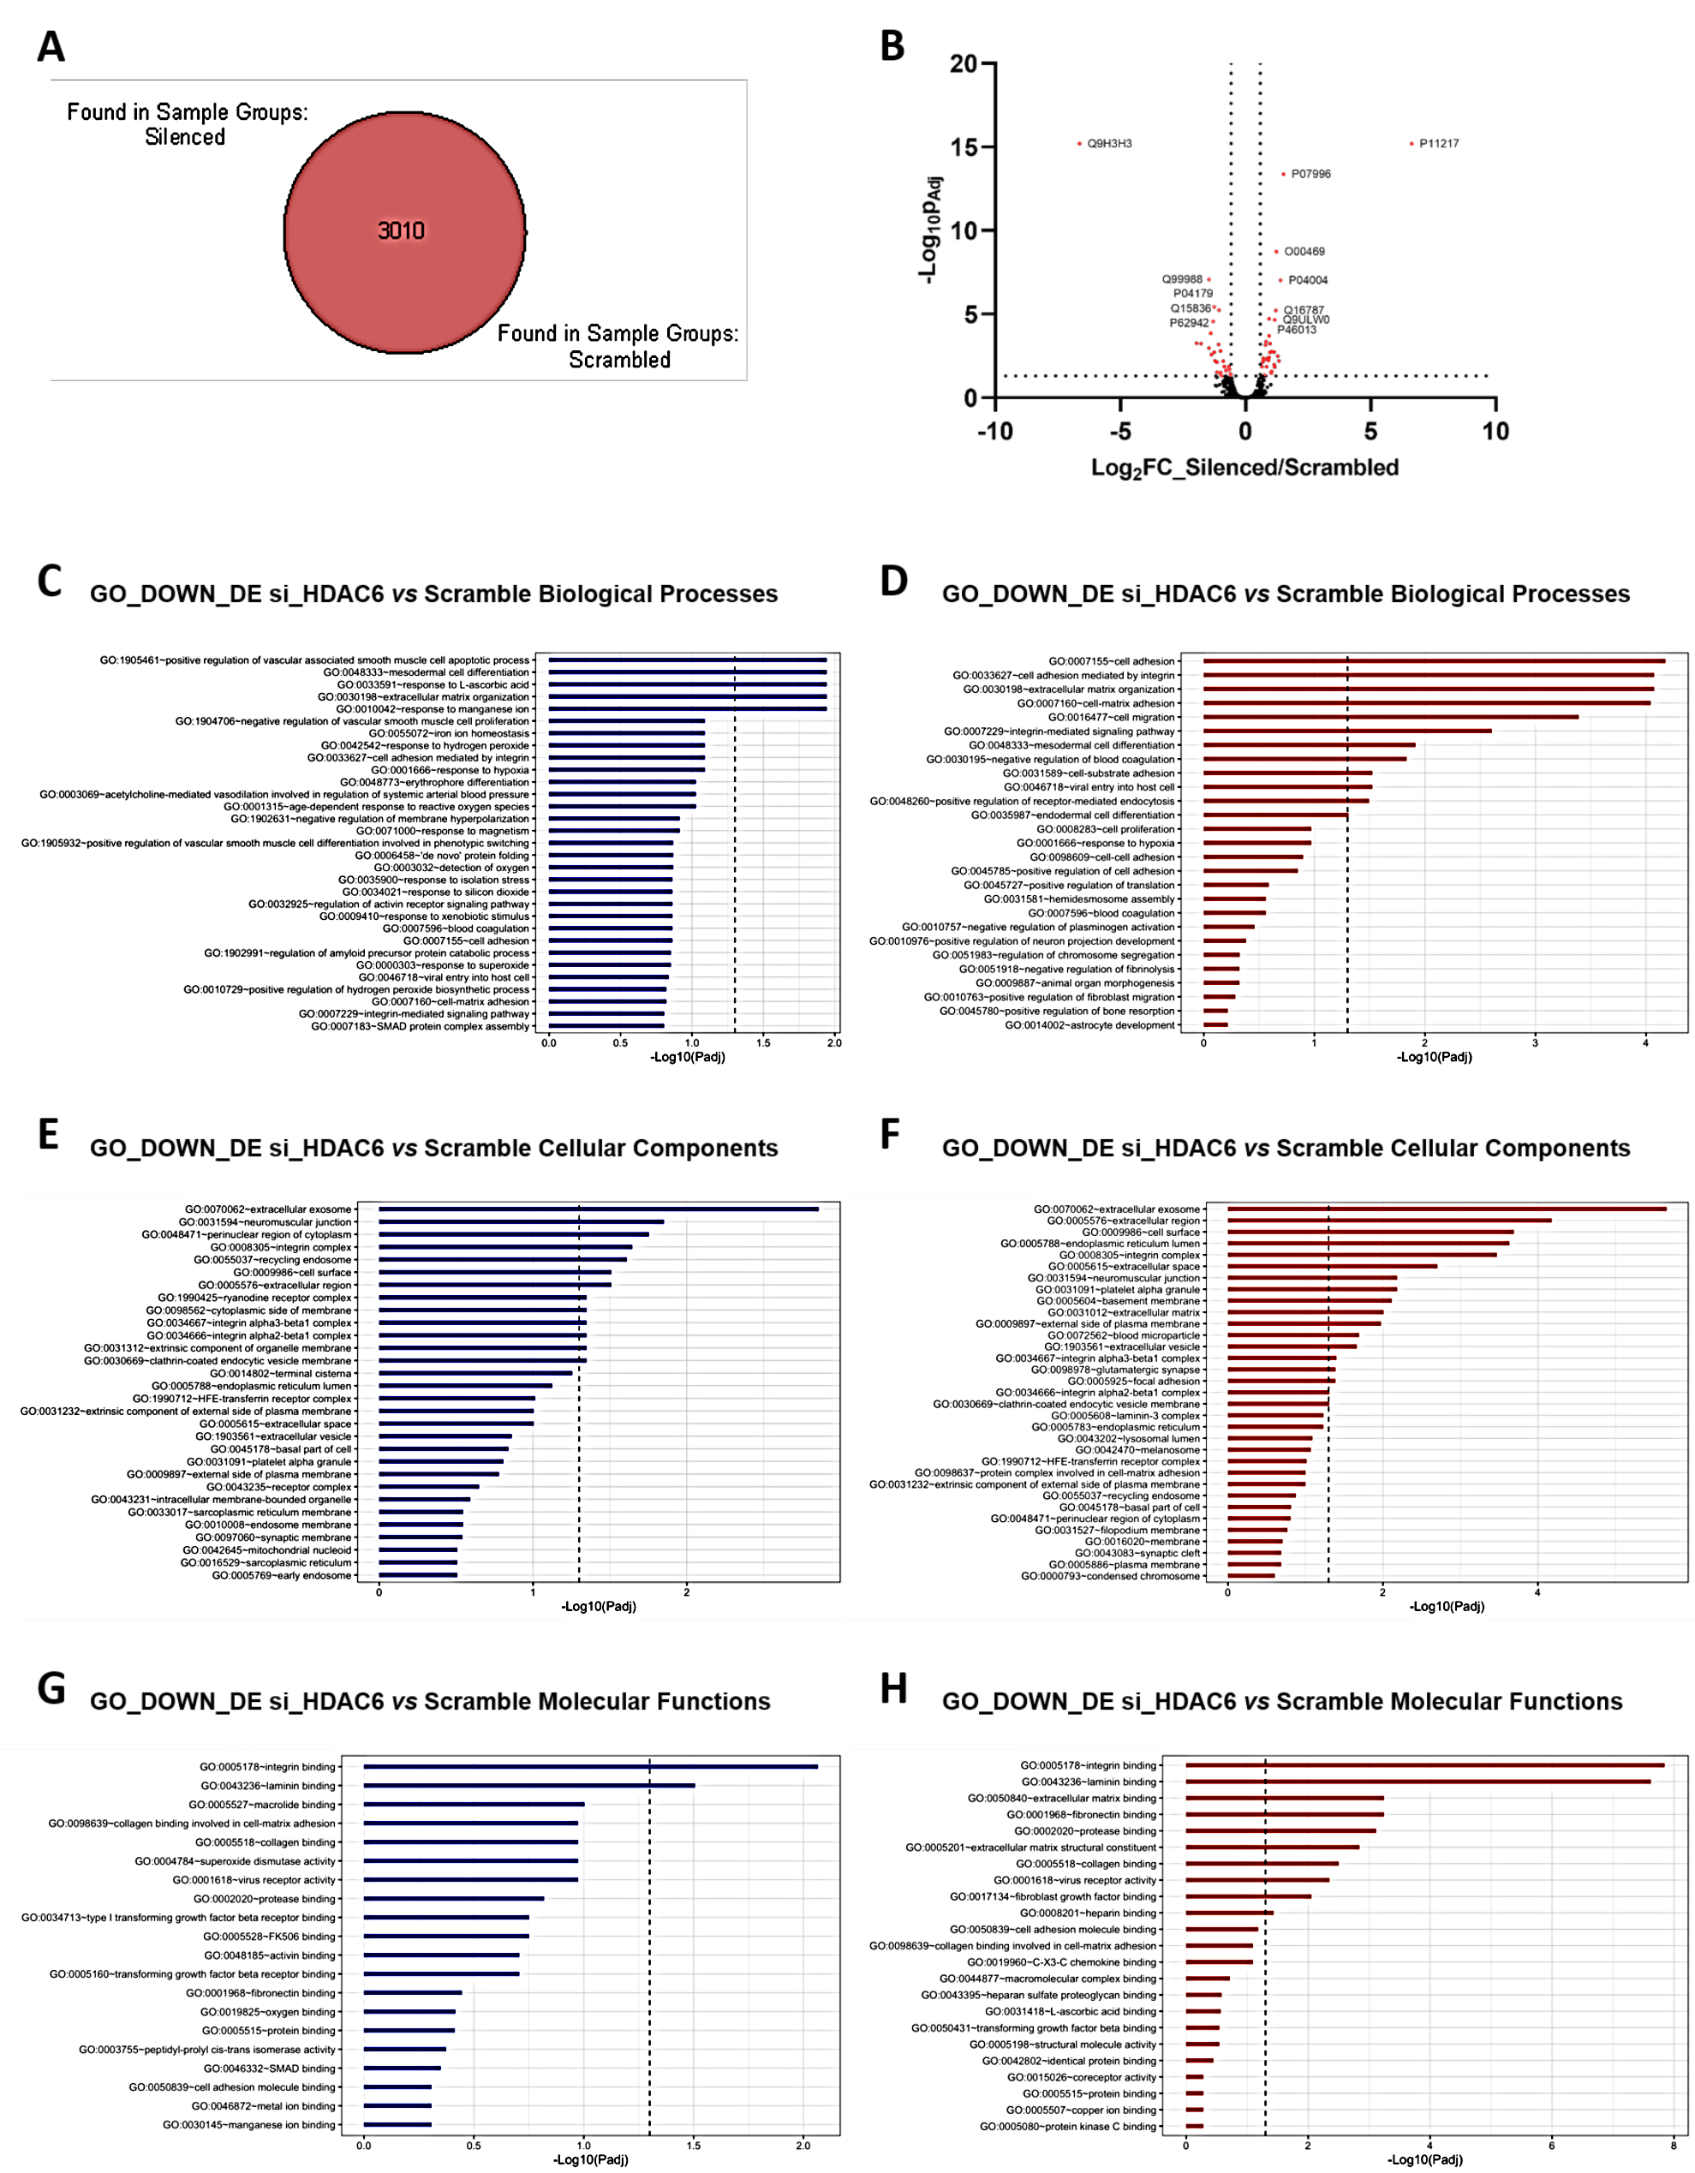
Figure S13. Proteomics Studies of si_HDAC6 vs Scramble HCC1806 cells. (A) Venn's diagram and (B) Volcano plot (right panel) of proteins identified by proteomics. By applying the filters, 3010 proteins were identified in scrambled and HDAC6-silenced cells. No proteins were found to be uniquely identified in either one of the two experimental groups. The volcano plot shows (red character) the protein found to be either upregulated or downregulated in the HDAC6-siRNA vs scrambled ratio. Filters were set for proteins showing a Log2FC=0.58 and -log10 of p-Value (0.05) adjusted by Benjamini-Hochberg correction (-Log10Padj in legend). The accession number of their gene highlights a selection of proteins showing the highest statistical significance. (C-H) Gene ontology analysis of proteins coming up as downregulated (C, E, G, blue bars) or upregulated (D, F, H, red bars) between HDAC6-silenced and scrambled cells. Dashed lines highlight the cut-off between terms, either for Biological Process (C, D), Cellular Component (E, F), and Molecular Function (G, H) that reached statistical significance expressed as -log10 of p-Value (0.05) adjusted by Benjamini-Hochberg correction.

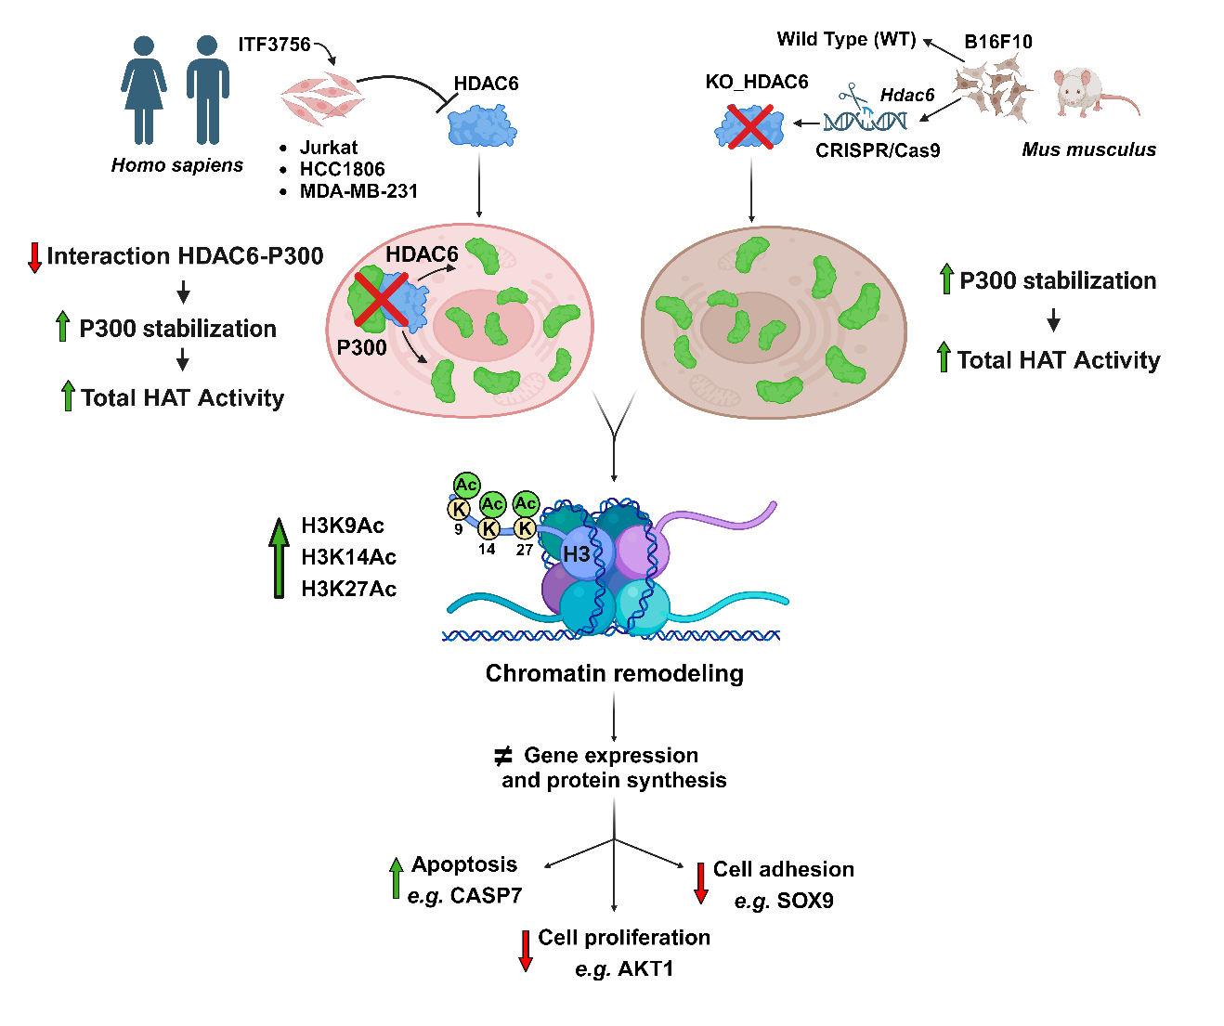

Graphical Abstract. HDAC6 inhibition/inactivation can impact cancer treatment via P300 stabilization. HDAC6 inhibition by ITF3756 causes an HDAC6/P300 complex dissociation and reduced P300 ubiquitination. HDAC6 pharmacological and genetic inactivation (by ITF3756 and by CRISPR/Cas9, respectively) lead to increased P300 protein levels and HAT activity in various cancer cell lines. Consequently, histone lysine acetylation increases: ATAC-seq and H3K27Ac ChIP-seq analyses revealed significant chromatin accessibility changes. Gene Ontology analysis showed altered expression of genes related to cell proliferation, cell adhesion, and apoptosis. The stabilization of P300 after HDAC6 inhibition and dissociation, influencing the expression of genes critical for cellular survival, enhances our understanding of HDAC6's role in cancer cell behavior and epigenetic regulation and contributes to therapeutic strategies envisaging the potential advantage of multiple targeting of epigenetic effectors.

