Supplementary Figures

Fig. S1 Discovery and Validation of Methylation Biomarkers through Bootstrapping.
A) Line plot depicting the number of biomarkers based on the reproducibility threshold during 1000 rounds of bootstrapping. DMS = Differentially Methylated Sites; B) Cumulative plot illustrating the count of biomarkers showing 95% or higher reproducibility. The bar and line plots represent the number of biomarkers satisfying each threshold. DMS = Differentially Methylated Sites; C) Plot representing the reproducibility information for biomarkers in the discovery set during bootstrapping on the volcano plot displaying the overall Differentially Methylated Sites (DMS) calculated from the entire dataset. The darker the color and the larger the size of the dots, the higher the reproducibility. D) Boxplot showing the methylation values of 17 biomarkers demonstrating 97% or higher reproducibility in both healthy controls and anxiety disorder patients for both the discovery set (left panel) and validation set (right panel). E) Plot highlighting only the 17 biomarkers with 97% or higher reproducibility in the volcano plot of the discovery set. F) Plot displaying only the 17 biomarkers with 97% or higher reproducibility in the volcano plot of the validation set.
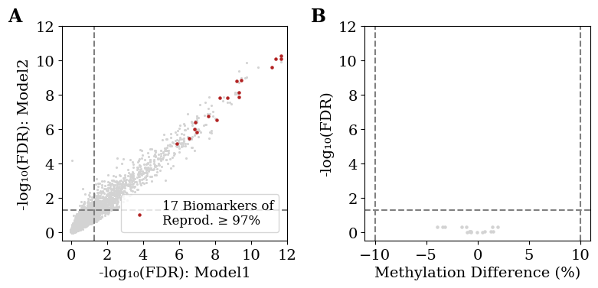

Fig. S2 The statistics of the 17 biomarkers to other confounders.
A) A scatter plot representing the false discovery rate (FDR) within the training set for each covariate adjustment model. Model 1 adjusts for Sex and Age, while Model 2 adjusts for Sex, Age, Current Smoking, and Current Alcohol Consumption. Among these, 17 markers with a reproducibility of 97% or higher are highlighted in red. The dashed line indicates the FDR < 0.05 threshold. Reprod = Reproducibility; B) A scatter plot showing the statistical relationship between the 17 CpG biomarkers and antidepressant usage within the anxiety disorder patient group. The x-axis represents methylation differences based on antidepressant use, and the y-axis represents FDR values adjusted using the Benjamini-Hochberg method for the p-values from Wilcoxon's rank-sum test. The dashed lines indicate the significance thresholds in this study.
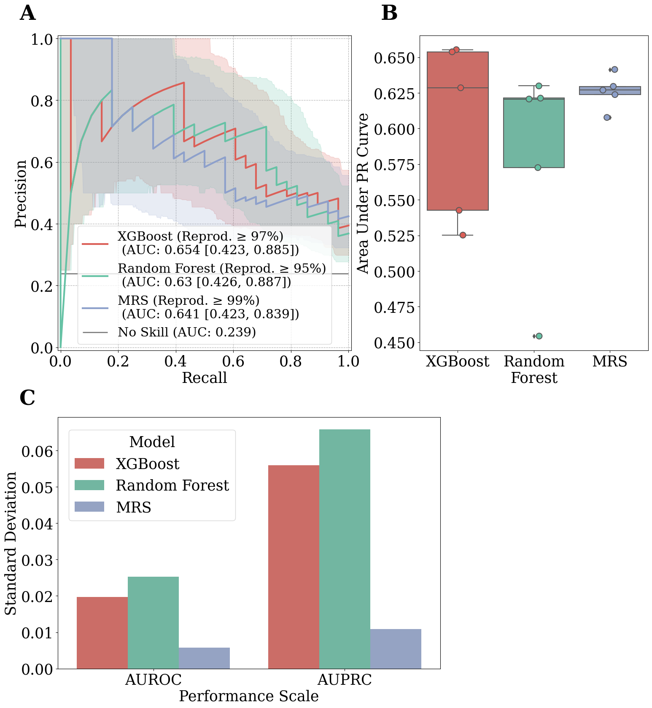

Fig. S3 Performance metrics for each anxiety disorder prediction model (XGBoost, MRS, Random Forest).
A) Precision-Recall (PR) curves for the biomarker sets with the highest Area Under the Receiver Operating Characteristic curve (AUROC) for each model type (XGBoost, Random Forest, MRS). The shaded regions indicate the 95% confidence intervals, while the legend displays the area under the ROC curve (AUC) and its corresponding 95% confidence intervals. Reprod = Reproducibility; B) Boxplot depicting each model type's Area Under the PR Curve (AUPRC) values. Each dot represents the model's performance for each of the five reproducibility thresholds. C) Barplot illustrating the standard deviation in performance (AUROC, AUPRC) across different biomarker sets for each model type (XGBoost, Random Forest, MRS).

Fig. S4 DNA methylation value patterns for regions with two or more biomarkers within 100bp for each sample.
The green line represents healthy controls, the orange line represents anxiety disorder patients, with the bold line indicating the group's mean value and the faint line indicating values for each sample. The positions of designated CpG sites as biomarkers within the region are marked with star symbols. A) Chromosome 7: 19708881 ~ 19709090. B) Chromosome 16: 30610179 ~ 30610388. C) Chromosome 17: 30379502 ~ 30379714. D) Chromosome 17: 38297034 ~ 38297237

Fig. S5 Boxplot showing the statistical significance of the methylation percentages for specific types of disorders among the 17 biomarkers exhibiting over 97% reproducibility.
The boxplot illustrates the methylation values of samples for each biomarker across different types of anxiety disorders. The position of each biomarker is indicated in the plot title, with significance levels denoted for differences between disease types. PD = Panic Disorder; SAD = Social Anxiety Disorder; GAD = Generalized Anxiety Disorder; HC = Healthy Control; A) chr1:45339798. B) chr7:19708981. C) chr7:19708988. D) chr7:19708990. E) chr10:632863. F) chr10:119892349. G) chr10:132767837. H) chr11:64304843. I) chr18:46104880. J) chr16:30610279. K) chr16:30610288. L) chr17:38297134. M) chr17:38297137. N) chr17:30379602. O) chr17:30379604. P) chr17:30379614. Q) chrX:2583990. ns: 5.00×10⁻² < p ≤ 1.00×10⁰; *: 1.00×10⁻² < p ≤ 5.00×10⁻² ; **: 1.00×10⁻³ < p ≤ 1.00×10⁻² ; ***: 1.00×10⁻⁴ < p ≤ 1.00×10⁻³ ; ****: p ≤ 1.00×10⁻⁴ ; Mann-Whitney-Wilcoxon test

